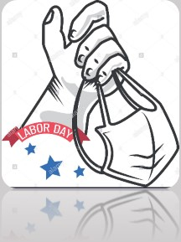
APPRECIATION is ESSENTIAL !!!!
(Especially to our 24/7 staff who have worked around the clock this holiday weekend!)

Typically, Labor Day marks the unofficial end to summer.
2020 has been anything but typical.
DCF leadership is very proud of the sacrifices made by our workforce in these trying times.
THANK YOU for making this abnormal circumstance WORK.

We also thank the labor unions' leadership who have WORKED hard with us over the past 6months on your behalf. We may not always agree… but we do have a common interest in balancing the needs of our workforce with that of service to the public.

There is certainly more uncertainty ahead…
What we know for sure is we will get through this TOGETHER!
#DCFstrongLABOR DAY2020!

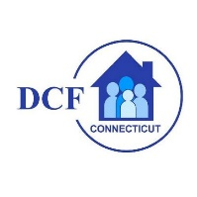
VANNESSA L. DORANTES, LMSW
COMMISSIONER
CT DEPT OF CHILDREN & FAMILIES
505 HUDSON STREET
HARTFORD, CT 06106

commissioner.dcf@ct.gov (860)550-6300
" I do my best because I'm counting on YOU counting on me…"
m angelou

