Healthy Working and PPE Tips for Staff
August 28, 2020
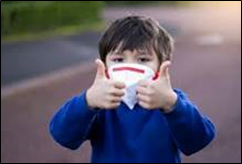
Our staff remain working diligently to ensure the children and families we serve are empowered and supported. While the pandemic has moved across the globe and affected each of our lives, the Department remained open- providing our mission critical work.

Visitation triage processes and protocols are in place to ensure in-person responses, including visitation between children in care and their families, are done so in a safe manner.

While over 80% of our staff are actively teleworking each day, there are circumstances where staff must report to an office or facility. It is important we remain vigilant to maintain the health and safety of our workforce.

We are providing you two videos which were produced in collaboration with Middlesex Community College. They review timely reminders about what to consider prior to entering the building and interacting with staff.

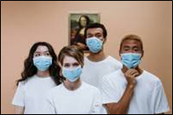
Staff have raised the questions of, "How can I return safely to work?" "Will my temperature be taken?" "Are staff going to be required to wear a mask?"

These and other questions are answered in this video: Healthy Working: A Return to the Workplace

Speaking of masks……. During our interactions with each other, as well as families, personal protective equipment (PPE) is expected to be utilized. this video was developed which provides guidance on the use of PPE.

Please take some time to view it here. Protecting Yourself: How to put on and take off PPE

We would especially like to thank the following individuals for their input and assistance:

Dr. Nicole Taylor
Elizabeth (Lisa) Bowen
Jane McFarlane
Liz Stokes
Paula Daquila
Melody Davis
Anna Cherian
Julie Flemmig

