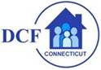

Resources for Families, Foster Parents and the Workforce - Return to School
August 21, 2020
The children and families we serve, our foster parents, as well as all of us in the workforce who are parents, may need help to navigate the uncertainties as children prepare to return to school.

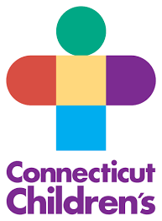
We have put together information for you which we believe will provide guidance in a number of areas from the Connecticut Children's Medical Center has prepared articles to support families.

One discusses how to prepare to have the back to school talk with your children: CCMC - Prepare for Back to School Talk. The other, tips on wearing a mask according to the age of the child: Tips to Make Kids More Comfortable with Mask Broken Down by Age

CCMC also provides this guidance on assessing the school environment and a checklist for parents: Connecticut Children's Back-To-School Kit.

These short videos discuss how to talk to children about many aspects of wearing a mask:

- CDC - How to Wear Masks
- Key Times to Wear a Mask
- How to Safely Wear a Mask
- Wearing a Mask Helps Stop the Spread of Germs
- Wear a Mask Song for Young Children

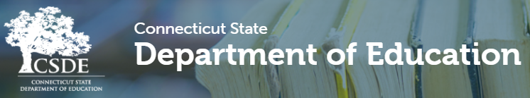

The State Department of Education has offered guidance to families to help them support their children. This link provides the school re-opening plans for all school districts: District Reopen Model Selection for the 2020-21 School Year

Take a look at the links below and share the information with the families who you are in contact with:

- Reopening FAQs Volume 1
- Reopening FAQs Volume 2
- Connecticut's Plan to Learn and Grow Together
- Reimaging Connecticut's Classroom

Lastly, UNICEF has also produced an article regarding what school may look like during a pandemic: What Will a Return to School Look Like

