

DPH Town Halls outreach campaign intended to increase
COVID-19 vaccine uptake within CT’s Black communities.
June 3, 2021
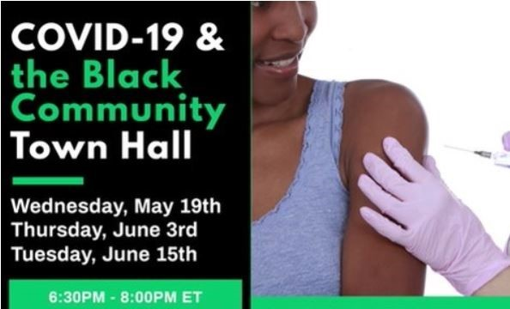
The state Department of Public Health is partnering with the Connecticut chapters of nine historically African American, Greek-lettered fraternities and sororities to combat COVID-19 vaccine hesitancy and increase access with the Black and Brown communities in the state.

Tonight, Commissioner Vannessa Dorantes will be a panel member through the Department of Public Health’s Trusted Messenger Forum program.

That program works to train and provide community leaders with methods to combat myths and misinformation with factual and scientific information about the COVID-19 vaccines, officials said.

As part of the partnership, these fraternities and sororities will hold a series of free town hall events that will include discussions with well-known doctors, clinicians, and public servants.

“This partnership is about stepping up to help our communities understand the vaccine and provide a direct connection to medical experts who can build trust in our health care system,” Lamont said.

He added that he was appreciative of the Connecticut chapters of the fraternities and sororities for standing up, taking leadership, and doing what is right for their members and allies.

Connecticut Public Health Acting Commissioner Dr. Deidre Gifford stressed due to the disproportionate impact on communities of color, the vaccine is proving to be one of the most effective tools we have against it.

“At the Department of Public Health, we are pleased to be working with community leaders like the nine historically African American fraternities and sororities to make sure everyone has factual, accurate information so that they can decide whether to get the vaccine,” she said.

The fraternities and sororities partnering in this initiative include: Alpha Phi Alpha, Alpha Kappa Alpha, Kappa Alpha Psi, Omega Psi Phi, Delta Sigma Theta, Phi Beta Sigma, Zeta Phi Beta, Sigma Gamma Rho, Iota Phi Theta.

Most have been in in existence for over 100 years and share the common goal to promote civic and social change through scholarship, advocacy and community service. Alpha Kappa Alpha Sorority Inc., Epsilon Omicron Omega Chapter has taken the lead in this effort to move this initiative forward in Connecticut.

Josie Wright, President AKA Inc, Epsilon Omicron Omega Chapter, said, “This panel is designed to share factual information and dismantle concerns surrounding the COVID Vaccine within the communities we serve.”

The schedule of the virtual town hall events is as follows:

- Community town hall event: Thursday, June 3, 2021, 6:30-8:00PM (Join the Webinar Meeting ID: 841 4616 0120 Passcode: 678815)
- Community town hall event: Tuesday, June 15, 2021, 6:30-8:00PM (Join the Webinar Meeting ID: 841 4616 0120 Passcode: 678815)

