

State Department of Education and Department of Public Health Release “Finish Strong” Guidance
April 9, 2021
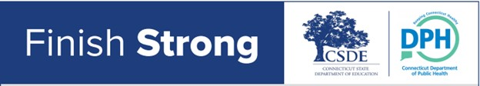
State Department of Education and Department of Public Health Release “Finish Strong” Guidance

Reminds School Communities that Everyone Has a Role in Protecting In-Person Learning for Remainder of 2020-21

(Hartford) – The Connecticut State Department of Education (CSDE) and Connecticut State Department of Public Health (CT DPH) have partnered to issue guidance identifying continued priorities for the 2020-21 academic year and into the summer to assist school administrators, teachers, school staff, students and families with finishing the final portion of the school year strong. The “Finish Strong” guidance affirms the importance of the mitigation strategies the state focused on this year, reminds school communities to remain vigilant despite warmer weather and vaccinations, and provides additional recommendations around the use of mitigation efforts in school, the community, and if traveling.

Connecticut schools have been setting a standard, nationwide, to provide students substantial in-person learning opportunities during the COVID-19 pandemic. Thanks to the ongoing efforts of districts, individuals and families to adapt, work together and protect each other, 99.9 percent of all students now have access to an in-school learning option.

Connecticut Learning Models*
March 29 - April 2
70.10%
Fully In-Person
27.40%
Hybrid
2.50%
Fully Remote
*Represents the percentage of public school districts offering a particular learning model during the reporting period. If a district is offering different models in different grades, the district is counted under the model offered in the majority of grades.

