

Channel 3 Sibling Camp Registration
April 8, 2021
Attached please find information related to this year's Channel 3 Sibling Connections Camp. Sibling Camp will be held: Sunday, August 8, 2021 through Friday, August 13, 2021.

The deadline for registration is July 1st and is done electronically at Channel 3 Sibling Camp Registration
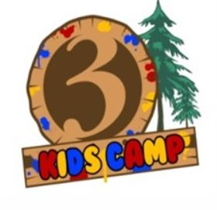
- Brochure
- COVID Safety at Camp
- Sibling Connections Website

Thank you once again to Jackie Ford for her coordination and efforts to make this happen!

We would like to have you quickly disseminate this to the Office Directors and for them to send to their staff.

In order to increase attendance, we have expanded eligibility to include:

- Children/youth placed in foster care or relative care are eligible to attend. Siblings who are placed in a shelter, group home or residential care facility will be considered.
- A sibling who has been reunified with parents or placed into an adoptive home is eligible to attend camp as long as one sibling is DCF-involved. The parent/guardian must provide authorization for them to participate.

Please contact Jacqueline.for@ct.gov with questions

