

Annual CAFAF Conference April 30- May 1, 2021
April 22, 2021
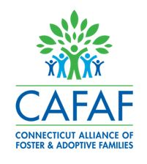


CAFAF 26th Annual Conference
“Foster Care the New Normal”
Friday, April 30 - Saturday, May 1, 2021
On the Zoom Platform

View the Conference Brochure!

Registration Link

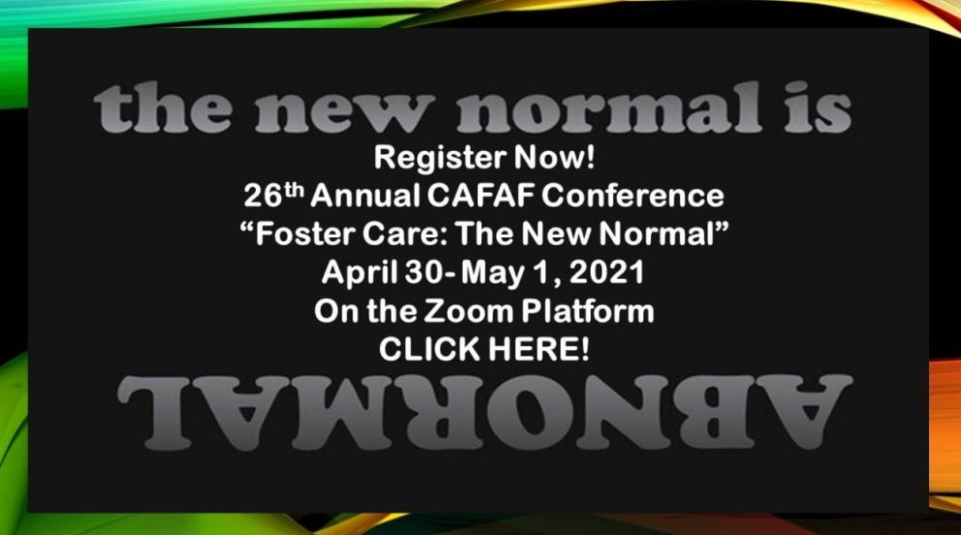

Contact:
Vanessa Williamson
Connecticut Alliance of Foster and Adoptive Families, Inc.
860-258-3400
vanessa.williamson@cafafct.org

