
Connecticut Adoption Day!
November 24, 2020
The Department of Children and Families celebrated Connecticut Adoption Day on 11/20/20!

And celebrate we did…………….. as over 25 children were adopted!
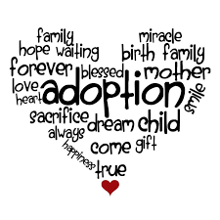
One preschooler, AJ, invited his entire class to watch his special day. For Gerricho, his adoption was finalized via a flat screen television which was set-up in his school's gym, as his first-grade classmates sat behind him and cheered. A standing ovation occurred when Isabella's adoption certificate was presented.

"Are you going to bang that round thing?" one young child asked the Judge as he referred to her gavel.

This year called for the partnership between DCF and the Judicial Branch to be creative in order to finalize adoptions during the pandemic - enter in Microsoft Teams. This technology resulted in families from New York, Oregon, Rhode Island, Canada, Copenhagen, Vienna and Serbia to participate remotely in the Connecticut hearings and experience this special day with their family members and friends.

Special thanks to Lieutenant Governor Susan Bysiewicz for her ongoing support and participation in two hearings!

There were tears of joy and appreciation for the dedicated and diligent Social Workers who worked so hard for the children and families they serve. "Thank God for people like you," stated one adoptive mother. "Quite literally you saved his life," was heard in another courtroom.

Please watch for next week's "Spotlight on What's Right" newsletter which highlights some very unique children and families.

Below are a number of links to media stories which highlight CT Adoption Day:

Capitol Report - Featuring Commissioner Dorantes
Capitol Report: One-on-One interview with DCF Commissioner Vannessa Dorantes

NBC 30 - Two Adoption Stories
‘CT Adoption Day:' DCF Commissioner On Keeping Kids Safe During the Pandemic

Fox 61
National Adoption Day 2020 goes on

WTNH
National Adoption Day: Children across the state finding their forever homes

