Central Bill Reconciliation Summary = 155
Go to reports/create

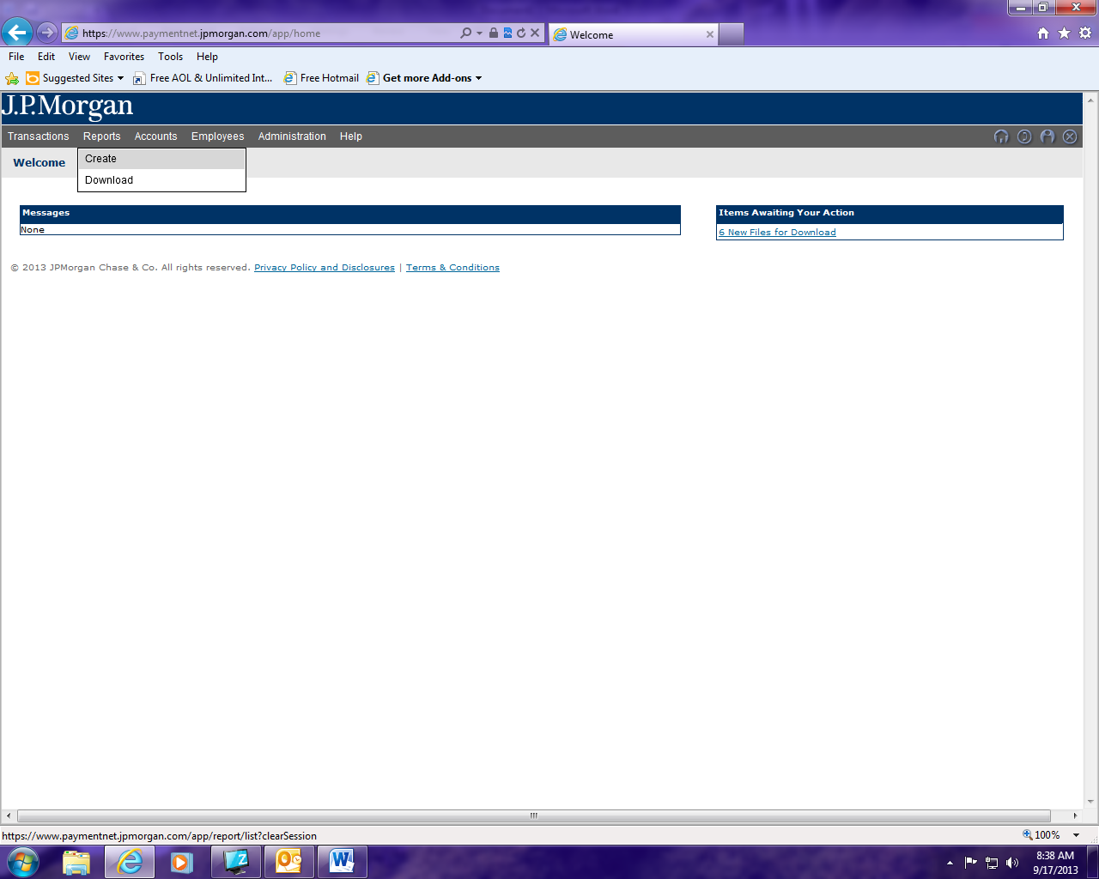

From the drop down menu select: Transaction

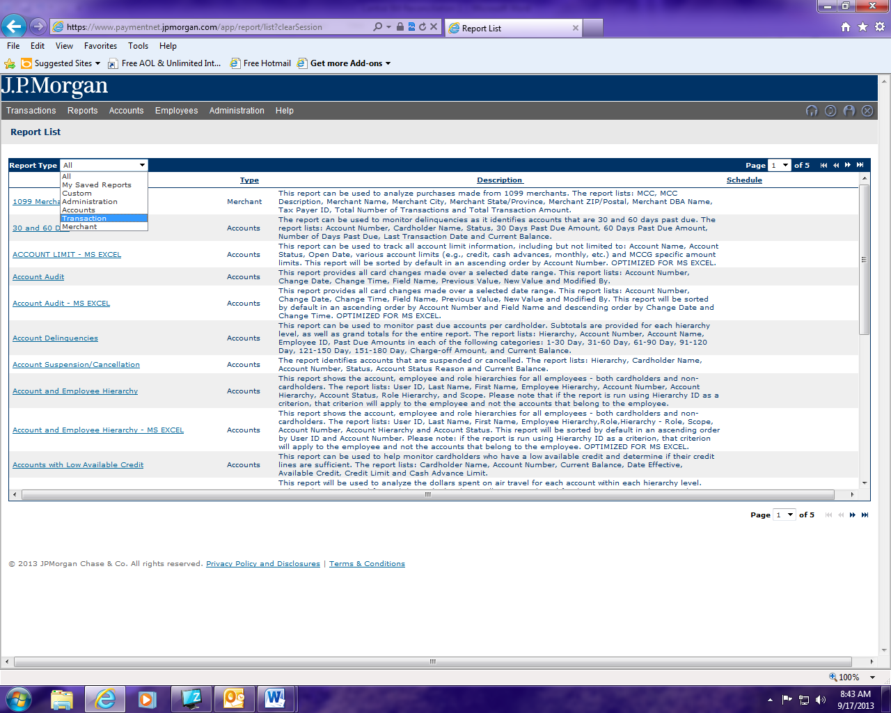

Locate report named Central Bill Reconciliation Summary and click on it.
Note this report can be run as either a PDF or excel document.

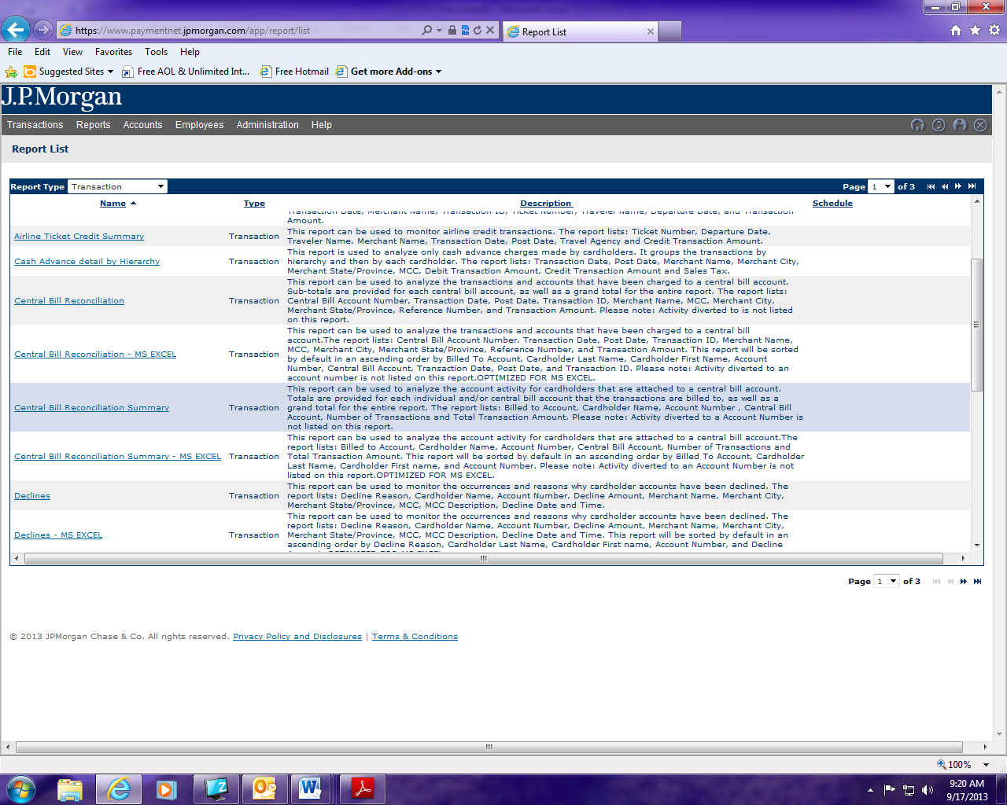

- If needed name your report/select report format
- Select your date range/from drop down menu select “cycle Is”/choose billing cycle needed
- Heirarchy: click on + icon and select your agency by clicking on the + sign next to ST of CT. Note if you know the ID for your agency you can just key it in.
- Click on process report.

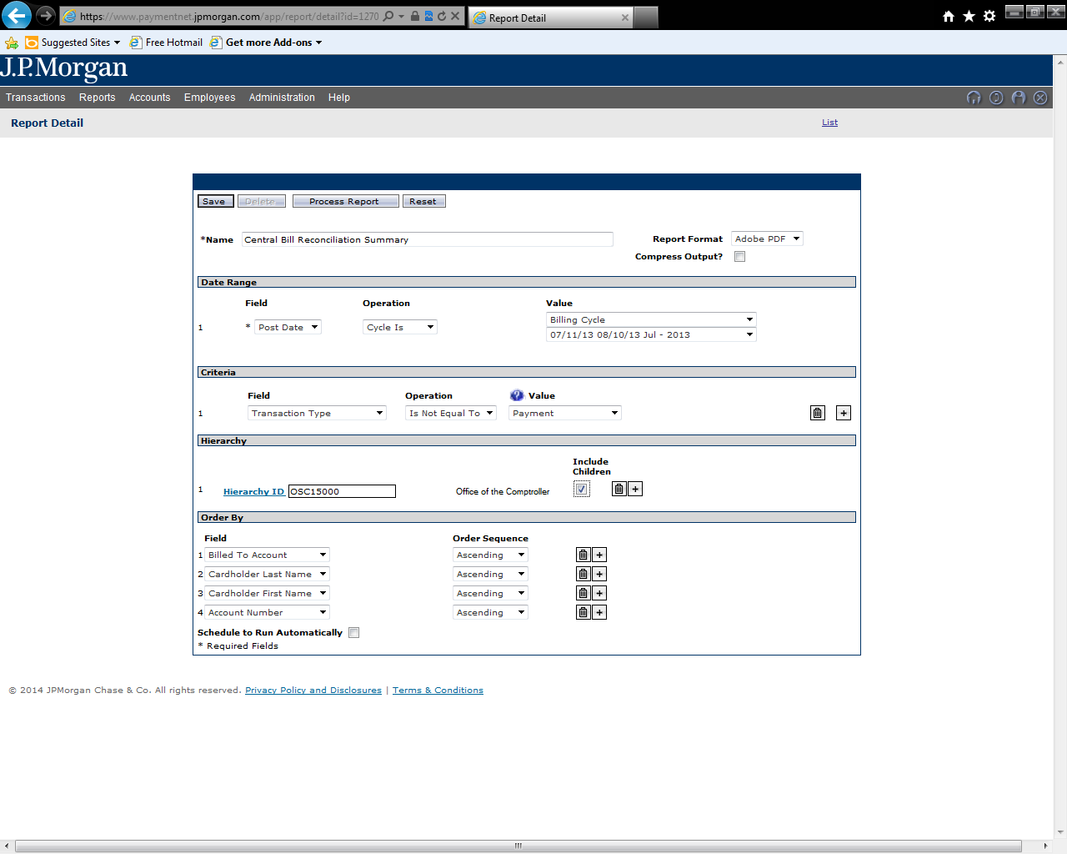

The reports available to download screen will come up showing the status of the report just run.
Once report status is succsessful run the report by clicking on report.

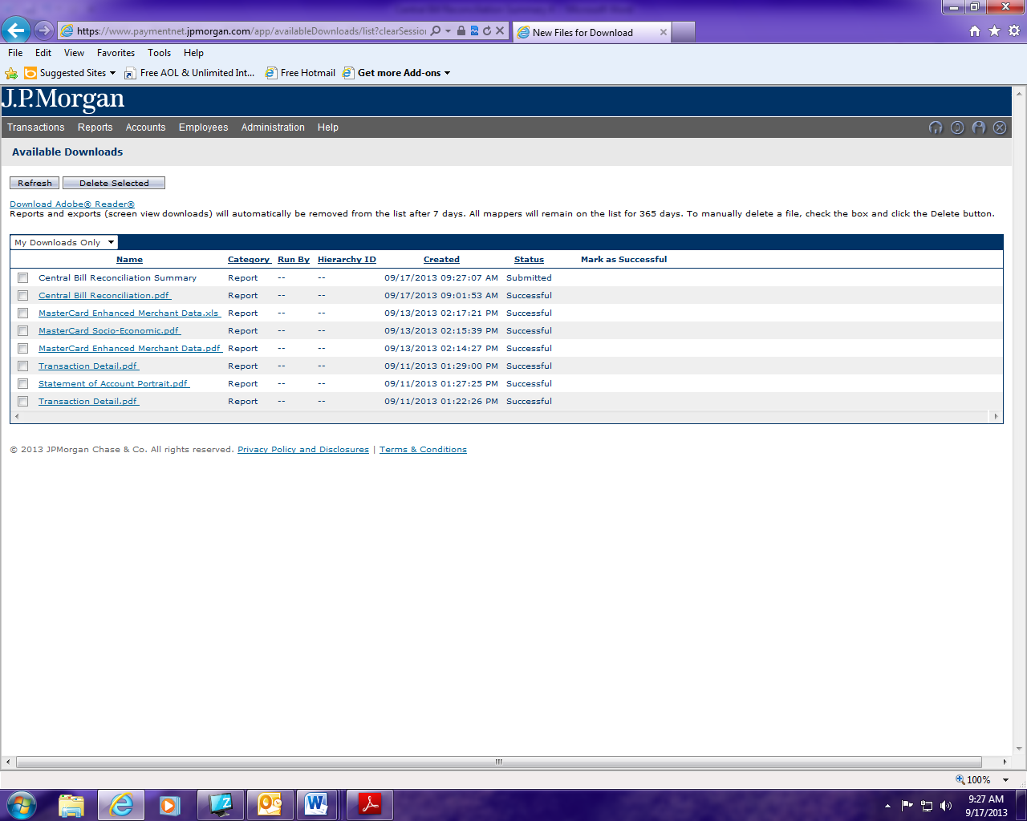

Once you have clicked on report to open you have the option to either open or save the report at bottom of the page.

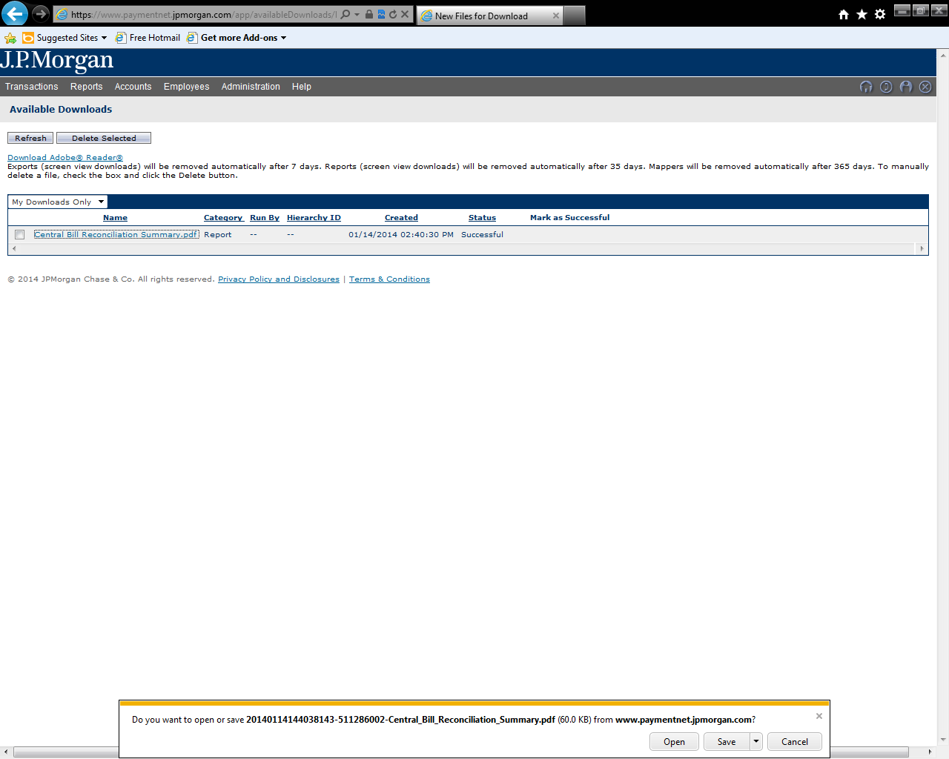

Sample Report / Central Bill Reconciliation Summary

