Billing Review User Instructions

- Go to the Chevin FleetWave link: https://fleetwave.das.ct.gov/FleetWave
- You can add the link to your favorites or create desktop shortcut
  - Favorites Bar Options:
    - Click the Star with arrow to add to favorites bar
    - Select Favorites Select Add to Favorites (Drop down list) or Select Add to Favorites Bar

- Create Shortcut:
  - Select File Select Send Select Shortcut to Desktop
- Login with your name and password. The system will bring to your Home Page:
- You have 5 modules (top left): Vehicles, Billing , Pool Booking Requests, Rental Records and Reports

- Vehicles Module: Lists all the vehicles assigned to your agency’s fleet. This will give you the Plate #, Equipment #, Monthly Lease Cost, VIN, Home Garage, Make, Model, Vehicle Type, etc.

- If you click on any of your vehicles plate # the summary page will appear. The 3 tabs you need are below:
  - Summary Tab: Summary information about the vehicle. This information will always remain the top box as you click different tabs for that vehicle.
  - PM Schedule: (Bottom box changes) Information on the next service dates of the vehicle.
  - Basics: More information of the selected vehicle.
  - Printer: (Last tab) You can print the information on the tab you are on.
- Billing: Shows you the billing for the month.
  - Select Month, Year, Agency, and click Run Report
  - Click Export to Excel to send the report to excel, if applicable
- Pool Booking Request: Shows the daily rental request in the system for your agency.
  - Request number, Status, Driver Name, Agency, From and To Dates.
- For more details click on a booking request number. It will give you a printable over view.
- Rental Records: Gives a list of the rental records that have been dispatched or returned.

- Select the rental code from the vehicle rental you would like to view.
- It will open up to a more detailed printable page showing dates, times, cost, miles driven, etc.
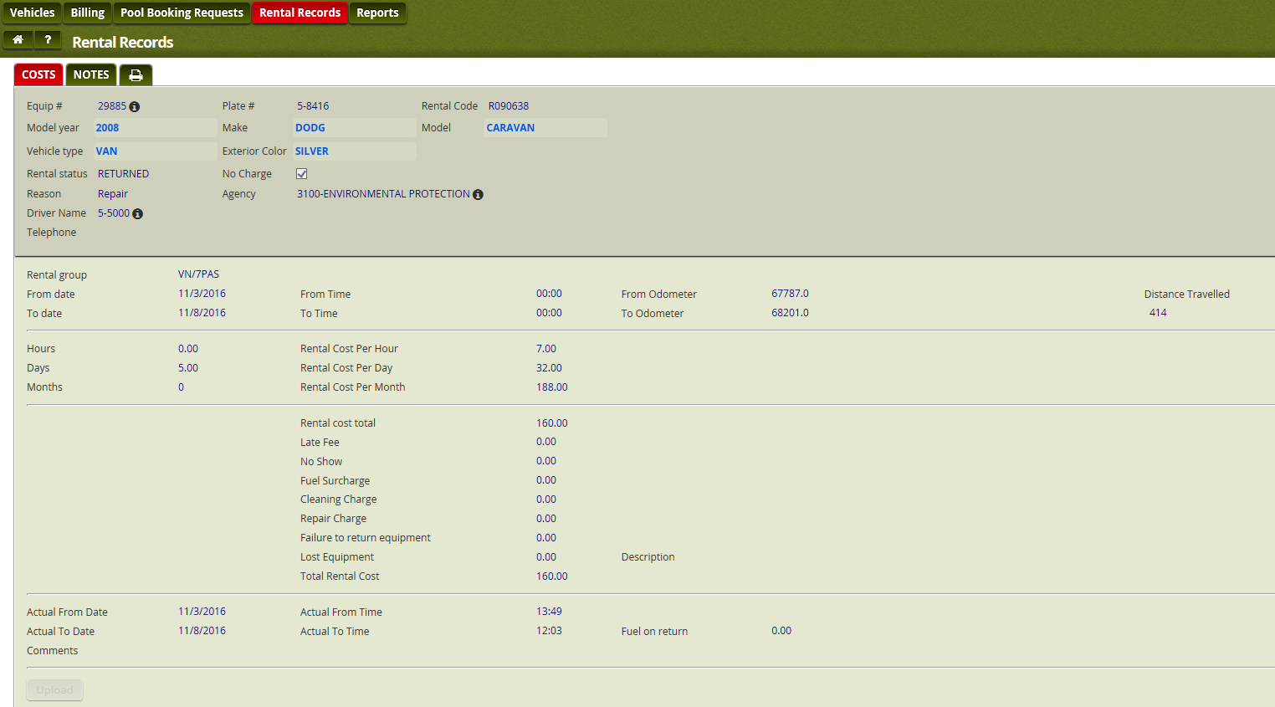

- Reports: Run reports based on your vehicles.
- Click the Report, Enter the next date you are looking for and click OK.
- Here you can view the vehicles that are due for either report. If you click on the equipment #, it will bring you to the vehicle view in the vehicle module
- If you click the print button you can print or export to Excel
- When you’re done, don’t forget to log off:
Things to note:
- This is an Excel based system, so almost all reports or pages can be printed or exported to excel.
- If you are done viewing something hit the CANCEL button on the page.
- If you forget your password, you can email Fleet to reset.

