ATA User Instructions

- Login with your name and password. https://fleetwave.das.ct.gov/FleetWave
- You can add the link to your favorites or create desktop shortcut
  - Favorites Bar Options:
    - Click the Star with arrow to add to favorites bar
    - Select Favorites Select Add to Favorites (Drop down list) or Select Add to Favorites Bar

- Create Shortcut:
  - Select File Select Send Select Shortcut to Desktop

- Login with your name and password. The system will bring to your Home Page:
- You have 7 modules (top left): Vehicles, Billing, Mileage Entry/Fuel, Batch Odometer Entry, Pool Booking Requests, Rental Records and Reports.
- You also have a KPI table (right top) which shows the emissions and service due dates for your agency’s vehicles. You can click on the KPI number boxes to open the report. If you click the print button, you can print or export to excel.

- Vehicles Module
  - Lists all the vehicles assigned to your agency’s fleet. This will give you the Plate #, Equipment #, Monthly Cost, VIN, Make, Model, Vehicle Type, etc.
- If you click on any of your vehicles plate numbers the summary page will appear. The 3 tabs you need are below:
  - Summary: Summary information about the vehicle. This information will always remain the top box as you click different tabs for that vehicle.
  - PM Schedule: (Bottom box changes) Information on the next service dates of the vehicle

  - Basics: Basic information of your agency’s vehicles.
  - Fuel: Shows when the vehicle fueled up at a DOT station
  - Printer: (Last tab) You can print the information on the tab you are on.
- Billing:
  - Shows you the billing for the month.
    - Select Month, Year, Agency, and click Run Report
    - Click Export to Excel to send the report to excel, if applicable

- Mileage Entry/Fuel:
  - View mileage entry for agency assigned vehicles.
    - You can search a specific vehicle, month, etc. to narrow down list

- Batch Odometer Entry
  - Enter Agency Pool Vehicle(s) Mileage
    - Click Search. If assigned to more than one agency then select the agency you need to add mileage in.
- Find the plate you are looking to report. Enter date read, odometer reading and click save.

- Pool Booking Request: Shows the daily rental request in the system for your agency.
  - Request number, Status, Driver Name, Agency, From and To Dates.
- For more details click on a booking request number. It will give you a printable over view.
- Rental Records: Gives a list of the rental records that have been dispatched or returned.
- Select the rental code from the vehicle rental you would like to view.
- It will open up to a more detailed printable page showing dates, times, cost, miles driven, etc.
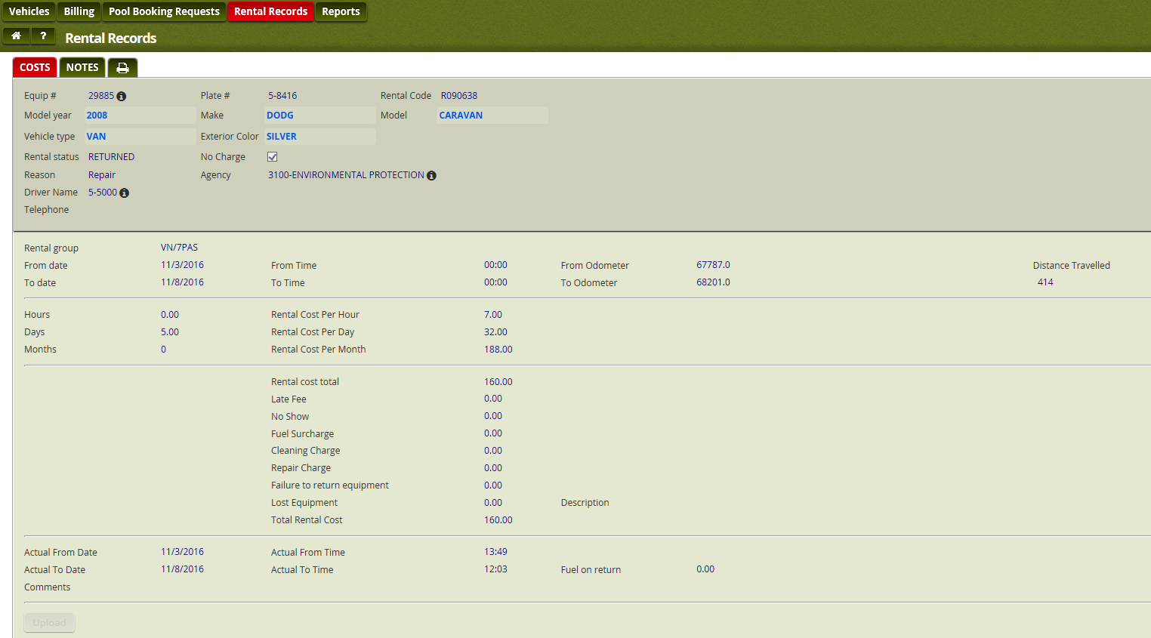

- Reports:
  - Run reports based on your vehicles. If you don’t see a report talk to your ATA and they can send us a request. We will try to accommodate the agency’s needs as best we can.
- Click the Report, Enter the next date you are looking for and click ok.
- Here you can view the vehicles that are due for either report. If you click on the equipment #, it will bring you to the vehicle view in the vehicle module
- If you click the print button you can print or export to excel
- When you’re done, don’t forget to log off:
Things to note:
- This is an Excel based system, so almost all reports or pages can be printed or exported to excel. Most pages have a button or a printer.
- If you are done viewing something hit the CANCEL button.
- If you forget your password, you can email Fleet to reset.

