DELETE THESE NOTES AFTER READING!
NOTES TO ARCHITECT/ENGINEER (A/E) & DAS/CS PROJECT MANAGER:
Insert project-specific available information behind these cover sheets. Insert the number of pages. Edit the Footer for the DAS/CS Project Number.
TEXT: Blue text is project-specific information that must be completed by the A/E as applicable to the specific project. When complete, change blue text to black text.
TABLES: To view table formatting in this MS Word document, click inside any table, then go to the Table Tools > Layout tab, Table group, and click View Gridlines.
HEADERS: The header for each page of the Project Manual shall match the format, font (Arial), size (9 pt), font style (BOLD & CAPITALIZED) and line borders, of the header shown herein. The header of each page shall contain the Section Number, the Section Title, and the page number & number of pages as shown herein.
FOOTERS: The footer for each page of the Project Manual shall match the format, font (Arial), size (9 pt), font style (BOLD & CAPITALIZED) and line borders, of the footer shown herein. The footer shall contain the project number in the right-hand side as shown herein. The revision date in the left side of the footer is to remain as it is for Department informational purposes only and should not be altered by the Architect/Engineer.
IMPORTANT NOTE REGARDING “HIDDEN TEXT”:
Some documents contain Editing Notes in the form of “hidden text”. The Editing Notes assist the Architect in modifying and editing the document to make it project-specific. In order to show the “hidden text”, click the Home tab, and in the Paragraph group, click the Show/Hide symbol (¶). Turn off the Show/Hide symbol (¶) before printing the document in order to indicate the correct number of pages.
IMPORTANT NOTE REGARDING FORMATTING:
Insert a blank page at the end of all odd numbered specification sections that states “THIS PAGE INTENTIONALLY LEFT BLANK”.

Section 50 10 00
Existing Conditions Information

Section 50 20 00
Environmental Assessment Information

Section 50 30 00
Hazardous Building Materials
Inspection and Inventory

Section 50 40 00
Subsurface Geotechnical Report

IMPORTANT NOTE REGARDING THIS ELEVATOR AGREEMENT:
Edit all elevator specification section names and numbers for hydraulic, traction, passenger freight elevators and etc. as is appropriate for the specific project. Add a requirement to all elevator specifications that mandates that the Contractor must obtain a signed copy of this Agreement from the Elevator Manufacturer prior to their submittal of elevator shop drawings for review and failure to receive a signed agreement will result in automatic rejection of the submittal. DELETE THIS NOTE.

Section 50 50 00
Elevator Agreement

ELEVATOR AGREEMENT
It is hereby agreed on this day of , between the State of Connecticut, Department of Administrative Services acting through its Commissioner, and acting through its that:
WHEREAS, the State of Connecticut owns several buildings which contain elevators manufactured by ;
WHEREAS, Provides a diagnostic device required for the complete service and maintenance of the elevators which diagnostic device has a six (6) month expiration date;
WHEREAS, the State of Connecticut retains several contractors and/or uses its own employees to service the elevators;
WHEREAS, the State of Connecticut finds any expiration period an excessive burden on the service and maintenance of the elevators;
NOW, THEREFORE, for good and sufficient consideration of $1.00 (one dollar) the parties agree as follows:
- shall provide the State of Connecticut with the proper diagnostic devices to service all , Inc. elevators in all state buildings at no cost to the State of Connecticut.
- The diagnostic devices shall not contain an expiration date or the use of any proprietary restraint and will be capable of servicing and maintaining the elevators for their life.
- In the event deems it necessary to update the diagnostic devices it shall exchange such devices at no cost to the State of Connecticut. The updated diagnostic devices shall not contain an expiration date and will be capable of servicing and maintaining the elevators for their life. This upgrade will occur prior to previous tools date of expiration.
- All employees of the State of Connecticut duly qualified or licensed and any contractors retained by the State of Connecticut to service and/or maintain the elevators shall use the diagnostic devices solely for the purpose of conducting normal service and maintenance activities.
- All employees of the State of Connecticut duly qualified or licensed and any contractors retained by the State of Connecticut to service and/or maintain the elevators shall not themselves or otherwise give, lend, sell, advertise, transfer or permit access to or the use of the diagnostic devices, in part or whole, in any manner by any means, by any other person.
- The State of Connecticut understands that the diagnostic devices are capable of programming and/or reprogramming critical equipment, operating performance functions and reprogramming critical equipment functions and parameters including safety and/or test sequences. Improper use may produce unsafe operating conditions.
- The State of Connecticut agrees that is not responsible for the results of the improper use, either directly or indirectly, of the diagnostic devices, unless the device is defective.
- The State of Connecticut agrees to make all reasonable efforts necessary or appropriate to maintain and protect the diagnostic devices and shall promptly notify in writing, of any unauthorized use, possession, loss or theft of the diagnostic devices in part or whole.
- This Agreement shall be interpreted and enforced pursuant to the laws of the State of Connecticut in the Superior Court for the Judicial District of Hartford, at Hartford, Connecticut.
Witness |  | [insert name of Commissioner]
 |  | Commissioner,
Witness |  | State of Connecticut
 |  | Department of Administrative Services
Witness |  | [insert name of signer and title]
 |  | [insert name of Elevator Manufacturer]
Witness |  | [insert address of Elevator Manufacturer]
End of Section 50 50 00 Elevator Agreement

Section 50 60 00
FM Global Checklist for
Roofing Systems

SAMPLE FM GLOBAL CHECKLIST FOR ROOFING SYSTEMS – page 1
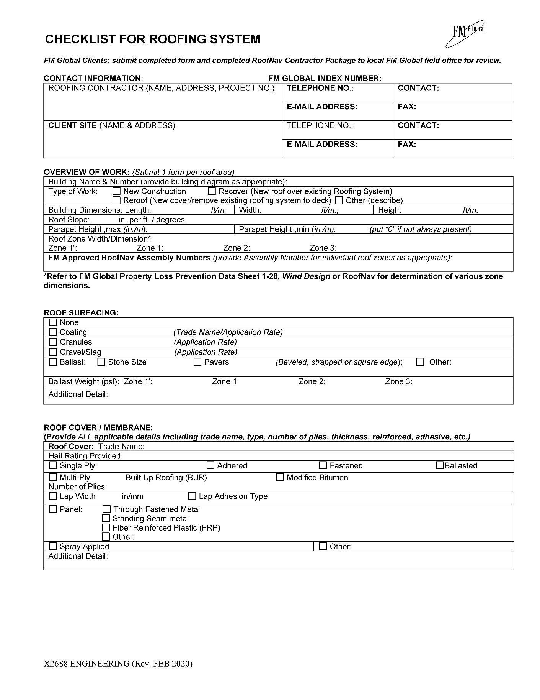

SAMPLE FM GLOBAL CHECKLIST FOR ROOFING SYSTEMS – page 2
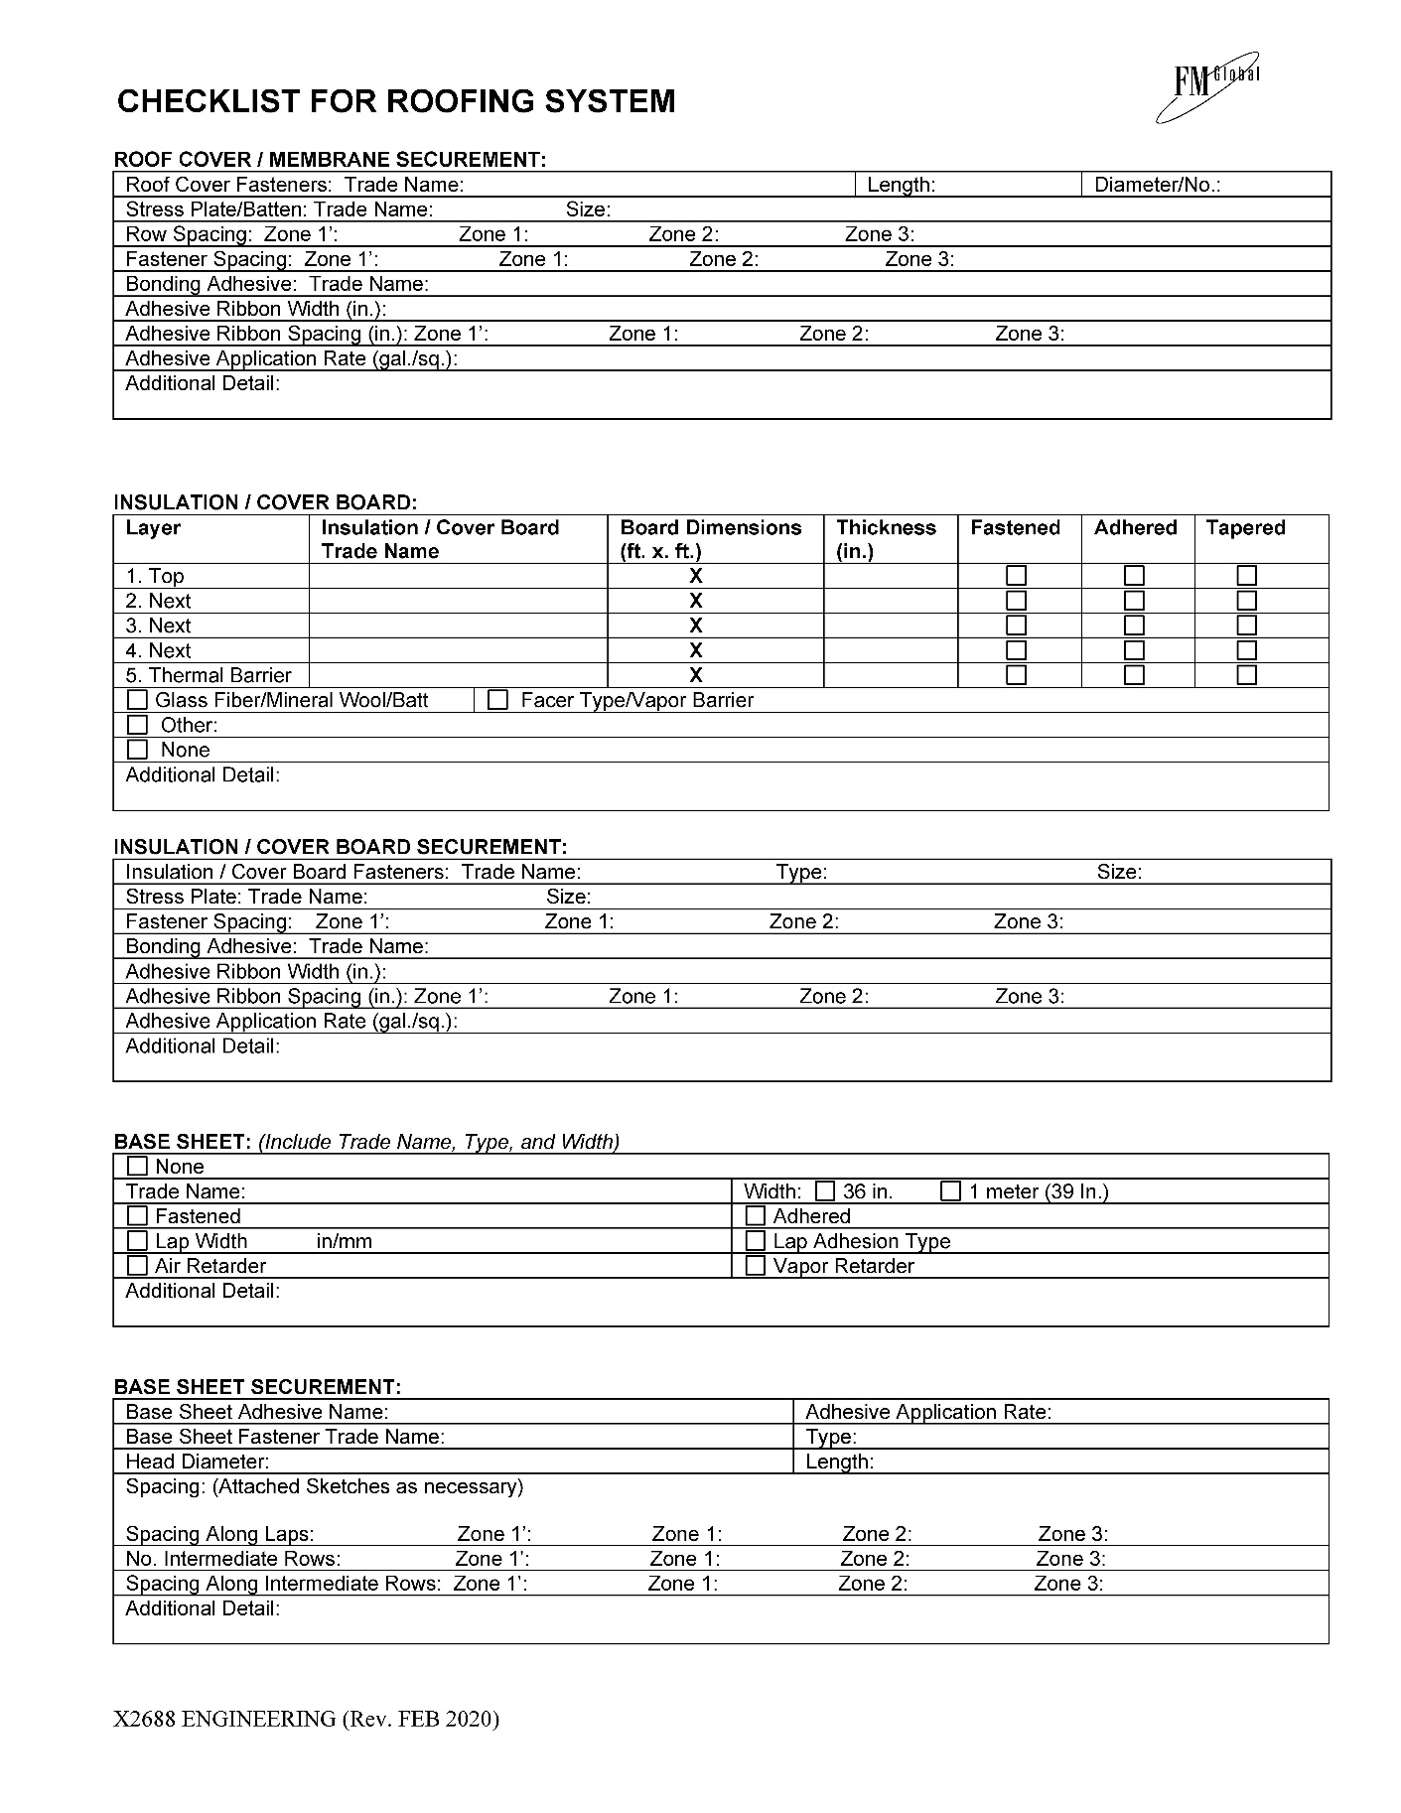

SAMPLE FM GLOBAL CHECKLIST FOR ROOFING SYSTEMS – page 3

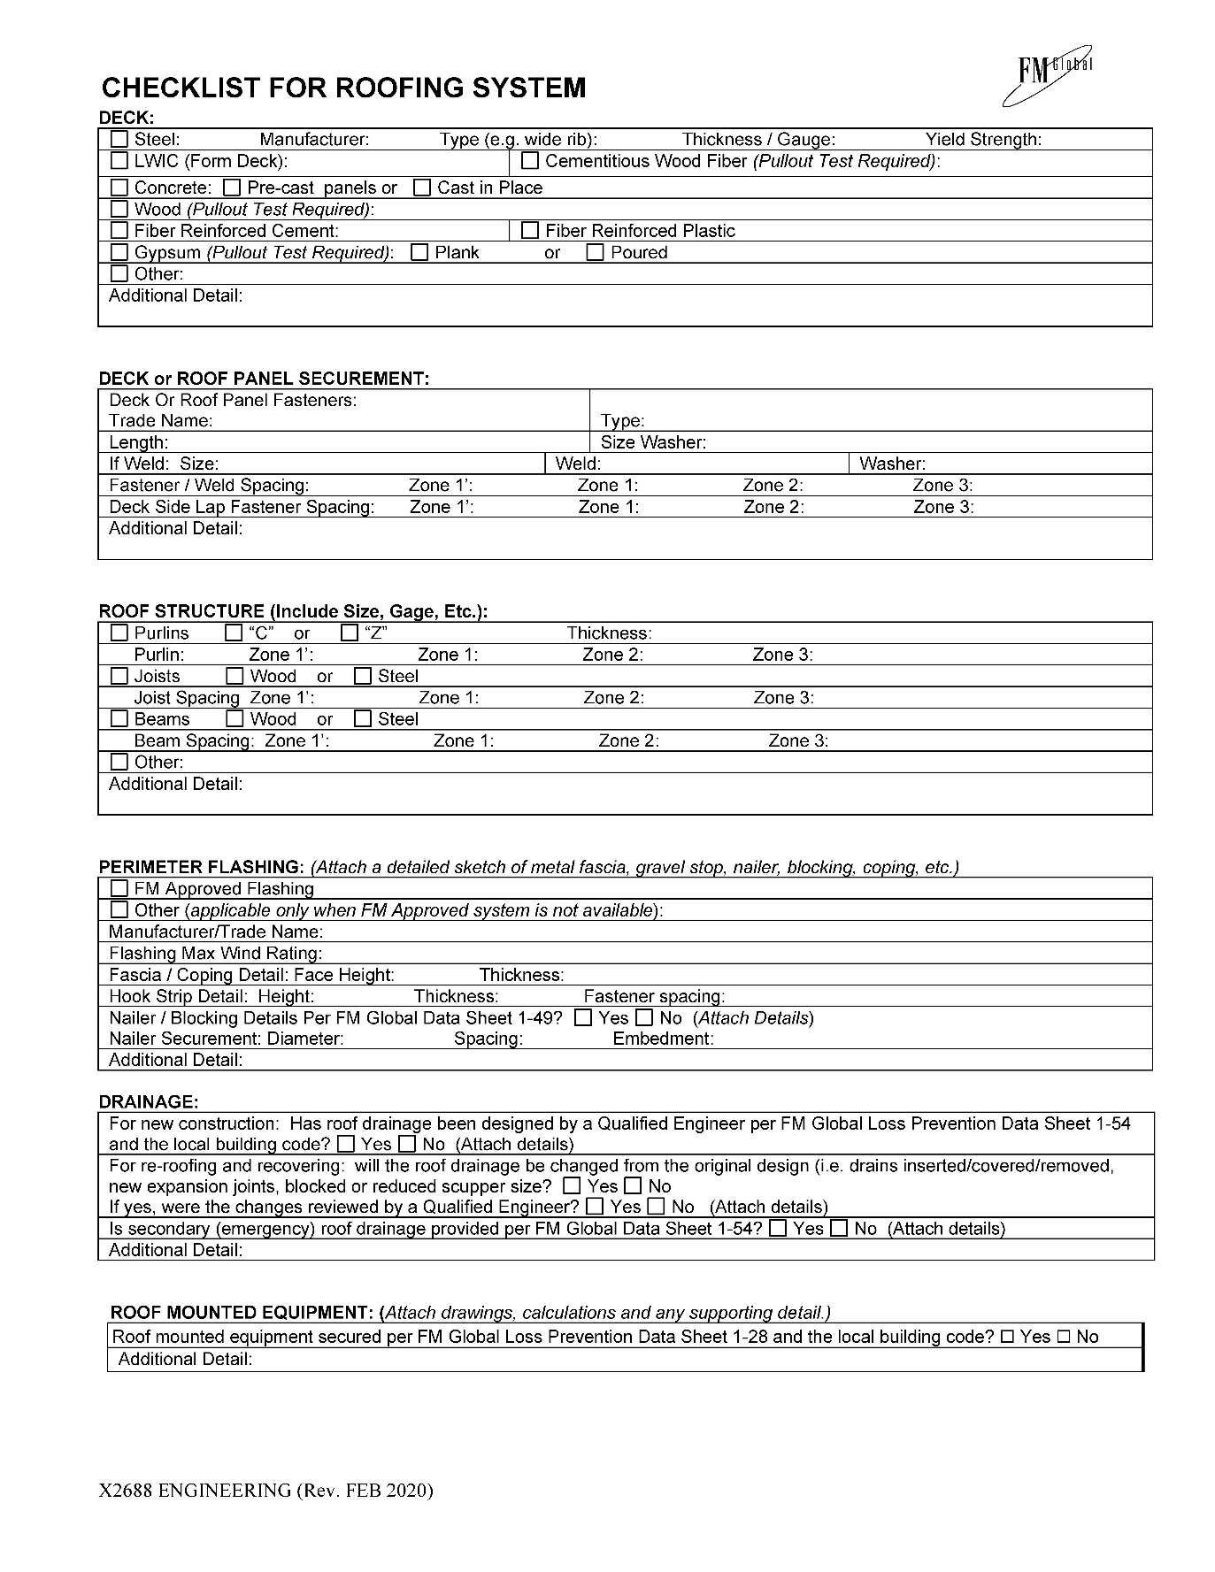
End of Section 50 60 00 FM Global Checklist for Roofing Systems

Section 50 70 00
Statement of Special Inspections

Section 50 80 00
Other Information

Subsection 50 80 00.1
[Insert Name of Report, etc.]

Section 50 80 00
Other Information

Subsection 50 80 00.2
[Insert Name of Report, etc.]

Section 50 80 00
Other Information

Subsection 50 80 00.3
[Insert Name of Report, etc.]

