**Annual Report**

**2014**



The Road to a

Good Life For Everyone

The Connecticut

Council on

Developmental Disabilities



The Connecticut Council on Developmental Disabilities

460 Capitol Avenue

Hartford, CT 06106

860-418-8737

800-653-1134

[**http://www.ct.gov/ctcdd/**](http://www.ct.gov/ctcdd/)

**Molly Cole, Director**

[**molly.cole@ct.gov**](mailto:molly.cole@ct.gov)

**Cathy Adamczyk, Disability Policy Specialist**

[**Cathleen.adamczyk@ct.gov**](mailto:Cathleen.adamczyk@ct.gov)

**Donna Devin, Program Assistant**

[**Donna.devin@ct.gov**](mailto:Donna.devin@ct.gov)

**Council Mission**

**The Council Mission is to Promote the Full Inclusion of All People with Disabilities in Community Life.**

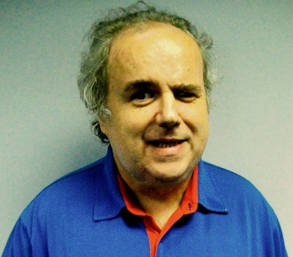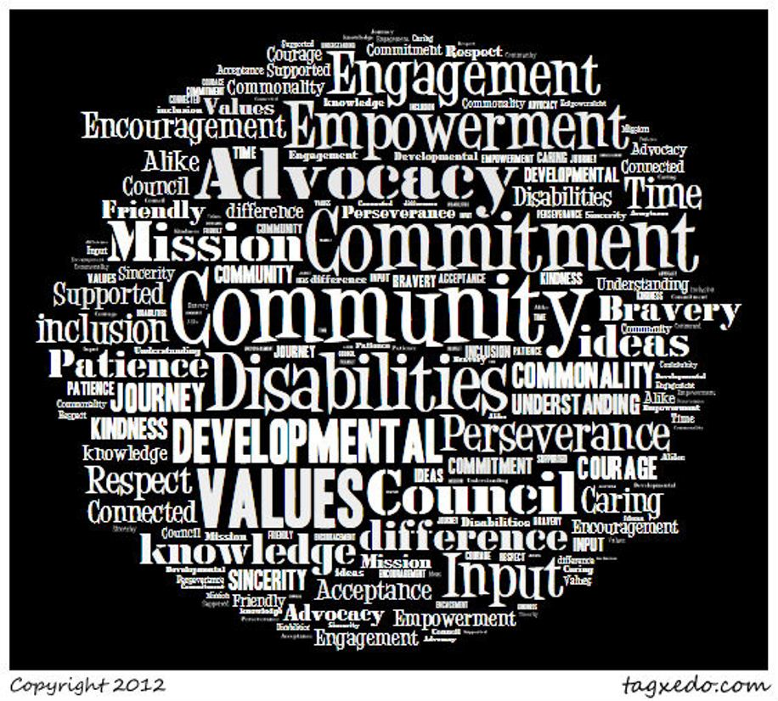

**Welcome Letter From Shelagh McClure**

**Chair, CT Council on Developmental Disabilities**

**As the Chair of the Council on Developmental Disabilities, I am pleased to write this welcome letter for our 2014 Annual Report.**



**This has been a busy year for the Council. Once again, the Council supported Partners in Policymaking leadership and advocacy training, in partnership with the Office of Protection and Advocacy for Persons with Disabilities and the University of Connecticut Center for Excellence in Developmental Disabilities. The Council has worked hard to implement many initiatives that can assist families and self-advocates in building good lives in their communities. These include customized employment, housing and on-demand transportation initiatives. Additionally, the Council has supported two youth leadership efforts: the Ct All Abilities Alliance and CT KASA.**

**Moving forward, we have begun a multi-year system change initiative which we are calling Campaign 2020. With our DD Network partners and others, we have called for the closure of Connecticut's remaining state-run institutions housing individuals with intellectual disabilities by the year 2020, moving the residents to new homes and fuller lives of participation and inclusion in the community AND rededicating the dollars saved to serve those with I/DD waiting for services."**

**The Council continues to build partnerships to promote the full inclusion of people with disabilities in their communities across our state as we travel down the road to a great life.**

**Sincerely,**

**Shelagh McClure, Chair**

**Council Funded Initiatives**

**Emergency Preparedness Training for People**

**with Access and Functional Needs**

**Grantee:** New Britain Emergency Medical Services

**Funding**: $65,000

This project was funded to improve the readiness of municipalities and people with disabilities to respond in emergency situations, to develop community planning councils that effectively engage consumers in planning emergency response, and to implement training in an array of organizations and communities across the state. Project outcomes include training materials and a website, *The Readys,* which can be found at<http://www.readystraining.com/>

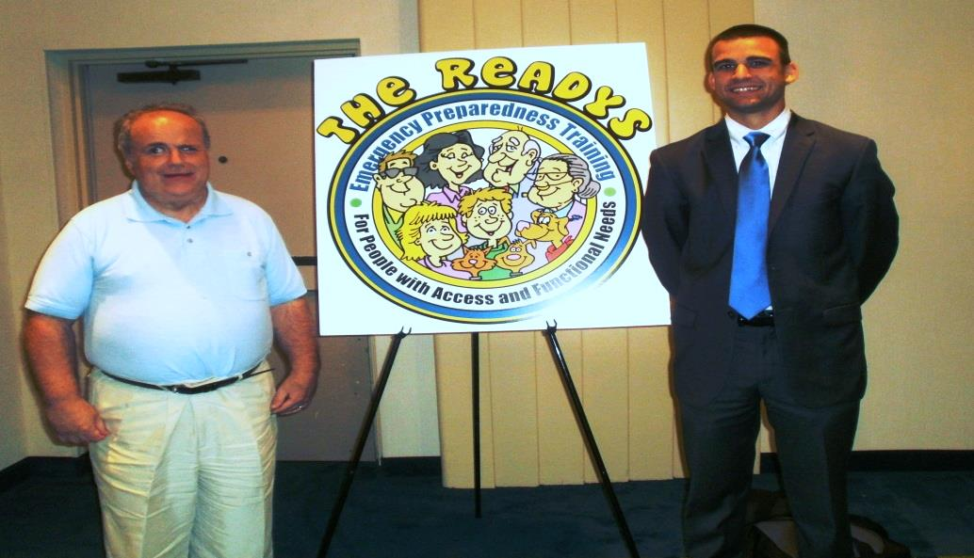

**Creating a Framework to Improve School Climate**

**for Students with Disabilities**



**Grantee:** Governor’s Prevention Partnership

**Funding:** $60,000

The goal of this initiative was to develop, implement and evaluate a pilot project to improve school climate for students with disabilities, which will mitigate bullying and harassment of students with disabilities. This included the development of materials for a school wide All Abilities Alliance, which is a student run effort to involve all students in disability awareness and other activities. The project has developed a handbook to assist other schools in developing this Alliance. <http://www.preventionworksct.org/resources/all-abilities-alliance-handbook.html>



***The All Abilities Alliance***

**Supporting Employment With Technology**

**Grantee:** CT Department of Developmental Services

**Funding:** $100,000

The Department of Developmental Services, in partnership with the New England Assistive Technology Center is implementing a project to work with providers who serve employed individuals. The goal of the project is to evaluate feasibility and develop recommendations for system-wide training needed to advance the use of iPad technology. A total of 15 provider agencies from across the state applied to be a part of this project. All applicants were offered introductory training at NEAT on the iPad’s basic navigation, accessibility features, pre-installed applications and accessories, and will be provided various resource materials throughout the course of the pilot program. Three provider agencies, have received extensive iPad training, assistive technology evaluations and technical assistance for the providers and the individuals they serve. Results of the pilot will be used to guide the design and development of DDS policies and procedures to effectively use iPad technology in supporting the employment of persons with intellectual disabilities in competitive employment positions.

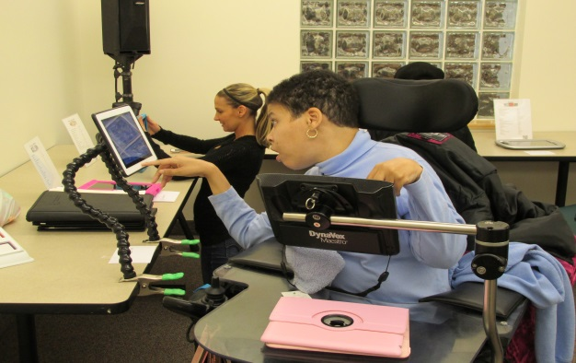

**Emergency Preparedness Training Project**

**Grantee:** University of Connecticut Center for Excellence in Developmental Disabilities

**Funding:** $89,074

The goal of this project is to develop and implement an emergency preparedness training curriculum for municipalities, first responders, community emergency response teams and people with disabilities. This curriculum will include some of 'the basics' about supporting people with disabilities in emergencies that are covered by existing programs and will also address specific “how-to's”. The curriculum will consist of a 'common core' of information that everyone should know, as well as three components geared toward the three distinct audiences. To accompany the curriculum, a detailed training manual as well as a train-the-trainer video will be developed and disseminated. An underlying theme will be that 'fair is what every person needs' and that there is great value of being creative in 'thinking out of the box' (e.g., honoring the request of family of a child with complex medical needs for ambulance transport of the entire family and child's equipment, not to the hospital, but to a familiar relative's home for temporary whole-family accommodations and 'nothing about me without me').

**Consumer Involvement Fund**

**Grantee:** Council on Developmental Disabilities Initiative

**Funding:** $5,000

The goal of the Consumer Involvement fund is to provide financial assistance for self-advocates and family members to attend conferences and meetings that will grow their leadership skills and knowledge.

**Connecticut Cross Disability Lifespan Alliance**

The CT Cross Disability Lifespan Alliance has a membership of over 70 individuals and organizations across the state. The Alliance met with Allan Bergman to craft its operating guidelines, which were adopted in March 2014. Funded through the Council, the Office of Protection and Advocacy for Persons with Disabilities and the University of Connecticut Center for Excellence, the Alliance hired a part time coordinator, who is contracted through the State Independent Living Council. The SILC also houses the Disability Calendar, an interactive calendar that can be found at <http://www.calendarwiz.com/ctdisabilityeventcalendar> The Alliance is led by a Steering Committee, with membership from 10 organizations, which oversees the Alliance work and meets monthly.

In 2013-14 the Alliance met at Manchester Community College and at the Beth El Temple in West Hartford. The Alliance meets six times a year to review issues and initiatives in the state that affect people with disabilities. This year, the Alliance adopted position papers on core issues of Housing, Employments and Transportation. They also coordinated a response to the proposed changes in funding for customized wheelchairs. As part of this response, the Alliance is now a member of the DSS Wheeled Mobility Committee.

The Connecticut Cross Disability



Lifespan Alliance

**ONE**

**VOICE**

Partners in Policymaking 2014

The Council, in partnership with the UCEDD and the Office of Protection and Advocacy, implemented Partners in Policymaking leadership training. This partnership venture utilized staff and resources from the Council and leveraged funds and support from our DD Network partners. Twenty-seven participants were selected for this program, including twelve self-advocates and fifteen parents. This intense leadership training program consisted of seven overnight sessions at a hotel. The content is based on a nationally recognized curriculum and included legislative advocacy, effective advocacy strategies, communication, disability policy, history, IDEA, assistive technology and strategies to run a meeting. All participants completed an advocacy project during the training. Graduates now serve on Boards, Commissions, Councils and in an array of advocacy efforts across the state.

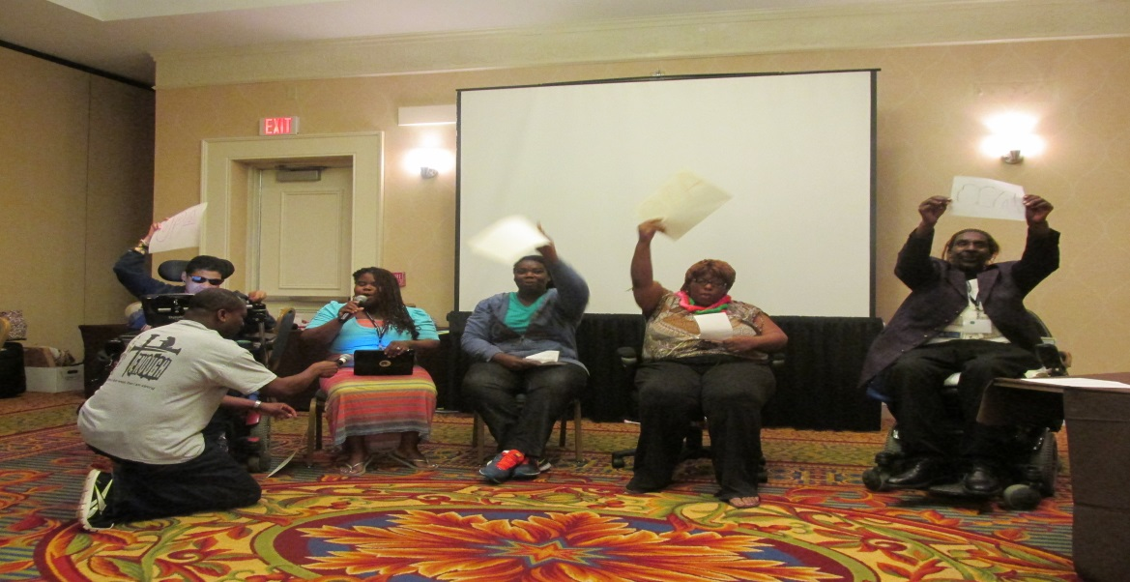

**Council Members**

**Chair Vice Chair**

**Shelagh McClure, West Hartford Antonio Orriola, New Britain**

**Family Member Self-Advocate**

**Self-Advocates**

April Burke

North Windham

John Curtin

Bolton

Michelle Duprey

New Haven

Michelle Johnson

Manchester

Zuleika Martinez

Bridgeport

Meg McDermott

Unionville

Adam Stuhlman

Middletown

**Family Members**

Michelle Chase

Bloomfield

Jacqueline Jamison

Stratford

Sabra Mayo

Hartford

Rabbi James Rosen

West Hartford

Brenda Stenglein

Ashford

**Non-Profit Agencies Serving People with Developmental Disabilities**

Chris Blake

SARAH-Tuxis

East Haven

Joyce Lewis

Key Human Services

Wethersfield

**Federally Mandated Representatives of State Agencies**

Thomas Boudreau

State Department of Education, Hartford

Mark Keenan Department of Public Health, Title V

Hartford

Alicia Kucharczyk Bureau of Rehabilitation Services, Hartford

Melissa Morton Department on Aging, Hartford

Ada Suarez

Office of Protection and Advocacy, Hartford

Christine Sullivan

UConn Center for Excellence in Developmental Disabilities, Farmington

Robin Wood

Department of Developmental Services

Hartford

**Council Staff**

**Director**

Molly Cole

**Disability Policy Specialist**

Cathy Adamczyk

**Program Assistant**

Donna Devin

**Contact the Council**

460 Capitol Avenue

Hartford, CT 06106

800-653-1134

860-418-8737

[www.ct.gov/ct](http://www.ct.gov/ct)