Minutes
CT Council on Developmental Disabilities
New Five Year Plan Committee Meeting
September 29, 2025, Monday
2:00 p.m. – 3:00 p.m.
On Teams

Present: Fran Traceski, Council Chair

Absent: Michelle Baughman, Andy Cirioli, Emily Cowen, Council Vice Chair and Committee Vice-Chair, Karen Healy, Elena Poma, Kathie Strout, Committee Chair;

Staff: Walter Glomb, Executive Director

Recorder of Minutes: Donna Devin, Program Assistant

- Call to Order with No Quorum: The meeting was called to order at 2:08 p.m. without a quorum.

- Report By Council Executive Director: Walter Glomb, Council Executive Director, gave a presentation on the content and timeline of the Council’s new Five-Year State Plan:

Development of a New Five Year State Plan for 2027-2031
- A new State Plan is due on Sat., August 15, 2026.
- The Plan must be published for 45 days of public comment.
- If the public comment is reviewed by the Council meeting on Tues., July 14, 2026
- then the draft plan must be published before Sat., May 30, 2026
- and approved by the Council at the meeting on Tues., May 12, 2026
- so new Goals and Objectives must be written in April 2026.
- New Goals and Objectives must be based on unmet needs that are identified in a Comprehensive Review and Analysis (CRA) of services, supports, and other assistance to individuals with developmental disabilities and their families in accordance with DD Act Sec. 124(c)(3).

Walt would like the CRA finished for January, so the committee can start having data based discussions on what Council goals and objectives should be. Following are Walt’s list of unmet needs in the state:

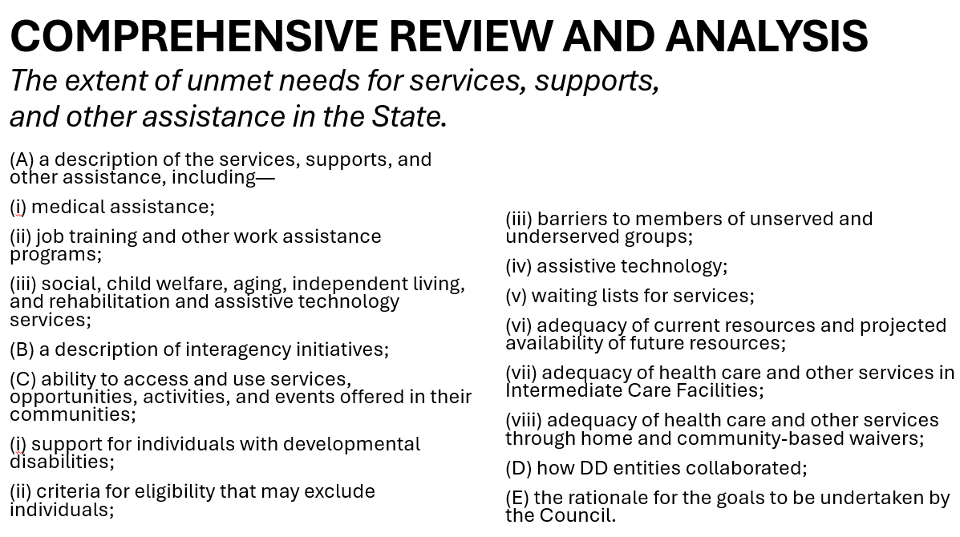

Before the meeting, Walt also sent an email to the committee containing the fourteen detailed summaries he compiled, edited, and wrote on the unmet needs listed in the CRA, most of it gleaned from state websites and their departments and different programs. His goal was to gather all the sources and put them in one place with a list of citations. Reports are also expected from some of the Council’s grantees such as the Center for Children’s Advocacy (CCA) on the needs of children with developmental disabilities. A survey is also being designed.

Walter Glomb, Executive Director, said it is most important for the committee to choose goals and objectives to address the most significant unmet needs. To aid them in doing this, the group needs to use the old summaries they received and create updated versions of them. The DDS Act contains a section that says in the state plan, the Council is supposed to justify the goals and objectives that they chose, based on data.

Walt said once the big gaps are identified and where the unmet needs are, then the question can be asked what can the Council actually do about them? If money is going to be spent, what can the Council do to really make a difference? What is the process, the path the Council can take that might make a difference where they can spend some money and improve things?

Another priority of the Council should be to focus on building relationships with the state healthcare cabinet, the Connecticut Commission on Human Rights and Opportunities (CHRO), the Commission on Women, Children, Seniors, Equity, and Opportunity (CWCSEO), and the State Office of Policy and Management (OPM), etc.

Fran Traceski, Council Chair, suggested the Council continue putting together smaller demonstration projects. Walt is interested in seeing those scaled up and pointed to former Council grantee, Futures, as an example.

Updating the unmet needs can be done by committee members individually and in their own time. Extra meetings aren’t necessary.

Walt sees the Eligibility issue as being big. Data supports it and more work should be done on it. He can write a memo or 2 to present the data on it.

The Civil Rights issue is significant. The state will be taking on more of it in the coming year.

Walt wants to stress to Council members that if there’s something they really care about and want the Council to work on, now is the time to speak up about it. It can be done via email. Once the new Five Year Plan is in place, it will be very difficult to shuffle priorities around.

- Adjournment: The meeting adjourned at 2:55 p.m.

