5 YEAR PLAN COMMITTEE MEETING – MARCH 5, 2026, THURSDAY

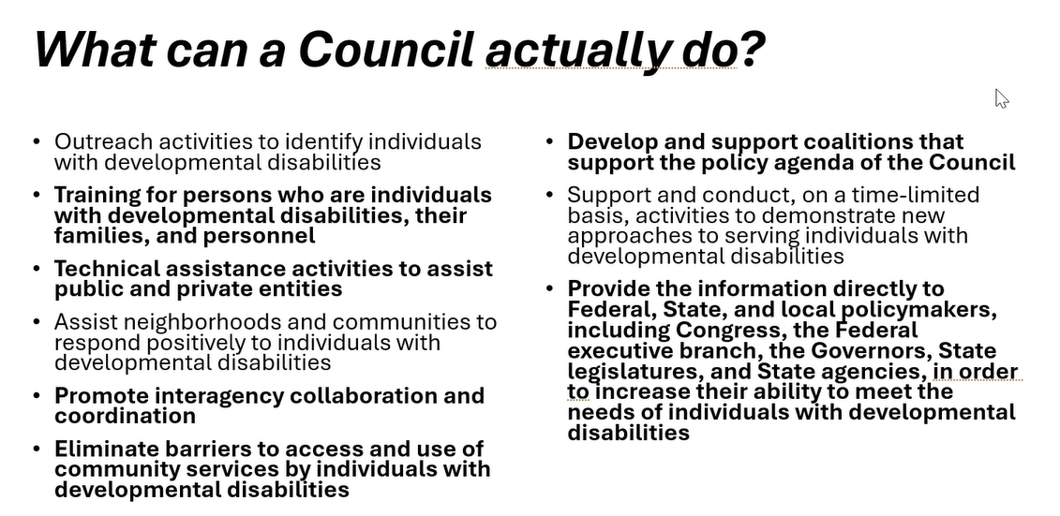

LENA
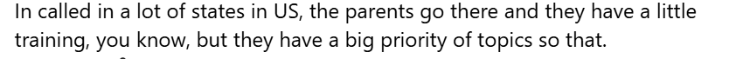But we don’t have anything, especially for parents or individuals with disabilities.
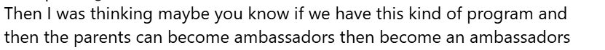
strengthen
