DOCKET NO. 288 – AT&T Wireless PCS, LLC d/b/a AT&T Wireless and Valley Communications, Inc. application for a Certificate of Environmental Compatibility and Public Need for the construction, maintenance and operation of a wireless telecommunications facility at 38 Spring Hill Lane, Bethel, Connecticut. | }  }  } | Connecticut  Siting  Council  August 12, 2004

Findings of Fact

Introduction

- AT&T Wireless PCS, LLC d/b/a AT&T Wireless and Valley Communications, Inc. (collectively the Applicant), in accordance with provisions of General Statutes §§ 16-50g through 16-50aa, applied to the Connecticut Siting Council (Council) on February 19, 2004 for the construction, operation, and maintenance of a wireless telecommunications facility at one of two locations at 38 Spring Hill Lane, Bethel, Connecticut. Valley Communications, Inc., owner of the site parcel, would be the Certificate Holder of the proposed facility. (Applicant 1, pp. 1-2)

2. The party in this proceeding is the Applicant. The intervenors in this proceeding are Sprint Spectrum L.P. d/b/a Sprint PCS (Sprint), Omnipoint Facilities Network 2 LLC d/b/a T-Mobile, William Huertas, Jr., an abutting property owner, James C. Kelleher, an abutting property owner, Steven Mitchell, an abutting property owner, State Representative Hank Bielawa, and First Selectman Alice M. Hutchinson. (Applicant 1, Attachment 5; Transcript 1- 3:00 p.m. [Tr. 1], pp. 5-6)

3. The primary purpose of the proposed facility is to provide service to coverage gaps identified by AT&T Wireless, Sprint, and T-Mobile on Route 58, Route 302, and local roads in central Bethel and to provide improved service to the Town of Bethel’s public communications network. (Applicant 1, Attachment 3; Sprint 1, Q. 1; T-Mobile 1, Q. 1; Tr. 1, p. 85)

- Pursuant to General Statutes § 16-50m, the Council, after giving due notice thereof, held a public hearing on May 26, 2004, beginning at 3:00 p.m. and continuing at 7:00 p.m. at the Bethel Municipal Center, 1 School Street, Bethel, Connecticut. (Council's Hearing Notice dated April 19, 2004; Tr. 1, p. 3; Transcript 2 – 7:00 p.m. [Tr. 2], p. 3)

- The Council and its staff made an inspection of the proposed sites on May 26, 2004, beginning at 2:00 p.m. During the field inspection, the applicant flew balloons at each site to simulate the heights of the proposed towers. (Council's Hearing Notice dated April 19, 2004)

- Notice of the application was provided to all abutting property owners by certified mail. Notice was unclaimed by one abutter, Jeffrey and Laurice Bagely. Public notice of the application was published in the Danbury News Times on February 16 and February 17, 2004 and in the Bethel Beacon on February 13, 2004. (Applicant 2, Q. 1, Q. 2)

- AT&T Wireless originally filed the proposal to the Council as a petition for a Declaratory Ruling that no Certificate of Environmental Compatibility and Public Need would be required for the proposed tower on May 30, 2003. A copy of the Petition, containing all technical information regarding the proposal, was provided to the Town on June 3, 2003. On June 24, 2003 AT&T Wireless withdrew the Petition and notified the Council and the Town of their intent to file the proposal as a Certificate application. AT&T Wireless met with the Town on August 4, 2003 to further discuss the proposal. (Applicant 1, pp. 20-21, Attachment 6)

- Ms. Alice Hutchinson, First Selectman of the Town of Bethel, stated the Town is opposed to this application due to the tower’s location within a residential zone. (Tr. 2, pp. 9-12)

- Mr. Steven Palmer, the Planning and Zoning official for the Town of Bethel, made a limited appearance statement at the May 26, 2004 proceeding requesting that the Council consider an upgrade of the driveway and additional methods to provide visual screening of the site if the application was approved. (Tr. 2, p. 12-14)

- Pursuant to General Statutes § 16-50j (h), on February 6 and April 29, 2004, the following State agencies were solicited to submit written comments regarding the proposed facility; Department of Environmental Protection (DEP), Department of Public Health (DPH), Council on Environmental Quality (CEQ), Department of Public Utility Control (DPUC), Office of Policy and Management (OPM), Department of Economic and Community Development (DECD), and the Department of Transportation (DOT). (Record)

- Comments were received from the DOT’s Bureau of Engineering and Highway Operations on May 18, 2004. (Record)

- The following agencies did not respond to a request for comments on the application: DEP, DPH, CEQ, DPUC, OPM, and the DECD. (Record)

Telecommunications Act

- In 1996, the United States Congress recognized a nationwide need for high quality wireless telecommunications services, including cellular telephone service. Through the Federal Telecommunications Act of 1996, Congress seeks to promote competition, encourage technical innovations, and foster lower prices for telecommunications services. (Council Administrative Notice No. 7, Telecom Act 1996)

- In issuing cellular licenses, the Federal government has preempted the determination of public need for cellular service by the states, and has established design standards to ensure technical integrity and nationwide compatibility among all systems. AT&T Wireless is licensed by the Federal Communications Commission (FCC) to provide personal wireless communication service in the FCC assigned D & E 1900 MHz frequency bands to Fairfield County, Connecticut. (Council Administrative Notice No. 7, Telecom. Act 1996; Applicant 1, pp. 6-7)

- The Telecommunications Act of 1996 prohibits local and state entities from discriminating among providers of functionally equivalent services. (Council Administrative Notice No. 7, Telecom. Act 1996)

- The Telecommunications Act of 1996, a Federal law passed by the United States Congress, prohibits any state or local entity from regulating telecommunications towers on the basis of the environmental effects of radio frequency emissions to the extent that such towers and equipment comply with FCC’s regulations concerning such emissions. This Act also blocks the Council from prohibiting or acting with the effect of prohibiting the provision of personal wireless service. (Council Administrative Notice No. 7, Telecom. Act 1996)
Site Selection

17. AT&T Wireless conducted a site search in central Bethel in early 2002 and identified the site as suitable for telecommunications use. The site contains an existing 90-foot guyed lattice tower owned and operated by Valley Communications, Inc. (Applicant 1, p. 2, Attachment 4; Applicant 3, Q. 1; Tr. 2, p. 9)

18. AT&T Wireless investigated the use of the existing structure and found that the tower was at structural capacity and the next available height for co-location, 80 feet above ground level (agl), was too low to provide adequate coverage to the target service area. Propagation studies indicated a tower height of 125 feet would be the minimum height to meet coverage objectives. AT&T Wireless therefore proposes to construct a 130-foot tower and remove the existing structure once the new tower is operational. No other properties were examined. (Applicant 1, pp. 9-10; Tr. 2, pp. 9, 68, 82-84)

19. The Connecticut Light and Power (CL&P) electric transmission structures proposed for installation within an existing right-of-way northeast of the site would not be suitable for telecommunications use since the right-of-way is approximately 60-70-feet lower in ground elevation than the proposed site. The proposed CL&P structures would be approximately 100 feet in height. (Tr. 2, pp. 66-68, 75-76)

20. There are no industrial or commercially zoned properties within the search ring. The nearest industrially zoned property is approximately 1.1 miles west of the site. (Applicant 3, Q. 2; Tr. 2, p. 74)

Existing Site Description

21. The 1.6 acre site contains a 90-foot guyed lattice tower with an overall height of 107 feet agl with antennas. Two equipment shelters are located within a fenced compound at the base of the tower. The existing tower supports the following:
a) Bethel Police Department – one 20 foot whip mounted at 87 feet agl.
b) Nextel Communications – three panel antennas mounted at 86 feet agl.
c) Thomas Refuse – one 21-foot whip mounted at 82 feet agl.
d) Utility Communications – one 14-foot whip antenna mounted at 76 feet agl.
e) Valley Communications, Inc. – two 21-foot whip antennas mounted at 64 feet agl.
f) Valley Communications, Inc. – one whip antenna mounted at 59 feet agl.
g) Yankee Gas – two 20-foot whip antennas mounted at 44 feet agl.
(Applicant 1, p. 2, Attachment 4; Tr. 1, p. 16; Tr. 2, pp. 41-45)

22. The site is accessed by an existing 400-foot gravel drive extending east from Spring Hill Lane. The existing drive has an average gradient of 16 percent with the first 175 feet at 16 percent, the next 100 feet at 20 percent, and the remaining 175 feet at 14 percent. (Applicant 1, Attachment 4; Tr. 2, pp. 47-48)

23. The site is located in a residential zone, R-40, and is immediately south and east of a developed residential area. The nearest residence to the existing tower is 212 feet to the west (Huertas residence). (Applicant 1, p. 11, Attachment 4)

24. The existing tower is located at an elevation of 801 feet above mean sea level (amsl). (Applicant 1, Attachment 4)

Proposed Site A and Site B

25. Proposed Site A is approximately 114 feet south of the existing tower, at an elevation of 806 feet amsl. A 75-foot by 75-foot fenced equipment compound would be constructed at the base of the proposed tower. AT&T Wireless, Sprint, and T-Mobile would install equipment cabinets on concrete pads within the proposed compound. The two existing shelters, used by Nextel and other tower users, would remain in their original location outside of the proposed compound and would connect to the proposed tower via a 90-foot long cable tray. The proposed compound would be able to accommodate the equipment of six wireless carriers. (Applicant 1, pp. 2, 11, Attachment 4; Sprint 1, Q. 8; T-Mobile 1, Q. 8; Tr. 1, p. 37; Tr. 2, pp. 68-69)

26. Proposed Site B is approximately 31 feet southeast of the existing tower, at an elevation of 804 feet amsl. A 75-foot by 75-foot fenced compound would be constructed at the base of the proposed tower. The compound would enclose the two existing shelters and the ground equipment proposed by AT&T Wireless, Sprint and T-Mobile and provides space for two additional tower users. (Applicant 1, pp. 2-3, 11, Attachment 4; Sprint 1, Q. 8; T-Mobile 1, Q. 8)

27. The Applicant would construct a 130-foot monopole at either site. The tower would be designed to support six levels of platform mounted antennas and whip antennas mounted at the top of the structure. The monopole would be approximately four feet wide at the base tapering to 1.2 feet at the top. (Applicant 1, Attachment 4)

28. At either site, AT&T Wireless would initially install three flush mounted panel antennas at a centerline height of 125 feet agl, with the possibility of expanding to 12 panel antennas on a platform depending on service needs. Sprint proposes to install 6 panel antennas on a platform at a centerline height of 115 feet agl. T-Mobile proposes to install 12 panel antennas at a centerline height of 105 feet agl. Nextel Communications would locate at the 85-foot level of the tower. (Applicant 1, Attachment 4; Applicant 2, Q. 4; Sprint 1, Q. 6; T-Mobile 1, Q. 6)

29. Communication service for the remaining tower users would be provided by new whip antennas up to 18 feet in length. The whip antennas would be installed at the top of the tower for an overall facility height of 148 feet. The exact number of whip antennas is unknown but would not exceed seven. The Applicant may be able to consolidate multiple users onto a single antenna, possibly reducing the total number of required whip antennas to three. (Applicant 1, Attachment 4; Tr. 1, pp. 16, 71-72, 75)

30. Access to both sites would be from the existing gravel drive. The Applicant would be willing to upgrade the gravel drive by using a different gravel mix and an adhesive compound to provide greater stabilization. Re-grading and paving the access road would require significant clearing of the trees lining the drive and would greatly increase stormwater runoff. (Applicant 1, Attachment 4; Tr. 2, pp. 47-48)

31. The nearest property boundary from the Site A tower is approximately 90 feet to the southwest (Herczeg property). The tower setback radius would extend onto Herczeg property and the Stephenson property, located 102 feet to the east, and the Mitchell property, located 105 feet to the northeast. The Herczeg and Mitchell properties both contain a single family residence. The Stephenson property is an undeveloped wooded parcel. (Applicant 1, Attachment 4; Applicant 2, Q. 7)

32. The nearest property boundary from the Site B tower is 25 feet to the northeast (Mitchell property). The Stephenson property is located 43 feet northeast of the tower site. The tower setback radius would extend onto both properties. (Applicant 1, Attachment 4)
33. There are 30 residential structures within 1,000 feet of both sites, the closest of which is the Huertas residence, approximately 281 feet northwest of site A and 248 feet northwest of Site B. (Applicant 1, p. 19, Attachment 4)

34. The estimated construction cost for the Site A facility is:

Electronic Equipment 70,000
Tower and Antennas 127,087
Site Development and Utilities 128,348

Total $325,435
(Applicant 1, p. 22)

35. The estimated construction cost for the Site B facility is:

Electronic Equipment 70,000
Tower and Antennas 109,700
Site Development and Utilities 123,340

Total $303,040
(Applicant 1, p. 22)

Environmental Concerns

36. The proposed facilities would have no effect on historic, architectural, or archaeological resources listed on or eligible for the National Register of Historic Places or upon properties of traditional cultural importance to Connecticut’s Native American community. (Applicant 1, Attachment 5)

37. The proposed sites contain no known existing populations of Federal or State Endangered, Threatened or Special Concern Species. (Applicant 1, Attachment 5)

38. No wetlands or watercourses would be impacted during development of either site. (Applicant 1, p. 16, Attachment 4)

39. Approximately 36 trees with a diameter greater than six inches breast height (dbh) would be removed during development of Site A. Approximately 16 trees with a diameter six inches dbh or greater would be removed to develop Site B. (Applicant 2, Q. 5)

40. Aircraft hazard obstruction marking or lighting of either tower would not be required. (Applicant 1, Attachment 4)

41. The conservative worst-case approximation of electromagnetic radiofrequency power density at either site with the operation of antennas by all of the proposed tower users would be 38.5 percent of Maximum Permissible Exposure limit established by the FCC. (Applicant 1, p. 15; Sprint 1, Q. 9; T-Mobile 1, Q. 9)

Visibility

42. A 148-foot facility, consisting of a 130-foot monopole with 18-foot whip antennas mounted at the top, would be visible year round from 116 acres within a two-mile radius of the site (refer to Figure 1). (Applicant 1, Attachment 4; Tr. 2, pp. 68-69)

43. A 148-foot facility, consisting of a 130-foot monopole with 18-foot whip antennas mounted at the top, would be visible from the following roads (refer to Figure 1):

Location Nearest Distance from Proposed Site Length of Road Visibility
Chestnut Ridge Road 0.3 miles west 0.3 miles
Chestnut Ridge Road 0.5 miles southwest 0.6 miles
Spring Hill Lane . 0.1 miles north 0.2 miles
Winthrop Road 0.2 miles northeast 0.2 miles
Whippoorwill Road 0.3 miles north 0.3 miles
Gale Court 0.3 miles northeast 0.1 miles
Wolfpits Road 0.9 miles northeast 0.3 miles
Wolfpits Road 0.9 miles east 0.3 miles
(Applicant 1, Attachment 4)

44. Approximately five residences on Spring Hill Lane, two residences on Winthrop Road, one residence on Whippoorwill Road, and one residence on Gretchen Lane would have year-round views of the tower. An additional four residences on Spring Hill Lane and two residences on Winthrop Road would have seasonal views of the tower. (Tr. 2, pp. 53-54)

45. The abutting residences at 36 and 40 Spring Hill Lane would have seasonal views of both proposed compounds. The abutting residence at 5 Gretchen Lane would have a seasonal view of the Site A compound. The residence at 40 Spring Hill Lane (Mitchell residence) has a year-round view of the existing compound. The Site B facility would be less visible than Site A to the Mitchell residence. (Applicant 1, p. 14; Tr. 2, pp. 52-53, 110-111)

46. Development of the Site A facility would require the removal of existing vegetation that presently offers screening of the existing facility from nearby residences. The facility would contain two separate compounds connected by a cable tray. Development of Site B would occur adjacent to the existing facility and would incorporate the two existing shelters into the compound. The Site A facility would be more visible to nearby residences than Site B. (Applicant 1, Attachment 4; Tr. 1, pp. 106-107; Tr. 2, p. 53)

AT&T Wireless - Existing and Proposed Wireless Coverage

47. AT&T Wireless has a lack of coverage in the Bethel area. Existing AT&T Wireless facilities in Bethel, Newtown, Redding, and Danbury do not provide coverage to large portions of Route 58, Route 302 and surrounding areas in Bethel (refer to Figure 2). (Applicant 1, Attachment 3)

48. Adjacent AT&T Wireless facilities that would interact with the proposed facility are as follows:

Location | Antenna Height agl | Approximate Distance from Sites
24 Hospital Ave, Danbury | 125 feet - rooftop | 3.9 miles northwest
7 Stoney Hill Road, Bethel | 145 feet – NU pole | 3.7 miles north
48 Newtown Road, Danbury | 110 feet – monopole | 3.1 miles northwest
8 Farris Road, Newtown | 88 feet - monopole | 3.7 miles northeast
4 Dittmar Road, Redding | 98 feet – guyed tower | 1.6 miles south
11 Francis J. Clarke Circle, Bethel | 127 feet – monopole | 1.5 miles west
156 Walnut Hill Road, Bethel | 46 feet - steeple | 3.3 miles north
(Applicant 1, Attachment 3)
49. The minimum antenna height AT&T Wireless is requesting at either site is 125 feet. Installing antennas at a centerline height of 125 feet agl at either site would provide coverage to the following roads (refer to Figure 3):

Road | Length of coverage provided ( <-90dBm)*
Route 58 | 0.3 miles
Route 302 | 1.8 miles
Wolf Pits Road | 1.1 miles
Sunset Hill Road | 0.9 miles
Chestnut Ridge Road | 1.7 miles
Plumtrees Road | 1.5 miles
Taylor Road | 1.0 miles
* based on drive test data at 130 feet. There would be a minimal difference in coverage between antenna heights of 125 feet and 130 feet.
(Applicant 1, Attachment 3; Tr. 2, p. 26)

50. The site would not be able to provide adequate coverage to Route 58 approximately 0.5 miles east of the site due to terrain shadowing. A 1.2 mile coverage gap would remain. AT&T Wireless may have to install a small site in the area to provide coverage. (Applicant 1, Attachment 3; Tr. 2, pp. 57-60)

51. AT&T Wireless would use this site if the maximum antenna height available was 115 feet agl. Although coverage would degrade when compared to an antenna height of 125 feet, the site would be acceptable. (Tr. 2, pp. 62-65)

Sprint - Existing and Proposed Wireless Coverage

52. Sprint operates in the 1950-1965 MHz frequency range and at a signal level threshold of -94 dBm, suitable for rural areas. (Sprint 1, Q. 1)

53. Sprint currently has no coverage on Route 58 in Bethel and a 0.7 mile gap in coverage on Route 302 in the vicinity of the Route 58 intersection (refer to Figure 4). (Sprint 1, Q. 4)

54. Sprint is requesting an antenna height of 110 feet either proposed site which would provide coverage to the following roads (refer to Figure 5).

Road | Length of coverage provided ( <-94 dBm)
Route 58 | 0.7 miles
Route 302 | 1.5 miles
Wolf Pits Road | 0.7 miles
Sunset Hill Road | 0.5 miles
Chestnut Ridge Road | 0.9 miles
Plumtrees Road | 0.8 miles
Taylor Road | 0.5 miles
(Sprint 1, Q. 5; Tr. 2, pp. 89-91)

55. Sprint could utilize the site if the maximum antenna height available was 110 feet agl. Sprint would not utilize the site if the maximum antenna height available was 105 feet agl. At 105 feet, coverage gaps would widen along Plumtrees Road, on Route 302 in the vicinity of Chestnut Ridge Road, and on Route 302 in the vicinity of the Route 58 intersection. Sprint would have to review coverage provided at 105 feet in more detail before committing to the site. Coverage attained at 115 feet is currently marginal. (Tr. 2, pp. 90-92)

56. Sprint would be willing to use t-arm antenna mounts at either site. (Tr. 2, p. 96)

T-Mobile - Existing and Proposed Wireless Coverage

57. T-Mobile operates in the 1900 MHz A & D frequency bands and at a signal level threshold of
-85 dBm for this area, suitable for In Car coverage. (T-Mobile 1, Q. 1, Q. 4)

58. T-Mobile currently has a lack of coverage in Bethel, with no service on Route 58 or Route 302 east of Bethel center (refer to Figure 6). (T-Mobile 1, Q. 1, Q. 4)

59. T-Mobile is requesting an antenna height of 105 feet. Installing antennas at either site at a centerline height of 105 feet agl would provide coverage to the following roads (refer to Figure 7):

Road | Length of coverage provided ( <-85dBm)
Route 58 | 1.1 miles
Route 302 | 1.2 miles
Wolf Pits Road | 1.1 miles
Sunset Hill Road | 0.6 miles
Chestnut Ridge Road | 1.5 miles
Plumtrees Road | 0.9 miles
Taylor Road | 0.7 miles
(T-Mobile 2; Tr. 2, pp. 99-100)

60. Coverage from the site with antennas at 105 feet would leave a 0.25 mile gap on Route 302 immediately west of the intersection with Route 58, and a 0.4 mile gap on Route 58 immediately east of the site. T-Mobile may require additional facilities to provide coverage to these areas. (Tr. 2, pp. 103-105)

61. T-Mobile would locate at this site if the maximum antenna height available was 100 feet agl. T-Mobile would not be willing to use this site at an antenna height of 95 feet. Coverage on Route 302 would be expected to degrade significantly at this height. (Tr. 2, pp. 103-104)

62. T-Mobile would be able to utilize t-arm antenna mounts at either site. (Tr. 2, p. 105)

Town Communication Needs

63. The Bethel Police Department is seeking to upgrade their existing communication system throughout the Town. The existing tower currently supports a repeater used by the police department that transmits a signal from a second facility located on Spring Hill Lane. This second facility is at a lower elevation than the proposed site and utilizes obsolete equipment. The existing police network is inadequate for current communication needs. (Tr. 1, pp. 60-66)

64. The police department is currently soliciting bids to upgrade the existing communication system, designed to provide coverage throughout the Town including coverage within buildings. The original communication needs study conducted for the police department assumed new whip antennas would be placed on the existing tower at a height of 60 feet. The study indicated communication service at this height was not adequate and further enhancements would be needed in certain areas of Town as well as within specific buildings to achieve adequate coverage. Some of the anticipated enhancements were the installation of four satellite receivers in Town and the installation of building specific amplifiers. Placing antennas at a higher location at the site would require fewer enhancements and reduce the cost of the proposed communication upgrades. (Tr. 1, pp. 66-70, 82, 88)

65. The police department is requesting use of this site at the highest possible location on the tower. (Tr. 1, pp. 73-76)

66. The police communication needs study found that the site is the optimum location for the placement of emergency communication services within the Town due to its central location and high elevation. (Tr. 1, pp. 96-97)

67. The Town intends to combine the separate fire department, public works department and police department radio networks into one network that would require one antenna for transmitting and one antenna for receiving. Studies of the fire department’s and the public works department’s communication needs have not been completed. (Tr. 1, pp. 62, 81-82, 85, 92)

68. The Town’s municipal services are operating at a transmit frequency of 453 MHz. (Tr. 1, p. 79)

FIGURE 1
LOCATION AND VISIBILITY OF PROPOSED SITES
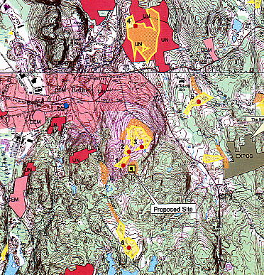
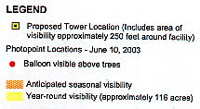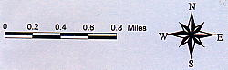

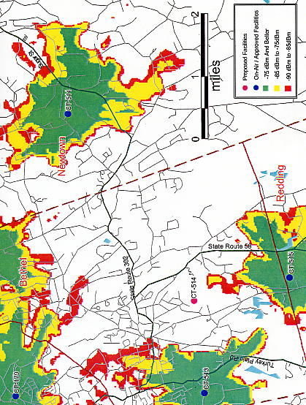
FIGURE 2
AT&T EXISTING COVERAGE

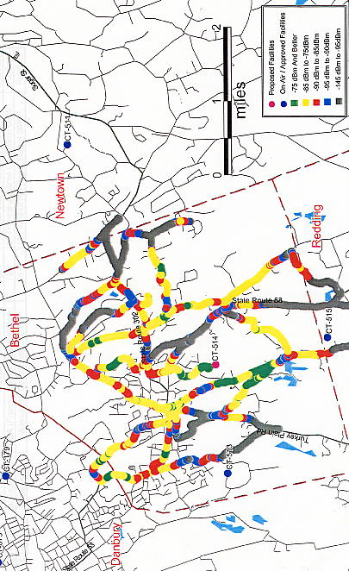
FIGURE 3
AT&T EXISTING AND PROPOSED COVERAGE FROM SITE WITH ANTENNAS
AT 130 FEET

FIGURE 4
SPRINT EXISTING COVERAGE
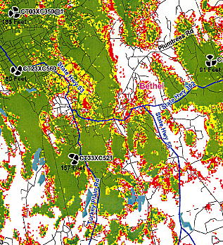
Chestnut Ridge Rd.
Bethel Center

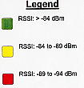

FIGURE 5
SPRINT EXISTING AND PROPOSED COVERAGE
WITH ANTENNAS MOUNTED AT 110 FEET AGL
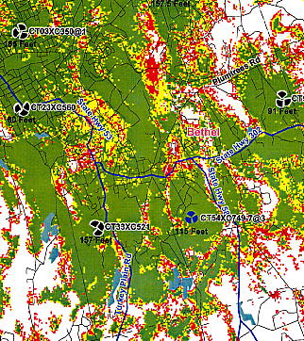
Bethel Center

FIGURE 6
T-MOBILE EXISTING COVERAGE
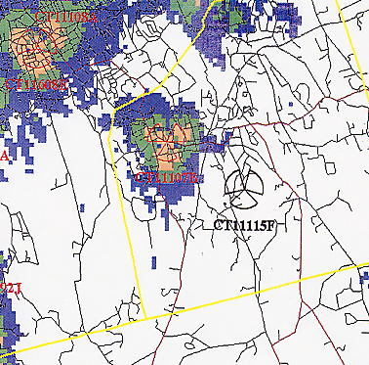



FIGURE 7
T-MOBILE EXISTING AND PROPOSED COVERAGE
WITH ANTENNAS INSTALLED AT 105 FEET AGL
