DOCKET NO. 285 - Sprint Spectrum, L.P. application for a Certificate of Environmental Compatibility and Public Need for the construction, maintenance and operation of a wireless telecommunications facility at 33 Boardman Road, New Milford, Connecticut. | }  }  } | Connecticut  Siting  Council  July 13, 2004

Findings of Fact

Introduction

- Sprint Spectrum, L.P. d/b/a Sprint PCS (Sprint), in accordance with the provisions of General Statutes §§ 16-50g through 16-50aa, applied to the Connecticut Siting Council (Council) on February 4, 2004 for the construction, operation, and maintenance of a wireless telecommunications facility at 33 Boardman Road, New Milford, Connecticut. (Sprint 1, pp. 1-2)

- The party in this proceeding is the applicant. The intervenor in this proceeding is Nextel Communications of the Mid-Atlantic Inc. d/b/a Nextel Communications (Nextel). (Transcript 1- May 18, 2004, 3:00 p.m. [Tr. 1], p. 6)

- The purpose of the proposed facility is to provide wireless service to coverage gaps identified by Sprint and Nextel on Route 7 and local roads in northwestern New Milford. (Sprint 1, p. 15; Nextel 1, Q. 3)

- The Council performed an inspection of the proposed site on May 18, 2004, beginning at 2:00 p.m. During the field inspection, the applicant flew a balloon at the proposed site to simulate the height of the proposed tower. (Council's Hearing Notice dated April 2, 2004)

- Sprint submitted a technical report to the Mayor of the Town of New Milford, Robert Gambino on July 28, 2003. At the request of the Town, Sprint attended a publicly noticed informational hearing on September 9, 2003. The New Milford Zoning Commission submitted written comments to Sprint on September 23, 2003. (Sprint 1, pp. 6-7)

- Sprint would provide space on the tower for no compensation for any public safety antennas, provided such antennas are compatible with the structural integrity of the tower. No public authority has expressed interest in the facility. (Sprint 1, p. 5)

- Notice of the application was provided to all abutting property owners by certified mail. Public notice of the application was published in the New Milford Spectrum on January 16, 2004, the New Milford Times on January 16 and 23, 2004, and the Voices - The Newspaper on January 14, 2004. (Sprint 1, p. 3)

- Pursuant to General Statutes § 16-50j (h), on April 2, and June 1, 2004, the following state agencies were solicited to submit written comments regarding the proposed facility; Department of Environmental Protection (DEP), Department of Public Health (DPH), Council on Environmental Quality (CEQ), Department of Public Utility Control (DPUC), Office of Policy and Management (OPM), Department of Economic and Community Development (DECD), and the Department of Transportation (DOT). (Record)

- Written comments were received from the DEP on April 22, 2004. (Record)

- The following agencies did not comment on the application: DOT, DPH, CEQ, DPUC, OPM, and the DECD. (Record)
Telecommunications Act

11 In 1996, the United States Congress recognized a nationwide need for high quality wireless telecommunications services, including cellular telephone service. Through the Federal Telecommunications Act of 1996, Congress seeks to promote competition, encourage technical innovations, and foster lower prices for telecommunications services. (Council Administrative Notice No. 7, Telecom Act 1996)

- In issuing cellular licenses, the Federal government has preempted the determination of public need for cellular service by the states, and has established design standards to ensure technical integrity and nationwide compatibility among all systems. Sprint is licensed by the Federal Communications Commission (FCC) to provide personal wireless communication service (PCS) in Connecticut. (Council Administrative Notice No. 7, Telecom. Act 1996; Sprint 1, p. 2)

13. The Telecommunications Act of 1996 prohibits local and state agencies from discriminating among providers of functionally equivalent services. (Council Administrative Notice No. 7, Telecom. Act 1996)

14. The Telecommunications Act of 1996, a Federal law passed by the United States Congress, prohibits any state or local agency from regulating telecommunications towers on the basis of the environmental effects of radio frequency emissions to the extent that such towers and equipment comply with FCC’s regulations concerning such emissions. This Act also blocks the Council from prohibiting or acting with the effect of prohibiting the provision of personal wireless service. (Council Administrative Notice No. 7, Telecom. Act 1996)

Site Selection

15. Sprint established a search ring in the Boardman Bridge section of New Milford, east of the Housatonic River. The search ring consisted of an oval area, 0.4 miles at its widest point, on a ridgeline with a maximum elevation of 590 feet above mean sea level (amsl). (Sprint 1, Q. 9; Sprint 2, Q. 3)

16. Prior to selecting the proposed site, Sprint considered 11 existing structures in the western New Milford area. The sites consisted of electric transmission structures, a water tank, a flagpole, an existing telecommunications tower, and two church steeples. All of the sites were rejected due to inadequate coverage to the target service area. (Sprint 1, p. 11; Attachment 11)

17. Locating antennas on multiple existing structures in western New Milford would not provide adequate coverage to the target service area due to the numerous ridges and valleys within the area and the relative low elevation of the existing structures. (Sprint 1, Attachment 11, Sprint 2, p. 5; Tr. 1, pp. 15-17)
Site Description

18. The proposed site is on a 349-acre parcel owned by Quarry Stone and Gravel LLC at 33 Boardman Road in New Milford. The parcel, zoned industrial, is used as a quarry and contains active and abandoned quarry works. The parcel encompasses the western aspect of a wooded north-south oriented ridge that slopes from approximately 300 feet amsl to a summit elevation of 590 feet amsl. (Sprint 1, p. 12, Attachment 5, Attachment 6)

19. The proposed tower site is located in a mostly cleared area on the western side of the ridge, south of the summit, at an elevation of 576 feet amsl. The tree line in the immediate vicinity of the site is 65 feet above ground level (agl). The tower site is depicted on Figure 1. (Sprint 1, Attachment 5, Attachment 6; Tr. 1, p. 23)

20. Sprint proposes to install a 150-foot monopole within a 75-foot by 75-foot lease area. The tower would be designed to support 7 levels of antennas with a 10-foot center-to-center vertical separation. (Sprint 1, Attachment 5)

21. Sprint would install 12, five-foot panel antennas on a platform at a centerline height of 150 feet agl. Nextel would install 12 panel antennas on a platform at a centerline height of 140 feet agl. A GPS antenna would be mounted at a height of 75 feet agl. The overall height of the facility with antennas would not exceed 153 feet agl. (Sprint 1, Attachment 5; Nextel 1, Q. 6)

22. A 50-foot by 50-foot equipment compound enclosed by a six-foot high chain link fence would be established at the base of the tower. The size of the lease area would be able to accommodate the equipment of seven wireless carriers. Sprint would install equipment cabinets, including an emergency battery system, on a concrete pad within the compound. Nextel would install 12-foot by 20-foot equipment shelter within the compound. An emergency battery system would be contained within the shelter. (Sprint 1, p. 13, Attachment 5; Nextel 1, Q. 7)

23. Access to the site would be from an existing gravel road that extends 5,030 feet from Boardman Road. Site work would grading of the compound area to allow for a five percent cross pitch and upgrading a 160-foot section of the access road in the vicinity of the compound. Above ground utilities would be installed along the existing gravel road to the site. (Sprint 1, pp. 12-13, Attachment 5; Tr. 1, p. 33)

24. The tower setback radius would be contained within the site parcel. (Sprint 1, Attachment 5; Sprint 2, Q. 1)

25. There are no residences within 1,000 feet of the site. The nearest residence is 2,137 feet northeast of the site. (Sprint 1, Attachment 5)

26. The nearest property line from the tower site is approximately 160 feet to the east (Lillis Property). (Sprint 1, Attachment 5)
27. The estimated construction cost for the proposed facility without appurtenances is:

Site Work 35,000
Monopole 30,000
Electrical & Telephone 20,000
Foundation 65,000
Landscaping 10,000
Road 20,000

Total $180,000
(Sprint 1, Attachment 13)

Environmental Concerns

28. The proposed facility would have no effect on historic, architectural, or archaeological resources listed on or eligible for the National Register of Historic Places or upon properties of traditional cultural importance to Connecticut’s Native American community. (Sprint 1, Attachment 18)

29. The proposed site contains no known existing populations of Federal or State Endangered, Threatened or Special Concern Species. (Sprint 1, Attachment 18; Sprint 1, Q. 8)

30. The proposed compound is 500 feet west of the nearest wetland area. The existing access road is immediately adjacent to several wetland areas; however, no further road improvements are proposed and the placement of overhead utilities would not directly impact these wetland areas. (Sprint 1, p. 18)

31. Approximately 1,800 square feet of woodlands would be removed to develop the site. (Sprint 1, Attachment 5)

32. Tower aircraft hazard obstruction marking or lighting would not be required. The nearest public use landing surface is the Candlelight Farms Heliport, approximately 2.5 miles southwest of the site. The heliport is at an elevation of 650 feet. (Sprint 1, Attachment 17; Tr. 1, pp. 37-39; Atlas of Connecticut Topographical Maps)

33.. The conservative worst-case approximation of electromagnetic radio frequency power density at the base of the proposed tower, assuming full operation of antennas installed by Sprint and Nextel, would be 12.3 percent of Maximum Permissible Exposure limit established by the FCC. (Sprint 1, Attachment 16; Nextel 1, Q. 9)

Visibility

34. Anticipated visibility of the proposed tower from the surrounding area is depicted on Figure 1. (Sprint 1, Attachment 15)
35. Visibility of the proposed tower is anticipated from the following roads within a two mile radius of the site (refer to Figure 1):

Location Nearest Distance from Proposed Site Length of Road Visibility
Aspetuck Ridge Road 0.6 miles southeast 0.5 miles
Aspetuck Ridge Road 0.5 miles east 0.4 miles
Aspetuck Ridge Road . 1.0 miles northeast 0.2 miles
Long Hill Road (scenic road) 0.9 miles northeast 0.2 miles
Cornwall Drive 0.9 miles northeast 0.3 miles
Sand Road 0.6 miles northeast 0.3 miles
Kent Road 0.9 miles southwest 0.2 miles
Wellsville Avenue 1.1 miles southeast 0.2miles

36. The proposed tower would be at least partially visible from approximately 328 acres within a two mile radius of the site. Approximately half of this acreage is within residential areas. The closest residential area with visibility is along Aspetuck Ridge Road, approximately 0.5 miles east of the site. (Sprint 1, Attachment 15)

37. Approximately 67 residences within a two mile radius of the site would have year round views of the tower. Approximately 15 residences would have views of the tower through vegetation. (Sprint 2, Q. 7; Tr. 1, pp. 27-28)

38. The proposed tower would not be visible from the Town little league fields along Boardman Road, approximately 0.5 miles south of the site. (Sprint 1, Attachment 15)

39. The proposed tower may be seasonally visible from the Housatonic Range Trail, a trail maintained by the Connecticut Forest and Parks Association approximately 1 mile west of the site. The tower would not be visible from the summit of Candlewood Mountain, the prominent viewpoint on the trail. (Sprint 1, Attachment 15; Tr. 1, pp. 6-7; Connecticut Walk Book, Map 11)

40. The Town provided written comment to the applicant requesting consideration of monopole with a stealth tree design at this site. Sprint would be willing to accommodate this request. The stealth tree design would not affect coverage objectives. A monopole with flush mounted antennas would negatively affect coverage on Route 7. (Sprint 1, Attachment 8; Tr. 1, pp. 20-21, 26)

41. Visibility of the proposed site from residential areas to the east would consist of tower views on a ridge with the sky as a backdrop. The treeline in the compound area is approximately 65 feet. (Sprint 1, Attachment 15; Tr. 1, pp. 22-25)

Sprint - Existing and Proposed Wireless Coverage

42. Sprint operates at a minimum signal level threshold of -94 dBm and in the 1900 MHz frequency band. The proposed site is located approximately 4 miles southeast of Sprint’s Gaylordsville facility and approximately 1.7 miles west of Sprint’s Elkington Road, New Milford site. Coverage from these existing sites leave substantial gaps in coverage on Route 7 and local roads north of New Milford center (refer to Figure 2). (Sprint 1, p. 15, Attachment 14)

43. Sprint is requesting a minimum antenna height of 150 feet agl. Installing antennas at 150 feet agl would provide 4.7 miles of coverage to Route 7, 1.7 miles to Long Mountain Road, 2.2 miles to Aspetuck Ridge Road, 1.2 miles to Boardman Road, and 2.5 miles to Merryall Road (refer to Figure 3). (Sprint 1, Attachment 14; Tr. 1, p. 15)

44. Installing antennas at 130 feet agl at the proposed site would weaken the signal along a quarter-mile section of Route 7 in the vicinity of Squash Hollow Road. (Sprint 2, Q. 5a; Tr. 1, p. 12)

Nextel - Existing and Proposed Wireless Coverage

45. Nextel’s service design operates at a minimum signal level threshold of -81 dBm and at a frequency of 851-866 MHz. (Nextel 1, Q. 2)

46. Currently, Nextel has no coverage on Route 7 and intermittent coverage on local roads north of New Milford center (refer to Figure 4). Nextel has antennas at the Elkington Road, New Milford site and on a monopole facility in the Bulls Bridge section of Kent, approximately 6 miles from the proposed site. (Nextel 1, Q. 3; Tr. 1, pp. 54, 56)

47. Installing antennas at 140 feet agl at the proposed site would provide coverage to 3.2 miles of Route 7 north of New Milford center, 1.2 miles Aspetuck Ridge Road, and 1.8 miles of Merryall Road (refer to Figure 5). (Nextel 1, Q. 4)

48. A coverage gap of 0.6 miles would remain on Route 7 northwest of the site in the vicinity of Squash Hollow Road. This gap is at the edge of Nextel’s coverage area. North of the coverage area, there would be no service on Route 7. Nextel would need an additional site or sites to the northwest to provide continuous coverage on Route 7 between the proposed site and Bull’s Bridge site. Nextel would design a site to provide service to the 0.6 mile gap in the vicinity of Squash Hollow Road. (Nextel 1, Q. 3, Q. 4; Tr. 1, pp. 27-28)

49. Installing antennas at 120 feet agl would increase the gap on Route 7 in the vicinity of Squash Hollow Road from 0.6 miles to 1.2 miles. The increase in the coverage gap on Route 7 would occur to the northwest, towards the edge of the coverage area. Coverage to the southeast would slightly degrade. (Nextel 1, Q. 3, Q. 4)

FIGURE 1

VISIBILITY OF PROPOSED 150-FOOT TOWER

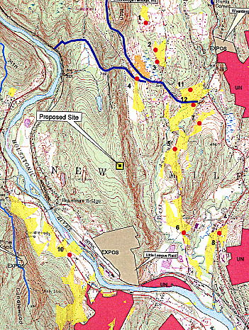

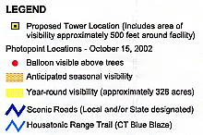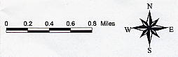

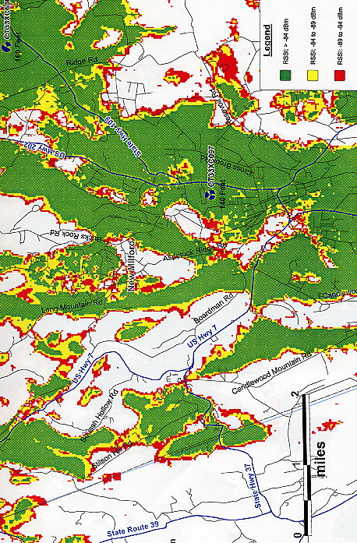
FIGURE 2

SPRINT EXISTING COVERAGE

(Sprint 1, Attachment 14)

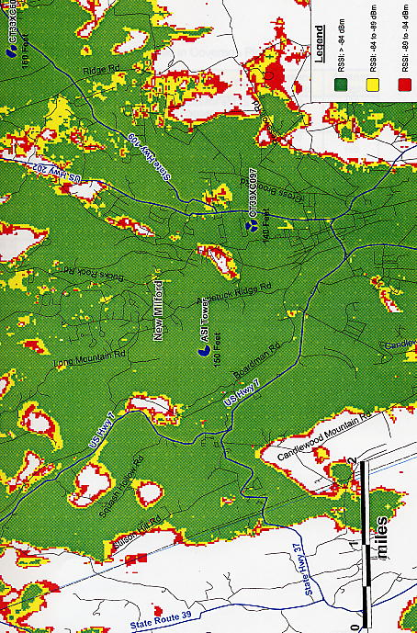
FIGURE 3

SPRINT EXISTING AND PROPOSED COVERAGE WITH ANTENNAS AT 150 FEET

(Sprint 1, Attachment 14)
FIGURE 4

NEXTEL – EXISTING COVERAGE

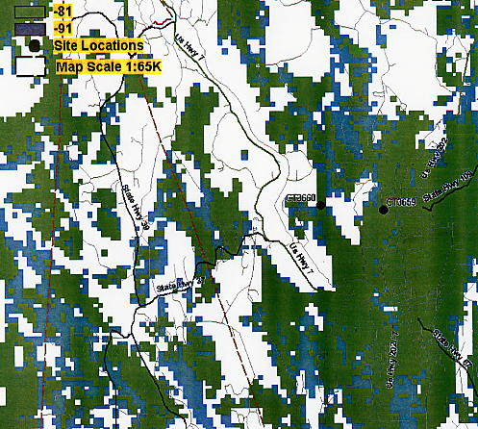

(Nextel 1, Q. 3)

FIGURE 5

NEXTEL – EXISTING AND PROPOSED COVERAGE
WITH ANTENNAS AT 140 FFET

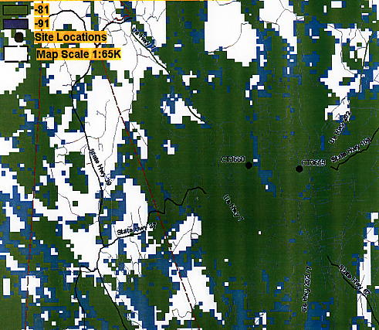

(Nextel 1, Q. 4)

