DOCKET NO. 281 – AT&T Wireless PCS, LLC application for a Certificate of Environmental Compatibility and Public Need for the construction, maintenance and operation of a telecommunications facility off of Town Line Road or 355 South Washington Street, Plainville, Connecticut. | }  }  } | Connecticut  Siting  Council  June 23, 2004

Findings of Fact

Introduction

- AT&T Wireless PCS, LLC d/b/a AT&T Wireless, in accordance with provisions of General Statutes §§ 16-50g through 16-50aa, applied to the Connecticut Siting Council (Council) on December 19, 2003 for the construction, operation, and maintenance of a wireless telecommunications facility off of Town Line Road or at 355 South Washington Street, Plainville, Connecticut. (AT&T Wireless 1, pp. 1-2)

2. The parties in this proceeding are the applicant and Robert S. Bocwinski, trustee of the abutting Stanley C. Bocwinski property. The intervenors in this proceeding are Cellco Partnership d/b/a Verizon Wireless (Verizon) and Omnipoint Communications Inc. (T-Mobile). (AT&T Wireless 1, Attachment 5; Transcript 1- 3:00 p.m. [Tr. 1], pp. 5-6)

3. The purpose of the proposed facility is to provide service to coverage gaps identified by AT&T Wireless, T-Mobile, and Verizon along Routes 10, 177, Interstate 84 and local roads in the Plainville, Bristol and Southington area. (AT&T Wireless 1, Attachment 3; Verizon 1, Q. 1; T-Mobile 1, Q. 1)

- Pursuant to General Statutes § 16-50m, the Council, after giving due notice thereof, held a public hearing on April 28, 2004, beginning at 3:00 p.m. and continuing at 7:00 p.m. at the Plainville Municipal Center, 1 Central Square, Plainville, Connecticut. (Council's Hearing Notice dated February 6, 2004; Tr. 1, p. 2; Transcript 2 – 7:00 p.m. [Tr. 2], p. 3)

- The Council and its staff made an inspection of the proposed sites on April 28, 2004, beginning at 2:00 p.m. During the field inspection, the applicant flew balloons at each site to simulate the heights of the proposed towers. (Council's Hearing Notice dated February 6, 2004)

- Notice of the application was provided to all abutting property owners by certified mail. Notice was unclaimed by one abutter, Jeffrey and Laurice Bagely. Public notice of the application was published both in The Hartford Courant and the Bristol Press on December 15 and December 17, 2003. (AT&T Wireless 1, p. 4, Attachment 10; AT&T Wireless letter dated February 24, 2004)

- AT&T Wireless notified the Town of Plainville of the proposal on August 27, 2002 by sending a technical report to the Town Manager, Robert Jackson. AT&T Wireless met with the Plainville Town Planner, John Vossi, in September 2002. The Town of Plainville further discussed the proposal at a Planning and Zoning Commission hearing. The Town did not comment on the proposal during the pre-application process. (AT&T Wireless 1, pp. 18-19, Attachment 8)

- Mr. Richard Corliss, a representative of the Town of Plainville Economic Development Agency, made a limited appearance statement at the April 28, 2004 proceeding stating the Economic Development Agency’s preference for the Site A location. No other town agencies provided comment on the proposal. (AT&T Wireless 1, pp. 18-19; Tr. 1, pp. 10-12)

- The City of Bristol and Town of Southington, both within 2,500 feet of the proposed facilities, were notified of the proposal on August 27, 2002. Neither municipality commented on the proposal. (AT&T Wireless 1, pp. 18-19)

- AT&T Wireless would provide space on the tower for no compensation for any public safety antennas, provided such antennas are compatible with the structural integrity of the tower. (AT&T Wireless 1, p. 9)

- Pursuant to General Statutes § 16-50j (h), on February 6 and April 19, 2004, the following state agencies were solicited to submit written comments regarding the proposed facility; Department of Environmental Protection (DEP), Department of Public Health (DPH), Council on Environmental Quality (CEQ), Department of Public Utility Control (DPUC), Office of Policy and Management (OPM), Department of Economic and Community Development (DECD), and the Department of Transportation (DOT). (Record)

- Comments were received from the DOT’s Bureau of Engineering and Highway Operations on March 26, 2004. (Record)

- The following agencies did not comment on the application: DEP, DPH, CEQ, DPUC, OPM, and the DECD. (Record)

Telecommunications Act

- In 1996, the United States Congress recognized a nationwide need for high quality wireless telecommunications services, including cellular telephone service. Through the Federal Telecommunications Act of 1996, Congress seeks to promote competition, encourage technical innovations, and foster lower prices for telecommunications services. (Council Administrative Notice No. 7, Telecom Act 1996)

- In issuing cellular licenses, the Federal government has preempted the determination of public need for cellular service by the states, and has established design standards to ensure technical integrity and nationwide compatibility among all systems. AT&T Wireless is licensed by the Federal Communications Commission (FCC) to provide personal wireless communication service (PCS) to Hartford County, Connecticut (Council Administrative Notice No. 7, Telecom. Act 1996; AT&T Wireless 1, p. 5)

- The Telecommunications Act of 1996 prohibits local and state bodies from discriminating among providers of functionally equivalent services. (Council Administrative Notice No. 7, Telecom. Act 1996)

- The Telecommunications Act of 1996, a Federal law passed by the United States Congress, prohibits any state or local agency from regulating telecommunications towers on the basis of the environmental effects of radio frequency emissions to the extent that such towers and equipment comply with FCC’s regulations concerning such emissions. This Act also blocks the Council from prohibiting or acting with the effect of prohibiting the provision of personal wireless service. (Council Administrative Notice No. 7, Telecom. Act 1996)

Site Selection

18. AT&T Wireless established a facility search area in the vicinity of Route 10, Route 177, and Town Line Road. (AT&T Wireless 1, Attachment 4)

19. Within the search ring, AT&T Wireless investigated seven parcels, two of which were selected for site development. The five rejected sites and reasons for their rejection are as follows:
- 2 Town Line Road – raw land site, unable to negotiate a lease.
- Southington Business Park – existing 120-foot water tank, would not provide adequate coverage to target service area.
- Forestville Lumber Company parcels – raw land site, unresponsive property owner.
- JW Green Company parcel – raw land site, unresponsive property owner.
- Redstone Hill water tanks – two existing 90-foot water tanks, would not meet coverage objectives.
(AT&T Wireless 1, Attachment 4; AT&T Wireless 2, Q. 8)

Site Description – Site A

20. Proposed Site A is located in the western portion of a 36-acre undeveloped parcel owned by Carpenter Realty Company and S. Carpenter Construction Company. The parcel, west of Route 177 and north of Town Line Road, is in the process of being cleared for industrial development and contains a paved access road. The Site A location is depicted on Figure 1. (AT&T Wireless 1, Attachment 5; Tr. 1, pp. 22-23)

21. The site parcel is zoned Restricted Industrial and is within the Plainville Enterprise Zone. The Town’s zoning regulations permit telecommunication towers in RI zone districts, subject to issuance of a Special Permit. (AT&T Wireless 1, p. 16)

22. The tower site is located in a level cleared area adjacent to a detention pond. The ground elevation of the tower site is 179 feet above mean sea level (amsl). (AT&T Wireless 1, Attachment 5)

23. The Site A facility would consist of a 120-foot monopole within a 75-foot by 75-foot leased area. The tower would be designed to support 6 levels of antennas with a 10-foot center-to-center vertical separation. A 65-foot by 65-foot equipment compound enclosed by an eight-foot high chain link fence would be established at the base of the tower. The size of the compound would be able to accommodate the equipment of six wireless carriers. (AT&T Wireless 1, Attachment 5)

24. AT&T Wireless would initially install three flush mounted or T-arm mounted panel antennas at a centerline height of 120-feet above ground level (agl). Verizon proposes to install 12 panel antennas on a platform with a centerline height of 110 feet agl. T-Mobile proposes to install 9 panel antennas on a platform with a centerline height of 100 feet agl. The total height of the facility with antennas would be 123 feet agl. (AT&T Wireless 1, Attachment 5; AT&T Wireless 2, Q. 9; T-Mobile 1, Q. 3; Verizon 1, Q. 3)
25. AT&T Wireless and T-Mobile both would install equipment cabinets on concrete pads within the compound. Verizon would install a 12-foot x 30-foot x 11-foot equipment building within the compound. (AT&T Wireless 1, Attachment 5; T-Mobile 1, Q. 6; Verizon 1, Q. 6; Tr. 2, p. 35)

26. Access to Site A would be provided by a 12-foot wide, 471-foot long gravel drive of new construction extending from an existing paved road within the industrial park. Underground utilities would be installed from Town Line Road along the paved industrial park road and tower access road. (AT&T Wireless 1, Attachment 5)

27. The tower setback radius would be contained within the site parcel. (AT&T Wireless 1, Attachment 5)

28. There are 23 residential structures within 1,000 feet of the site, 22 of which are located in a residential zone. The nearest residence is approximately 375 feet west of the tower site. (AT&T Wireless 1, p. 13; Tr. 1, p. 17; Town of Plainville Zoning Map.)

29. Land use within 0.25 miles of the site is a mix of industrial, commercial, retail, and residential. Property abutting the site is zoned Single Family Residential and Restricted Industrial. (AT&T Wireless 1, Attachment 5; Tr. 1, p. 86; Town of Plainville Zoning Map)

30. The nearest property line from the tower site is approximately 154 feet to the south. The property, owned by the estate of Stanley Bocwinksi, contains a residence and is zoned industrial. (AT&T Wireless 1, Attachment 5; Tr. 1, p. 87

31. The estimated construction cost for the Site A facility is:

Electronic Equipment 70,000
Tower and Antennas 145,000
Site Development and Utilities 390,000

Total $605,000
(AT&T Wireless 1, p. 20)

Site Description – Site B

32. Proposed Site B is located in the northwest corner of an 8-acre parcel owned by Display Properties LLC. The parcel is developed with a commercial building and is zoned Restricted Industrial. The parcel abuts Route 177 to the east. The property abuts the Site A parcel to the west. The Site B location is depicted on Figure 2. (AT&T Wireless 1, p. 12, Attachment 6)

33. The tower site is located in a cleared grassy area west of the Display Properties LLC building. The tower site is at an elevation of 179 feet amsl. (AT&T Wireless 1, Attachment 6)

34. The Site B facility would consist of a 120-foot monopole within a 100-foot by 100-foot leased area. The tower would be designed to support 6 levels of antennas with a 10-foot center-to-center vertical separation. A 75-foot by 75-foot compound enclosed by an eight-foot high chain link fence would be established at the base of the tower. The size of the compound would be able to accommodate the equipment of six wireless carriers. (AT&T Wireless 1, Attachment 6)

35. AT&T Wireless would initially install three flush mounted or T-arm mounted panel antennas at a centerline height of 120-feet above ground level (agl). Verizon proposes to install 12 panel antennas on a platform with a centerline height of 110 feet agl. T-Mobile proposes to install 9 panel antennas on a platform with a centerline height of 100 feet agl. The total height of the facility with antennas would be 123 feet agl. (AT&T Wireless 1, Attachment 6; AT&T Wireless 2, Q. 9; T-Mobile 1, Q. 3; Verizon 1, Q. 3)

36. AT&T Wireless and T-Mobile both would install equipment cabinets on concrete pad within the compound. Verizon would install a 12-foot by 30-foot by 11-foot equipment building within the compound. (AT&T Wireless 1, Attachment 5; T-Mobile 1, Q. 6; Verizon 1, Q. 6; Tr. 2, p. 35)

37. Access to Site B would be provided by a 12-foot wide, 361-foot long gravel drive of new construction extending from the existing paved parking lot on south side of the property. Underground utilities would be installed from South Washington Street (Route 177) along the north property boundary. (AT&T Wireless 1, Attachment 6)

38. The tower setback radius would be contained within the site parcel. (AT&T Wireless 1, Attachment 6)

39. There are 8 residences within 1,000 feet of the site. All of the residences are located within an industrial zone and are a non-conforming use. The nearest residence to the Site B tower is approximately 650 feet to the west. (AT&T Wireless 1, p. 13; Tr. 1, pp. 17, 87; Town of Plainville Zoning Map)

40. Land use within 0.25 miles of the site is a mix of industrial, commercial, retail, and residential. Property abutting the site is zoned General Industrial and Restricted Industrial. (AT&T Wireless 1, Attachment 6; Tr. 1, p. 86; Town of Plainville Zoning Map)

41. The nearest property line from the tower site is approximately 150 feet to the north (Gelt property). (AT&T Wireless 1, Attachment 6)

42. The estimated construction cost for the Site B facility is:

Electronic Equipment 70,000
Tower and Antennas 145,000
Site Development and Utilities 260,000

Total $475,000
(AT&T Wireless 1, p. 20)

Environmental Concerns

43. The proposed facilities would have no effect on historic, architectural, or archaeological resources listed on or eligible for the National Register of Historic Places or upon properties of traditional cultural importance to Connecticut’s Native American community. (AT&T Wireless 1, Attachment 7)
44. The proposed sites contain no known existing populations of Federal or State Endangered, Threatened or Special Concern Species. (AT&T Wireless 1, Attachment 7)

45. Development of either site would not directly impact any wetlands or watercourses or occur within a Town designated 50-foot wetland buffer zone. An unnamed brook and associated wetlands are approximately 100 feet west of Site A. A detention pond abuts Site A to the south. No wetlands or watercourses are within 100 feet of Site B. (AT&T Wireless 1, Attachment 5, Attachment 6, Town of Plainville Inland Wetlands and Watercourses Regulations)

46. Aircraft hazard obstruction marking or lighting of either tower would not be required. (AT&T Wireless 1, Attachment 5, Attachment 6)

47. The conservative worst-case approximation of electromagnetic radiofrequency power density at either site with the operation of AT&T Wireless, T-Mobile and Verizon antennas would be 24.9 percent of Maximum Permissible Exposure limit established by the FCC. (AT&T Wireless 2, Q. 8; T-Mobile 1, Q. 3, Verizon 1, Q. 3)

Visibility

48. The Site A facility would be visible from 228 acres within a two-mile radius of the site (refer to Figure 1). Site B would be visible from 178 acres within a two-mile radius of the site (refer to Figure 2). (AT&T Wireless 2, Q. 4)

49. Visibility of the Site A tower is anticipated from the following roads (refer to Figure 1):

Location/Land Use Nearest Distance from Proposed Site Length of Road Visibility
Town Line Road - industrial 0.1 miles south 0.5 miles
Route 177 - commercial/industrial 0.2 miles east 0.6 miles
Red Oak Drive - residential . 0.3 miles south 0.8 miles
Redstone Street - residential 0.2 miles south 0.3 miles
Queen Street - mix 0.4 miles southeast 0.6 miles
Red Stone Hill - residential 0.2 miles west 0.3 miles
Julia Road – residential 0.2 miles west 0.2 miles

(AT&T Wireless 2, Q. 4)

50. Visibility of the Site B tower is anticipated from the following roads (refer to Figure 2):

Location/Land Use Nearest Distance from Proposed Site Length of Road Visibility
Town Line Road - industrial 0.1 miles south 0.5 miles
Route 177 - commercial/industrial 0.1 miles east 0.6 miles
Red Oak Drive - residential . 0.3 miles south 0.8 miles
Redstone Street - residential 0.4 miles south 0.3 miles
Red Stone Hill - residential 0.4 miles west 0.2 miles
Julia Road – residential 0.4 miles west 0.3 miles

(AT&T Wireless 2, Q. 4)

51. Both sites would be visible from portions of Flanders Road, Ledge Road, and Shuttle Meadow Road in Southington, approximately 1.5 miles east of the sites. (Tr. 2, p. 11)

52. Neither tower would be visible from Norton Park, approximately 0.3 miles north of the site. (AT&T Wireless 2, Q. 3, Q. 4; Tr. 1, p. 37)

53. The Site A tower would be more visible than the Site B tower from mobile home park in the Red Oak Drive/Redstone Street area, approximately 0.4 miles south of the sites. (AT&T Wireless 2, Q. 4; Tr. 2, p. 30)

54. The Site A tower would be more visible than the Site B tower from residences on Redstone Hill, approximately 0.2 miles west of Site A and 0.4 miles west of Site B. (AT&T Wireless 2, Q. 4; Tr. 2, pp. 28-29)

55. All residences within 1,000 feet of each site would have views of both towers. (Tr. 2, p. 12)

AT&T - Existing and Proposed Wireless Coverage

56. AT&T Wireless operates in the FCC assigned D & E 1900 MHz frequency bands and at minimum signal level threshold of -85 dBm. (AT&T Wireless 1, Attachment 2; Tr. 1, p. 25)

57. AT&T Wireless is currently experiencing an approximate 0.4 mile gap on Route 177 and a 0.8 mile gap on Interstate 84 (refer to Figure 3). (AT&T Wireless 1, Attachment 3)

58. The minimum antenna height AT&T Wireless is requesting at either site is 120 feet. Installing antennas at a centerline height of 120 feet agl at either site would provide coverage to the identified coverage gaps and would increase the signal strength in the along the Route 10 corridor (refer to Figure 4). Site B offers slightly stronger coverage to Interstate 84 in the Plainville-Southington town line area. (AT&T Wireless 1, Attachment 3; Tr. 1, pp. 25-26)

59. Installing antennas at a lower height at either site would cause coverage degradation on Interstate 84. Service would not be acceptable for In-Car coverage. (Tr. 1, p. 25)

T-Mobile - Existing and Proposed Wireless Coverage

60. T-Mobile operates in the 1900 MHz frequency band and has a at a signal level service design of -76 dBm for this area, suitable for In-Building Residential coverage. (T-Mobile 1, Q. 2; Tr. 1, p. 78)

61. T-Mobile currently has a signal level of >/= to -84 dBm on the Route 10 ands Route 177 corridors (refer to Figure 5). An area of local roads west of Route 177 and south of Route 372 in Plainville, experiences less than reliable coverage (>-84 dBm). (T-Mobile 1, Q. 1, Q. 4)

62. Installing antennas at either site at a centerline height of 100 feet agl would provide coverage at a signal level </= -76 dBm to 1.4 miles of Route 10, 1.3 miles of Route 177, and local roads northwest of the sites (refer to Figure 6). (T-Mobile 1, Q. 5)

63. An area of less than reliable coverage would remain northwest of the proposed site in the vicinity of Route 372. T-Mobile intends to establish a search ring for a facility in this area in the future. (T-Mobile 1, Q. 5; Tr. 1, p. 76)

64. T-Mobile would be able to utilize T-arm antenna mounts at either site. (Tr. 1, p. 67)
Verizon - Existing and Proposed Wireless Coverage

65. Verizon proposes to install three 800 MHz and nine 1900 MHz antennas at the 110-foot level of either tower. (Verizon 1, Q. 2)

66. Verizon is seeking In-Car service for this area which has a signal level threshold of -85 dBm. (Verizon 1, Q. 2; Tr. 1, p. 70)

67. Verizon currently experiences a coverage gap of 0.5 miles on Interstate 84, 0.5 miles on Route 10, 0.8 miles on Route 177, 1.2 miles on Route 372, and 3.6 miles on Route 72 (refer to Figure 7). (Verizon 1, Q. 1, Q. 4)

68. Verizon would be able to utilize T-arm antenna mounts at either site. (Tr. 1, p. 76)

69. Installing antennas at a centerline height of 110 feet agl at either proposed site would provide continuous coverage to Interstate 84, Route 10, Route 177, Route 72 and Route 372 (refer to Figure 8). (Verizon 1, Q. 1, Q. 4)
FIGURE 1
LOCATION AND VISIBILITY OF PROPOSED SITE A
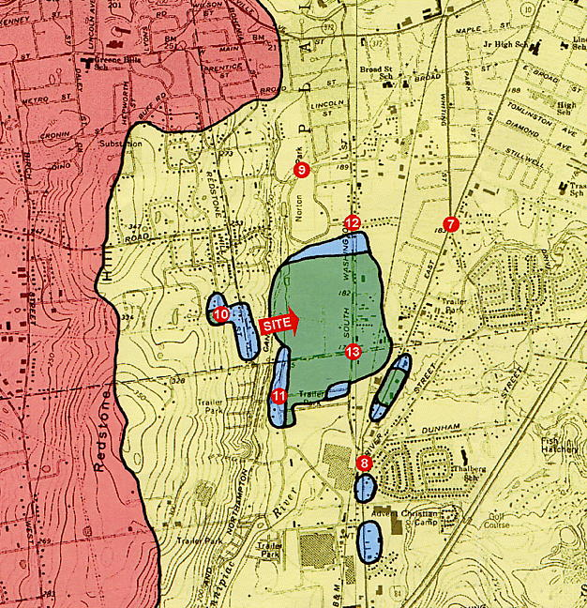
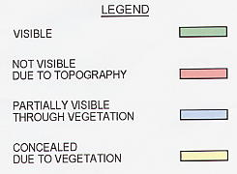
1” = 2000’

FIGURE 2
LOCATION AND VISIBILITY OF PROPOSED SITE B
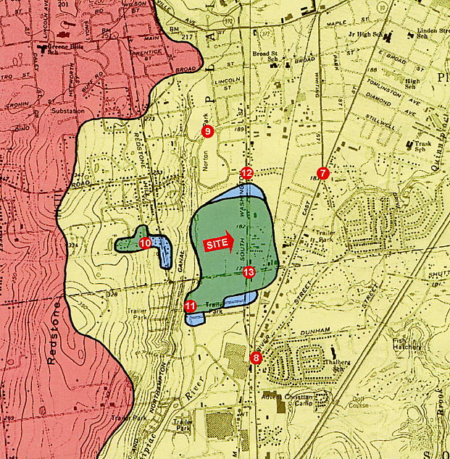
1” = 2000’
FIGURE 3
AT&T EXISTING COVERAGE
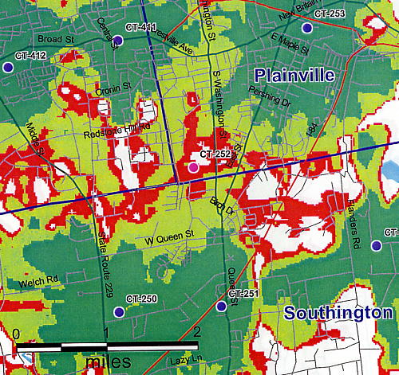

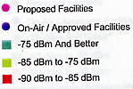

FIGURE 4
AT&T EXISTING AND PROPOSED COVERAGE
WITH ANTENNAS MOUNTED AT 120 FEET AGL AT SITE A
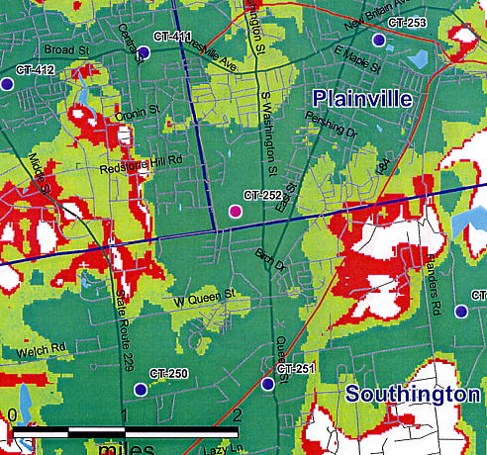

FIGURE 5
T-MOBILE EXISTING COVERAGE
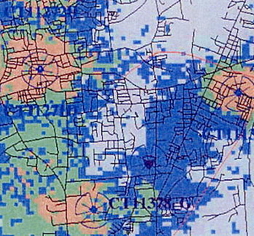
Route
10
Route 72

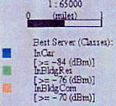

FIGURE 6
T-MOBILE EXISTING AND PROPOSED COVERAGE
WITH ANTENNAS MOUNTED AT 100 FEET AGL AT SITE A
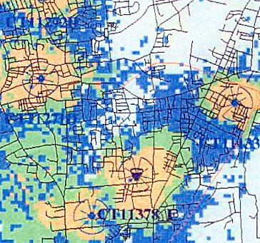
Route
10
Route
177
Route 72

FIGURE 7
VERIZON EXISTING COVERAGE
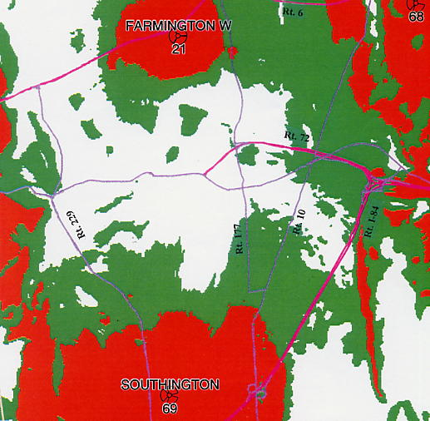

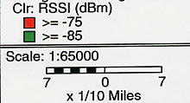

FIGURE 8
VERIZON EXISTING AND PROPOSED COVERAGE
WITH ANTENNAS INSTALLED AT 110 FEET AGL
