DOCKET NO. 271 - Sprint Spectrum, L.P., d/b/a Sprint PCS application for a Certificate of Environmental Compatibility and Public Need for the construction, maintenance and operation of a wireless telecommunications facility at 370 Rockland Road or 4158 Durham Road, Guilford, Connecticut. | }  }  }  } | Connecticut  Siting  Council  April 15, 2004

Findings of Fact
Introduction

- Sprint Spectrum L.P., d/b/a Sprint PCS (Sprint), in accordance with provisions of General Statutes §§ 16-50g through 16-50aa, applied to the Connecticut Siting Council (Council) on October 6, 2003, for the construction, operation, and maintenance of a wireless telecommunications facility at 370 Rockland Road (Site A) or 4158 Durham Road (Site B) in Guilford, Connecticut. The proposed facility is intended to provide coverage to existing gaps along Route 77. (Sprint 1, p. 1, 3, 5)

- Sprint is a wholly owned subsidiary of WirelessCo L.P. licensed by the Federal Communications Commission (FCC) to provide wireless personal communication service (PCS). Sprint operates in 32 major trading areas within the United States including Connecticut. (Sprint 1, p. 2)

- The parties in this proceeding are the applicant and the Guilford Land Conservation Trust, Inc. The intervenor is AT&T Wireless PCS, LLC d/b/a AT&T Wireless. (Tr. 1, 3:00 p.m., p. 5, 6; Tr. 2, 7:00 p.m., p. 5, 6)

- Pursuant to General Statutes § 16-50m, the Council, after giving due notice thereof, held a public hearing on February 11, 2004, beginning at 3:00 p.m., and continuing at 7:00 p.m. in the Menunkatuck Room of the Nathanael B. Greene Community Center, 32 Church Street, Guilford, Connecticut. (Tr. 1, p. 3; Tr. 2, p. 3)

- The Council and its staff made inspections of the proposed sites on February 11, 2004. Sprint flew balloons at proposed Site A, at 150 feet above ground level (AGL), and Site B, at 160 feet AGL, from 8:45 a.m. until approximately 9:45 a.m. on February 11, 2004. The winds did not allow sustained flight of the balloons so they were taken down during the field inspection. (Sprint 1, p. 27; Tr. 1, p. 16, 17)

- On April 30, 2003, Sprint submitted a notice and technical report for the proposed project to the Town of Guilford First Selectman, Carl A. Balestracci, Jr., and the Town of Madison First Selectman, Thomas Scarpati. At the time, the Towns of Guilford and Madison had no comments regarding the proposed project. (Sprint 1, p. 7, 8, Tab 9)

- Public notice of the application was published in the New Haven Register on September 25, 2003 and September 27, 2003 and the Shoreline Times on September 27, 2003. Sprint notified all adjacent landowners of the proposed project, return receipt requested, on September 18, 2003, which had the map and block numbers of the two proposed properties transposed. On September 24, 2003, Sprint sent a revised letter to all of the abutting landowners, explaining the error. Notices were re-sent via First Class Mail to 21 adjacent land owners of proposed Site A and 12 adjacent land owners of proposed Site B for which return receipts were not received. (Sprint 1, p. 3; Sprint 2, Q. 1)

- Pursuant to General Statutes § 16-50j (h), the following state agencies were notified of the project on November 21, 2003: Department of Environmental Protection (DEP), Department of Public Health (DPH), Council on Environmental Quality (CEQ), Department of Public Utility Control (DPUC), Office of Policy and Management (OPM), Department of Economic and Community Development (DECD), and the Department of Transportation (DOT). (record)

- Comments were received from the DOT on February 2, 2004 and from the DEP on February 10, 2004. (record)

- The following agencies did not offer comments on the application; DPH, CEQ, DPUC, OPM, and the DECD. (record)

Telecommunications Act

- In issuing cellular licenses, the federal government has preempted the determination of public need for cellular service by the states, and has established design standards to ensure technical integrity and nationwide compatibility among all systems. (Council Admin. Notice, no. 7, Telecom. Act 1996)

- In 1996, the United States Congress recognized a nationwide need for high quality wireless telecommunications services, including cellular telephone service. Through the Federal Telecommunications Act of 1996, Congress seeks to promote competition, encourage technical innovations, and foster lower prices for telecommunications services. (Council Admin. Notice, no. 7, Telecom Act 1996)

- The Telecommunications Act of 1996 prohibits local and State bodies from discriminating among providers of functionally equivalent services. (Council Admin. Notice, no. 7, Telecom. Act 1996)

- The Telecommunications Act of 1996, a federal law passed by the United States Congress, prohibits any State or local agency from regulating telecommunications towers on the basis of the environmental effects of radio frequency emissions to the extent that such towers and equipment comply with Federal Communications Commission’s (FCC) regulations concerning such emissions. This Act also blocks the Council from prohibiting or acting with the effect of prohibiting the provision of personal wireless service. (Council Admin. Notice, no. 7, Telecom. Act 1996)

Site Search

- Sprint identified one existing communications tower within approximately two miles of the proposed sites, which is a 180-foot tower owned by Cingular located at 500 Cooks Road in Guilford. (Sprint 1, p. 10, Tab 11)

- Sprint identified and investigated four potential sites, including proposed Site A and Site B, within or near a search ring in Guilford. Proposed Site B is outside of the search ring and does not fully meet the coverage objective. The potential sites investigated and rejected by Sprint include property at 300 Rockland Road, which was withdrawn by the real estate department, and a silo which would not provide adequate coverage to Route 77. (Sprint 1, p. 10, Tab 10, Tab 12; Tr. p. 58, 59)

Site and Equipment

- Proposed Site A consists of a 60-foot by 40-foot compound within a 100-foot by 100-foot lease area, which would be enclosed by a six foot high chain link fence with three strands of barbed wire on top. Sprint would install equipment on an 18-foot by nine foot six inch concrete pad located at the base of the monopole. AT&T Wireless would install equipment on a seven-foot by 13-foot concrete pad. The proposed tower is a 150-foot monopole. Sprint’s antennas would be located at 147 feet six inches above ground level (AGL), and a global positioning system (GPS) antenna would be mounted on the southwest side at 75 feet AGL. AT&T Wireless would install antennas on the proposed monopole at 137 feet six inches AGL. The proposed tower and compound is designed to accommodate a total of three carriers. (Sprint 1, p. 10, 12, 13; Tr. 1, p. 87)

- Proposed Site B consists of a 60-foot by 60-foot compound within a 100-foot by 100-foot lease area, which would be enclosed by a six foot high chain link fence with three strands of barbed wire on top. Sprint would install equipment on an 18-foot by nine foot six inch concrete pad located at the base of the monopole. AT&T Wireless would install equipment on a seven-foot by 13-foot concrete pad. The proposed tower is a 160-foot monopole. Sprint’s antennas would be located at 157 feet five inches AGL and a GPS antenna would be mounted on the southwest side of the monopole at 75 feet AGL. AT&T Wireless would install antennas on the proposed monopole at 147 feet five inches AGL. The proposed tower and compound is designed to accommodate a total of three carriers. (Sprint 1, p. 10, 12, 13; AT&T 1, Q. 8; Tr. 1, p. 87)

- AT&T Wireless has a commitment to locate equipment at one of the proposed sites. (Sprint 1, p. 6; AT&T 1, Q. 10)

- The tower setback radius at proposed Site A would remain on the lessor’s property. The tower setback radius at proposed Site B would extend onto an adjacent property to the south. The property to the south of proposed Site B is a forested, vacant parcel. Sprint is willing to design the proposed Site B tower with a yield point so the tower setback radius remains on the owner’s property. (Sprint 1, Tab 5, Tab 6; Sprint 2, Q. 9)

- A battery back-up system would be installed at the proposed site to maintain operations during power outages. The battery would last approximately six to eight hours. Sprint may bring in a portable diesel powered electrical generator temporarily to the site if the power outage exceeds 24 hours. (Sprint 1, p. 13)

- The approximate costs of construction for the proposed Site A and Site B are estimated as follows:

 | SITE A | SITE B
Site Work | $ 15,000 | $ 15,000
Tower | 35,000 | 35,000
Electrical & Telephone | 25,000 | 25,000
Foundation | 20,000 | 20,000
Compound | 15,000 | 15,000
Road | 80,000 | 64,000
RF Work | 122,500 | 122,500
Total Costs | $ 312,500 | $ 296,500
(Sprint 1, Tab 14)

Proposed Site A/ Site B

- Proposed Site A is located on an approximately 87 acre parcel owned by the Woodbridge Sportsmen Club, Inc. The elevation of the proposed site is approximately 371.5 feet above mean sea level (AMSL). The property is primarily used for hunting and fishing. Surrounding land use includes residential parcels and undeveloped tracts of forested land. (Sprint 1, p. 1, 10, Tab 5)

- Proposed Site B is located on an approximately 34 acre parcel owned by the New Haven Sportsmens Club, Inc. The elevation of the proposed site is approximately 378 feet AMSL. The property is mostly undeveloped; however there are shooting ranges, outbuildings and a clubhouse on the property. Surrounding land use includes residential parcels and undeveloped tracts of forested land. (Sprint 1, p. 1, 10, Tab 6)

- Proposed Site A and Site B are located within a residential zone (R-8). The Town of Guilford’s Zoning Regulations indicate a preference for communications towers and antennas with co-location on existing structures or towers. The Town would least prefer a new communication tower in a residential district. (Sprint 1, Zoning Regulations)

- There is a condominium complex with 20 units located within a 1,000-foot radius of proposed Site A and seven residences within a 1,000-foot radius of Site B. The nearest residence to proposed Site A, which is the condominium complex owned by Country Home Development Corporation, is located 730 feet to the northwest. The nearest residence to proposed Site B, which is owned by William and Amelia Casey, is located 803 feet to the north. (Sprint 1, Tab 5, Tab 6; Tr. 1, p. 20, 21)

- Proposed access to Site A would be an existing gravel access road extending from Rockland Road to the proposed site for a distance of 1,350 feet. The first 870 feet of the proposed access road is on the Chagnon property, which is to the south of the Site A property. Sprint proposes to pave the first 520 feet of the existing access road, which is the portion that is parallel to, and provides access for, the Durso property located to the south of the Chagnon property. Sprint proposes to install 4-foot wide 5-foot long, 6-inch deep rip rap aprons with 12-inch by 12-inch pressure treated spreaders at approximately 160 feet, 340 feet and 370 feet into the proposed access road. The existing culvert located approximately 280 feet into the access road would be upgraded. Utilities would run overhead along the access road from a nearby utility pole on 11 poles to proposed Site A. (Sprint 1, p. 11, 12; Sprint 2, Q. 16)

- Proposed access to Site B would extend from Durham Road to the proposed site for a distance of 1,280 feet. The first 170 feet of the proposed access road would run over a shared gravel right-of-way, then for approximately 870 feet over an existing gravel access road which leads to a parking area, and then a new 12-foot wide gravel access road would be constructed to proposed Site B. Utilities would run overhead on eight to twelve poles to proposed Site B. (Sprint 1, p. 12; Sprint 2, Q. 16)

- Sprint would be willing to construct the proposed tower as a stealth structure or use T-bar antenna mounts, if ordered by the Council. AT&T Wireless would be willing to install flush mounted antennas or a T-bar antenna platform at the proposed sites. (Sprint 2, Q. 13, 14; AT&T 1, Q. 7)

Environmental Considerations

- The proposed Site A access road crosses an intermittent watercourse which is associated with seasonal groundwater seepage from a wetland (Wetland 2). Wetland 2 is located approximately 10 feet to the south of the proposed access drive. Three wetlands were identified in proximity to the proposed Site A lease area and immediately adjoining a portion of the proposed access road. Wetland 1 is a forested groundwater slope wetland located approximately 150 feet to the north of the Site A lease area. Wetland 2, located approximately 200 feet to the east of the Site A lease area, is a forested riparian corridor associated with an intermittent watercourse that drains into Sucker Brook. Wetland 3 is currently crossed by the existing gravel access road and is a forested riparian wetland associated with Sucker Brook. Sprint proposes to replace two existing culverts with three 24 inch reinforced pipes to allow passage for fish and other aquatic organisms that are indigenous to the watercourse. Drainage swales would be added to both sides of the paved portion of the access road to the north and south of the existing wetland and stream crossing to allow treatment of stormwater runoff. (Sprint 1, p. 17, 18)

- There are no known existing populations of federal or State Endangered, Threatened or Special Concern Species at proposed Site A or Site B. (Sprint 1, p. 21)

- Construction of the proposed facilities would have no effect on Connecticut’s archaeological heritage. (Sprint 1, p. 26, Tab 18, Tab 19)

- The Mattabesett Trail, part of the Connecticut Blue Blaze Trail System, crosses to the north of the proposed sites. The nearest portion of the Mattabesett Trail is approximately 0.45 miles to the northeast of proposed Site A, and 0.6 miles to the northeast of proposed Site B. (Sprint 1, p. 11)

- Clearing of approximately 12 trees with diameters of six inches or greater at breast height at Site A and approximately 100 trees with diameters of six inches or greater at breast height at Site B would be required to construct the proposed site compounds and access roads. (Tr. 1, p. 21)

- The proposed towers located at Site A or Site B would not require registration with the Federal Aviation Administration (FAA) and would not require marking or lighting. (Sprint 2, Q. 17)

- The electromagnetic radio frequency power densities, calculated using the FCC Office of Engineering and Technology Bulletin 65, using conservative worst-case approximation of radio frequency power density levels at the base of each tower, would cumulatively be 14 percent of the American National Standards Institute (ANSI) Standard for Site A and 12 percent for Site B. (Sprint 1, p. 25; AT&T 2, Q. 6)

Visibility

- A viewshed analysis was conducted for the proposed sites within a two mile radius, or 8,042 acre, study area. Proposed Site A would be visible from 44 acres of the study area, as shown in Figure 1, and proposed Site B would be visible from 16 acres of the study area, as shown in Figure 2. Proposed Site A would be visible from portions Rockland Road, Route 77, Hoop Hill Road and Lake Drive; and would be seasonally visible from portions of Route 77 and the Wauwinet Trail. Proposed Site B would be visible from portions of Route 77, Quonnipaug Lane, Madaket Court and Lake Drive. Although proposed Site A would be visible from a larger area, proposed Site B would have a more direct visual impact to adjacent residential properties. Proposed Site A would be visible from approximately 12 residences. Proposed Site B would be visible from approximately 24 residences. (Sprint 1, p. 24; Tr. 1, p. 17, 18, 20)

- Bluff Head, located along the Mattabesett Trail, is a prominent vista from which proposed Site A would be visible. Proposed Site A is located approximately 1.45 miles to the southeast of Bluff Head. Surrounding vegetation and topography would block the view of the proposed Site B tower from Bluff Head. (Sprint 1, p. 24; Tr. 1, p. 19, 35, 36)

- Proposed Site B would have a greater visual impact on travelers using Route 77, which has been designated a State scenic road, and from the eastern shore of Quonnipaug Lake. (DOT comments dated February 2, 2004; DEP comments dated February 10, 2004)

- The visibility of the proposed 150-foot tower at Site A from various locations in the area, according to the photographic documentation, would be as follows:

Visibility of Proposed 150-foot Tower

Location | Visible | Approx. Distance (ft.) and Direction to Tower
Rockland Road | Yes | 1,848 feet S
Route 77 | Yes | 6,230 feet SW
Scenic View Drive | Yes | 5,966 feet SW
Intersection of Hoop Pole Road and Lake Drive | Yes | 7,814 feet SW
Hoop Pole Road | Yes | 8,712 feet SW
(Sprint 1, Tab 16)

- The visibility of proposed 160-foot tower at Site B from various locations in the area, based the photographic documentation, would be as follows:

Visibility of Proposed 160-foot Tower

Location | Visible | Approx. Distance (ft.) and Direction to Tower
Quonnipaug Lane | Yes | 1,848 feet SE
Madaket Court | Yes | 1,742 feet E
Intersection of Lake Drive and Madaket Court | Yes | 1,848 feet E
Lake Drive | Yes | 1,795 feet NE
Lake Drive | Yes | 1,690 feet NE
Route 77 | Yes | 1,584 feet NE
Route 77 (north of Lake Drive) | Yes | 1,795 feet NE
Intersection of Route 77 and Great Hill Road | Yes | 2,270 feet NE
(Sprint 1, Tab 16)

Coverage Needs

- Existing facilities in Guilford and Madison (to the east), leave gaps in wireless coverage in the northern Guilford area. Gaps are defined as areas receiving less than -94 dBm coverage. The minimum signal level threshold for Sprint is -94 dBm for rural areas and -79 dBm to -84 dBm for urban areas. Sprint proposes to locate their antennas with a centerline at 147 feet six inches at proposed Site A and 157 feet five inches at proposed Site B. The primary purpose of this application is to provide coverage to gaps along Route 77 and the surrounding area. (Sprint 1, p. 14; Sprint 2, Q. 5)

- Existing wireless coverage and coverage from proposed Site A at 150 feet AGL and proposed Site B at 160 feet AGL, at 1900 MHz, within a three mile radius of the proposed sites is as follows:

Existing Coverage

(see Figures 3, 4, 5)

Route | Existing Gaps  < -94 dBm | Gaps from Site A  <-94 dBm | Gaps from Site B  <-94 dBm | Total Road  Miles within a Three Mile Radius
77 | 4.5 miles | 1.6 miles | 2.4 miles | 6.0 miles
(Sprint 1, Tab 15)

AT&T Wireless Coverage

- The proposed tower would provide AT&T Wireless with coverage to Route 77 and the surrounding area. AT&T Wireless would locate antennas at the 140-foot level at proposed Site A and at the 150-foot level at proposed Site B. AT&T Wireless would locate their antennas ten feet below the proposed Sprint antennas, which would bring AT&T Wireless antennas to 137 feet six inches at proposed Site A and 147 feet five inches at proposed Site B. The three foot difference in antenna centerline between the propagation plots and the proposed location of antennas would not make a substantial difference in the propagation plots and would not change AT&T Wireless’s decision to locate on the proposed facility. Existing coverage combined with proposed coverage from antennas at the listed heights above ground level, at 1900 MHz, would leave the following gaps within a three mile radius of each proposed site as follows: (AT&T 1, Q. 4-5; Tr. 1, p. 87)

Existing and Proposed Coverage at 140 feet AGL

(see Figures 6 & 7)

Route | Gaps from Site A  at < -90 dBm | Gaps from Site B  at <-90 dBm | Total Road Miles within a Three Mile Radius
77 | 2.6 miles | 3.5 miles | 6.0 miles

(AT&T 1; Q. 4, 5)

- A coverage gap would remain along Route 77 to the north and south of the proposed sites. AT&T Wireless does not currently have plans to fill that coverage gap. (Tr. 1, p. 83, 84)

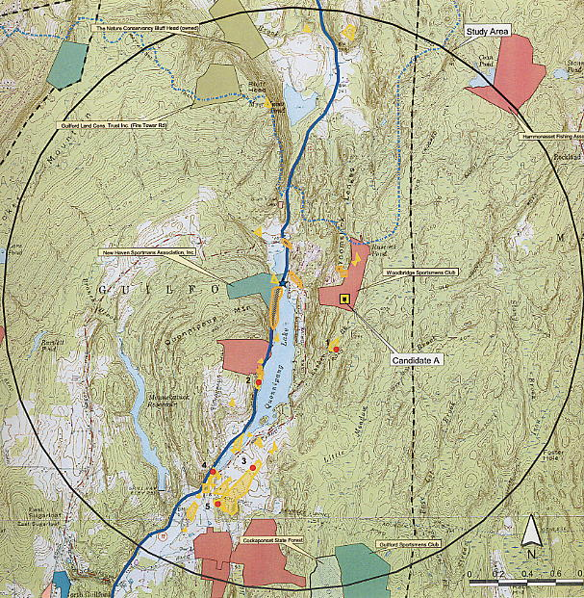

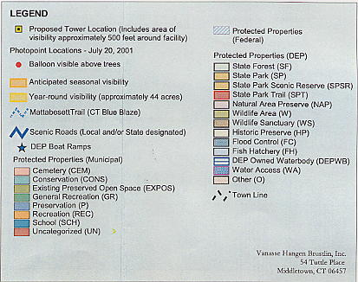

Figure 1. Viewshed analysis for proposed Site A. (Sprint, Tab 16)

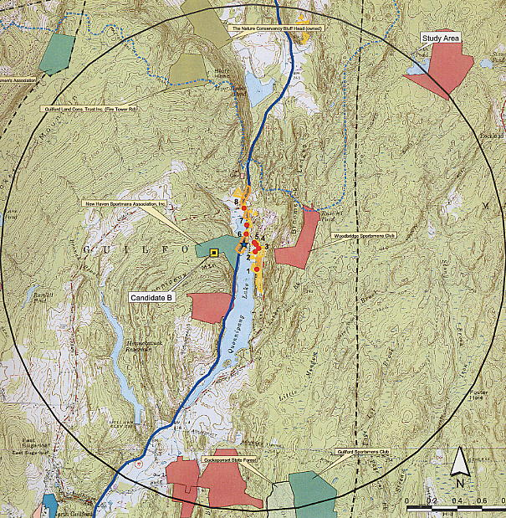

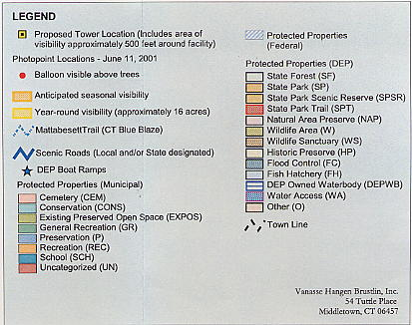

Figure 2. Viewshed analysis for proposed Site B. (Sprint 1, Tab 16)

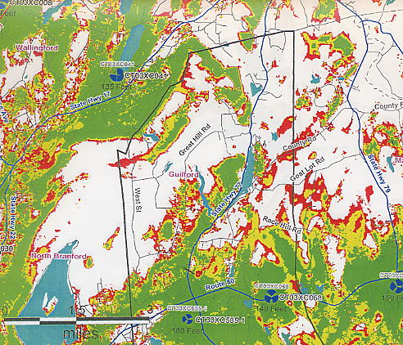

Figure 3. Existing Sprint coverage within a three-mile radius of the proposed sites in the
Town of Guilford. (Sprint 1, Tab 15)

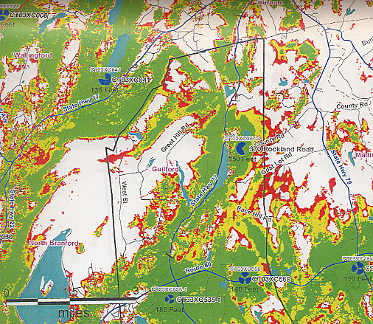

Figure 4. Existing coverage with coverage from proposed Site A at 150 feet AGL (1900 MHz).
(Sprint 1, Tab 15)

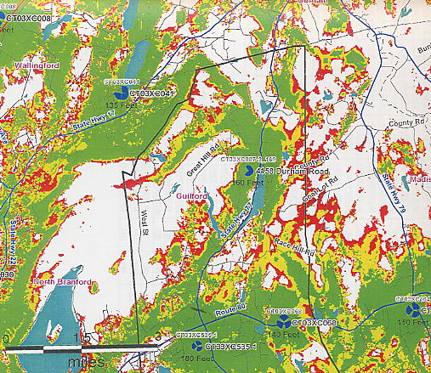

Figure 5. Existing coverage with coverage from proposed Site B at 160 feet AGL (1900 MHz). (Sprint 1, Tab 15)

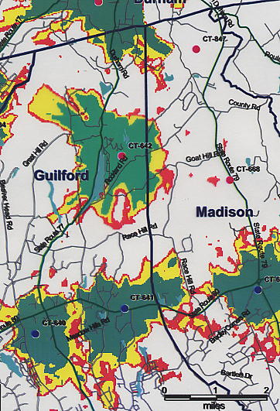

Figure 6. Existing coverage with coverage from Site A at 140 feet AGL
(1900 MHz). (AT&T 1, Q. 4, 5)

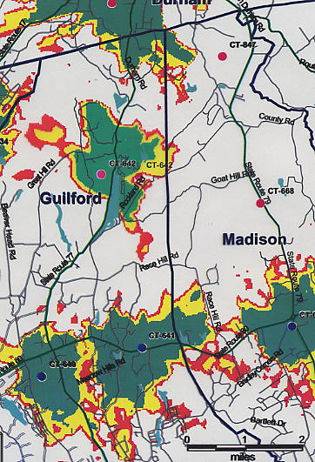

Figure 7. Existing coverage with coverage from Site B at 150 feet AGL
(1900 MHz). (AT&T 1, Q. 4, 5)

