DOCKET NO. 264 - Tower Ventures II, LLC application for a Certificate of Environmental Compatibility and Public Need for the construction, maintenance and operation of a wireless telecommunications facility at either 146 Brown Road or Brown Road (Lot 34) Brooklyn, Connecticut. | }  }  } | Connecticut  Siting  Council  January 12, 2004

Findings of Fact

Introduction

- Tower Ventures II, LLC (TV), in accordance with provisions of General Statutes §§ 16-50g through 16-50aa, applied to the Connecticut Siting Council (Council) on July 11, 2003, for the construction, operation, and maintenance of a wireless telecommunications facility in the Town of Brooklyn at either 146 Brown Road, Lot 46, identified as Site A-1, or Brown Road, Lot 34, identified as Site A-2. (TV 1, p. 1)

- TV is a privately owned company providing wireless telecommunications facilities and infrastructure in New England. TV provides infrastructure to providers of licensed wireless carriers and data providers. (TV 1c, pp. 1-2)

- The purpose of the proposed facility is to provide wireless service to coverage gaps identified by AT&T Wireless PCS, LLC (AT&T) and Omnipoint Holdings d/b/a T-Mobile (T-Mobile) along Route 6 in Brooklyn, Connecticut. Both wireless providers intend to install antennas at the facility. (TV 1, pp. 4, 8; Transcript 1 - November 3, 2003, 3:00 p.m. [Tr. 1], p. 46)

- The party in this proceeding is the applicant. The intervenors in this proceeding are AT&T and T-Mobile. (Tr. 1, p. 6)

- Pursuant to General Statutes § 16-50m, the Council, after giving due notice thereof, held a public hearing on November 3, 2003, beginning at 3:00 p.m. and continued at 7:00 p.m., at the Brooklyn Community Center, 31 Tiffany Street, Brooklyn, Connecticut. (Council's Hearing Notices dated April 11 and August 27, 2003; Tr. 1, p. 3; Transcript 2 - November 3, 2003, 7:00 p.m. [Tr. 2], p. 3)

- The Council and its staff conducted an inspection of the proposed sites on November 3, 2003, beginning at 2:00 p.m. During the field inspection, the applicant flew a balloon at both sites to a height of 150 feet to represent the height of the proposed towers. (TV 9)

- TV issued a technical report describing the proposed project to the Town of Brooklyn on April 28, 2003. Subsequent to the submission, the Town discussed the proposal at a publicly noticed Planning and Zoning Commission hearing on June 4, 2003. At the Commission’s request, TV conducted a balloon float on June 21, 2003 that was attended by approximately 10 area residents and a representative from the Town. (TV 1, pp. 20-21, Attachment N; Tr. 1, p. 70; Tr. 2, p. 14)

- The Planning and Zoning Commission prefers Site A-2, citing less visual impact on the surrounding area. (TV 1, Attachment O)

- Pursuant to General Statute § 16-50l(b), public notice of the application was published in The Hartford Courant and the Norwich Bulletin on July 2 and July 3, 2003. (TV 1, p. 3; TV 2)

- Pursuant to General Statute § 16-50l(b), on July 7, 2003, notice of the application was sent to all abutting landowners by certified mail. All return mail receipts have been received. (TV 1, Attachment B)

- Pursuant to General Statute § 16-50j(h), on August 28 and November 4, 2003, the following State agencies were solicited to submit written comments regarding the proposed facility; Department of Environmental Protection (DEP), Department of Public Health (DPH), Council on Environmental Quality (CEQ), Department of Public Utility Control (DPUC), Office of Policy and Management (OPM), Department of Economic and Community Development (DECD), and the Department of Transportation (DOT). (Record)

- Comments were received from the DEP on October 3, 2003 and from the DOT’s Office of Environmental Planning and the Bureau of Engineering and Highway Operations on September 15, 2003, and October 30, 2003, respectively. (Record)

13. The following agencies did not offer comments on the application: DPH, CEQ, DPUC, OPM, and DECD. (Record)

Telecommunications Act of 1996

- In 1996, the United States Congress recognized a nationwide need for high quality wireless telecommunications services, including cellular telephone service. Through the Federal Telecommunications Act of 1996, Congress seeks to promote competition, encourage technical innovations, and foster lower prices for telecommunications services. (Council Admin. Notice, no. 7, Telecom Act 1996)

- In issuing cellular licenses, the Federal government has preempted the determination of public need for cellular service by the states, and has established design standards to ensure technical integrity and nationwide compatibility among all systems. (Council Admin. Notice, no. 7, Telecom. Act 1996)

- The Telecommunications Act of 1996 prohibits local and state bodies from discriminating among providers of functionally equivalent services. (Council Admin. Notice, no. 7, Telecom. Act 1996)

- The Telecommunications Act of 1996, a federal law passed by the United States Congress, prohibits any State or local agency from regulating telecommunications towers on the basis of the environmental effects of radio frequency emissions to the extent that such towers and equipment comply with Federal Communications Commission’s (FCC) regulations concerning such emissions. This Act also blocks the Council from prohibiting or acting with the effect of prohibiting the provision of personal wireless service. (Council Admin. Notice, no. 7, Telecom. Act 1996)

Site Search

- TV examined 16 parcels in Brooklyn, two of which were selected for site development. The fourteen rejected parcels and reasons for their rejection are as follows:
- 131 Prince Hill Road – contains residential development.
- 134 Prince Hill Road – commercially zoned but lot too small (1.5 acres).
- Prince Hill Road, Lot 3 – owner unresponsive.
- 185 Providence Road – wetlands impact.
- Prince Hill Road, Lot 19 – Town of Brooklyn property, would not meet coverage objectives.
- 12 Gorman Road – owners unresponsive.
- Ennis Road, Lot 55 – owners unresponsive.
- 289 Providence Road owners unresponsive.
- Ennis Road, Lot 53 – owners unresponsive.
- Providence Road, Lots 04 & 30 – two separate lots, owner unresponsive.
- Brown Road, Lot 2 – owners unresponsive.
- Brown Road, Lot 31 – low elevation, wetlands.
- Brown Road, Lot 1A – visibility.
(TV 1, Attachment F; TV 5, Q. 18)

- There are no existing structures in the search area of sufficient height to provide coverage to the identified coverage gaps. (TV 1, p. 7; TV 5, Q. 16; Tr. 1, p. 17)

Tower and Compound Design

- TV would construct a 150-foot monopole at either site. The tower would be designed to support six levels of flush mounted antennas with a 10-foot center-to-center vertical separation. The use of flush mounted antennas is preferred by the Town. TV would not restrict telecommunication carriers to this configuration if coverage design and/or capacity needs require the installation of a more prominent antenna configuration. (TV 1, Attachment D, Attachment E; Tr. 1, pp. 49-50, 59; Tr. 2, p. 20)

- AT&T would install six flush mounted panel antennas at a centerline height of 147.5 feet above ground level (agl). AT&T would redesign the antenna configuration to a T-arm design if capacity demands increase. A T-arm antenna configuration has a width of five feet per mounting side compared to a width of 12-14 feet for an antenna platform. AT&T expects to maintain a flush mount design in this location for at least two years. (TV 1, Attachment D; AT&T 1, Q. 6; Tr. 1, p. 104; Tr. 2, p. 28)

- T-Mobile would install nine flush-mounted panel antennas at a centerline height of 137.5 feet agl. T-mobile would redesign the antenna configuration to a platform design if capacity demands increase. T-mobile expects to maintain a flush mount design for a minimum of two years. (TV 1, Q. 6; Tr. 1, pp. 79-80)

- The president of the Quinebaug Valley Emergency Communications, Inc. (QVEC), Jeffery Otto, made a limited appearance statement into the record at the November 3, 2003 hearing, requesting that the QVEC be allowed to use the top of the tower to mount communication equipment. The QVEC operates a 911 dispatch center servicing 34 fire departments, nine ambulance operations and three police departments in 15 area towns. TV would accommodate the QVEC, providing lease-free space for an omni-directional whip antenna at the top of the tower. Operation of QVEC’s antenna would not interfere with the operation of AT&T’s antennas. (Tr. 1, pp. 7-9, 33, 67, 102)

- At either site, a 75-foot by 75-foot compound, enclosed by a ten-foot high chain link fence, would be established at the base of the tower. The compound would be able to accommodate the equipment of six wireless carriers. AT&T would install up to four equipment cabinets on a concrete pad within the compound. T-Mobile would install up to three equipment cabinets on a concrete pad within the compound. (TV 1, pp. 4-6; AT&T 1, Q. 7; T-Mobile 1, Q. 7)

- Underground utilities would be installed to either compound from a utility pole on Brown Road. Blasting would be required to install utilities at either site. Blasting could be avoided by installing overhead utilities. (TV 1, Attachment D; Tr. 1, pp. 44-45)

- The estimated cost to develop a facility at either site is:

Acquisition $10,000
Siting 43,000
Construction 130,000

Total $183,000
(TV 1, p. 18)

Site Description – Site A-1

- Proposed Site A-1 is located on a 4.6-acre parcel identified as 146 Brown Road, Lot 46, in Brooklyn. The site parcel has no town road frontage and is one of five contiguous parcels on the west and north side of Brown Road used as part of Ingalls Tree Farm. The tower site is located in an open, level area at an elevation of 392 feet above mean sea level (amsl). The tower would be located in the northwest corner of the compound. (TV 1, p. 4, Attachment D; TV 4, Q. 2)

- Access to the proposed site would be from an existing dirt drive that services the tree farm and extends from Brown Road. A 12-foot wide, 35-foot long gravel drive of new construction would extend from the service road to the site. The existing service road traverses tree farm property identified as 47 Brown Road, Lot 47, before extending onto the site parcel. The service road on Lot 47 parallels abutting property owned by John and Elise Guari to the southwest. Brown Road is approximately 600 feet southeast of the compound. (TV 1, Attachment D; TV 4, Q. 2)

- Development of the site would require 129 cubic yards of fill and 215 yards of cut. (TV 4, Q. 15)

- The tower setback radius would be contained within the site parcel. (TV 1, Attachment D)

- The site parcel and abutting parcels are zoned Residential-Agricultural, RA. The nearest property not owned by the lessor is 170 feet southwest of the tower, owned by John and Elise Guari. A row of hardwoods, 60-75 feet in height, is located on the property boundary abutting the existing service road. (TV 1, Attachment D; TV 1a, Property Line Base Map; TV 4, Q. 2)

- Three residences are located within 1,000 feet of the tower site. The nearest residence, owned by George Allen et al at 99 Brown Road, is approximately 600 feet east of the site. (TV 1, Attachment D, Attachment E; TV 4, Q. 4)

Site Description – Site A-2

- Proposed Site A-2 is located on a 17.5-acre parcel known as Brown Road, Lot 34. The parcel is one of three that total 40 acres on the southeast side of Brown Road that are used as part of Ingalls Tree Farm. The tower site is located in an open area that slopes sharply downward to the east. The base of the tower would be located at an elevation of 303 feet agl. (TV 1, p. 4, Attachment E; TV 4, Q. 2)

- Access to the site would follow a grass drive, 472 feet in length, originating from Brown Road. TV would widen the drive to 12 feet, install a gravel surface and extend it by 95 feet to the proposed compound area. The existing grass drive parallels abutting property to the south owned by George F. Allen, et al for most of its length and parallels abutting property to the north, owned by Beatrice and Roland Gadboury, for 195 feet. (TV 1, Attachment E; TV 4, Q. 2)

- TV would re-grade the sloping hillside to accommodate a three level compound. The levels would be separated by an elevation difference of two to three feet. The multi-level design could accommodate the equipment of six wireless carriers. The tower would be located on the north side of the compound, in the middle tier. (TV 1, Attachment E; DEP comments dated October 30, 2003)

- Development of the site would require 190 cubic yards of fill and 650 yards of cut. (TV 4; Q. 15)

- To reduce the amount of grading, TV could move the tower 75 feet to the south to an area with a moderately sloping grade and similar elevation. (DEP Comments dated October 30, 2003; Tr. 1, p. 18; Tr. 2, p. 23)

- The tower setback radius would be contained within the site parcel. (TV 1, Attachment E)

- The parcel is zoned Residential-Agricultural, RA, and abuts RA zoned property. The nearest property boundary from the tower site is 150 feet to the west. The abutting property, owned by George Allen et al at 99 Brown Road, contains a residence. A row of mature pine trees is located on the property boundary in the vicinity of the tower site. (TV 1, Attachment E; TV 4, Q. 2)

- There are three residences within 1,000 feet of the tower site. The nearest residence, owned by Beatrice and Roland Gadboury at 111 Brown Road, is 450 northwest of the tower site. (TV 4, Q. 4)

Environmental and Cultural Considerations

- The proposed sites are in the vicinity of known populations of the frosted elfin moth (Callophrys irus), a State species of special concern. Development of either site would not impact moth populations since suitable moth habitat was not identified within the development area of either site. (TV 3, TV 7, TV 8)

- Development of either site would not directly impact any wetlands or watercourses. There are no wetlands or watercourses in the vicinity of Site A-1. A wetland is approximately 115 feet east and down gradient of the Site A-2 development area. (TV 1, Attachment D, Attachment E)

- The nearest historic district to Site A-1 is the Brooklyn Green National Register Historic District, approximately 0.3 miles south of the site. The nearest historic district to Site A-2 is the Trinity Church National Register Historic District, approximately 0.5 miles east of the site. (TV 1, Attachment J)

- The proposed facilities would have no effect upon historic, architectural, or archaeological resources listed on or eligible for the National Register of Historic Places or upon properties of traditional cultural importance to Connecticut’s Native American community. (TV 1, Attachment I)

- Site A-1 would not require aircraft hazard obstruction marking or lighting. An aeronautical study was not performed for Site A-2. Site A-2 is 90 feet lower in elevation than Site A-1 and aircraft hazard obstruction marking or lighting would not be expected. However, TV would be required by the FAA to obtain an aeronautical determination prior to site construction. (TV 3; Tr. 2, pp. 20-22)

- The conservative worst-case approximation of electromagnetic radiofrequency exposure to T-Mobile and AT&T antennas at the base of either tower would be 19.8 percent of the Maximum Permissible Exposure limit established by the Federal Communications Commission. (TV 1, Attachment K)

- The Brooklyn Conservation Commission provided written comment to the Council on October 20, 2003, indicating a preference for Site A-2. The Commission commented Site A-2 is more consistent with the objectives presented in the Town’s Open Space and Conservation Plan. Site A-1 is listed in the plan as a scenic vista and potential archeological resource. (Brooklyn Conservation Commission Letter dated October 20, 2003)

48 There are no public hiking trails in the vicinity of the sites. (TV 4, p. 14)

Visibility

- Visibility of the Site A-1 tower is anticipated from the following roads (refer to Figure 1):
Limited Visibility
- 0.3 miles of Church Street, approximately 0.8 miles east of the site.
- 0.1 miles of Gormon Road, approximately 0.8 miles southeast of the site.
High Visibility
- 0.3 miles of Brown Road, approximately 0.1 miles east of the site.
- 0.1 miles of Church Street, approximately 0.7 miles east of the site.
- 0.4 miles of Route 6, approximately 0.5 miles southeast of the site.
- 0.1 miles of Gormon Road, approximately 0.8 miles southeast of the site.
(TV 1, Attachment D; Tr. 1, p. 27)

- Visibility of the Site A-2 tower is anticipated from the following roads (refer to Figure 2):
Limited Visibility
a) 0.3 miles of Church Street, approximately 0.6 miles east of the site.
b) 0.1 miles of Gormon Road, approximately 0.5 miles southeast of the site.
c)` <0.1 mile of Barrett Road, approximately 1.0 mile northwest of the site.
High Visibility
- 0.3 miles of Brown Road, approximately 0.1 miles west of the site.
- 0.2 miles of Brown Road, approximately 0.2 miles north of the site.
- 0.1 miles of Church Street, approximately 0.5 miles east of the site.
- 0.4 miles of Route 6, approximately 0.3 miles southeast of the site.
- 0.1 miles of Gormon Road, approximately 0.5 miles southeast of the site.
(TV 1, Attachment D; Tr. 1, p. 27; Tr. 2, p. 18)

51. Visibility from Church Street is partially obscured by vegetation along the road. Open views of both towers with the sky as a backdrop would exist in a cleared area along the road (refer to Figures 3A & 3B). (TV 1, Attachment E; Tr. 2, pp. 12-13)

52. Visibility of both sites from Route 6 and Brown Road would consist of tower views with the sky as a backdrop (refer to Figures 4A, 4B, 5A & 5B). (TV1, Attachment E, Attachment F)

53. The Site A-1 tower would be visible from five residences on Brown Road, from #65 to #111, two residences on Melbourne Lane, #7 and #10, and two residences on Church Street #92 and #129. Site A-1 would be visible from the Baptist Church at 198 Prince Hill Road and Brooklyn General Repair at 245 Route 6. (AT&T 5, Q. 19)

54. The Site A-2 tower would be visible from 11 residences on Brown Road, from #65 to #111 and #163 to #203. The tower would also be visible from the residences at #7 and #10 Melbourne Lane, #92 and #129 Church Street, and from the Baptist Church at 198 Prince Hill Road and Brooklyn General Repair at 245 Route 6. (TV 5, Q. 19; Tr. 2, pp. 17-18)

55. Six of the residences on Brown Road, from #163 to #203, face the north side of the road. The Site A-2 tower is located south of the residences beyond an area of woodlands. Visibility of the tower from these residences may be obscured by the woodland area. Tower views from these residences may be reduced if the site was moved 75 feet to the south. (TV 1, Attachment F; Tr. 2, pp. 17-18)

56. Site A-1 is located on an open knoll 40 feet above Brown Road, within a tree farm. Mature vegetation, consisting of hardwoods 60- 75 feet in height, exists approximately 250 feet south of the site. No other mature vegetation exists within 500 feet of the site. (TV 1, Attachment E; TV 4, Q. 2)

57. Site A-2 is located 25 feet down slope of Brown Road, behind a stand of mature pine trees. The pine trees are 150 feet west of the tower site. Mature vegetation also exists with 250 feet to the north, south and east. (TV 1, Attachment F; TV 4, Q. 2)

58. Due to the topographical differences between the two sites, views of Site A-1 would have a sky backdrop whereas a majority the views of Site A-2 would have forested terrain as a backdrop. (Tr. 1, p. 46)

59. A brown-painted tower at either site would be more visible than a galvanized tower to residents on Brown Road since most of the tower views in this area would be upward with the sky as a backdrop. (Tr. 1, p. 27)

60. The nearest scenic road to the sites is Route 169, a National Scenic Byway, approximately 0.4 miles to the west. The Site A-1 tower would be visible from approximately 30 feet of the scenic byway. The tower backdrop would consist of vegetation. Site A-2 is not visible. (Tr. 2, 18-20)

61. Both sites would be visible through vegetation from select portions of the Trinity Church National Register Historic District. Site A-1 would be visible from the Brooklyn Green National Register Historic District in the vicinity of the Route 6 and Route 198 intersection. (Tr. 1, pp. 20-21; Tr. 2, pp. 11-14)

62. Relocating Site A-2 75 feet to the south, as recommended by the DEP, would reduce the visibility of the tower from the Trinity Church National Register Historic District but may slightly increase visibility along Route 6. Relocating the site would not increase tower visibility to adjacent residences. (Tr. 2, 11-14)
T-Mobile - Existing and Proposed Wireless Coverage

- Adjacent T-Mobile facilities that would interact with the proposed facility are as follows:

Location | Antenna Height agl | Approximate Distance from Sites
130 Old Tatnic Road, Brooklyn | 140 feet | 2.7 miles southwest
56 Roper Road, Plainfield | 162 feet | 4.7 miles southeast
246 East Franklin St., Danielson | 137 feet | 3.5 miles east
116 Grant Hill Road, Brooklyn | 137 feet | 3.8 miles west
(T-Mobile 1, Q. 3, Q. 4; Tr. 1, p. 74)
64. T-Mobile transmits in the 1935-1945 MH frequency band and has a service design minimum signal level threshold of -85 dBm in this area. This will allow for in-car coverage. (T-Mobile 1, Q. 1, Q. 2)

- T-Mobile is currently experiencing a 2.2 mile coverage gap, defined as <-85 dBm, on Route 6 between Brooklyn center and Danielson (refer to Figure 6). (T-Mobile 1, Q. 4)

66. Installing antennas at 137.5 feet agl at either site would provide seamless coverage to the identified coverage gap (refer to Figure 7). (T-Mobile 1, Q. 5)

- T-Mobile would require a minimum antenna height of 100 feet agl at either site to meet coverage objectives. (Tr. 1, p. 75)

- Although there is a 90-foot elevation difference between the two sites, coverage from the sites is comparable. Site A-1 provides a slight increase in coverage to roads north of the site, particularly along Darby Road. (T-Mobile 1, Q. 5; Tr. 1 p. 76)

AT&T - Existing and Proposed Wireless Coverage

- AT&T operates in the FCC assigned D & E 1900 MHz frequency bands and has a service design minimum signal level threshold of -85 dBm. (AT&T 1, Q. 2)

- Adjacent AT&T facilities that would interact with the proposed facility are as follows:

Location | Antenna Height agl | Approximate Distance from Sites
43 Conn. Mills Rd., Plainfield | 115 feet | 3.3 miles northeast
246 East Franklin St., Danielson | 127 feet | 3.5 miles east
116 Grant Hill Road, Brooklyn | 127 feet | 3.8 miles west
(AT&T 1, Q. 3, Q. 4)

- AT&T seeks to provide coverage along both Route 6 and Route 169 in Brooklyn. AT&T has identified a 2.5 mile gap in coverage on Route 6 in the vicinity of Brooklyn center (refer to Figure 5). AT&T currently has no coverage on Route 169 in Brooklyn (refer to Figure 8). (AT&T 1, Q. 1, Q. 4)

- Installing antennas at 147.5 feet agl or 127.5 agl feet at Site A-1 would meet coverage objectives on Route 6 and would provide approximately two miles of coverage to Route 169 (refer to Figure 9). (AT&T 1, Q. 5; Tr. 1, pp. 95-96, 100)

- Installing antennas at 147.5 feet agl at Site A-2 would provide marginal coverage along Route 6 with an approximate 0.75 mile gap in coverage between the proposed site and the 116 Grant Hill Road site to the west (refer to Figure 10). AT&T would most likely require a second low elevation facility to service this section of Route 6. Site A-2 would provide coverage to 1.3 miles of Route 169 in the vicinity of the Town center. (AT&T 1, Q. 5; Tr. 1, pp. 95-99)

FIGURE 1

VISIBILITY OF PROPOSED SITE A-1 TOWER

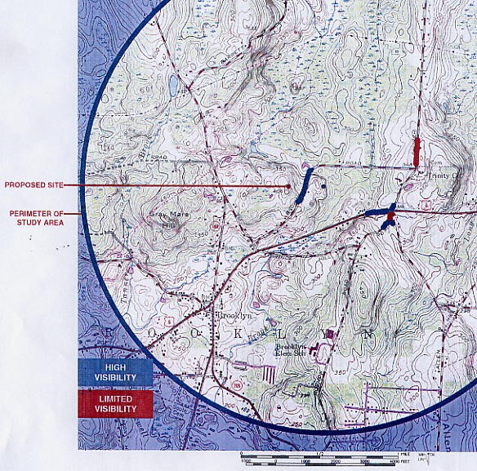
Route 169
Route 6

(TV 1, Attachment D)

FIGURE 2

VISIBILITY OF PROPOSED SITE A-2 TOWER

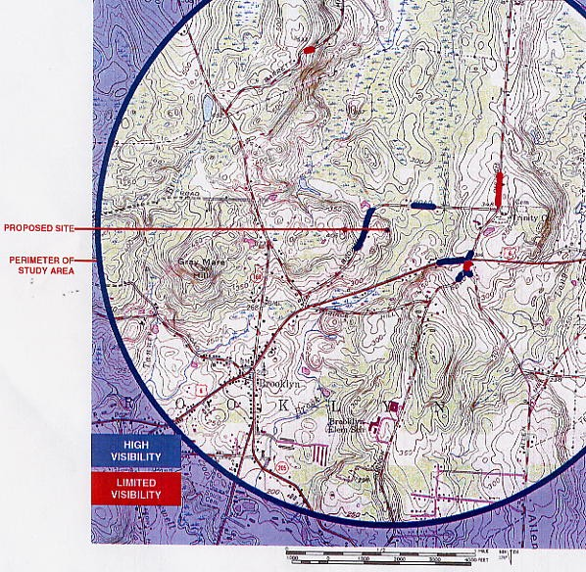
Route 169
Route 6

(TV 1, Attachment E)
FIGURE 3A
VISIBILITY OF SITE A-1 FROM CHURCH STREET
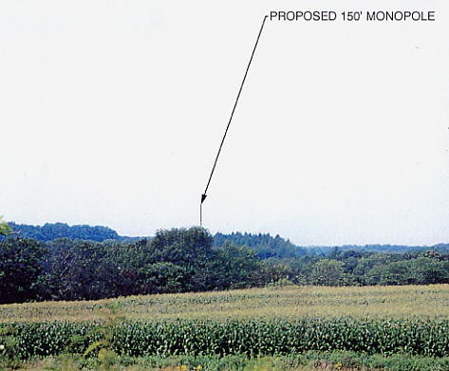

FIGURE 3B
VISIBILITY OF SITE A-2 FROM CHURCH STREET
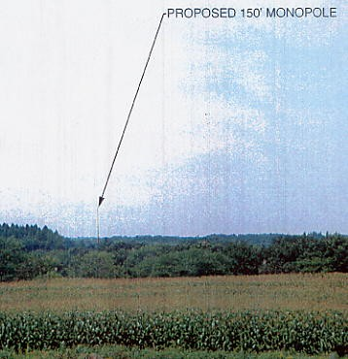
(TV 1, Attachment E, Attachment F)
FIGURE 4A
VISIBILITY OF SITE A-1 FROM ROUTE 6
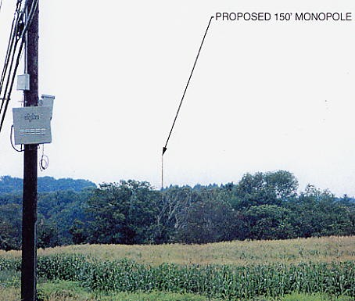

FIGURE 4B
VISIBILITY OF SITE A-2 FROM ROUTE 6
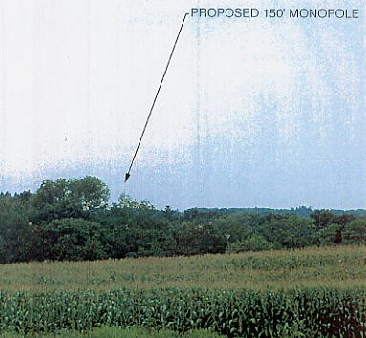
(TV 1, Attachment E, Attachment F)
FIGURE 5A

VISIBILITY OF SITE A-1 FROM BROWN ROAD
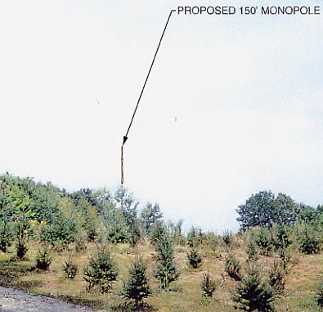

FIGURE 5B

VISIBILITY OF SITE A-2 FROM BROWN ROAD
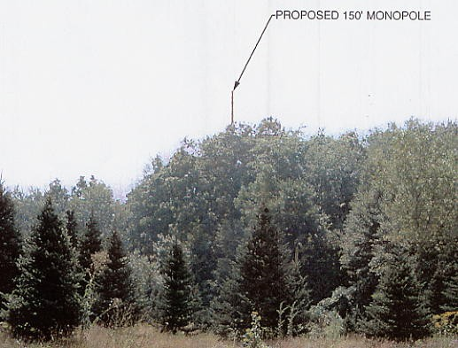
(TV1, Attachment E, Attachment F)
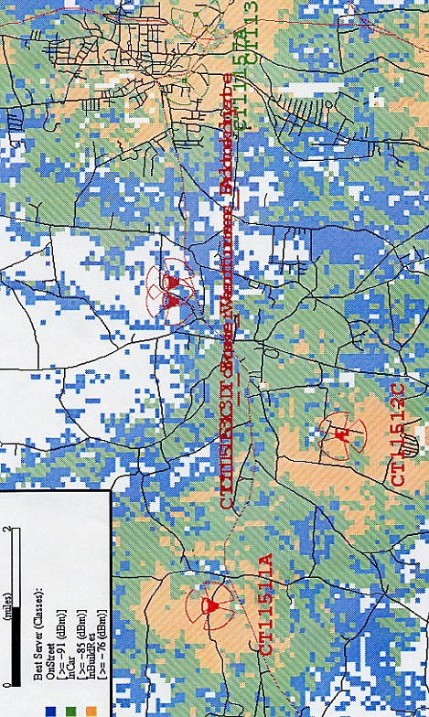
Route 169
Route 6
Route 6
FIGURE 6
T-MOBILE EXISTING COVERAGE
(T-Mobile 1, Q. 4)

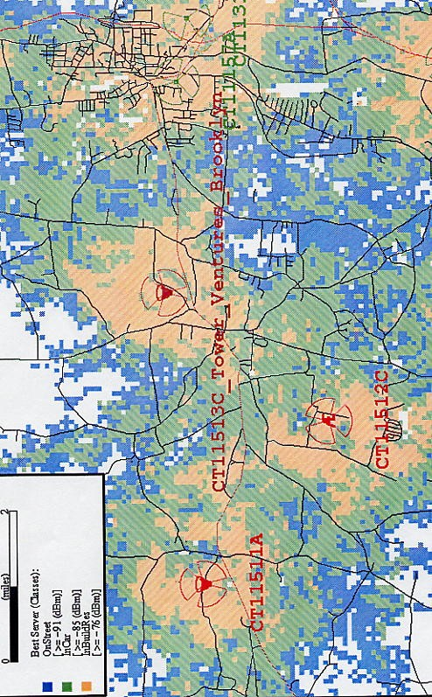
Route 6
Route 6
Darby Rd.
Route 169
FIGURE 7
T-MOBILE EXISTING AND PROPOSED COVERAGE
SITE A-1 WITH ANTENNAS AT 137.5 FEET
(T-Mobile 1, Q. 5)

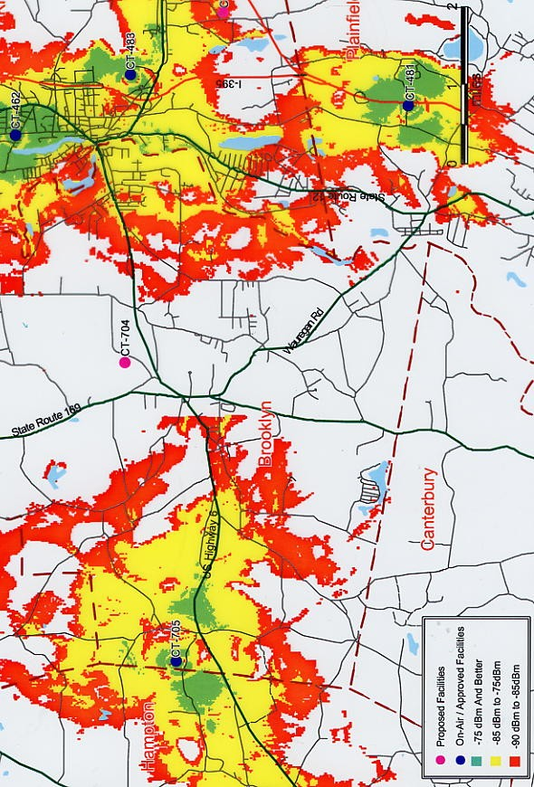
(AT&T 1, Q. 4)
Route 169
Route 6
FIGURE 8
AT&T EXISTING COVERAGE

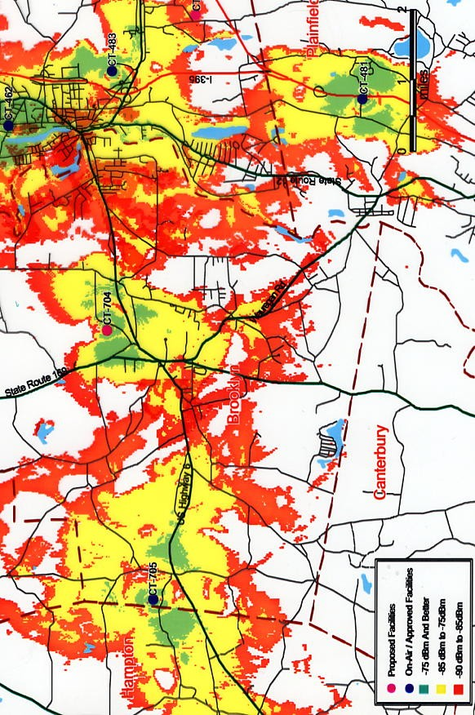
Route 169
Route 6
Route 6
FIGURE 9
AT&T EXISTING AND PROPOSED COVERAGE
SITE A-1 WITH ANTENNAS AT 147.5 FEET AGL
(AT&T 1, Q. 5)
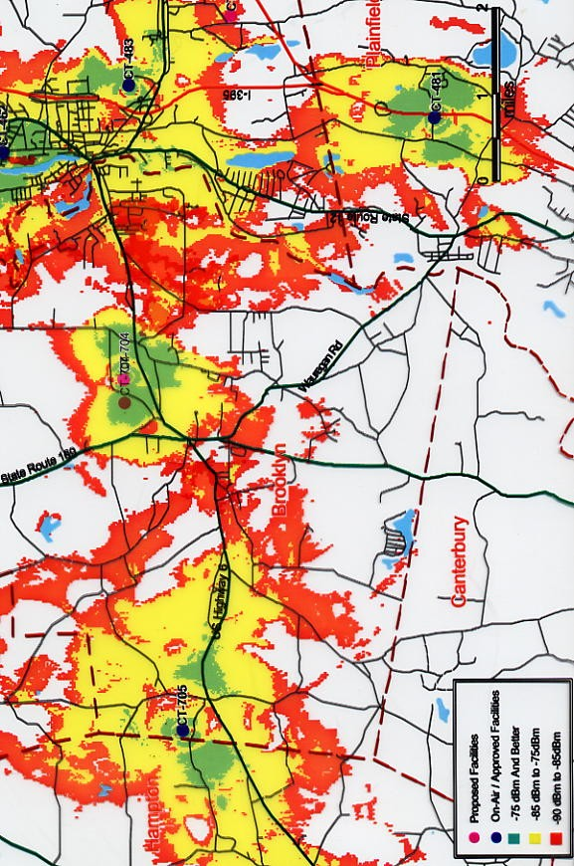
Route 169
Route 6
Route 6
FIGURE 10
AT&T EXISTING AND PROPOSED COVERAGE
SITE A-2 WITH ANTENNAS AT 147.5 FEET AGL
(AT&T 1, Q. 5)

