`
DOCKET NO. 262 - Sprint Spectrum, L.P. d/b/a Sprint PCS application for a Certificate of Environmental Compatibility and Public Need for the construction, maintenance and operation of a wireless telecommunications facility at 707 Cranberry Lane or off of Grassy Hill Road, Orange, Connecticut. | }  }  }  } | Connecticut  Siting  Council  January 12, 2004

Findings of Fact
Introduction

- Sprint Spectrum L.P., d/b/a Sprint PCS (Sprint), in accordance with provisions of General Statutes §§ 16-50g through 16-50aa, applied to the Connecticut Siting Council (Council) on June 16, 2003, for the construction, operation, and maintenance of a wireless telecommunications facility in Orange, Connecticut. The proposed facility would provide wireless coverage to existing gaps in Orange along Route 15 (Wilbur Cross Parkway) and Route 121. Proposed Site A is located at 707 Cranberry Lane, Orange and Site B and Site C are located on a parcel off of Grassy Hill Road, Orange, Connecticut. (Sprint 1, p. 1, 3, 4; Tab 5, Tab 6, Tab 10)

- Sprint is a wholly owned subsidiary of Wireless Co, L.P., licensed by the Federal Communications Commission (FCC) to provide wireless personal communication service (PCS). Sprint operates in 32 major trading areas within the United States, including Connecticut. (Sprint 1, p. 2, 3)

- The party in this proceeding is the applicant. The intervenors are AT&T Wireless PCS, LLC d/b/a AT&T Wireless (AT&T), and Cellco Partnership d/b/a Verizon Wireless (Verizon). (Tr. 1, 3:00 p.m., p. 5, 6; Tr. 2, 7:00 p.m., p. 5, 6)

- Pursuant to General Statutes § 16-50m, the Council, after giving due notice thereof, held a public hearing on October 22, 2003, beginning at 3:00 p.m., and continuing at 7:00 p.m. at the High Plains Community Center, 525 Orange Center Road, Orange, Connecticut. (Tr. 1, p. 3; Tr. 2, p. 3)

- The Council and its staff made inspections of the proposed sites on October 22, 2003. During the field inspection, the applicant flew two red balloons at proposed Site A, a black balloon at proposed Site B, and a red balloon at proposed Site C. All of the balloons were flown at 140 feet to simulate the height that AT&T has requested, with a flag at 125 feet to simulate the height proposed by Sprint in this application. (Sprint 1, p. 27; Tr. 1, p. 16, 17)

- On December 6, 2000, Sprint filed an application to the Inland Wetlands and Water Courses Commission for a permit to construct a wireless communications facility at Site B. On January 9, 2001, Sprint withdrew the application due to the Federal Court decision that granted the Council jurisdiction for PCS facilities. During 2001 and 2002, Sprint worked with Town of Orange First Selectman, Mitchell Goldblatt to reach an agreement regarding the construction of a tower at Site B. Sprint could not reach an agreement with the Town of Orange and Sprint continued with its plan to file an application with the Council. (Sprint 1, p. 6, 7)

- On March 4, 2003, Sprint filed a notification and technical information to the Town of Orange for the proposed Site A and Site B. In response, the Town of Orange recommended that Sprint propose a site in the northwest corner of the property off of Grassy Hill Road with the nearest residential property greater than 500 feet away and close to Route 15. The Town recommended tower location is referred to as Site C. (Sprint 1, p. 7, 8)

- Public notice of the application was published in The New Haven Register on June 5 and 12, 2003, and in The Amity Observer and The Bulletin (Orange) on June 12, 2003. A notice was sent to all abutting landowners via certified mail, return receipt requested on June 5, 2003. Return receipts were received for all but two adjacent landowners, which were sent another copy of the notice via first class mail on June 13, 2003. (Sprint 1, p. 3)

- Pursuant to General Statutes § 16-50j (h), the following state agencies were notified of the project on July 25, 2003: Department of Environmental Protection (DEP), Department of Public Health (DPH), Council on Environmental Quality (CEQ), Department of Public Utility Control (DPUC), Office of Policy and Management (OPM), Department of Economic and Community Development (DECD), and the Department of Transportation (DOT). (record)

- Comments were received from the DOT on August 5, 2003, and November 7, 2003 and from the DEP on October 21, 2003. DOT comments state that the tower must be far enough away from Route 15 to protect the traveling public if the tower were ever to collapse. (record)

- The following agencies did not offer comments on the application; DPH, CEQ, DPUC, OPM, and the DECD. (record)

Telecommunications Act

- In issuing cellular licenses, the federal government has preempted the determination of public need for cellular service by the states, and has established design standards to ensure technical integrity and nationwide compatibility among all systems. (Council Admin. Notice, no. 7, Telecom. Act 1996)

- In 1996, the United States Congress recognized a nationwide need for high quality wireless telecommunications services, including cellular telephone service. Through the Federal Telecommunications Act of 1996, Congress seeks to promote competition, encourage technical innovations, and foster lower prices for telecommunications services. (Council Admin. Notice, no. 7, Telecom Act 1996)

- The Telecommunications Act of 1996 prohibits local and State bodies from discriminating among providers of functionally equivalent services. (Council Admin. Notice, no. 7, Telecom. Act 1996)

- The Telecommunications Act of 1996, a federal law passed by the United States Congress, prohibits any State or local agency from regulating telecommunications towers on the basis of the environmental effects of radio frequency emissions to the extent that such towers and equipment comply with Federal Communications Commission’s (FCC) regulations concerning such emissions. This Act also blocks the Council from prohibiting or acting with the effect of prohibiting the provision of personal wireless service. (Council Admin. Notice, no. 7, Telecom. Act 1996)

Site Search

- Sprint identified six existing communications towers located within approximately three miles of the proposed sites: a 160-foot tower owned by the Town of Orange located at 525 Orange Center Road, Orange; a 160-foot tower owned by Cellco, located on Ogg Meadow Road, Orange; a 180-foot tower owned by the Town of Orange, located on South Orange Center Road, Orange; a 120-foot flagpole tower owned by VoiceStream, located at 309 River Road, Shelton; a 150-foot tower owned by Sprint, located at 1027 Race Brook Road, Woodbridge; and a 150-foot tower owned by Sprint, located at 1116 Johnson Road, Woodbridge. These towers would not provide adequate coverage to this section of Orange. Sprint is not aware of any plans by other telecommunications entities to construct a new telecommunication facility within two miles of the search area. (Sprint 1, p. 9, Tab 12)

- Sprint identified and investigated nine potential sites, including proposed Site A, Site B and Site C, within a search ring in Orange. The potential sites include 579 Glenwood Drive, High Ridge Road, Derby-Milford Road, and Town of Orange property on Wheelers Farm Road, which were investigated and rejected by Sprint due to inadequate coverage. A site at Turkey Hill School, and a site originally proposed by Dwyer Co., Inc., were rejected because they were withdrawn by the property department. (Sprint 1, p. 10; Tab 13)

Site and Equipment

- Sprint proposes to construct a 125-foot monopole at Site A, Site B or Site C, which would be designed to accommodate two additional carriers with a 10-foot center-to-center vertical separation. AT&T has requested that the height of the proposed structures be extended to 140 feet to provide adequate AT&T coverage to the area. If a 140-foot tower were to be approved by the Council at the proposed sites, Sprint would locate their antennas at the 130-foot level to make efficient use of the tower. (Sprint 1, p. 4, 9, Tab 5, Tab 6; AT&T 1, Q. 2; Tr. 1, p. 26)

- AT&T published a legal notice of the request that the Council consider a 140-foot monopole at the proposed sites in The New Haven Register, The Bulletin, Stratford Bard, and the Amity Observer. AT&T sent a notice of the request for additional height to all adjacent landowners. (AT&T 3, Tab C; AT&T 3-C)

- Proposed Site A would include a 60-foot by 40-foot lease area on which Sprint would develop a 40-foot by 40-foot equipment compound. Proposed Site B and Site C would include a 100-foot by 100-foot lease area on which Sprint would develop a 30-foot by 56-foot equipment compound. The proposed tower and equipment compound at the proposed sites would be enclosed by a 6-foot high chain link fence. The proposed Site A monopole would have a global positioning system (GPS) antenna at 50 feet above ground level (AGL). The proposed Site B and Site C monopole would have a GPS antenna at 75 feet. A gravel surface would be established within the tower compound and access road at each of the proposed sites. (Sprint 1, p. 12, Tab 5, Tab 6; Sprint 3, Q. 1)

- Sprint would use a battery back up, which would operate for approximately six hours, during power outages. During a power outage that exceeds 24 hours, Sprint would bring in a diesel powered electrical generator temporarily. (Sprint 1, p. 12, 13)

- AT&T, Verizon and T-Mobile have expressed an interest in using the proposed facility. AT&T would require a height of 140 feet AGL. If a 135-foot tower was approved at one of the proposed sites then AT&T would locate at that level because there would be marginal coverage loss from the 140-foot facility AT&T has requested. Verizon would locate at the 115-foot level of the 125-foot proposed tower and at 120 feet on a 140-foot tower. Sprint would offer space on the proposed tower to the Town of Orange, free of charge. (Sprint 3, Q. 20; AT&T 1, Q. 2; Verizon 1, Q. 2; Tr. 1, p. 25, 62, 69)

- The tower setback radius of the proposed 125-foot Site A tower would extend approximately 90 feet onto the Route 15 right-of-way to the east and 100 feet to the west/northwest across Cranberry Road and onto a parcel of land. The tower setback radius of the proposed 125-foot Site B tower would extend approximately 60 feet to the north/northwest onto the Route 15 right-of-way. The tower setback radius of the proposed 125-foot Site C tower would extend approximately 100 feet to the north and west onto the Route 15 right-of-way. Sprint would be willing to design the structure with a yield point that would keep the structure from extending onto adjacent property if it were to fall. (Sprint 1, Tab 5, Tab 6, Tab 10; Tr. 1, p. 25)

- The approximate costs of construction for the proposed Site A, Site B, and Site C are estimated as follows:

Activity Description | Site A | Site B | Site C
Clearing & Grubbing Road | $ 2,231 | $ 3,300 | $ 1,649
Clearing & Grubbing Compound | 485 | 485 | 485
Access Road | 66,000 | 100,000 | 50,000
Utilities | 6,300 | 8,920 | 2,935
Electrical | 5,000 | 5,000 | 5,000
Tower | 40,000 | 40,000 | 40,000
Tower Foundation | 30,000 | 30,000 | 30,000
Compound Development | 19,360 | 19,360 | 19,360
Tower Construction | 10,000 | 10,000 | 10,000
RF Work | 25,000 | 25,000 | 25,000
Total Costs | $204,376 | $242,065 | $184,429
(Sprint 3, Q. 14)

Proposed Site A/ Site B/ Site C

- Proposed Site A would be located on an approximately 1.5-acre parcel owned by Frank Woodruff Rogers. The elevation of Site A is 108 feet above mean sea level (amsl). Proposed Site B and Site C would be located on an approximately 20-acre parcel owned by Julia Rogers Schen, Ellen Rogers Saylor, and Harriet Rogers Wood. The elevation of Site B is 85 feet amsl. The elevation of Site C is 87 feet amsl. The forest cover in the area consists mostly of mixed deciduous hardwood species with an average estimated height of 75 feet agl. (Sprint 1, p. 11; Sprint 3, Q. 1)

- Site A, Site B, and Site C are located within a Residential zone (R-1). The Town of Orange Zoning Regulations express a preference for locating on Town of Orange owned land or buildings. The Town of Orange would least prefer a new tower located in the residential district. (Sprint 1, p. 10, 11, Tab 14)

- There are five residences within a 1,000-foot radius of proposed Site A, the nearest of which is owned by the G. Thomas Vitagliano Family Trust and is located approximately 282 feet to the north. There are three residences within a 1,000-foot radius of proposed Site B, the nearest of which is owned by Victor and Penelope Mitchell and is located approximately 424 feet to the southwest. There is one residence within a 1,000-foot radius of proposed Site C, which is located approximately 600 feet to the northwest. (Sprint 1, Tab 5, Tab 6; Sprint 3, Q. 8; Tr. 1, p. 23)

- Access to Site A would be an upgraded twelve-foot wide access road extending from Cranberry Lane along an abandoned road for 480 feet, then continuing to the site for an additional 100 feet. Telephone and electrical utilities would be installed underground from an adjacent utility pole at the corner of Cranberry Lane and Turkey Hill Road to the proposed compound at Site A. Access to Site B would be an upgraded twelve-foot wide access road extending from Grassy Hill Road along an existing dirt access road for approximately 1,015 feet. Telephone and electrical utilities would run from a nearby utility pole above ground across four poles, until after an existing culvert, and then underground to the Site B compound. Access to Site C would be an upgraded twelve-foot wide access road extending from Grassy Hill Road along an existing dirt access road for approximately 450 feet. Telephone and electrical utilities would run from a nearby utility pole above ground across four poles to the proposed Site C. Sprint would be willing to underground utilities from Grassy Hill Road to the proposed Site B and Site C. (Sprint 1, p. 11; Sprint 3, Q. 2; Tr. p. 51)

- Sprint would be willing to install antennas on a T-bar platform at the proposed sites, which would provide the same amount of coverage as a traditional antenna platform. Flush mounted antennas would result in coverage and capacity problems for Sprint. AT&T would be willing to install the antennas on a T-bar platform at the proposed sites. Verizon would accept any antenna mounting structure that would allow them to maintain a 12-foot horizontal separation between the two outer antennas. (Tr. 1, p. 21, 22, 61, 71)

Environmental Considerations

- No wetlands or watercourses were identified within the Site A, Site B, or Site C development areas. The closest wetland to Site A is located 230 feet to the south of the compound. At the proposed Site B, two wetland areas were identified immediately adjacent to the north and south sides of the access drive. A 12-inch culvert maintains flow between the two wetlands. Both wetlands at the Site B property are associated within the floodplain of the Wepawaug River. Wetland 1 is a large floodplain system, and Wetland 2 was disconnected from the main wetland system by the existing dirt path. Wetland 1 is approximately 21 acres and is located approximately 25 feet to the east of the proposed Site B compound. Wetland 2 is approximately 0.35 acres and is located approximately 2 feet to the east of proposed Site C. (Sprint 1, p. 16, 17, 19; Sprint 3, Q. 9)

- The existing culvert that crosses the proposed Site B access road is clogged and has separations between pipe segments at two locations. Sprint would be willing to replace the existing culvert at a location 10 yards away where a lower ground elevation approaches the road on both sides, increasing the amount of time water would flow through the culvert. (DEP comments dated October 21, 2003; Tr. 1, p. 31)

- Erosion and sediment controls would be established as required by the State of Connecticut Department of Environmental Protection. Silt fencing would be placed immediately down slope of the project area prior to construction. (Sprint 1, p. 16; Sprint 3, Q. 10)

- Site A is within an area characterized as second growth forest, consisting of mostly red and black oak, tulip poplar, sugar maple and white ash. The trees at Site A range in size from 15 inches to 24 inches in diameter at breast height. Site B and Site C are within an area characterized as second growth forest, consisting mostly of sugar maple, black cherry, and tulip poplar. The trees at Site B and Site C range in size from 15 inches to 28 inches in diameter at breast height. (Sprint 1, p. 19)

- There are no known existing populations of Federal or State Endangered, Threatened or Special Concern Species at the proposed sites. (Sprint 1, p. 19)

- The area surrounding proposed Site B and Site C has a moderate to high sensitivity for prehistoric archaeological resources. The Connecticut Historical Commission recommended that a professional reconnaissance survey be undertaken at the Grassy Hill Road property to identify and evaluate archaeological resources that may exist within the project area. Studies were conducted for a 125-foot and a 140-foot tower on the Grassy Hill Road property, which determined that construction would not impact historic, architectural, or archaeological resources listed on or eligible for the National Register of Historic Places. Therefore, construction of the proposed Site A, Site B, or Site C at 125 feet or 140 feet would have no effect on historic, architectural, or archaeological resources listed on or eligible for the National Register of Historic Places. (Sprint 1, p. 24, Tab 21, Tab 22; AT&T 3, SHPO letter)

- Clearing of approximately nine trees with six inches or greater diameter at breast height (dbh) at Site A, one tree with six inches or greater dbh at Site B, and no trees with six inches or greater dbh at Site C would be required to construct the proposed compounds and access roads. (Sprint 3, Q. 6)

- Proposed Site A, Site B, and Site C do not have to be registered with the Federal Aviation Administration (FAA). (Sprint 1, p. 23)

- The electromagnetic radio frequency power densities, calculated using the FCC Office of Engineering and Technology Bulletin 65, using conservative worst-case approximation of radio frequency power density levels at the base of each tower, if AT&T was located at 140 feet agl, Sprint at 130 feet agl, and Verizon at 120 feet agl, would total 19.4 percent of the American National Standards Institute (ANSI) Standard for Site A, Site B, and Site C. If AT&T was located at 135 feet agl, Sprint at 125 feet agl and Verizon at 115 feet agl, the power density levels at the base of each tower would total 21 percent of the ANSI Standard for Site A, Site B, and Site C. (Sprint 1, p. 23; Sprint 3, Q. 10; AT&T 1, Q. 6; Verizon 1, Q. 6)

Visibility

- A visibility analysis of the proposed 125-foot facility was performed by Sprint using computer aided spatial analysis techniques and field studies. The study area is a total of 8,042 acres. Proposed Site A would be visible, year-round, from approximately 30 acres of the study area. Proposed Site B would be visible, year-round, from approximately 23 acres of the study area. Proposed Site C would be visible, year-round, from approximately 16 acres of the study area. (Sprint 1, p. 22, Tab 17, Tab 18, Tab 19)

- A 125-foot structure located at Site A would be visible from locations along Old Grassy Hill Road, Ridge Road and Route 15. Site B would be visible from locations along Arrowhead Drive, Old Hickory Road and North Greenbriar Drive. Site C would be visible from portions of Grassy Hill Road, Old Grassy Hill Road and Prudden Lane. The visibility map is attached as Figure 1. (Sprint 1, p. 22, Tab 17, Tab 18; Tab 19)

- A computer aided visibility analysis for a 140-foot structure at proposed Site A, Site B, and Site C was conducted by AT&T. Proposed Site A would be visible, year-round, from approximately 32 acres and seasonally from an additional approximately 18 acres. Proposed Site B would be visible, year-round, from approximately 29 acres and seasonally from an additional approximately 19 acres. Proposed Site C would be visible, year-round, from approximately 16 acres, and seasonally from an additional approximately 26 acres. (AT&T 2, viewshed analysis)

- A 140-foot structure at each of the proposed sites would be visible from approximately a 0.5 portion of Route 15, south of Interchange 56, and from Lake Wepewaug and its southern shoreline. Year-round visibility of a 140-foot structure at any of the proposed sites is expected from portions of Old Grassy Hill Road, Arrowhead Drive, Prudden Lane, Sportsman Road, Riverside Drive and Grassy Hill Road. The top of the structure would be visible from portions of Old Hickory Drive/South Hickory Road, Cellar Hill/Greenbriar Drive, and the Grassy Hill Country Club. Comparative visibility maps for a 140-foot structure at proposed Site A, Site B and Site C are attached as Figures 2, 3, and 4. (AT&T 2, viewshed analysis; Tr. 1, p. 18, 19)

- Three homes would have seasonal visibility of proposed Site A tower. Three homes to the south of proposed Site B would have a seasonal view of the proposed tower. One home would have a seasonal view of the proposed Site C tower. (Tr. 1, p. 25)

Coverage Needs

Sprint

- Existing facilities in Orange, Milford (to the south), and Shelton (to the west) leave gaps in wireless coverage in the southwestern Orange area. Gaps are defined as areas receiving less than –94 dBm coverage. The minimum signal level threshold for Sprint is –94 dBm for rural areas and –79 dBm to –84 dBm for urban areas. The primary purpose of this application is to provide coverage to these gaps along Route 15, and Route 121. (Sprint 1, p. 4, 13, Tab 16; Sprint 3, Q. 15)

- Existing wireless coverage, at 1900 MHz, within a three mile radius of the proposed sites is as follows:

Existing Coverage

(see Figure 5)

Route | Existing Gaps (miles)  < -94 dBm | Total Road  Miles within a Three Mile Radius
15 | 1.8 | 6.5
121 | 2.2 | 5.3
Total | 4.0 miles | 11.8 miles
(Sprint 3, Q. 16)

- Existing coverage combined with antennas on the proposed towers at 125 feet above ground level, at 1900 MHz, would leave the following gaps within a three mile radius of the proposed Site A, Site B, and Site C as follows:

Existing and Proposed Coverage at 125 feet AGL

(see Figures 6, 7, 8)

Route | Gaps (miles) from Site A at  < -94 dBm | Gaps (miles) from Site B at <-94 dBm | Gaps (miles) from Site C at <-94 dBm | Total Road Miles within a Three Mile Radius
15 | 0.5 | 0.4 | 0.4 | 6.5
121 | 0.2 | 0.2 | 0.2 | 5.3
Total | 0.7 miles | 0.6 miles | 0.6 miles | 11.8 miles

(Sprint 3; Q. 16-19)

- A gap would remain along Route 15 south of the Orange/Milford line with the facility at 125 feet at any of the proposed sites. Sprint does not have any plans to fill that gap at this time. (Tr. 1, p. 20)

AT&T Coverage

- The proposed tower would provide AT&T with coverage to Route 15, Route 121 and local roads. AT&T would locate antennas at the 140-foot level at the proposed sites. Existing coverage combined with proposed coverage from antennas at 140 feet above ground level, at 1900 MHz, would leave the following gaps within a three mile radius of each proposed site as follows: (AT&T 1, Q. 3-5)

Existing and Proposed Coverage at 140 feet AGL

(see Figures 9, 10, 11)

Route | Gaps (miles) from Site A at  < -90 dBm | Gaps (miles) from Site B at <-90 dBm | Gaps (miles) from Site C at <-90 dBm | Total Road Miles within a Three Mile Radius
15 | 0.7 | 0.4 | 0.3 | 6.5
121 | 0.9 | 0.8 | 0.8 | 5.3
Total | 1.6 miles | 1.2 miles | 1.1 miles | 11.8 miles

(AT&T 1; Q. 3, 5)

- A coverage gap would remain along Route 121 near the Orange/Milford town line with AT&T antennas located at the 140-foot level. AT&T would have to locate a site to the east of Route 121 to fill that gap in coverage but currently does not have plans for locating a facility in that area. (Tr. 1, p. 59)

Verizon Coverage

- The proposed tower would provide Verizon with coverage to Route 15, Route 121, and local roads. Verizon would locate antennas at the 115-foot level at the proposed sites. On a 140-foot tower at the proposed sites, Verizon would locate at the 120-foot level. Existing coverage combined with antennas on the proposed towers at 115 feet above ground level, at 800 MHz, would leave the following gaps within a three mile radius of each proposed site as follows: (Verizon 1, Q. 1; Tr. 1, p. 76)

Existing and Proposed Coverage at 115 feet AGL

(see Figures 12, 13, 14)

Route | Gaps (miles) from Site A at  < -85 dBm | Gaps (miles) from Site B at <-85 dBm | Gaps (miles) from Site C at <-85 dBm | Total Road Miles within a Three Mile Radius
15 | 0.2 | 0.2 | 0.2 | 6.5
121 | 0.0 | 0.0 | 0.0 | 5.3
Total | 0.2 miles | 0.2 miles | 0.2 miles | 11.8 miles

(Verizon 1, Q. 4, 5)

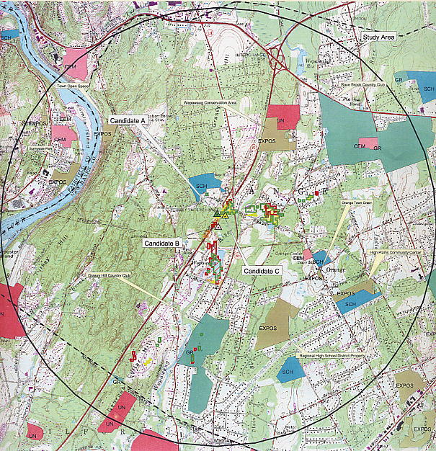

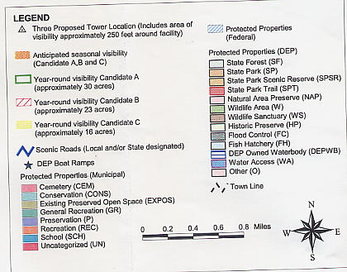
Figure 1. Viewshed map of a 125-foot tower at the proposed sites. (Sprint 1, Tab 19)

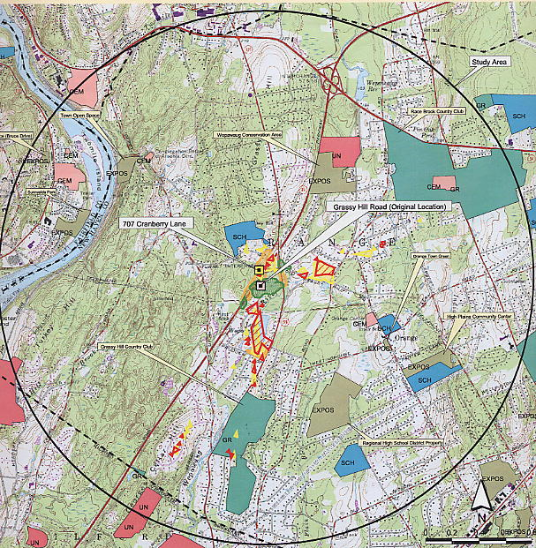

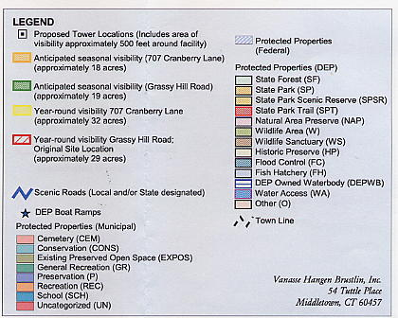

Figure 2. Viewshed map of a 140-foot tower at proposed Site A and Site B. (AT&T 2,
viewshed maps)

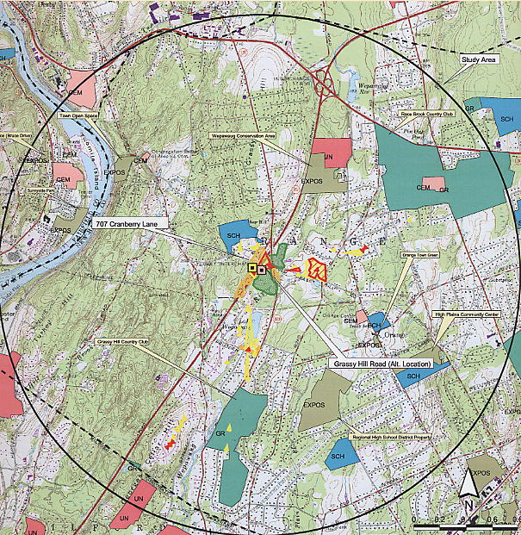

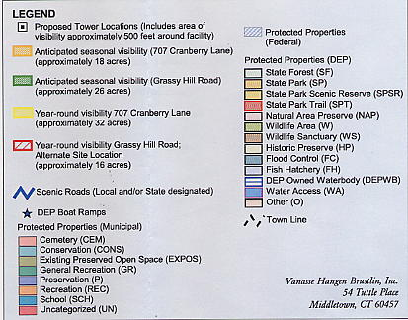

Figure 3. Viewshed map of a 140-foot tower at proposed Site A and Site C. (AT&T 2,
viewshed maps)

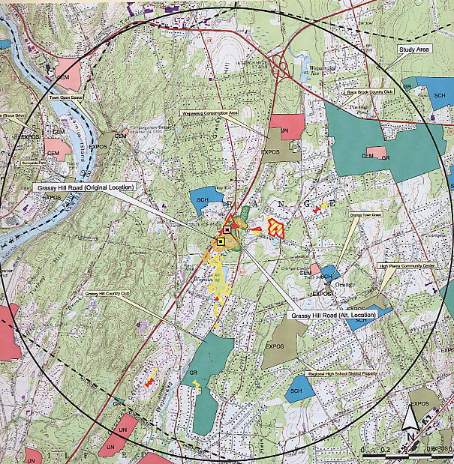

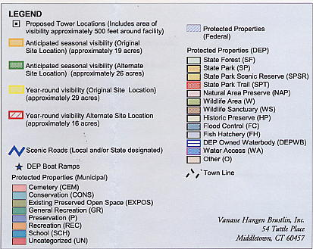

Figure 4. Viewshed map of a 140-foot tower at proposed Site B and Site C. (AT&T 2,
viewshed maps)

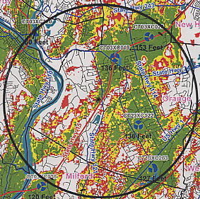

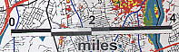
Figure 5. Existing Sprint coverage within three miles of the proposed sites. (Sprint 2, Q.
16)

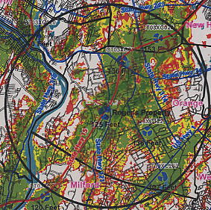

Figure 6. Sprint existing and proposed coverage from Site A at 125 feet AGL. (Sprint 2, Q.
17)

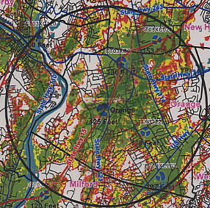

Figure 7. Sprint existing and proposed coverage from Site B at 125 feet AGL. (Sprint 2, Q.
18)

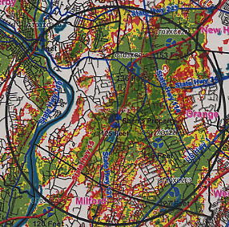

Figure 8. Existing and proposed coverage from Site C at 125 feet AGL. (Sprint 2, Q. 19)

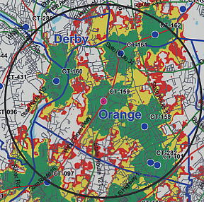

Figure 9. AT&T existing and proposed coverage from Site A at
140 feet AGL. Scale is 1:100,000. (AT&T 1, Q. 3, 5)

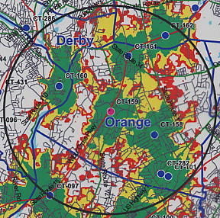
Figure 10. AT&T existing and proposed coverage from Site B at
140 feet AGL. Scale is 1:100,000. (AT&T 1, Q. 3, 5)

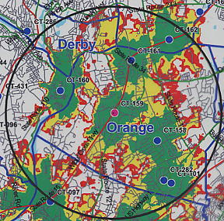
Figure 11. AT&T existing and proposed coverage from Site C at
140 feet AGL. Scale is 1:100,000. (AT&T 1, Q. 3, 5)

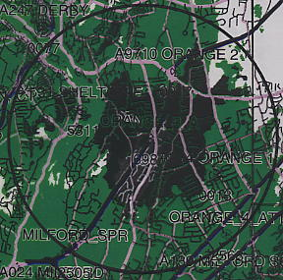
Figure 12. Verizon existing and proposed coverage from Site A at
115 feet AGL. Scale is 1:100,000. (Verizon 1, Q. 4, 5)

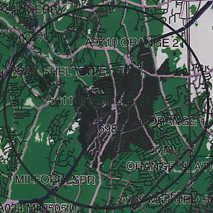
Figure 13. Verizon existing and proposed coverage from Site B at
115 feet AGL. Scale is 1:100,000. (Verizon 1, Q. 4, 5)

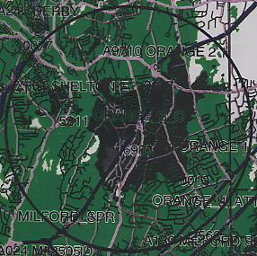
Figure 14. Verizon existing and proposed coverage from Site C at
115 feet AGL. Scale is 1:100,000. (Verizon 1, Q. 4, 5)

