DOCKET NO. 257 - AT&T Wireless PCS, LLC d/b/a AT&T Wireless application for a Certificate of Environmental Compatibility and Public Need for the construction, maintenance and operation of a wireless telecommunications facility at 1593 Exeter Road or one of two sites on Levita Road, Lebanon, Connecticut. | }  }  } | Connecticut  Siting  Council  October 29, 2003

Findings of Fact

Introduction

- AT&T Wireless PCS, LLC d/b/a AT&T Wireless (AT&T), in accordance with the provisions of General Statutes §§ 16-50g through 16-50aa, applied to the Connecticut Siting Council (Council) on May 9, 2003 for the construction, operation, and maintenance of a wireless telecommunications facility at 151 Young Street or 162 Young Street, East Hampton, Connecticut. (AT&T 1, pp. 1-2)

- The party in this proceeding is the applicant. (Transcript 1- 3:00 p.m. [Tr. 1], p. 4)

- The primary purpose of the proposed facility is to provide service to Route 207 (Exeter Road) in western Lebanon. (AT&T 1, p. 6; Attachment 3)

- Pursuant to General Statutes § 16-50m, the Council, after giving due notice thereof, held a public hearing on September 3, 2003, beginning at 3:05 p.m. and continuing at 7:05 p.m. at the Town of Lebanon Fire Safety Complex, 23 Goshen Hill Road, Lebanon, Connecticut. (Council's Hearing Notice dated June 26, 2003; Tr. 1, p. 2; Transcript 2 – 7:00 p.m. [Tr. 2], p. 2)

- The Council performed an inspection of the proposed sites on September 3, 2003, beginning at 2:00 p.m. During the field inspection, the applicant flew balloons at the proposed sites to simulate the heights of the towers. Sites A and B were both identified by balloons flown to 150 feet above ground level (agl) with a red flag attached to each balloon tether at 120 feet agl. A balloon flown to 170 feet agl identified Site C. (Council's Hearing Notice dated May 29, 2003; Tr. 1, pp. 18-19)

- AT&T submitted a technical report to the First Selectman of the Town of Lebanon, Daniel McGuire, on October 31, 2002. The applicant offered to meet with Town officials on three occasions after the application was filed but received no response. The Town did not provide written comment on the proposal. (AT&T 1, p. 21; Tr. 1, p. 12)

- Mr. David Scata, Chairman of the Lebanon Conservation Commission, made a limited appearance statement at the September 3, 2003 proceeding indicating a preference for Site A. (Tr. 2, pp. 13-15)

- Notice of the application was provided to all abutting property owners by certified mail. Notice was unclaimed by three abutters. Public notice of the application was published in The Hartford Courant on May 6 and May 7, 2003. (AT&T 1, pp. 4-5, AT&T 3, Q. 1)

- Pursuant to General Statutes § 16-50j (h), the following state agencies were solicited to submit written comments regarding the proposed facility on June 26 and September 4, 2003; Department of Environmental Protection (DEP), Department of Public Health (DPH), Council on Environmental Quality (CEQ), Department of Public Utility Control (DPUC), Office of Policy and Management (OPM), Department of Economic and Community Development (DECD), and the Department of Transportation (DOT). (Record)

- Written comments were received from the DOT’s Office of Environmental Planning on July 2, 2003 and the DEP on August 26 and September 25, 2003. (Record)

- The following agencies did not comment on the application: DPH, CEQ, DPUC, OPM, and the DECD. (Record)

Telecommunications Act

- In 1996, the United States Congress recognized a nationwide need for high quality wireless telecommunications services, including cellular telephone service. Through the Federal Telecommunications Act of 1996, Congress seeks to promote competition, encourage technical innovations, and foster lower prices for telecommunications services. (Council Admin. Notice, no. 7, Telecom Act 1996)

- In issuing cellular licenses, the Federal government has preempted the determination of public need for cellular service by the states, and has established design standards to ensure technical integrity and nationwide compatibility among all systems. (Council Admin. Notice, no. 7, Telecom. Act 1996)

- The Telecommunications Act of 1996 prohibits local and state bodies from discriminating among providers of functionally equivalent services. (Council Admin. Notice, no. 7, Telecom. Act 1996)

- The Telecommunications Act of 1996, a Federal law passed by the United States Congress, prohibits any state or local agency from regulating telecommunications towers on the basis of the environmental effects of radio frequency emissions to the extent that such towers and equipment comply with FCC’s regulations concerning such emissions. This Act also blocks the Council from prohibiting or acting with the effect of prohibiting the provision of personal wireless service. (Council Admin. Notice, no. 7, Telecom. Act 1996)

Site Selection

16. The closest existing telecommunications tower to the proposed sites is approximately 2.2 miles southeast of Site C at 859 Goshen Hill Road in Lebanon. AT&T has antennas at the 130-foot level of this tower. The tower does not provide coverage to the target service area. No other structures over 35 feet in height were identified in the search area. (AT&T 1, p. 9, Attachment 3, Attachment 4)

- The application detailed a site search involving seven parcels/areas in Lebanon, two of which were selected for site development. The five rejected areas and reasons for their rejection are as follows:
- 1667 Exeter Road (Spa at Grand Lake) – unable to reach lease agreement.
- Colchester Road parcels – sensitive environmental area.
- Exeter Road parcels (west) – did not meet coverage objectives.
- Amston Lake area – too close to residential areas.
- Lake Williams area – too close to Williams Pond development and Airline State Park Trail.
(AT&T 1, Attachment 4)

Site Description – Site A

- Proposed Site A is located in the west central portion of a 16-acre parcel owned by Harold and Florence Leibman. The parcel, south of Route 207, is identified in Town records as Map 242, Lot 15. The property is undeveloped and is characterized by reverting fields and bands of trees 50 to 55 feet in height. (AT&T 1, Attachment 5, Attachment 12; AT&T 3, Q. 3; Tr. 1, pp. 11-12)

19. The proposed road and compound site is located in a level reverting field. Wooded areas are located northeast and southwest of the site. The geographical location of the tower is latitude and longitude coordinates 41° 37’ 40.4” N and 72° 18’ 20.7” W. The elevation of the tower site is 488 feet above mean sea level (amsl). (AT&T 1, Attachment 5; DEP letter dated August 26, 2003)

- Access to Site A would be from a 12-foot wide, 550-foot long gravel drive extending from Route 207 (Exeter Road), generally following an existing overgrown dirt road. Underground utilities would be installed along the access road from an existing utility pole on Route 207. Development of the site would require minimal grading and filling. (AT&T 1, Attachment 5)

- The Site A facility would consist of a 150-foot monopole within a 100-foot by 100-foot leased area. The tower would be designed to support six levels of antennas with a ten-foot center-to-center vertical separation. An 80-foot by 80-foot equipment compound enclosed by an eight-foot high chain link fence would be established at the base of the tower. The compound would be able to accommodate the equipment of six wireless carriers. (AT&T 1, p. 10, Attachment 5)

- AT&T would install six panel antennas on T-arm mounts at a centerline height of 150 feet agl. Equipment cabinets would be installed on a 12-foot by 24-foot concrete slab within the compound. (AT&T 1, p. 10, Attachment 5; Tr. 1, pp. 32, 34)

- The tower setback radius would be contained within the site parcel. The nearest property line from the compound is approximately 150 feet to the southwest. The nearest residence is approximately 480 feet north of the site. Eight residential structures and one commercial structure are located within 1,000 feet of the site. (AT&T 1, p. 14; AT&T 3, Q. 13; Tr. 1, p. 10)

24. The estimated construction cost for the Site A facility is as follows:

Electronic Equipment 70,000
Tower and Antennas 144,200
Site Development 151,200
Utility Construction Costs 47,000

Total $412,400
(AT&T 1, p. 22; Tr. 1, pp. 10-11)

Site Description – Site B

- Proposed Site B is located in the northeastern portion of a 70-acre parcel owned by Botticello, Inc. The undeveloped parcel, south of Route 207 and east of Old Colchester Road, is identified in Town records as Map 255, Lot 4. The geographical location of the tower is latitude and longitude coordinates 41° 37’ 25.8” N and 72° 18’ 19.2” W. The elevation of the tower site is 492 feet amsl. The proposed access road and compound site are located in a reverting field and shrubby area. (AT&T 1, p. 12, Attachment 6)

- Access to proposed Site B would be from a 12-foot wide, 265-foot long gravel drive extending from Old Colchester Road. The road follows an existing dirt drive on the property. Underground utilities would be installed along the access road from an existing utility pole on Old Colchester Road. Development of the site would require minimal grading and no filling. (AT&T 1, Attachment 6)

- The proposed Site B facility would consist of a 150-foot monopole within a 100-foot by 100-foot leased area. The tower would be designed to support six levels of antennas with a ten-foot center-to-center vertical separation. AT&T would install six panel antennas on T-arm mounts at a centerline height of 150-feet agl. An 80-foot by 80-foot equipment compound enclosed by an eight-foot high chain link fence would be established at the base of the tower. (AT&T 1, pp. 11-12, Attachment 6; Tr. 1, pp. 32, 34)

- The tower setback radius would be contained within the site parcel. The nearest property line from the compound site is approximately 245 feet to the west. The nearest residence is approximately 470 feet north of the site. Three residential structures and one commercial structure are located within 1,000 feet of the site. (AT&T 1, p. 18, Attachment 6; AT&T 3, Q. 13; Tr. 2, p. 19)

29. The estimated construction cost for the Site B facility is as follows:

Electronic Equipment 70,300
Site Development 146,000
Tower and Antennas 98,900
Utility Construction Cost 22,700

Total $337,900
(AT&T 1, p. 23; Tr. 1, pp. 10-11)

Site Description – Site C

- Proposed Site C is located in the southern portion of the Botticello property, approximately 1,600 feet southeast of Site B. The proposed road and compound site is located in a cornfield. The geographical location of the tower is latitude and longitude coordinates 41° 37’ 13.3 N and 72° 18’ 18.1” W. The elevation of the tower site is 511 feet amsl. (AT&T 1, pp. 12-13, Attachment 7; DEP comments dated August 26, 2003)

- Access to Site C would be from a 12-foot wide, 130-foot long gravel drive extending from Levita Road. Underground utilities would be installed along the access road from an existing utility pole on Levita Road. Development of the site would require minimal grading and no filling. (AT&T 1, Attachment 7)

- The Site C facility would consist of a 170-foot monopole within a 100-foot by 100-foot leased area. The tower would be designed to support six levels of antennas with a ten-foot center-to-center vertical separation. An 80-foot by 80-foot equipment compound enclosed by an eight-foot high chain link fence would be established at the base of the tower. (AT&T 1, Attachment 7)

- AT&T would install six panel antennas on T-arm mounts at a centerline height of 170-feet agl. Equipment cabinets would be installed on a 12-foot by 24-foot concrete slab within the compound. (AT&T 1, p. 10, Attachment 5; Tr. 1, pp. 32, 34)

- The tower setback radius would be contained within the site parcel. The nearest property line from the compound site is approximately 150 feet to the southwest. The nearest residence is approximately 1,190 feet west of the site. No occupied structures are located within 1,000 feet of the site. (AT&T 1, p. 14, Attachment 7; AT&T 3, Q. 13; Tr. 1, p. 10)

35. The estimated construction cost for the proposed Site C facility is as follows:

Electronic Equipment 70,000
Tower and Antennas 148,600
Site Development 82,700
Utility Construction 22,700

Total $324,000
(AT&T 1, p. 23; Tr. 1, pp. 10-11)

Municipal Regulations

- The selected site parcels and the surrounding properties within 0.25 miles of each site are zoned rural agricultural residential (RA), and lake (L). One property, zoned planned business (PB) abuts Site A to the west. Town zoning regulations permit telecommunication towers in all zone districts, subject to issuance of a Special Permit. (AT&T 1, p. 18; Attachment 5, Attachment 6, Attachment 7; AT&T 2, a)

- Town Zoning Regulations encourage the placement of telecommunications equipment on existing towers or structures. Construction of a new tower greater than 60 feet in height on property not occupied by an existing tower is the least preferred option for placement of telecommunication equipment. No other structures over 35 feet in height were identified in the search area. (AT&T 1, Attachment 4; AT&T 2, a)

- Town Zoning Regulations require a minimum distance of 500 feet from a proposed tower to the nearest residence. Sites A and B are approximately 480 and 470 feet, respectively, from the nearest residence. (AT&T 2, a; Tr. 1, p. 10; Tr. 2, p. 19)

- Town Zoning Regulations require the tower radius to be outside of the front and side yard setbacks of the applicable zone district. Parcels zoned RA have a front yard setback of 50 feet and a side yard setback of 25 feet. The tower radius at Site C extends into the front yard setback. AT&T 1, Attachment 7; AT&T 2, a)

- Town Zoning Regulations require towers with a monopole design that can accommodate a minimum of five levels of antennas. The proposed 150-foot monopoles at Sites A and B and the 170-foot monopole at Site C would be designed to support six levels of antennas. (AT&T 1, Attachment 5, Attachment 6, Attachment 7; AT&T 2, a)

Environmental, Historic, and Safety Concerns

- The proposed facilities would have no effect upon historic and archaeological resources and properties of traditional cultural importance to Connecticut’s Native American community. (AT&T 1, Attachment 8; Tr. 1, pp. 34-37)

- The proposed sites contain no known existing populations of Federal or State Endangered, Threatened or Special Concern Species. (AT&T 1, Attachment 8)

43. Trees in the vicinity of sites A and C are approximately 50-55 feet in height. Trees in the vicinity of Site B are 60 to 65 feet in height. Development of Site A would require the removal of 12 trees with a diameter greater than six inches at breast height (dbh). Development of Site C would require the removal of two trees. No trees with a diameter greater than six inches dbh would be removed at Site B. (AT&T 3, Q. 3)

- There are no wetlands or watercourses in the vicinity of the Site A development area. At Site B, a wetland is located 50 feet north of the access road and 150 feet north of the compound area. Site C is approximately 100 feet west of a wetland. Development of Site B and Site C would occur within the town’s designated 100-foot wetland buffer zone. (AT&T 1 p. 20, Attachment 5, Attachment 6, Attachment 7)

- Aircraft hazard obstruction marking or lighting of the proposed towers would not be required. (AT&T 1 p. 22, Attachment 5, Attachment 6, Attachment 7)

- There are no town or state designated scenic roads within two miles of the sites. The Airline State Park Trail is located approximately 1.5 miles northeast of the sites. The proposed towers would not be visible from the trail. (AT&T 3, Q. 9; Tr. 1, pp. 55-56)

- The conservative worst-case approximation of electromagnetic radiofrequency emissions, expressed as a percentage of the Maximum Permissible Exposure limit established by the Federal Communications Commission, would be 4.8 percent at Site A and Site B, and 3.7% at Site B. (AT&T 3, Q. 11)

Visibility

48. Anticipated visibility of the proposed sites is depicted on Figure 1. (AT&T 3, Q. 7)

- A 150-foot tower at Site A would be visible from approximately eight acres of land within two miles of the site and from 133 acres of Williams Pond, approximately 0.2 miles northeast of the site. Approximately 12 residences on the northeast shore of the Williams Pond, approximately 1.5 miles from the site, would have partial views of Site A. (AT&T 3, Q. 6; Q. 7; Tr. 1, pp. 24-25)

- A 150-foot tower at Site B would be visible from 40 acres of land within two miles of the site and 74 acres of Williams Pond, approximately 0.3 miles north of the site. Approximately 27 residences on the northeast shore of the Williams Pond, approximately 1.5 miles from the site, would have partial views of Site B. (AT&T 3, Q. 6, Q.7; Tr. 1, pp. 24-25)

- A 170-foot tower at Site C would be visible from 31 acres of land within two miles of the site and from 75 acres of Williams Pond, approximately 0.6 miles north of the site. Approximately 27 residences on the northeast shore of the Williams Pond, approximately 1.8 miles north of the site, would have partial views of Site B. (AT&T 3, Q. 7; Tr. 1, pp. 24-25)

- Visibility of the Site A tower is anticipated from the following receptors within 0.5 miles of the site:

Seasonal Visibility
- 0.3 miles of Exeter Road (Route 207), approximately 0.1 miles north of the site.
- 0.1 miles of Old Colchester Road, approximately 0.2 miles south of the site.
- Residence at 1732 Exeter Road, approximately 0.1 miles north of the site
- Residence at 1720 Exeter Road, approximately 0.1 miles north of the site.
- Residence at 31 Old Colchester Road, approximately 0.1 miles east of the site.
- Rear parking lot of the Spa at Grand Lake, approximately 0. 3 miles east of the site.
Year-round Visibility
- <0.1 miles of Exeter Road (Route 207), approximately 0.1 miles north of the site.
- 0.2 miles of Exeter Road (Route 207), approximately 0.3 miles east of the site.
- Williams Pond parking area, approximately 0.25 miles northeast of the site.
- Lake Williams Campground Store, approximately 0.1 miles north of the site.
- Residence at 1736 Exeter Road, 0.1 miles north of the site.
(AT&T 3, Q. 6, Q. 7; DEP letter dated August 26, 2003; Tr. 1, pp. 28-29, 50, 58)

- Visibility of the Site B tower is anticipated from the following receptors within 0.5 miles of the site:

Seasonal Visibility
- 0.2 miles of Levita Road, approximately 0.3 miles southwest of the site.
- Two residences along Old Colchester Road (address undetermined), approximately 0.2 miles southwest of the site.
- Residence at 96 Levita Road, approximately 0.3 miles west of the site.
Year-round Visibility
- 0.5 miles of Old Colchester Road, 240 feet west of the site.
- 0.2 miles of Levita Road, approximately 0.2 miles south of the site.
- Residence at 31 Old Colchester Road, approximately 0.2 miles north of the site
- Residence at 54 Old Colchester Road, approximately 0.1 miles north of the site.
- Residence at 99 Old Colchester Road, approximately 0.2 miles southwest of the site.
(AT&T 3, Q. 6, Q. 7; Tr. 1, pp. 26-28)

- Visibility of the Site C tower is anticipated from the following receptors within 0.5 miles of the site:

Seasonal Visibility
a) 0.2 miles of Levita Road, approximately 0.1 miles south of the site.
Year-round Visibility
a) 0.2 miles of Old Colchester Road, 0.2 miles west of the site.
- 0.1 miles of Levita Road, 170 feet south of the site.
- Residence at 125 Old Colchester Road, approximately 0.2 miles west of the site.
(AT&T 3, Q. 6, Q. 7; Tr. 1, pp. 27-28; DEP letter dated August 26, 2003)

55. AT&T would be willing to move the tower up to 150 feet to the southeast to provide a greater visibility buffer to residences on Exeter Road. This would place the proposed tower closer to the residence at 31 Old Colchester Road. (AT&T 1, Attachment 5; Tr. 1, p. 55)

- Reducing the height of the Site A tower to 120 feet would decrease the area of visibility from Williams Pond from 133 acres to five acres. Visibility from Route 207 would be reduced by 0.1 miles in the vicinity of Williams Pond. A 120-foot tower, although shorter and closer to the treeline, would be visible from the other identified visual receptors in the area. (AT&T 3, Q. 6, Q. 7)

57. Reducing the height of the Site B tower to 120 feet would decrease the area of visibility from land areas from 40 acres to 32 acres. Visibility from Williams Pond would be reduced from 74 acres to 40 acres. (AT&T 3, Q. 7)

AT&T - Existing and Proposed Wireless Coverage

- AT&T operates in the FCC assigned D & E 1900 MHz frequency bands and at minimum signal level threshold of -85 dBm. (AT&T 1, Attachment 2; Tr. 1, pp. 23-24 )

- The minimum antenna height AT&T is requesting at Sites A & B is 120 feet agl. AT&T proposes to construct a 150-foot monopole at both sites to allow for an increased ability for tower sharing. The minimum height AT&T is requesting at Site C is 170 feet agl. (AT&T 1, pp. 10-12)

60. The length of existing coverage gaps (signal strength < -85 dBm) on select roads within a two-mile radius of each proposed site is presented in the table below.

Existing Road Gaps*
Road | Site A  120 feet | Site B  120 feet | Site C  170 feet
Route 207 | 4.2 | 4.3 | 4.1
Old Colchester Rd. | 1.6 | 1.6 | 1.6
Levita Rd. | 3.0 | 3.2 | 3.2
Total | 8.8 | 9.1 | 8.9
*approximate miles; signal strength -85 dBm
(AT&T 1, Attachment 3)

61. The length of remaining coverage gaps (signal strength < -85 dBm) on select roads within a two-mile radius of each site after installation of antennas at the minimum requested height is presented in the table below.

Remaining Road Gaps after Antenna Installation*
Road | Site A | Site B | Site C
Route 207 | 1.6 | 1.8 | 2.1
Old Colchester Rd. | 0.0 | 0.0 | 0.0
Levita Rd. | 1.1 | 0.8 | 0.8
Total | 2.7 | 2.6 | 2.9
*approximate miles; signal strength -85 dBm
(AT&T 1, Attachment 3)

- A facility at any of the three sites would result in an approximate 0.2-mile gap in coverage on Route 207 west of the intersection Route 16. Increasing the antenna height would not increase coverage to this area. Site A would provide the best coverage to this gap area. (AT&T 1, Attachment 3; Tr. 1, pp. 61-65)

- Installing antennas at Site C would result in a coverage gap of 0.7 miles on Route 207 in the vicinity of Williams Pond. Call service would be interrupted in the gap area. AT&T pursued development of the site since anticipated coverage is acceptable. (AT&T 1, Attachment 3; Tr. 1, pp. 19-22)

- Installing antennas at 150 feet agl at either Site A or Site B would not appreciably increase coverage to the target service area. (Tr. 1, pp. 22-23)

FIGURE 1

VISIBILITY OF PROPOSED SITES
Site A at 150 feet, Site B at 150 feet , Site C at 170 feet

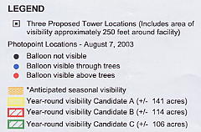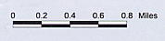
(AT&T 3, Q. 7)

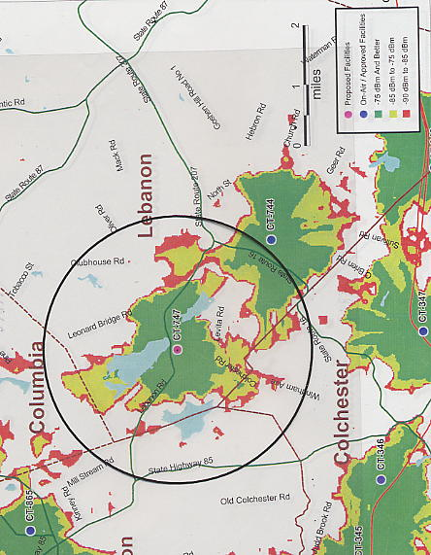
FIGURE 2

AT&T EXISTING AND PROPOSED COVERAGE FROM SITE A WITH ANTENNAS
AT 120 FEET

(AT&T 1, Attachment 3)

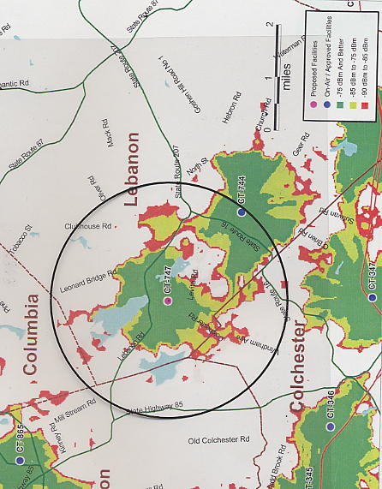
FIGURE 3

AT&T EXISTING AND PROPOSED COVERAGE FROM SITE B WITH ANTENNAS
AT 120 FEET

(AT&T 3, Q. 7)

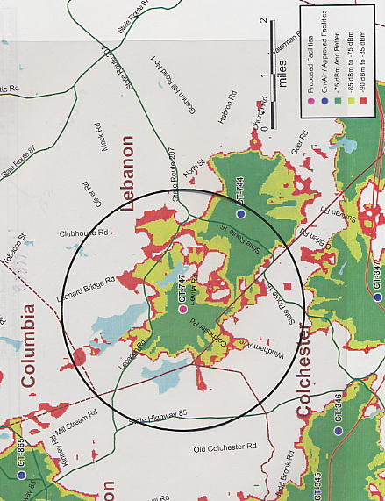
FIGURE 4

AT&T EXISTING AND PROPOSED COVERAGE FROM SITE C WITH ANTENNAS
AT 170 FEET

(AT&T 3, Q. 7)

