DOCKET NO. 254 - Sprint Spectrum, L.P. d/b/a Sprint PCS application for a Certificate of Environmental Compatibility and Public Need for the construction, maintenance and operation of a wireless telecommunications facility at 134R Creamery Road, Durham, Connecticut. | }  }  } | Connecticut  Siting  Council  December 9, 2003

Findings of Fact

Introduction

- On April 22, 2003, Sprint Spectrum L.P., d/b/a Sprint PCS (Sprint) applied to the Connecticut Siting Council (Council) for the construction, operation and maintenance of a 130-foot telecommunications tower at 134R Creamery Road, Durham, Connecticut. (Sprint 1, p. 1)

- Sprint is a Delaware limited partnership, a wholly owned subsidiary of Sprint Corporation, a Kansas corporation. Sprint Corporation is a wholly owned subsidiary of Wireless Co., L.P., a Delaware limited partnership. Sprint is licensed by the Federal Communications Commission (FCC) in thirty-two major United States trading areas, including Connecticut and the Town of Durham. (Sprint 1, p. 1)

- The primary purpose of the proposed facility is to provide wireless service to coverage gaps Sprint has identified on State Routes 17 and 77 in Durham, as part of Sprint's network build-out in Connecticut. (Tr. 1, p.56; Tr. 2, p. 8; Sprint 1, p. 4, p. 5)

- Pursuant to Connecticut General Statutes (CGS) §§ 16-50m, the Council, after giving due notice thereof, held a public hearing on August 18, 2003, beginning at 3:00 p.m. and continued at 7:00 p.m. in the Lower Level Conference Room of the Durham Public Library, 7 Maple Avenue, Durham, Connecticut. (Transcript, 8/13/03, p. 3; [Tr. 1]; Transcript, 8/13/03, 7:00 p.m., p. 3 [Tr. 2])

- The Council and its staff made an inspection of the proposed site on August 18, 2003. During the field inspection, the applicant flew a red weather balloon measuring approximately four feet in diameter at a height of 130 feet above ground level (agl) to simulate the height of the proposed tower. The balloon flew from approximately 12:30 p.m. to 7:00 p.m. (Tr. 1, p. 30)

- Sprint provided notice of the application to the Council to all abutters of the proposed site via certified mail. All return receipts of the abutters were received except for one. Another copy of the notice was sent by first class mail to this abutter with no return receipt requested. (Sprint 1, p. 3; Sprint 2, PHQ. 1)

- The party in this proceeding is the applicant. The intervenor is Tower Ventures II, LLC. (Tr. 1, pp. 5-6)

- Pursuant to General Statutes 16-50j(h), the following state agencies were requested to submit written comments regarding the proposed facility on May 27, 2003: the Department of Environmental Protection (DEP); Department of Public Health (DPH); Council on Environmental Quality (CEQ); Department of Public Utility Control (DPUC); Office of Policy and Management (OPM); Department of Economic and Community Development (DECD); and the Department of Transportation (DOT). (Record)

- Comments were received from the DOT dated June 2, 2003, and from the DEP dated August 13, 2003. (Record)

The following agencies did not offer comments on the application: DPH, CEQ, DPUC, OPM and the DECD. (Record)

- Public Notice of the application was published in The Town Times on January 31, 2003, and in The Hartford Courant, and The Middletown Press on January 28 and 30, 2003. (Sprint 1, p.3 Tab 2)

Municipal Consultation

- In accordance with CGS §§ 16-50l(e), Sprint notified the First Selectman of the Town of Durham on November 8, 2002, of its intention to file this application with the Council. The Town Planner of the Town of Durham was also notified. Previously, Sprint had filed an application for a special permit with the Durham Planning and Zoning Commission on June 7, 2000, for a 150-foot tower at the proposed site. The Durham Planning and Zoning Commission held public hearings on this application on July 5, August 2, and September 6, 2000. On November 15, 2000, the Durham Planning and Zoning Commission denied Sprint's application. (Sprint 1, p. 6)

- On February 5, 2003, the Durham Planning and Zoning Commission voted to recommend denial of this application to the Council. (Sprint 1, Tab 8, Legal Notice, 2/08/03)

- The First Selectman of the Town of Durham, Maryann Boord, stated the Town’s opposition to the proposed tower site at the hearing on August 13, 2003. (Tr. 2, p . 9)

Need

- In 1996 the Congress of the United States recognized a nationwide need for high quality wireless telecommunications services. Through the Federal Telecommunications Act of 1996 (the Act), Congress seeks to promote competition, reduce regulation to encourage technical innovation and foster lower prices for wireless telecommunications services. The Act pre-empts any state or local determination of public need. (Telecommunications Act of 1996)

- The Telecommunications Act of 1996, a Federal law passed by the United States Congress, prohibits any state or local agency from regulating telecommunications towers on the basis of the environmental effects of radio frequency emissions to the extent that such towers and equipment comply with FCC's regulations concerning such emissions. This Act also blocks the Council from prohibiting or acting with the effect of prohibiting the provision of personal wireless service. (Telecommunications Act of 1996)

- The Telecommunications Act of 1996 prohibits local and state bodies from discriminating among providers of functionally equivalent services. (Telecommunications Act of 1996)

Site Search

- Sprint currently experiences coverage gaps in the Durham area along Route 79 for approximately 0.55 miles, along Route 17 for approximately 1.98 miles, and along Route 77 for approximately 1.49 miles. (Sprint 3, PHQ. 17)

- Sprint identified two search rings in the area between Route 17 and 77 to locate sufficiently tall buildings, towers or other structures to meet its coverage needs. Sprint identified no existing structures in the vicinity of its search rings to meet its coverage objectives. (Sprint 1, p. 8)

- Sprint investigated eleven sites in the Durham area as potential tower sites and rejected ten of them as not meeting coverage objectives along Route 77; the remaining site became the proposed site on Creamery Road. The other rejected sites were off of Guilford Street (4 sites); 152 R Creamery Road; 500 R New Haven Road; Wilmer property; 553 Guilford Street; 7 Main Street; and 108 Mica Hill Road. (Sprint 1, p. 9)

The Proposed Site

- The proposed site is located on an approximately 67-acre parcel of land owned by William W. Lawson, Jr. at 134R Creamery Road, Durham. A portion of this property has been cleared and is used for farming. The area of the proposed tower site itself is wooded and consists of red cedar, red maple, and black birch. The compound site slopes gradually to the southeast. (Sprint 1, p. 10; DEP comments 8/13/03)

- The proposed site is zoned Farm Residential and includes a residence, outbuildings, and a horse barn. No homes or other structures are presently visible from the proposed tower site. There are 4 residences within a 1000-foot radius of the proposed site, the nearest of which is approximately 908 feet to the northeast at 102 Creamery Road, owned by Karen Fiske. (DEP comments, 8/13/03; Sprint 1, Tab 5, Site Plans; Sprint 3, PHQ 14, Abutters Map; Sprint 1, p. 17)

- No wetland soils were found on the lease or easement areas. The nearest wetland to the proposed site is approximately 150 feet south of the lessor's property boundary and approximately 350 feet from the tower compound. (Sprint 1, Tab 5, Sheet C-2; Sprint 1, p. 15, p. 19)

- The tower compound would be a 50-foot by 50-foot area surrounded by a 6-foot chain link fence on the 100-foot by 100-foot leased parcel. The proposed site has an elevation of 462 feet above mean sea level (amsl). Blasting is not expected to be needed to build the site. (Sprint 1, Tab5, Sheet C-3; Tr. 2, p. 8; Sprint 2, PHQ. 11)

- The access road from Creamery Road to the proposed site would follow an existing driveway on the Lawson property for approximately 950 feet, and then proceed through fields and wooded areas for approximately another 930 feet. The access road would be approximately 12 feet in width. (Tr. 2, p. 8; Sprint 1, Tab 5, Sheet C-3)

- To construct the proposed site, an estimated 25 trees greater than 6 inches in diameter would have to be removed for the construction of the tower compound, and an estimated 37 trees greater than 6 inches in diameter would be removed for the construction of the access road. (Sprint 3, PHQ. 14, Abutters Map)

- Utilities would be brought into the proposed site underground following a parallel route to an existing electric line. Single-phase electric power would be used. (Tr. 1, pp. 76-77; Sprint 1, Tab 5, Existing Conditions Map)

Estimated Costs

The estimated costs to construct the proposed site are shown as follows:

Site Work | $10,000.
Tower | 90,000.
Electrical and Telephone | 45,000.
Foundation | 36,000.
Compound | 8,000.
Road | 45,500.
Radio-frequency Work | 25,000.
Total | $259,500.
(Sprint 1, Tab 13)

Environmental Considerations

There are no known existing populations of state endangered, threatened, or special concern species at the proposed site. (Sprint 2, PHQ. 9, DEP Letter of 2/06/03)

- A Professional Reconnaissance Survey was conducted of the proposed site to identify and evaluate archaeological resources in the proposed project area, and no significant archaeological resources were encountered during this survey. The proposed tower facility would have no effect on historic, architectural or archeological resources listed on or eligible for the National Register of Historic Places. (Sprint 1, Tab 18, Connecticut Historic Commission letter of 7/01/02)

- Route 77 in Durham is a State Scenic Road from the center of Durham into Guilford, a distance of about 2.3 miles. Route 17 is a State Scenic Road from approximately the intersection with Route 77 north to the intersection with Route 147. The Town of Durham has acquired the development rights to approximately 200 acres of ridgeline west of Route 77 and immediately south of the proposed site. (Tr. 1, pp. 42-45; Sprint 1, Tab 15, Visibility Map, Tr. 2 p. 34, p. 49; State Tourism Map, 2002-2003)

- The proposed site is mapped as a Locally High Area on the DEP Ridgelines and Summit Protection Policy Areas map. The site is not on a statutorily zoned ridgeline or an area greater than 20 percent out slope. (DEP comments, 8/13/03)

- The proposed 130-foot tower would not require marking or lighting under Federal Aviation Administration regulations. (Sprint 1, Tab 17)

- Based on conservative assumptions, including the main beam of the antennas pointing directly toward the ground at the base of the tower, the worst case radio-frequency power density concludes the proposed Sprint antennas would result in a maximum permissible exposure level of approximately 7.7 percent at the base of the proposed tower, based on FCC Bulletin 65. (Sprint 1, p.20, Tab 17)

Visibility

- Due to topography and surrounding vegetation, the proposed tower is not expected to be visible from Creamery Road. The tower may be visible during winter months from Park Place, which is off of Creamery Road and from Ridge Road North off Creamery Road at approximately 2000 feet. Limited views are expected from David Road, which is west of the site, off of Parmelee Hill Road. Some visibility is expected from Clark Road at a distance of approximately 1.5 miles. (Tr. 1, pp. 31-34, Sprint 1, Tab 15, Visibility Map, DEP Comments, 8/13/03; Sprint 2, PHQ. 7)

- The proposed tower would be most significantly visible from roads and residences east of Route 77 on the westward-facing hillside across the valley from the proposed site, at a distance of approximately 2500 to 3000 feet in an area known as Crooked Hill. (DEP Comments, 8/13/03, Sprint 1, Tab 15, Visibility Map)

- The area of Crooked Hill would have an unobstructed view of the ridgeline on which the proposed tower would be constructed, including views from Mica Hill Road, Banta Lane, and Surrey Drive. The existing Totoket Mountain tower in Guilford is also visible from this area. (Tr. 1, pp. 35-39. P.41)

- The proposed tower would be visible year round from approximately 0.6 miles of total roadway along Route 77. There would be more limited visibility from Route 17, with some visibility expected in the area of the intersection of Route 17 and Route 77, at a distance of over 1.5 miles. (Sprint 1, Tab 15, Visibility Map; Tr. 1, pp. 35-37, Sprint 1, Tab 15, Photograph No. 11)

- Seasonal visibility of the proposed tower is possible from the Mattabesset Trail at a distance of approximately one mile at its nearest section. (Tr. 1, pp. 41-42; Sprint 1, Tab 15, Visibility Map)

- Sprint has proposed a stealth design for this tower in the form of a pine tree and visual simulations were based on this design. The pine tree-design tower would be approximately twice as tall as the other trees in the deciduous forest surrounding the proposed tower site, and would create a larger profile on the skyline from a distance. Sprint would also be willing to construct another type of tower at this site, including a brown stick or flush-mount, which is a bare pole without a full antenna array. A white flagpole or standard monopole would also be functional, but a brown stick with close-contact arrays would provide the least intrusive pattern on the skyline. (DEP Comments, 8/13/03; Sprint 1, Tab 15, Photo simulations; Tr. 1, pp. 82-84, p.87)

Wireless Telecommunications Coverage

- Sprint has a minimum standard coverage level of -94 dBm for rural areas and -79 to -84 dBm for urban areas. (Sprint 1, p. 12, Tr. 1, pp. 67-68)

- The proposed site would provide coverage to fill existing Sprint coverage gaps along Route 17 and Route 77. The extensive range of these gaps along these roads and their distance from each other could otherwise require the use of multiple towers. ( DEP Comments, 8/13/03, Sprint 1, Tab 14, Coverage without proposed candidate map)

- Sprint currently has antennas on three of the towers in the Durham area which would interact with the proposed Creamery Road tower: at the 87-foot level of the existing Verizon tower on Old Blue Hill Road in Durham; at the 135-foot level of the existing Apple Orchard tower in North Branford; and at the 162-foot level of an existing tower on Durham Road in Wallingford. Sprint expects to place future antennas at the 150-foot level of the North Madison Fishing Association tower and at 150-foot level of the North Guilford Sportsman Club tower. (Sprint 2, PHQ 12, Sprint 1, Tab 14, Coverage Map; Tr. 1, pp. 93-94)

- Sprint has offered to provide space for Town of Durham antennas on the proposed tower free of charge. The Town would be interested in two antenna positions at or near the top of the tower for municipal use. (Sprint 2, PHQ. 5; Town of Durham letter of September 11, 2003)

- No carriers other than Sprint have expressed interest in sharing the proposed Durham tower. (Sprint 2, PHQ. 6)

- Sprint has a goal of less than a one- percent dropped call rate. Currently, Sprint is experiencing the following dropped call rates: 70 dropped calls at 4 percent at the Old Blue Hills Road (BAM) tower in Durham and 10 dropped calls at 2.5 percent at the Route 68 tower in Wallingford. (Sprint 1, Tab 14 Coverage Map; Sprint 2, PHQ. 4; Tr. 1, p. 60)

- The proposed tower would have E-911 capabilities. (Sprint 3, PHQ. 16)

- Sprint is currently experiencing the following coverage gaps on state routes in the Durham area as shown below.

Road | Existing Gap (miles) | Total Miles
Route 79 | .55 | 2.2
Route 17 | 1.98 | 3.9
Route 77 | 1.49 | 2.4
Route 68 | .14 | 2.9
(Sprint 3, PHQ. 17) (See Appendix A)

- Placing Sprint antennas at the 130-foot or 100-foot levels of the proposed Durham tower would leave the following coverage gaps:

Road | Gap at 130ft. (miles) | Gap at 100ft. (miles)
Route 79 | .55 | .55
Route 17 | .30 | .37
Route 77 | 0.00 | .02
Route 68 | 0.00 | .04
(Sprint 3, PHQ. 17) (See Appendices B and C)

- Sprint use of the proposed Tower Ventures Docket No. 237 proposed site at 853R New Haven Road (The Raccoon Club) or at the proposed alternate sites at the same location would provide no additional coverage to Route 68, Route 77, or Route 79 with Sprint antennas at 130 feet agl. The site would provide Sprint with some coverage on Route 17, but would not provide Sprint coverage to most of Durham. (Tr. 1, pp. 71-72; Sprint 4, PHQ. 25, Coverage Maps Site 1 at 130 feet, Site 2 at 130 feet) (See Appendix D)

- Attaching Sprint antennas at 140 feet agl at the proposed Tower Ventures site would still leave Sprint with gaps along Route 77, Route 68, and the Tri Mountain Road area. A significant hill blocks Sprint coverage to Route 68 along the Durham-Wallingford border. (Tr. 1, pp.56-57; Sprint7, Responses to TV PHQ. 3a; Coverage Map) (Appendix E)

- Combining the Tower Ventures site with Sprint antennas at 140 feet agl on the proposed Tower Ventures tower with Sprint antennas mounted on the existing Totoket Mountain tower at 500 Cooks Lane, Guilford, at 160 feet agl would provide some Sprint coverage to Route 17 in southern portions of Durham. However, it would leave gaps along Route 17 to the north near Meeting House Hill Road. A gap would remain along Route 77 east of Totoket Mountain and along Route 77 east of the proposed Tower Ventures site. (Tr. 1 pp. 108-110; Sprint 7, Responses to TV PHQ. 3b, Coverage Map) (See Appendix F)

- Sprint evaluated the Totoket Mountain tower, but found this tower is very heavily used and available space is uncertain. Sprint would not be able to install all of its antennas at the same level, raising antenna orientation concerns, and inter-modulation concerns. Two small obsolete antennas may be removed at 80 feet agl and 130 feet agl. The Totoket Mountain tower is 1.98 miles south of the proposed Sprint site. (Tr. 1, pp. 110-111; Tr. 2 p. 39; Appendix F)

- The proposed tower would be designed and constructed in accordance with the American National Standards Institutes/Electronics Industries Association Manual 222, Revision F, Structural Standards. The tower would be designed to accommodate two additional carriers, and would also have a global positioning system antenna at 75 feet agl on the southwest side of the tower. (Sprint 1, p.11)

- Use of repeater antennas at Route 77 and Route 68 would not provide adequate coverage for the Sprint gaps now existing on these roads. (Tr. 2, p. 44-45)

- In comparison with the proposed Tower Ventures site, the Sprint site on Creamery Road, which is between Routes 17 and 77, would provide coverage to both Route 17 and 77, while the proposed Tower Ventures site, which is near Route 17, would primarily cover Route 17, but not Route 77, due to an intervening ridge between the Raccoon Club site and Route 77. (Tr. 2, pp. 56-57, AT&T 1, Tab 7, Coverage Map of AT&T; Sprint Coverage Map at 130 feet in Sprint 2, PHQ. 2)

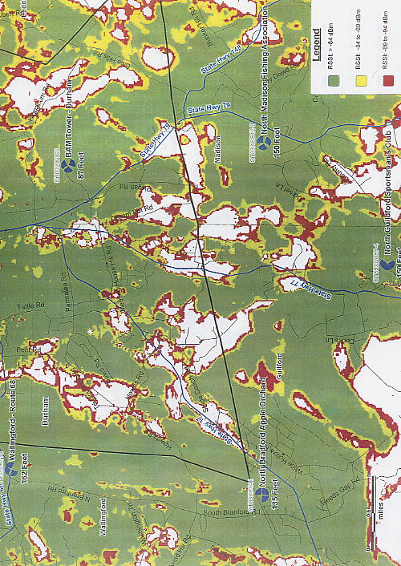
APPENDIX A
(Existing Sprint Coverage in Durham Area)

(Sprint 1, Tab 14 Coverage Plot)

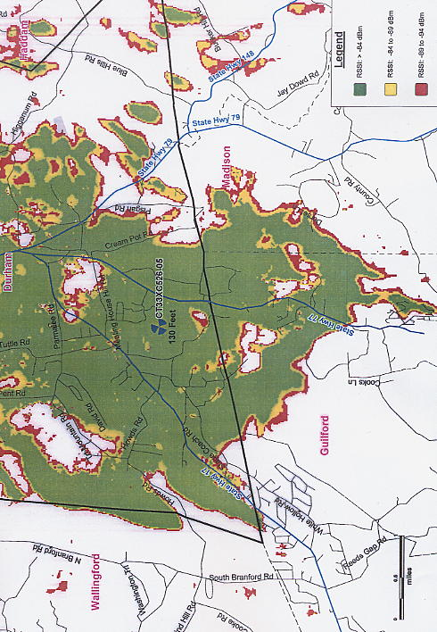
APPENDIX B
(Proposed Sprint Coverage at 130 feet agl)

(Sprint 3, PHQ. 17, Coverage Plot)

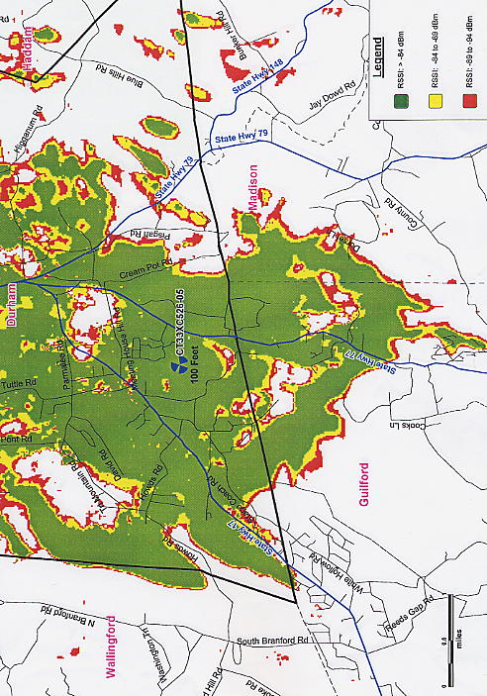
APPENDIX C
(Proposed Sprint Coverage at 100 feet agl)

(Sprint 3, PHQ. 17, Coverage Plot)

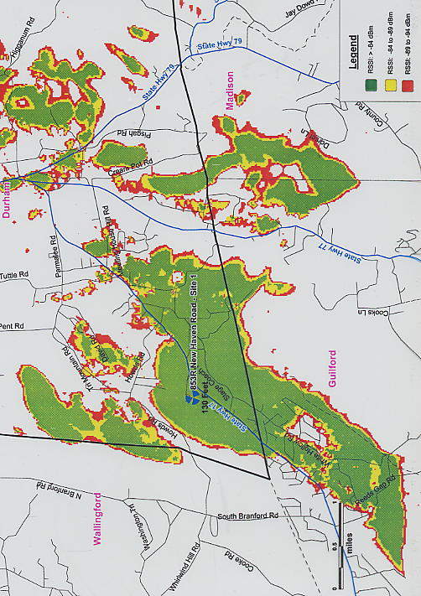
APPENDIX D
(Sprint Coverage from Tower Ventures Tower at 130 feet agl)

(Sprint 4, PHQ. 25, Coverage Plot)

APPENDIX E
(Sprint Coverage from Surrounding Sites and
Tower Ventures Tower at 140 feet agl)

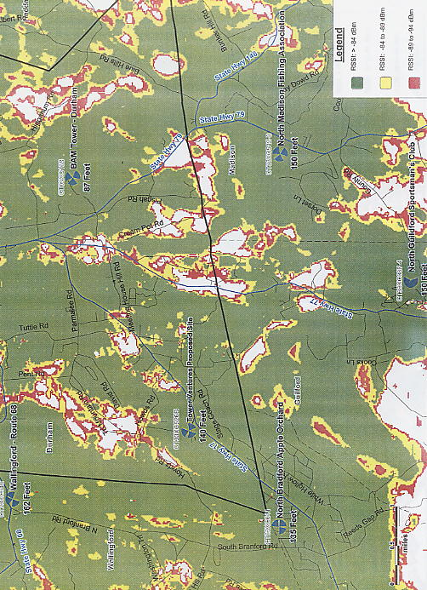
(Sprint 7, Responses to TV PHQ. 3(a) Coverage Plot)

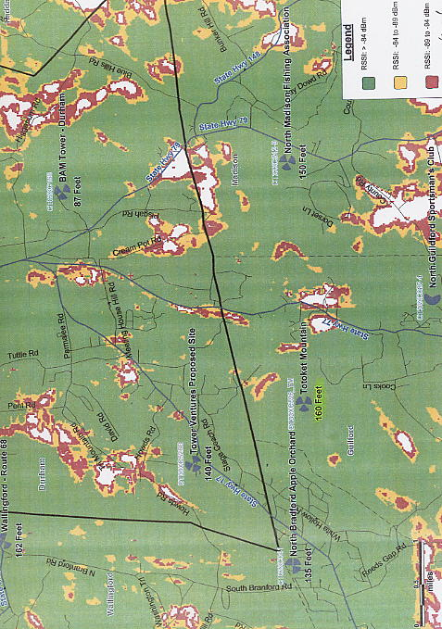
APPENDIX F
(Sprint Coverage from Surrounding Sites, Tower
Ventures Proposed Tower at 140 feet agl and Totoket
Mountain Tower at 160feet agl)

(Sprint 7, Responses to TV PHQ. 3 (b), Coverage Map)

