DOCKET NO. 250 - AT&T Wireless PCS, LLC d/b/a AT&T Wireless application for a Certificate of Environmental Compatibility and Public Need for the construction, maintenance and operation of a wireless telecommunications facility at 371 Terryville Avenue or 522 Terryville Avenue, Bristol, Connecticut. | }  }  }  } | Connecticut  Siting  Council  October 14, 2003

Findings of Fact
Introduction

- AT&T Wireless PCS, LLC d/b/a AT&T Wireless (AT&T) in accordance with provisions of General Statutes §§ 16-50g through 16-50aa applied to the Connecticut Siting Council (Council) on March 31, 2003 for the construction, operation, and maintenance of a wireless telecommunications facility at 371 Terryville Avenue (Site A) or 522 Terryville Avenue (Site B) in Bristol, Connecticut. (AT&T 1, p. 1, 2)

- AT&T is licensed by the Federal Communications Commission to provide wireless personal communication service (PCS) within Connecticut. AT&T has a license for the Hartford Basic Trading Area (BTA), which includes Hartford County. (AT&T 1, p. 3, 5)

- The party in this proceeding is the applicant. The intervenor is Sprint Spectrum L.P. d/b/a Sprint PCS (Sprint). (Transcript 1, 3:00 p.m. (Tr. 1), p. 5; Transcript 2, 7:00 p.m., (Tr. 2), p. 5)

- Pursuant to General Statutes § 16-50m, the Council, after giving due notice thereof, held a public hearing on July 23, 2003, beginning at 3:00 p.m. and continuing at 7:00 p.m. in the Bristol City Hall, 111 North Main Street, Bristol, Connecticut. (Tr. 1, p. 3; Tr. 2, p. 3)

- The Council and its staff made inspections of proposed Site A and Site B on July 23, 2003, beginning at 2:00 p.m. During the field inspection, the applicant flew a balloon at the proposed sites to simulate the height of the towers proposed at this location. The height at the top of the balloon at Site A was 160 feet above ground level (AGL). The balloon at Site B was flown at 120 feet AGL with a red flag at 100 feet AGL to show the maximum potential height, shown in the site plan in the application, and the requested height of the proposed tower. (AT&T 1, p. 13; Tr. 16)

- AT&T notified the City of Bristol of the proposed project on October 30, 2002. Notice was sent to Frank N. Nicastro, Sr., Mayor of the City of Bristol. On January 30, 2003, AT&T flew balloons at each site and prepared visual simulations of the balloon flight at the request of the Bristol City Council. A public information session, at which AT&T appeared, was conducted on March 11, 2003 by the Mayor and the Bristol City Council. In a letter dated March 14, 2003, the City Clerk indicated that the City Council voted to support the development of proposed Site A. (AT&T 1, p. 18)

- Notice of the application was provided to all abutting landowners by certified mail, return receipt requested. The notice was unclaimed by two abutting property owners. No documentation was returned from the post office for two other adjacent property owners. AT&T sent an additional notice by certified mail, return receipt to the two adjacent property owners for which no documentation was returned from the post office. Public notice of the application was published in the Bristol Press on March 27, 2003 and March 28, 2003. (AT&T 1, p. 4; AT&T 2, Q. 1; AT&T 3, Q. 19)

- Pursuant to General Statutes § 16-50j (h), the following state agencies were solicited to submit written comments regarding the proposed facility on April 25, 2003; Department of Environmental Protection (DEP), Department of Public Health (DPH), Council on Environmental Quality (CEQ), Department of Public Utility Control (DPUC), Office of Policy and Management (OPM), Department of Economic and Community Development (DECD), and the Department of Transportation (DOT). (record)

- Comments were received from the DOT on June 2, 2003. Comments were received from the DEP on July 22, 2003. (DOT letter dated June 2, 2003; DEP letter dated July 22, 2003)

- The following agencies did not offer comments on the application: DPH, CEQ, DPUC, OPM, and the DECD. (record)

Need

- AT&T located the proposed facility to provide wireless telecommunications service to Bristol, particularly along Route 6 and adjacent areas. (AT&T 1, p. 6)

- In issuing cellular licenses, the Federal government has preempted the determination of public need for cellular service by the states, and has established design standards to ensure technical integrity and nationwide compatibility among all systems. (Council Admin. Notice, no. 7, Telecom. Act 1996)

- In 1996, the United States Congress recognized a nationwide need for high quality wireless telecommunications services, including cellular telephone service. Through the Federal Telecommunications Act of 1996, Congress seeks to promote competition, encourage technical innovations, and foster lower prices for telecommunications services. (Council Admin. Notice, no. 7, Telecom Act 1996; AT&T 1, p. 4, 5)

Site Search

- AT&T identified existing towers and structures of adequate height within and near the site search area that could accommodate AT&T’s equipment. There is one tower within approximately two miles of the site search area; a ham radio tower located at 371 Terryville Avenue, which would not provide adequate coverage to the area. An approved site that will be built into the turret of St. Joseph’s Church located at 335 Center Street, and a proposed site located at 80 Main Street, owned by Plymouth Town Hall would interact with the proposed Site A or Site B. (AT&T 1, p. 8, Tab 3, Tab 4; AT&T 2, Q. 2; Tr. 1, p. 13, 31)

- AT&T identified and investigated eleven potential sites for the proposed project, including the proposed sites, within Bristol. The potential sites investigated and rejected by AT&T include 521 Terryville Avenue, which was rejected because of the refusal of the property owner; existing towers located on South Mountain, a property at 225 North Main Street, a property at 139 Center Street, the Fire Department at Matthews Street and Hill Street, and a farm at Matthews Street and Hill Street were rejected because they would not provide adequate coverage to the area; residential properties at Everett Street, Matthews Street and Bird Road, 653 Terryville Avenue, and an existing ham radio tower located at 771 Terryville Avenue were rejected due to the dense residential development in the adjacent area. (AT&T 1, p. 9, Tab 4)

Sites and Equipment

- The proposed Site A would include a 6,000 square foot leased parcel on which AT&T would develop a 60-foot by 100-foot equipment compound, which would be enclosed by an 8-foot high security fence. Equipment cabinets would be placed on a 12-foot by 24-foot concrete slab within the fenced area. The proposed tower is a 160-foot monopole. The proposed tower and equipment compound will be designed to accommodate AT&T’s equipment and up to five additional carriers. (AT&T 1, p. 9, Tab 5)

- The proposed Site B would include a 10,000 square foot lease parcel on which AT&T would develop an 80-foot by 80-foot equipment compound, which would be enclosed by an 8-foot high security fence. Equipment cabinets would be installed on a 12-foot by 24-foot concrete slab within the fenced area. The proposed tower is a 100-foot monopole. The proposed tower and equipment compound will be designed to accommodate AT&T’s equipment and up to five additional carriers. However, due to the unlikely chance of a carrier being interested in a position at 50 feet AGL, AT&T would construct the tower with the ability to extend to 120 feet AGL. (AT&T 1, p. 10, Tab 6; Tr. 1, p. 46)

- The City of Bristol has expressed an interest in locating equipment at one of the proposed sites for the City’s public safety communications system. Sprint has expressed an interest in locating equipment at either of the proposed sites. (AT&T 2, Q. 6, Q. 14)

- The tower setback radius at proposed Site A would extend onto an adjacent property to the west owned by St. Joseph Church Corp. There is an existing covered storage area, located on the lessor’s property, within the tower setback radius of proposed Site A. AT&T would be willing to design the proposed structure at Site A with a failure point that would reduce the tower setback radius in the event that the tower fell. The tower setback radius at proposed Site B would remain within the owner’s property. There are no structures located within the tower setback radius of proposed Site B. (AT&T 1, Tab 5, Tab 6; AT&T 2, Q. 7; Tr. 1, p. 25, 26)

- The approximate costs of proposed construction for Site A is estimated as follows:

Electronic Equipment | $ 102,500
Tower and Antenna | 151,000
Site Development | 110,000
Total Costs | $ 363,500
(AT&T 1, p. 19)

- The approximate costs of proposed construction for Site B is estimated as follows:

Electronic Equipment | $ 180,000
Tower and Antenna | 145,000
Site Development | 122,500
Total Costs | $ 447,500
(AT&T 1, p. 19, 20)

Proposed Site A/ Site B

- The proposed Site A is located on an approximately 10.7-acre parcel owned by Laviero Realty, LLC. The elevation of the proposed site is 541.5 feet above mean sea level (amsl). A portion of the property on the proposed site is developed for a construction business. The developed portion includes a level parking and storage area with some buildings. Surrounding land use includes St. Joseph Cemetery, single family residences, a rail line and Route 6. The proposed compound is located on a slope above the developed portion of the lessor’s property. The tree line surrounding the site ranges from 55 feet to 60 feet in height and is upgrade from the proposed compound. (AT&T 1, p. 2, 9, Tab 5; Tr. 1, p. 26)

- AT&T would be willing to move the proposed Site A leased area approximately 20 feet to 30 feet to the east to get it closer to the flat slope if the elevation at the top of the tower remained the same as proposed. (Tr. 1, p. 41, 42)

- The proposed Site B is located on an approximately 41.95 acre parcel owned by St. Joseph Church Corp., which is the location of St. Joseph Cemetery. The elevation of the proposed site is 642 feet amsl. Surrounding land use includes single family residences to the north, west and northeast, and St. Joseph Cemetery to the south and southeast. Route 6 is to the south of the property. The proposed site is level and wooded. The tree line surrounding the site ranges from 55 feet to 60 feet in height. (AT&T 1, p. 2, 9, Tab 6; Tr. 1, p. 26)

- The proposed Site A is located within an Industrial Zone. The proposed Site B is located within a residential zone (R-25). The City of Bristol has interpreted wireless telecommunications facilities to fall under the public utility buildings or facilities classification. The City’s Zoning Regulations express that public utility buildings or facilities are a permitted use in the Industrial Zone and permitted with a special permit in the R-25 zone. (AT&T 1, p. 10, 11, 16)

- There are 23 residential structures located within a 1,000-foot radius of proposed Site A, the nearest of which is located approximately 475 feet to the east/northeast. There are 40 residences within a 1,000-foot radius of proposed Site B, the nearest of which is approximately 350 feet to the southwest. The nearest portion of St. Joseph’s Cemetery that is in use is approximately 175 feet away. (AT&T 1, p. 13; AT&T 2, Q. 3, Q. 5)

- The proposed access road at Site A would be a new gravel access road extending approximately 300 feet from Route 6 to the proposed compound. AT&T would use riprap to protect the slope where necessary. Underground utility connections will extend along the proposed access road to the Site A compound. The proposed access road at Site B would follow an existing paved drive through the cemetery for a distance of approximately 995 feet, an existing gravel drive and dirt area for a distance of approximately 535 feet, and a new gravel access drive would be constructed for a distance of approximately 105 feet. The total length of the proposed access drive to Site B is approximately 1,635 feet. Underground utility connections will extend along the access drive to the Site B compound. (AT&T 1, p. 2, 10, 11, Tab 5, Tab 6; AT&T 3, Q. 21)

- AT&T would design a plan to access proposed Site A through the existing driveway and parking area, if required by the Council. (AT&T 2, Q. 21)

Environmental Considerations

- According to the DEP’s Natural Diversity Database, there are no known federal or State Endangered, Threatened or Special Concern Species at Site A. The DEP recommended that a herpetological study for Eastern box turtles be performed for Site B after June 1, when the turtle would be active. The Herpetofaunal Survey Report found that the Eastern box turtle was not detected on the property during multiple surveys. A wildlife biologist from the DEP recommends that “any transient box turtles be moved, unharmed, to an area immediately outside of the construction area in the same direction that it was walking.” The DEP also recommends that no vegetation be removed from stream banks, no erosion or siltation be discharged into the stream, and that no polluted runoff be discharged into the stream. (AT&T 1, p. 14; AT&T 2, Q. 4; AT&T 5; Tr. 1, p. 14)

- The State Historic Preservation Office (SHPO) has determined that construction of the proposed sites would have no effect on historic, architectural, or archaeological resources listed on or eligible for the National Register of Historic Places. (AT&T 1, Tab 5, Tab 6)

- The nearest hiking trail to the proposed sites is the Tunxis Compounce Ridge Trail, which is approximately 2.08 miles from Site A and approximately 2.43 miles from Site B.

- Clearing of approximately 11 trees at Site A and 8 trees at Site B with diameters of six inches or greater at breast height would be required to construct the proposed site and access road. (AT&T 2, Q. 8)

- The Site A compound and access drive would require moderate clearing, significant grading and the development of retaining wall systems. The Site B compound and new access drive would require minimal grading and moderate clearing. (AT&T 1, p. 10, 11, Tab 5, Tab 6)

- A stream is located approximately 100 feet to the northeast of the proposed Site B compound within the owner’s property. Erosion and sediment controls would be established and maintained throughout the construction of the proposed facility to protect nearby wetlands. AT&T would install silt fencing prior to any grading activities in accordance with the Connecticut Guidelines for Soil Erosion and Sedimentation Control. (AT&T 1, p. 17; AT&T 2, Q. 9)

- Neither of the proposed facilities would require registration with the Federal Aviation Administration (FAA). No FAA lighting or marking would be required for the proposed towers. (AT&T 1, p. 18, 19)

- The electromagnetic radio frequency power density was calculated using the FCC Office of Engineering and Technology Bulletin 65, using conservative worst-case approximation of radio frequency power density levels at the base of each tower, would be 4.2 percent of the American National Standards Institute (ANSI) Standard for Site A and Site B would be 10.79 percent of the Standard. (AT&T 1, p. 14 Tab 5, Tab 6)

Visibility

- Visibility of the proposed structures at Site A and Site B was determined using visual simulations and sight line graphs. The visual impact of the proposed tower at Site A would be limited due to the topography and existing vegetation in the area. The proposed tower at Site A would be visible from portions of Route 6, and Hill Street, and seasonal visibility is expected from portions of the residential areas in the vicinity of the site. The visual impact of the proposed tower at Site B would be limited due to existing vegetation. The proposed Site B tower would be visible from portions of Route 6, Hill Street and residential areas to the north and east of the site. (AT&T 1, p. 12, 13, Tab 5, Tab 6, Tab 8; Tr. 1, p. 22)

- Based on the visual simulations, there were 14 locations where Site B was visible and 10 locations where Site A was visible. Site B would be visible from mostly residential areas as opposed to travel-ways and intersections. (Tr. 1, p. 27)

- The visibility of proposed tower at Site A from various locations in the area, according to sight line graphs, would be as follows:

Visibility of Proposed 160-foot Tower

Location | Visible | Approx. Distance (ft.) and Direction to Tower
Matthews Street | No | 3,168 feet NW
Intersection of Marlene Street and Boivin Street | No | 6,864 feet NE
Intersection of Route 6 and Route 69 | Yes | 5,808 feet E
Rockwell Park Road | No | 1,584 feet S
School Road | Yes | 7,392 feet SW
Intersection of Route 6 and Everett Street | Yes | 1,584 feet W
(AT&T 1, Tab 5)

- The visibility of proposed tower at Site B from various locations in the area, according to sight line graphs, would be as follows:

Visibility of Proposed 100-foot Tower

Location | Visible | Approx. Distance (ft.) and Direction to Tower
Matthews Street | Yes | 1,056 feet NW
Intersection of Marlene Street and Boivin Street | No | 6,336 feet NE
Intersection of Route 6 and Route 69 | Yes | 6,864 feet E
Rockwell Park Road | No | 3,168 feet SE
School Road | Yes | 6,600 feet SW
Intersection of Route 6 and Everett Street | Yes | 1,320 feet S
(AT&T 1, Tab 6)

Coverage Needs

AT&T

- Existing facilities in Bristol, and Plymouth (to the west) leave gaps in wireless coverage in the Bristol area. Gaps are defined as areas receiving less than –85 dBm coverage. AT&T uses the minimum signal level threshold of –85 dBm to provide in-vehicle coverage and, to a lesser extent, coverage within structures. The primary purpose of this application is to provide coverage to these gaps along Route 6, and local roads within Bristol. (AT&T 1, p. 1, AT&T 2, Q. 10)

- Existing wireless coverage, at 1900 mhz, within a three mile radius of the proposed sites is as follows:

Existing Coverage

(see Figure 3)

Route | Existing Gaps (miles)  < -85 dBm | Total Road  Miles within a 3-mile Radius
6 | 4.3 | 6.0
72 | 1.3 | 4.4
Total | 5.6 miles | 10.4 miles
(AT&T 2, Q. 11)

- Existing coverage combined with antennas on the proposed Site A tower at 160 feet AGL and the proposed Site B tower at 100 feet AGL, at 1900 mhz, would leave the following gaps within a three mile radius of the proposed sites as follows:

Proposed Site A at 160 Feet AGL

(see Figure 4)

Route | Gaps (miles)  < -85 dBm | Total Road Miles within a Three Mile Radius
6 | 3.5 | 6.0
72 | 1.2 | 4.4
Total | 4.7 miles | 10.4 miles
(AT&T 2, Q. 12)

Proposed Site B at 100 Feet AGL

(see Figure 5)

Route | Gaps (miles)  < -85 dBm | Total Road Miles within a Three Mile Radius
6 | 3.1 | 6.0
72 | 1.0 | 4.4
Total | 4.1 miles | 10.4 miles
(AT&T 2, Q. 13)

Sprint

- Sprint would install antennas on the proposed facility to operate in the PCS frequency range. An additional site may be needed in the future to provide coverage to a gap along Route 69. Sprint’s minimum signal level threshold is –94 dBm, however –89 dBm is preferred in this area because it is a residential/commercial area. Sprint prefers Site B because it provides better coverage along Route 6 and it fits into the network better than Site A. Existing coverage combined with antennas on the proposed Site A tower at 150 feet AGL and the proposed Site B tower at 90 feet AGL would leave the following gaps within a three mile radius of the proposed sites as follows: (Sprint 1, Q. 2, 3; Tr. 1, p. 59, 60, 63)

Proposed Site A at 150 Feet AGL

(see Figure 6)

Route | Gaps (miles)  < -94 dBm | Total Road Miles within a Three Mile Radius
6 | 0.5 | 6.0
72 | 0.2 | 4.4
Total | 0.7 miles | 10.4 miles
(Sprint 1, Q. 2, 3)

Proposed Site B at 90 Feet AGL

(see Figure 7)

Route | Gaps (miles)  < -94 dBm | Total Road Miles within a Three Mile Radius
6 | 0.3 | 6.0
72 | 0.4 | 4.4
Total | 0.7 miles | 10.4 miles
(Sprint 1, Q. 2, 3)

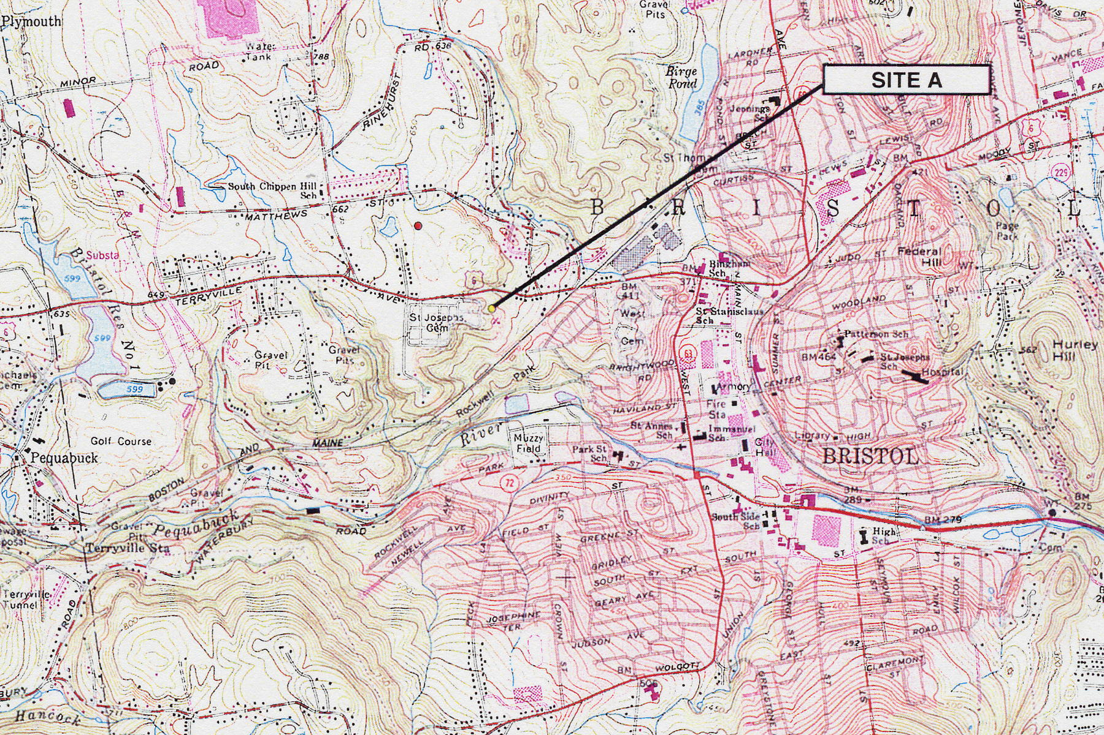
Figure 1. Location of Site A. (AT&T 1, Tab 5)

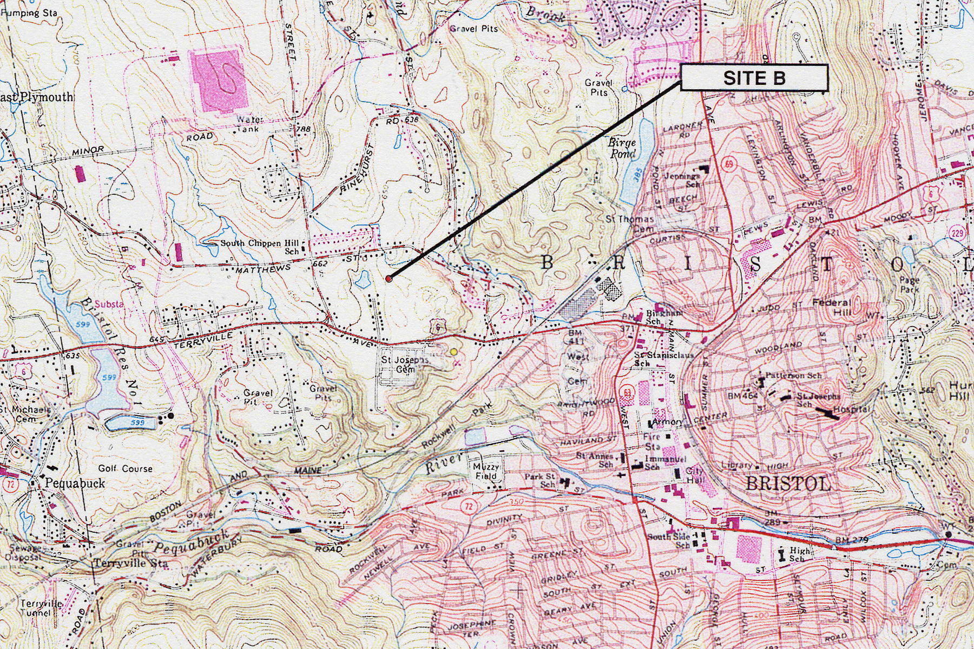
Figure 2. Location of Site B. (AT&T 1, Tab 6)

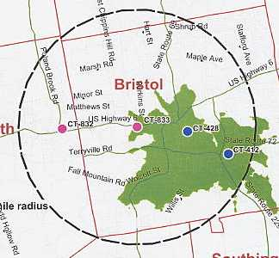

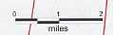

Figure 3. Existing AT&T coverage in Bristol. (AT&T 2, Q. 11)

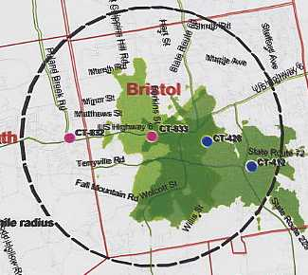

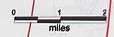

Figure 4. Existing AT&T coverage with coverage from proposed Site A at 160 feet
AGL. (AT&T 2, Q. 11, 12)

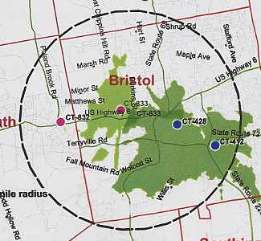

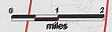

Figure 5. Existing AT&T coverage with coverage from proposed Site B at 100 feet
AGL. (AT&T 2, Q. 11, 13)

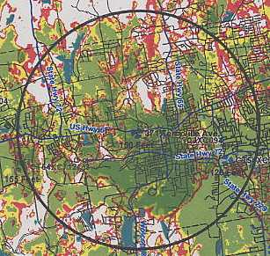

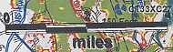

Figure 6. Existing Sprint coverage with coverage at proposed Site A at 150 feet
AGL. (Sprint 1, Q. 2, 3)

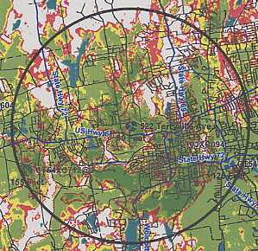

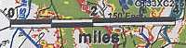

Figure 7. Existing Sprint coverage with coverage at proposed Site B at 90 feet
AGL. (Sprint 1, Q. 2, 3)

