DOCKET NO. 243 - Omnipoint Facilities Network 2, L.L.C., a subsidiary of T-Mobile, USA, Inc. application for a Certificate of Environmental Compatibility and Public Need for the construction, maintenance and operation of a wireless telecommunications facility at 270 Valley Road, New Canaan, Connecticut. | }  }  } | Connecticut  Siting  Council  February 18, 2004

Findings of Fact

Introduction

- Omnipoint Facilities Network 2, LLC a subsidiary of T-Mobile, USA, Inc. (T-Mobile), in accordance with provisions of General Statutes §§ 16-50g through 16-50aa applied to the Connecticut Siting Council (Council) on February 25, 2003 for the construction, operation, and maintenance of a wireless telecommunications facility at 270 Valley Road, New Canaan, Connecticut. (T-Mobile 1, p. 1)

- T-Mobile is licensed by the Federal Communications Commission (FCC) to provide wireless personal communication service (PCS) in Connecticut. T-Mobile formed Omnipoint Facilities Network 2, LLC to operate its telecommunications infrastructure in the New York Basic Trading Area, which includes Fairfield County, Connecticut. (T-Mobile 1, pp. 3-4)

- The parties in this proceeding are the applicant, Marie Louise Brown, Iona C. Hubbard, the Citizens for Responsible Cellular Planning, Dayton Ogden, Jr. and Margaret R. Ogden, and the Town of New Canaan. The intervenors are AT&T Wireless PCS, LLC d/b/a AT&T Wireless, Diane M. Baldwin, Janet Z. Congdon, John D. Hough and Sally N. Hough, and Nancy G. Neuser and Gary A. Neuser. (Transcript 1, 2:00 p.m., 05/22/03 (Tr. 1), p. 8, 9; Transcript 2, 7:00 p.m., 05/22/03 (Tr. 2), p. 7)

- Pursuant to General Statutes § 16-50m, the Council, after giving due notice thereof, held a public hearing on May 22, 2003, beginning at 2:00 p.m. and continuing at 7:00 p.m. in the auditorium of the New Canaan Town Hall, 77 Main Street, New Canaan, Connecticut. The public hearing was continued on July 31, 2003 and on August 27, 2003, at the offices of the Connecticut Siting Council, Ten Franklin Square, New Britain, Connecticut. The May 22, 2003 and July 31, 2003 hearing sessions were held in conjunction with Docket number 244, which is proposed at 95 Country Club Road in New Canaan. The August 27, 2003 hearing session was bifurcated from Docket number 244. (Tr. 1, p. 5; Tr. 2, p. 5; Transcript 3, 07/31/03 (Tr. 3), p. 5; Transcript 4, 08/27/03 (Tr. 4), p. 4; record)

- The Council and its staff made inspections of the proposed site on May 22, 2003, beginning at 1:00 p.m. During the field inspection, the applicant flew a balloon at the proposed site to simulate the height of the tower proposed at this location. (Tr. 4, p. 202)

- T-Mobile located the proposed facility to provide wireless telecommunications service to the eastern portion of New Canaan and the western portion of Wilton. (T-Mobile 1, p. 6)

- T-Mobile has been trying to obtain local approvals from the Town of New Canaan for the proposed site since 2000, but encountered opposition to changing municipal requirements. When Connecticut law shifted jurisdiction of PCS facilities in 2001 from towns to the Council, T-Mobile filed its 60-day notice with the Town of New Canaan. (T-Mobile 1, p. 15)

- The Town of New Canaan has indicated its preference of multiple shorter towers to fewer taller towers. (T-Mobile 1, p. 15)

- On May 13, 2002, T-Mobile notified the Towns of New Canaan and Wilton of its intent concerning the proposed telecommunications facility through a technical report sent to Richard T. Bond, First Selectman of the Town of New Canaan, and Paul F. Hannah, Jr., First Selectman of the Town of Wilton. The Town of Wilton is approximately 1,200 feet away from the proposed site. (T-Mobile 1, p. 3, 15)

- On June 26, 2002, a meeting was held at the New Canaan Town Hall with town officials and T-Mobile representatives. The Town of New Canaan suggested that T-Mobile consider alternative properties that are in the vicinity of the proposed site. At a public information meeting on August 13, 2002, the Town asked T-Mobile to investigate Silver Hill Hospital as an alternative location for the proposed facility. T-Mobile determined that the Silver Hill Hospital would work from a radio frequency coverage perspective. In December 2002, the Silver Hill Hospital administration indicated that they were not interested in allowing a lease for a telecommunications facility on the property. (T-Mobile 1, p. 23-25)

- Notice of the application was provided to all abutting landowners by certified mail. Three of the eight notices sent were returned as unreceived. Notice to Sarah H. Guerra went unclaimed after two attempts. In the initial notice, T-Mobile made errors in the addresses of Iona C. Hubbard and John R. and Marianne Campbell, the addresses were corrected and re-sent to both addresses return receipt requested. T-Mobile has received the receipts for both of these parties. Public notice of the application was published in The Stamford Advocate on February 21 and February 24, 2003. (T-Mobile 1, p. 5, affidavit of publication dated February 27, 2003; T-Mobile 2, Q. 1)

- Pursuant to General Statutes § 16-50j (h), the following State agencies were solicited to submit written comments regarding the proposed facility on March 27, 2003; Department of Environmental Protection (DEP), Department of Public Health (DPH), Council on Environmental Quality (CEQ), Department of Public Utility Control (DPUC), Office of Policy and Management (OPM), Department of Economic and Community Development (DECD), and the Department of Transportation (DOT). (record)

- Comments were received from the DOT on April 7, 2003 and the DEP on May 8, 2003. (record)

- The following agencies did not offer comments on the application: DPH, CEQ, DPUC, OPM, and DECD. (record)

Telecommunications Act

- In issuing cellular licenses, the federal government has preempted the determination of public need for cellular service by the states, and has established design standards to ensure technical integrity and nationwide compatibility among all systems. (Council Admin. Notice, no. 7, Telecom. Act 1996)

- In 1996, the United States Congress recognized a nationwide need for high quality wireless telecommunications services, including cellular telephone service. Through the Federal Telecommunications Act of 1996, Congress seeks to promote competition, encourage technical innovations, and foster lower prices for telecommunications services. (Council Admin. Notice, no. 7, Telecom Act 1996)

- The Telecommunications Act of 1996 prohibits local and State bodies from discriminating among providers of functionally equivalent services. (Council Admin. Notice, no. 7, Telecom. Act 1996)

- The Telecommunications Act of 1996, a federal law passed by the United States Congress, prohibits any State or local agency from regulating telecommunications towers on the basis of the environmental effects of radio frequency emissions to the extent that such towers and equipment comply with Federal Communications Commission’s (FCC) regulations concerning such emissions. This Act also blocks the Council from prohibiting or acting with the effect of prohibiting the provision of personal wireless service. (Council Admin. Notice, no. 7, Telecom. Act 1996)

Site Search

- T-Mobile investigated two potential sites, including the proposed site, for the construction of a tower within the search ring. The only alternative site identified is a commercial property used for a health care facility owned by Silver Hill Foundation, located adjacent to the property on which the proposed site would be located. The Silver Hill Foundation declined to permit a tower facility to be located anywhere on its property at that time. (T-Mobile 1, p. 7, 8)

- A portion of the Silver Hill Hospital property was placed on the market in June/July 2003. (Tr. 3, p. 269; Tr. 4, p. 47)

- A site analyzed at the Armory would not provide coverage to the area surrounding the proposed site. (Tr. 3, p. 49)

- The Thayer Lake Club is located approximately one-mile to the north of the proposed site. A tower located at the Thayer Lake Club would provide more geographic coverage to the Town of New Canaan than the proposed site but a 1.7 mile gap would remain along Valley Road. (Tr. 3, p. 74; Tr. 4, p. 162, 163)

- There are no towers located within the search ring that would provide co-location opportunities suitable for T-Mobile. (T-Mobile 1, p. 7)

Site Description

- The proposed site would be located on a 30-foot by 20-foot leased fenced compound located on an approximately 2-acre site owned by City of Norwalk’s First District Water Company (Water Company). The proposed site is located on the hillside behind the Water Company filtration plant. A new five-foot retaining wall would be constructed to create level ground for the compound, which would consist of 8-foot by 8-foot railroad ties. A 6-foot chain link fence and 6-foot high arborvitae or similar shrubs would surround the compound. (T-Mobile 1, p. 9; T-Mobile 3, Q. 5)

- The proposed equipment compound would contain an 8-foot by 12-foot concrete pad to accommodate two equipment cabinets and an 8-foot by 20-foot concrete pad to accommodate cabinets for future carriers. (T-Mobile 1, p. 10)

- T-Mobile would construct a 150-foot steel silhouette pole, designed to accommodate four sets of antennas contained within the pole. T-Mobile would install antennas at the 146-foot level and the 139-foot level. Space would be available at the 129-foot level and the 119-foot level for future carriers. Two small measurement function receiver antennas would be installed within the pole and one global positioning system (GPS) antenna would be installed on one of the equipment cabinets for enhanced 911 position location. The minimum dimensions for the proposed silhouette structure are 36 inches at the base and 24 inches at the top. (T-Mobile 1, p. 9-11; T-Mobile 2, Q. 5)

- Access to the proposed site would be from an existing approximately 20-foot wide, 380-foot long paved drive extending from Valley Road. Access from the parking area at the top of the existing driveway to the proposed site will be by foot except as needed during construction. During construction, T-Mobile will use rigs that can be driven up to the pole location if possible, or rigs can be brought in by crane and dropped down into the site. Utilities would run from an existing utility pole near the top of the existing access drive. A new utility pole would be installed just outside of the proposed T-Mobile compound. (T-Mobile 1, p. 9; Tab 3; T-Mobile 2, Q. 3; Tr. 4, p. 203)

- AT&T Wireless has a firm commitment to locate equipment at the proposed facility at the 129-foot level. Cingular has expressed an interest in locating equipment at the proposed facility. (T-Mobile 2, Q. 16; AT&T Wireless 1, Q. 3, 8; Tr. 3, p. 89)

- The proposed site is located adjacent to a residential area. The area surrounding the Water Company property consists of residential homes. The Water Company property is zoned as 2-acre residential. The nearest residence is located 230 feet to the southwest of the proposed site. (T-Mobile 1, p. 18, 19)

- There are approximately 30 residential structures within a 1,000-foot radius of the proposed site. (T-Mobile 2, Q. 4)

- The southern corner of the proposed compound is approximately 56 feet from the adjacent property boundary to the south. The tower setback radius at the proposed site would extend onto adjacent property to the south and to the east. There are three existing structures located within the tower radius. T-Mobile could relocate the proposed tower in an attempt to keep the tower setback radius within the lessor’s property; however that would result in a loss of ground elevation. T-Mobile would design the tower with a yield point to prevent the tower from extending onto an adjacent property if it were to fall if the Council orders it as a requirement. (T-Mobile 1, Tab 5; T-Mobile 2, Q. 8; Tr. 3, p. 112; Tr. 4, p. 204, 205)

- T-Mobile could relocate the proposed facility within the Valley Road property without compromising the radio frequency coverage to the area. T-Mobile could relocate the proposed site approximately 40 feet to the southeast corner of the property. This portion of the property is approximately 15 feet higher in ground elevation, which would allow the height of the tower to be reduced. There is a tree line on the southern and eastern side of the Valley Road property, which would provide some screening of the proposed tower. The top of the proposed tower would still be visible but the bottom would be screened more than the proposed site. (Tr. 4, p. 170, 209-212)

- The approximate costs of construction to T-Mobile for the proposed site are estimated as follows:

150’ Silhouette pole and antenna | $ 35,000
Utility Systems | 19,500
Caisson (foundation) | 30,000
Miscellaneous labor costs | 7,500
Total Costs | $ 92,000
(T-Mobile 1, p. 27)

Environmental Considerations

- The State Historic Preservation Office has determined that the proposed facilities would have no effect on historic, architectural, or archaeological resources listed on or eligible for the National Register of Historic Places. (T-Mobile 1, Tab 6)

- The proposed project would not likely affect threatened or endangered species or critical habitats, based on a National Environmental Policy Act (NEPA) review using the Connecticut Department of Environmental Protection Natural Diversity Database. (T-Mobile 1, Tab 6)

- No trees with diameters of 6 inches or greater at breast height would have to be removed for the construction of the proposed site and access road. A moderate amount of fill would be necessary to level the proposed site. (T-Mobile 2, Q. 9)

- There are no wetlands in the vicinity of the proposed site. The Water Company property is located within Zone X on the Flood Insurance Rate Maps, which is an area outside of the 500-year flood plain. (T-Mobile 1, p. 22)

- The applicant performed an air-space analysis for the proposed facility, which determined that the site would not constitute an obstruction or hazard to air navigation. The proposed tower would not require hazard lighting or paint striping. (T-Mobile 1, p. 26)

- The electromagnetic radiofrequency power density, calculated using the FCC Office of Engineering and Technology Bulletin 65, August 1997, using conservative worst-case approximation of radiofrequency power density levels at the base of the tower, with all T-Mobile antennas transmitting simultaneously on all channels at full power, would be 2.9 percent of the American National Standards Institute (ANSI) and National Council on Radiation Protection and Measurements standards at the proposed site. (T-Mobile 1, p. 13, Tab 1)

Visibility

- A field investigation was used to perform a viewshed analysis of an approximately 8,035-acre (2 mile radius) area around the proposed facility. The analysis concludes that approximately 0.49% of the 2-mile area would have at least a partial view of the proposed tower. Visibility of the proposed structure would primarily impact the immediate area including a portion of Valley Road to the northwest and southeast of the proposed site, Wardwell Drive, and portions of Thayer Drive. The surrounding tree height ranges from 70-95 feet above ground level (AGL) and consists primarily of hardwoods and pines. A map depicting the visibility of the proposed tower is included as Figure 1. (T-Mobile 1, Tab 7)

- The home at 2 Wardwell Drive and two homes to the east across Valley Road at 253 and 269 Valley Road are visible from the proposed site. A home at 286 Valley Road, to the north of the proposed site can be seen through the trees at a lower elevation than the site. Two homes, at 17 Wardwell Drive and 94 Thayer Drive, would have seasonal views of the proposed tower. (DEP letter dated May 8, 2003)

- The compound is proposed behind a utility infrastructure facility to avoid the need for extensive tree removal and minimize impact to the surrounding residential area. The area to the west of the proposed compound is heavily wooded with trees and underbrush, which would provide a screen of the compound from the residential properties on Wardwell Drive. (T-Mobile 1, p. 11)

- The visibility of the proposed tower, based on photographs taken of a balloon flown at 150 feet AGL from public roadways, would be as follows:

Visibility of Proposed 150-foot Tower

Location | Visibility | Approx. Distance (ft.) and direction
Valley Road | Yes | 370 NE
Valley Road | Yes | 475 N
Valley Road | Yes | 1,480 SE
Intersection of Cheese Spring Road and Mariom Road | No | 9,665 N
Intersection of Rosebrook Road and Country Club Road | No | 4,910 W
Intersection of Brushy Ridge Road and Rosebrook Road | No | 5,280 SW
Intersection of Borglum Road and Old Boston Road | No | 7,025 E
Intersection of Carter Street and Canoe Hill Road | No | 3,275 S
(T-Mobile 1, Tab 7)

- T-Mobile could build a tree monopole as an alternative to the proposed silhouette pole. A tree monopole of 120 feet AGL could support the antennas of two carriers. (Tr. 4, p. 221)

Existing and Proposed Wireless Coverage
T-Mobile Coverage

- T-Mobile operates a personal communications service network using a 1900 MHz frequency signal allocated by the FCC. Drive test data for the proposed tower was performed by T-Mobile, using a minimum signal level of –87 dBm for in-vehicle coverage. According to the drive test data, the proposed facility would fill a gap in the area and bridge the gap to existing facilities in New Canaan. T-Mobile designs the system for in-vehicle coverage, but also intends to provide coverage for in-building uses. (T-Mobile 1, p. 3; T-Mobile 4 , Tr. 1, p. 89, 93)

- The drive test was performed with a test phone that is connected to a computer and a GPS. T-Mobile representatives would drive around a particular area and collect signals from existing facilities, using an antenna mounted on the outside of the vehicle. To determine projected coverage using drive test analysis, a crane was brought to the proposed site and raised to a height of 150 feet AGL. A transmitter is attached to the top of the crane and radio frequency data is collected. (Tr. 3, p. 18-21)

- Adjacent existing T-Mobile facilities that would interact with the proposed facility are as follows:

Location | Antenna Height AGL (ft)
39 Locust Avenue, New Canaan | 46
46 Fenwood Lane, Wilton | 122
(T-Mobile 2, Q. 2; T-Mobile 3, Q. 23)

- Use of alternative technologies like microcells, or the use of smart antennas or multiplexing, which would allow multiple carriers to share the same antenna, would not be adequate to provide coverage to this area. (T-Mobile 1, p. 24, 25)

- The proposed silhouette structure would provide coverage similar to a traditional monopole structure. A traditional monopole can accommodate multiple carriers with a ten-foot separation between each carrier. A silhouette structure requires two elevations on a structure for one carrier. A traditional monopole could accommodate more carriers than a silhouette structure of the same height. (T-Mobile 2, Q. 14)

- To maintain operations during power outages, the proposed site would include a battery back-up system. During a substantial power outage, a gas generator may be brought to the proposed site. (T-Mobile 2, Q. 21)

- Existing T-Mobile facilities in New Canaan and Wilton leave gaps in wireless coverage in the eastern New Canaan and western Wilton area. T-Mobile uses the minimum signal level threshold of –87 dBm. Existing gaps in coverage, at 1900 MHz, within a three-mile radius of the proposed site are presented in the table below.

Existing Coverage

(see Figure 2)

Route | Existing Gaps (miles)  < -87 dBm | Total Road  Miles within a 3-mile Radius
106 | 2.7 | 4.6
Total | 2.7 miles | 4.6 miles
(T-Mobile 3, Q. 24)

- Existing coverage combined with antennas on the proposed tower at 139 feet AGL, at 1900 MHz, would leave the following gaps within a three mile radius of the proposed site as follows:

Proposed Site at 139 Feet AGL

(see Figure 3)

Route | Gaps (miles)  < -87 dBm | Total Road Miles within a Three Mile Radius
106 | 0.9 | 4.6
Total | 0.9 miles | 4.6 miles
(T-Mobile 3, Q. 24)

AT&T Coverage

- AT&T Wireless would use one antenna mount on the proposed silhouette structure. The proposed structure would provide coverage along Route 106 and work with existing AT&T Wireless sites on the State Police Tower, Fenwood Lane, Wilton and at Chase Bank, Main Street, New Canaan. AT&T Wireless would gain an approximately one mile radius of coverage from the proposed structure. (AT&T 1, Q. 1; Tr. 2, p. 112, 114)

- AT&T Wireless’s minimum signal level threshold for the New Canaan area is –85 dBm, which is intended to provide in-vehicle coverage and, to a lesser extent, coverage within buildings. Existing coverage combined with antennas on the proposed tower at 129 feet AGL would leave the following gaps within a three mile radius of the proposed site as follows: (AT&T 1, Q. 2, 3)

Proposed Site at 129 Feet AGL

(see Figure 4)

Route | Gaps (miles)  < -85 dBm | Total Road Miles within a Three Mile Radius
106 | 0.0 | 4.6
Total | 0.0 miles | 4.6 miles
(AT&T Wireless 1, Q. 2, 3)

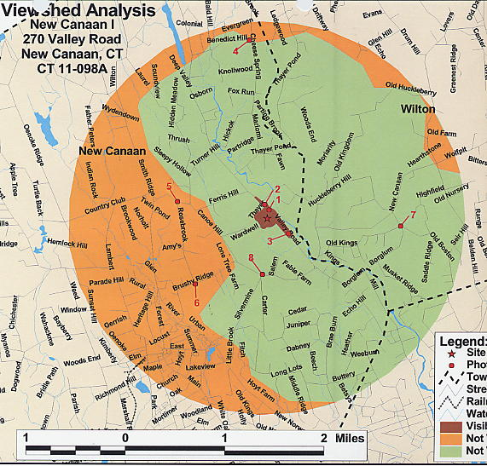

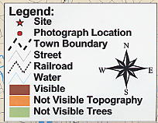

Figure 1. Viewshed Analysis for the proposed T-Mobile site. (T-Mobile 1, Tab 7)

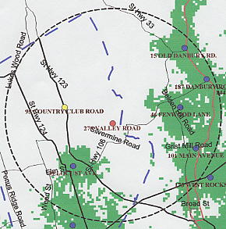
Figure 2. Existing T-Mobile Coverage in New Canaan at a scale of 1:100,000.
(T-Mobile 3, Q. 24)

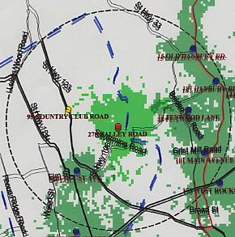
Figure 3. Existing T-Mobile coverage with coverage from the proposed site at
139 feet AGL at a scale of 1:100,000. (T-Mobile 3, Q. 24)

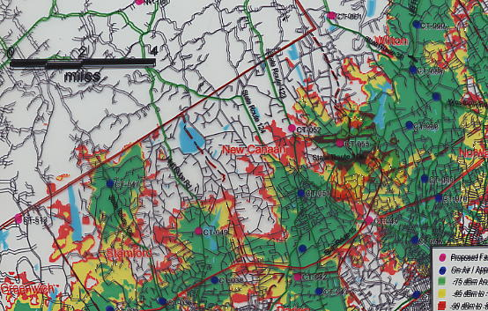
Figure 4. Existing AT&T Wireless coverage with coverage from the proposed site at a height of 99 feet AGL at a scale of 1:100,000. (AT&T Wireless 1, Q. 2, 3 )

