DOCKET NO. 241 - Omnipoint Facilities Network 2, LLC, application for a Certificate of Environmental Compatibility and Public Need for the construction, maintenance and operation of a wireless telecommunications facility at 79 Church Hill Road or 3 Edmond Road, Newtown, Connecticut. | }  }  } | Connecticut  Siting  Council  December 22, 2003

Findings of Fact

Introduction

- Omnipoint Facilities Network 2, L.L.C., a subsidiary of T-Mobile USA, Inc. (T-Mobile), in accordance with provisions of General Statutes §§ 16-50g through 16-50aa applied to the Connecticut Siting Council (Council) on January 17, 2003 for the construction, operation, and maintenance of a wireless telecommunications facility at one of two locations at 79 Church Hill Road, Newtown, Connecticut. An additional two sites, one located at 1 Edmond Road and one located at 3 Edmond Road, were presented to the Council on April 30, 2003. (T-Mobile 1, pp. 1, 8; T-Mobile 7, cover letter; Transcript 1, May 1, 2003, 3:00 p.m. [Tr. 1], p. 3)

- T-Mobile withdrew both the 1 Edmond Road site and the 79 Churchill Road alternate site from consideration on September 23, 2003 and October 23, 2003, respectively. (T-Mobile 12, cover letter; Transcript 3, October 23, 2003, 2:30 p.m. [Tr. 3], p. 6)

- T-Mobile is licensed by Federal Communications Commission (FCC) to provide PCS wireless telecommunications service in Connecticut. T-Mobile operates telecommunications infrastructure in the New York Basic Trading Area including all of Fairfield County, Connecticut. T-Mobile seeks to provide telecommunication service to I-84 between Exits 9 and 10 and sections of Route 6 and Route 25 in Newtown not adequately served by existing facilities. (T-Mobile 1, pp. 3, 5, Attachment 2; T-Mobile 3, Q. 1)

- In 1996, the United States Congress recognized a nationwide need for high quality wireless telecommunications services, including cellular telephone service. Through the Federal Telecommunications Act of 1996, Congress seeks to promote competition, encourage technical innovations, and foster lower prices for telecommunications services. (Council Admin. Notice, no. 7, Telecom Act 1996)

- In issuing cellular licenses, the Federal government has preempted the determination of public need for cellular service by the states, and has established design standards to ensure technical integrity and nationwide compatibility among all systems. (Council Admin. Notice, no. 7, Telecom. Act 1996)

- The Telecommunications Act of 1996 prohibits local and state bodies from discriminating among providers of functionally equivalent services. (Council Admin. Notice, no. 7, Telecom. Act 1996)

- The parties in this proceeding are the applicant and the Town of Newtown. The intervenors in this proceeding are AT&T Wireless PCS, LLC d/b/a AT&T Wireless (AT&T), Representative Julia Wasserman, and Zoltan Csillag and Julia Nable. (Tr. 1, p. 6)

- Pursuant to General Statute § 16-50m, the Council, after giving due notice thereof, held a public hearing on May 1, 2003, beginning at 3:00 p.m. and continued at 7:00 p.m. at the Edmond Town Hall, 45 Main Street, Newtown, Connecticut and on October 23, 2003, beginning at 2:30 p.m., at the office of the Council, 10 Franklin Square, New Britain, Connecticut. (Council's Hearing Notices dated April 11 and August 27, 2003; Tr. 1, p. 2; Transcript 2- May 1, 2003, 7:00 p.m. [Tr. 2], p. 3; Tr. 3, p. 3)

- The Council and its staff conducted an inspection of the proposed sites on May 1, 2003, beginning at 1:30 p.m. During the field inspection, the applicant flew a balloon to a height of 150 feet at both sites to represent the height of the proposed towers. (T-Mobile 13, Q. 13; Tr. 1, pp. 58-59)

- T-Mobile issued a technical report describing the proposed project to the Town of Newtown on October 31, 2002. Subsequent to the submission, T-Mobile discussed the proposal with the Newtown First Selectman Herbert Rosenthal, the Director of Community Development, Elizabeth Stocker, and the Planning and Zoning Director, Rita McMillan. (T-Mobile 1, pp. 20-21, Attachment 8; Tr. 1, p. 15)

- Pursuant to General Statute § 16-50l(b), public notice of the application was published in the Newtown Bee on January 10, January 17, and January 24, 2003. (T-Mobile letter dated February 24, 2003)

- Pursuant to General Statute § 16-50l(b), on January 8, 2003, notice of the application was sent to all abutting landowners by certified mail except for the owner of Lot 22, Block 6/Map 38, located east of the 79 Church Hill Road parcel. The owner of this parcel was not listed in town records. Notice was sent to property owners abutting the 3 Edmond Road parcel by certified mail on September 24, 2003. (T-Mobile 3, Q. 5; T-Mobile 15)

- Pursuant to General Statute § 16-50j(h), on April 11 and October 24, 2003, the following State agencies were solicited to submit written comments regarding the proposed facility; Department of Environmental Protection (DEP), Department of Public Health (DPH), Council on Environmental Quality (CEQ), Department of Public Utility Control (DPUC), Office of Policy and Management (OPM), Department of Economic and Community Development (DECD), and the Department of Transportation (DOT). (Record)

- Comments were received from the DEP on March 17, 2003 and from the DOT’s Office of Environmental Planning on February 27, 2003 and Office of Maintenance on November 7, 2003. (Record)

- The following agencies did not offer comments on the application: DPH, CEQ, DPUC, OPM, and DECD. (Record)

Site Search

- T-Mobile examined six parcels in Newtown, two of which were selected for site development. The four rejected parcels and reasons for their rejection are as follows:
- 1 Edmond Road – lease could not be negotiated with the landowner.
- 11 Edmond Road – lease could not be negotiated with the landowner.
- 17 Papoose Hill Road – lease could not be negotiated with the landowner.
- 151 Berkshire Road – existing 120-foot monopole; does not meet coverage objectives.
(T-Mobile 1, pp. 7-8; T-Mobile 12, cover letter)

- Use of alternative technologies like microcells or repeaters are useful for filling coverage in small areas or providing service in buildings, but are limited as to coverage and capacity. These alternatives would not provide adequate coverage to the identified coverage gaps. (T-Mobile 3, Q. 1; Tr. 1, p. 96)

Facility Description – 79 Church Hill Road

- The 79 Church Hill Road facility would consist of a 150-foot monopole and associated equipment on a wooded, undeveloped 40-acre parcel owned by Carmen Renzulli. The property slopes downward from Chestnut Hill Road to its lowest point adjacent to Interstate 84 (I-84). An underground gas transmission line, operated by the Iroquois Gas Transmission Company (Iroquois), traverses the southern portion of the property adjacent to I-84. The tower site is located in the south-central portion of the property at an elevation of 371 feet above mean sea level (amsl). The tower site is adjacent to the I-84 Exit 10 exit/entrance ramp and the Iroquois gas line. (T-Mobile 1, pp. 9-11, Attachment 3-Plan S-1, Attachment 5-Plan S-2)

- Access to the proposed site would be from a 12-foot wide, 430-foot long gravel drive of new construction extending from Walnut Tree Hill Road. The road would be parallel to and eleven feet from the Iroquois gas line right-of-way. Underground utilities would be installed along the access road from a utility pole on Walnut Tree Hill Road. (T-Mobile 1, p. 10, Attachment 3 – Plan S-1; Tr. 1, p. 14)

- The 150-foot tower would be designed to support four levels of antennas with a 10-foot center-to-center vertical separation. T-Mobile would install twelve panel type directional antennas at a centerline height of 147.5 feet agl. AT&T would install 6 panel antennas at a centerline height of 137.5 feet agl. (T-Mobile 1, pp. 9-11, Attachment 3-Plan S-1; AT&T 1, Q. 3)

- A 50-foot by 50-foot equipment compound enclosed by an eight-foot high chain link fence topped with barbed wire would be established at the base of the tower. The size of the compound would be able to accommodate the equipment of four wireless carriers. T-Mobile would install three equipment cabinets on a concrete pad within the compound. The cabinets would be approximately six feet tall. AT&T would also install up to four equipment cabinets, approximately six feet tall, on a concrete pad within the compound. Vegetative screening would be placed around the compound. (T-Mobile 1, pp. 9-11, Attachment 3 – Plan S-1, Plan Z-1; AT&T 1, Q. 6; Tr. 3, p. 48)

- The tower setback radius would extend by 68 feet onto property owned by the DOT, used for the I-84 corridor. The setback radius would not extend onto any travel portion of the highway or associated exit/entrance ramps. (T-Mobile 1, p. 11, Attachment 3 – Plan S-1)

- The parcel is zoned residential, R-1, and abuts residentially zoned property to the north, east and northwest. I-84 is located to the south-southwest. (T-Mobile 1, Attachment 5-Plan S-2; Tr. 3, p. 56)

- Walnut Tree Hill Road is located 526 feet east of the tower site. The nearest residence from the tower site, 8 Walnut Tree Hill Road, is approximately 620 feet to the east. Eight residences are located within 1,000 feet of the tower site. An elderly condominium complex is located approximately 1,000 feet north of the site. (T-Mobile 1, p. 17, Attachment 5 – Plan S-2; Tr. 3, p. 83)
25. The estimated construction cost for the 79 Church Hill Road facility is as follows:

Access Road and Utilities 50,000
Tower and Antennas 85,000
Foundation 30,000
Miscellaneous 45,000

Total $210,000
(T-Mobile 1, p. 22)

Site Description – 3 Edmond Road

- The proposed 3 Edmond Road facility consists of a 150-foot monopole and associated equipment located on a wooded, undeveloped 12.5-acre parcel owned by Reid and Harriet Edwards. Edmond Road, a private road extending from Church Hill Road to School House Road, traverses the eastern portion of the parcel. The proposed tower would be located in the northern portion of the parcel, 119 feet from Edmond Road and at an elevation of 350 feet amsl. (T-Mobile 12, Plan S-1, Plan S-2; Tr. 1, pp. 36-39)

- Access to the site would be from a 12-foot wide, 135-foot long gravel drive of new construction extending from Edmond Road. The drive would extend through a 10-foot wide wetland area adjacent to Edmond Road. The utility route to the site has not been determined but would most likely consist of an overhead installation from School House Hill Road or Church Hill Road. (T-Mobile 12, Plan S-1; Tr. 3, p. 89)

- T-Mobile would install a 150-foot monopole, designed to support four antenna platforms with a 10-foot center-to-center vertical separation, at the site. T-Mobile would install twelve panel type directional antennas at a centerline height of 147.5 feet agl. AT&T would install 6 panel antennas at a centerline height of 137.5 feet agl. (T-Mobile 12, Plan S-1; AT&T 1, Q. 3)

- A 50-foot by 50-foot equipment compound enclosed by an eight-foot high chain link fence topped with barbed wire would be established at the base of the tower. The compound fence would include privacy slats. The size of the compound would be able to accommodate the equipment of four wireless carriers. The existing terrain in the compound area would be lowered by two feet to create a level surface. (T-Mobile 12, Plan S-1; Tr. 3, pp. 46-48)

- T-Mobile would install three equipment cabinets on a concrete pad within the compound. The cabinets would be approximately six feet tall. AT&T would also install up to four equipment cabinets, approximately six feet tall, on a concrete pad within the compound. Vegetative screening, including a wetland buffer zone consisting of wetland species, would be planted around the compound. (T-Mobile 12, Plan S-1, Plan Z-1, Attachment 4; AT&T 1, Q. 6; Tr. 3, pp. 35-36)

31. The tower setback radius would extend by 19 feet onto a wooded portion of the Rand Whitney Container property, a developed industrial property west of the site. T-Mobile would be willing to construct a tower with an engineered fault point that would prevent the tower from extending onto the adjacent property in the event of tower failure. The tower setback radius also extends over Edmond Road, a private road owned by the lessor. (T-Mobile 12, Plan S-1, Plan Z-1; Tr. 1, pp. 36-37; Tr. 3, pp. 43-45)

- The property is zoned industrial, M-2, and abuts I-84 to the north, the Penn Central Railroad corridor to the south, and industrial zoned property to the east and west. Residentially zoned parcels are located north of I-84. Three parcels zoned Borough of Newtown are located south of the railroad corridor. (T-Mobile 12, Plan Z-1)

33. The nearest property line from the tower site is 131 feet to the west. The I-84 corridor is located 216 feet to the north. Two residential structures are located within 1,000 feet of the site, both of which are located north of the I-84 corridor. (T-Mobile 12, Plan Z-1; T-Mobile 13, Q. 15)

Environmental, Cultural, and Safety Concerns

- The proposed sites contain no known populations of Federal or State Endangered, Threatened or Special Concern Species. (T-Mobile 3, Q. 9; T-Mobile 9)

- Development of the proposed 79 Church Hill Road site would not directly impact any wetlands or watercourses. A wetland is approximately 95 feet north of the compound location. Site development would occur within a Town designated 100-foot wetland buffer zone. (T-Mobile 1, Attachment 3-Plan S-1)

- The 3 Edmond Road site is located on a knoll surrounded by a forested wetland system. Development of the access road would directly impact 300 square feet of wetlands between the knoll and Edmond Road, an area which functions as a drainage easement associated with the road. The northwest edge of the compound and the western edge of the compound parking area directly abuts designated wetlands. T-Mobile would be willing to reduce the size of the parking area to provide a buffer to the adjacent wetland. T-Mobile would not be able to move the compound to the east due to lease restrictions. (Newtown 2; T-Mobile 12, Attachment 1, Plan S-1; Tr. 3, pp. 31-35)

- The proposed facilities would have no effect upon historic, architectural, or archaeological resources listed on or eligible for the National Register of Historic Places or upon properties of traditional cultural importance to Connecticut’s Native American community. The 79 Church Hill Road tower would be visible from the Newtown Borough Historic District, approximately one-mile west of the site. (T-Mobile 1, Attachment 5-Section D, Attachment 6; T-Mobile 13, Q. 12)

- Neither site would require aircraft hazard obstruction marking or lighting. (T-Mobile 1, Attachment 15; T-Mobile 16, Tr. 3, p. 90)

- The conservative worst-case approximation of electromagnetic radiofrequency emissions from T-Mobile and AT&T antennas at the base of the tower at the proposed sites would be 8.9 percent of the Maximum Permissible Exposure limit established by the Federal Communications Commission. (T-Mobile 1, Attachment 1; AT&T 1, Q. 3)

- Iroquois provided written comment to T-Mobile on May 7, 2003, requesting that tower grounding wire be relocated to the northeast side of the site and that intrinsically safe electrical devices be used on the tower. (T-Mobile 12, Attachment 5)

Visibility

- Year-round visibility of the 79 Church Hill Road tower is anticipated from the following roads within two miles of the site (refer to Figure 1).

Location/Land Use Nearest Distance/Direction from Proposed Site Length of Road Visibility
I-84 - highway 0.1 miles southwest 1.4 miles
I-84 - highway 0.8 miles east 0.5 miles
Church Hill Road - commercial/res. 0.1 miles south 0.7 miles
Church Hill Road - historic district 1.0 mile west <0.1 miles
Mile High Road - residential/school 1.2 miles south 0.2 miles
Mile High Road - residential 1.2 miles southeast 0.2 miles
Philo Curtis Road - residential 1.3 miles east 0.2 miles
Commerce Road - commercial 0.6 miles south 0.3 miles
Edmond Road - wooded 0.4 miles southwest 0.2 miles
(T-Mobile 1, Attachment 6, Attachment 7; T-Mobile 3, Q. 7)

- Year-round visibility of the 3 Edmond Road tower is anticipated from the following roads within two miles of the site (refer to Figure 2).

Location/Land Use Nearest Distance/Direction from Proposed Site Length of Road Visibility
I-84 - highway 0.1 miles north 0.3 miles
Church Hill Road - highway overpass 0.5 miles east <0.1 miles
Church Hill Road - commercial 0.3 miles southeast 0.1 miles
Edmond Road - commercial 120 feet north 0.4 miles
School House Hill Road - commercial 0.2 miles northwest 0.2 miles
(T- Mobile 3, Q. 7; T-Mobile 12, Attachment 4, Plan S-2; Tr. 3, p. 30)

43. There are no state designated scenic roadways within Newtown. The nearest Town designated scenic road is Sanford Road, approximately 2 miles north of the 3 Edmond Road site. Neither tower would be visible from this road. (T-Mobile 1, Attachment 7, T-Mobile 1a, Memo 7 - p. 18; T-Mobile 12, Attachment 4)

44. Neither tower would be visible from Rocky Glen State Park, a 44-acre state park with hiking trails along the Pootatuck River approximately 0.6 miles north of the 79 Church Hill Road site. (T-Mobile 1, Attachment 7; T-Mobile 1a, Memo 6 - pp. 4, 6, Memo 7 - p. 18; T-Mobile 12, Attachment 4)

T-Mobile - Existing and Proposed Wireless Coverage

- Adjacent T-Mobile facilities that would interact with the proposed facility are as follows:

Location Antenna Height agl Approximate Distance from Sites
20 Barnabus Road, Newtown 150 feet 2.8 miles west
21-23 Berkshire Road, Newtown 130 feet 1.2 miles east
31 Main Street, Newtown 74 feet 1.0 mile south
(T-Mobile 1, Attachment 4 – Plan S-3; T-Mobile 3, Q. 2)

46. T-Mobile operates at a minimum signal level threshold of -87 dBm and in the 1930-1950 MHz frequency band. Gaps in existing and proposed wireless coverage on select roads in the vicinity of the 79 Church Hill Road site are presented in the table below and on Figures 3, 4 & 5.

79 Church Hill Road
Road | Existing Road Gaps *  (see Figure 3) | 150 feet^  (see Figure 4) | 130 feet  (see Figure 5)
I-84 | 1.2 | 0.0 | 0.0
Route 6/25 | 0.5 | <0.1 | 0.1
Boulevard | 0.7 | 0.0 | 0.0
Hanover Road (south of I-84) | 0.4 | 0.0 | 0.0
Currituck Road | 0.4 | 0.0 | 0.0
Total | 3.2 | <0.1 | 0.1
* approximate miles; signal strength -87 dBm
^antennas would be installed at 147.5 feet agl
(T-Mobile 1, Attachment 1, Attachment 2; T-Mobile 3, Q. 2, Q. 3)

- Installing antennas at 130 feet agl at the 79 Church Hill Road site would provide marginal coverage on I-84 in the handoff area between the proposed site and existing Barnabus Road site. A call would most likely be carried through the marginal area. (T-Mobile 3, Q. 3; Tr. 1, pp. 59-61)

48. Gaps in existing and proposed wireless coverage on select roads in the vicinity of the 3 Edmond Road site are presented in the table below and on Figures 2, 5 & 6.

3 Edmond Road
Road | Existing Road Gaps *  (see Figure 3) | 150 feet^  (see Figure 6) | 125 feet  (see Figure 7)
I-84 | 1.2 | 0.0 | 0.0
Route 6/25 | 0.5 | 0.1 | 0.2
Boulevard | 0.7 | 0.0 | <0.1
Hanover Road (south of I-84) | 0.4 | 0.0 | 0.2
Currituck Road | 0.4 | 0.2 | 0.2
Total | 3.2 | 0.3 | ~0.7
* approximate miles; signal strength -87 dBm
^antennas would be installed at 147.5 feet agl
(T-Mobile 12, Attachment 3; Tr. 3, pp. 36-41)

48. Installing antennas at 125 feet agl at the 3 Edmond Road location would provide marginal coverage on I-84 in the handoff area between the proposed site and existing Barnabus Road site. (Tr. 3, p. 48)

AT&T - Existing and Proposed Wireless Coverage

49. AT&T operates in the FCC assigned D & E 1900 MHz frequency bands and at minimum signal level threshold of -85 dBm. (AT&T 1, Q.2)

- AT&T seeks to provide coverage to I-84 and surrounding local roads. An approximate 2.1 mile coverage gap exists on I-84. (AT&T 1, Q. 1, Q. 5)

- Coverage objectives for I-84 can be met with antennas mounted at 140 feet at the 79 Church Hill Road site (refer to Figure 8) and at 120 feet at the 3 Edmond Road site (refer to Figure 9). (AT&T 1, Q. 5; AT&T 2, Q. 1; Tr. 3, pp. 95-97)

Municipal Comment

- Herbert C. Rosenthal, First Selectman of the Town of Newtown, provided written comment to the Council on October 14, 2003 indicating the town’s preference for the 3 Edmond Road site since the site is located in an industrial zone, abuts industrially zoned parcels, and is more remote from neighboring residences. (Town of Newtown 4)

- The Newtown Conservation Commission reviewed the proposed 3 Edmond Road site on August 27, 2003 and determined construction impacts to the wetland between the site and Edmond Road would not be significant. This area was previously disturbed by sewer construction and road improvements. (Town of Newtown 2)

FIGURE 1

VISIBILITY OF PROPOSED 79 CHURCH HILL ROAD TOWER

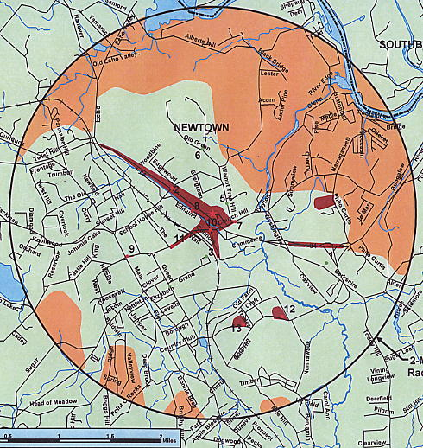

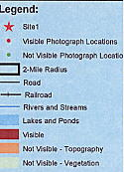
(T-Mobile, Attachment 7)

FIGURE 2

VISIBILITY OF PROPOSED 3 EDMOND ROAD TOWER

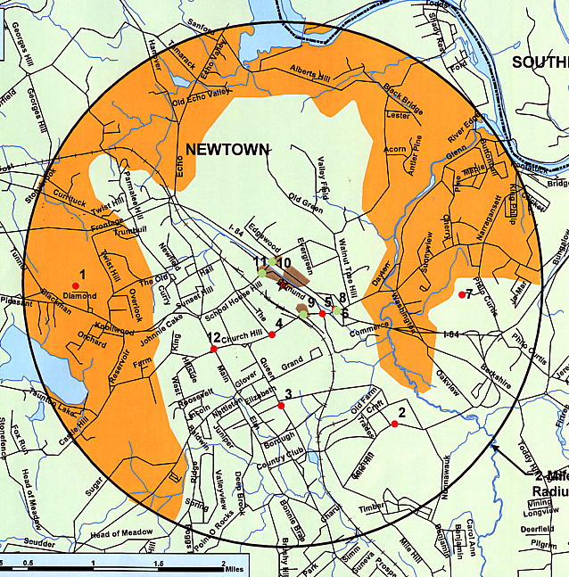

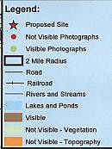
(T-Mobile 12; Attachment 4)

FIGURE 3A

T-MOBILE EXISTING COVERAGE – DRIVE TEST DATA

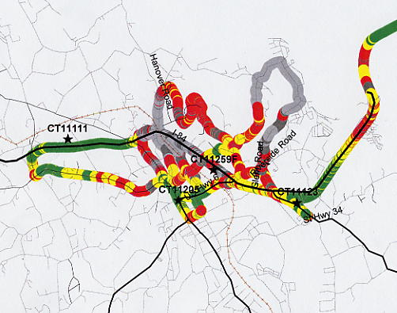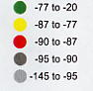
I-84
Rt. 6/25
Rt. 25
Currituck Rd.

FIGURE 3 B

T-MOBILE EXISTING COVERAGE – COVERAGE MODEL

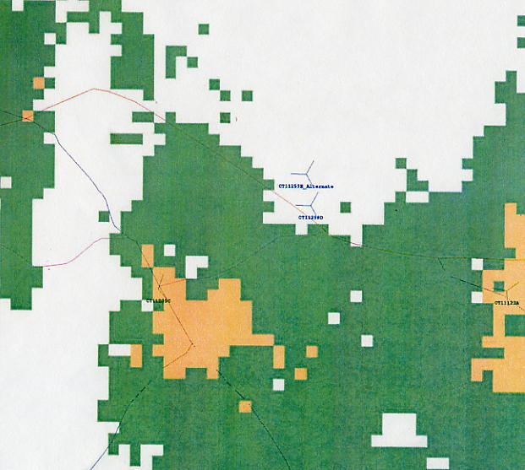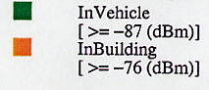
I-84
Rt. 6
Rt. 6/25
Currituck Rd.

(T-Mobile 1, Attachment 1; T-Mobile 12, Attachment 3)

FIGURE 4

T-MOBILE EXISTING AND PROPOSED COVERAGE
79 CHURCH HILL ROAD – 150 FEET

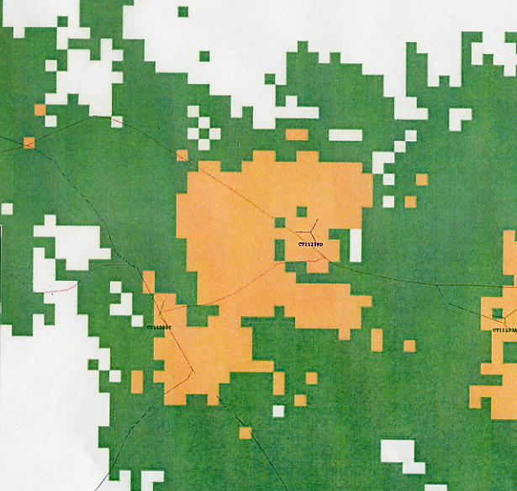
I-84
Route 6
Route 6/25
I-84
Currituck Rd.

(T-Mobile 1, Attachment 1)

FIGURE 5

T-MOBILE EXISTING AND PROPOSED COVERAGE
79 CHURCH HILL ROAD – 130 FEET

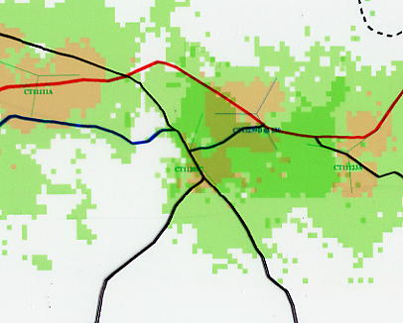
I-84
I-84
Route 6
Route 6/25
Route 25
Currituck Rd.

(T-Mobile 3, Q. 3)

FIGURE 6

T-MOBILE PROPOSED COVERAGE
3 EDMOND ROAD – 150 FEET

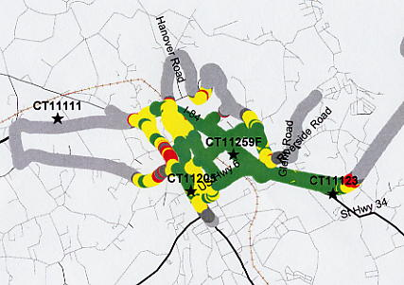
Rt. 25
Rt. 6/25
I-84
I-84

FIGURE 7
T-MOBILE PROPOSED COVERAGE
3 EDMOND ROAD – 125 FEET

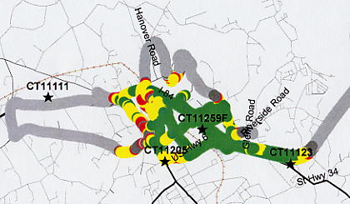
I-84
I-84
Rt. 6/25

(scale 1:75,000)

(T-Mobile 12, Attachment 3)

FIGURE 8

AT&T EXISTING AND PROPOSED COVERAGE
79 CHURCH HILL ROAD – 140 FEET

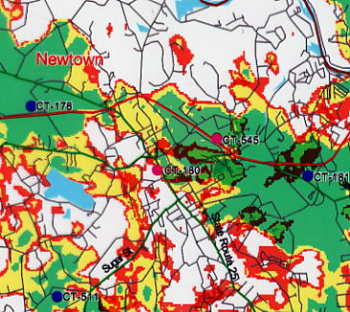
I-84
Rt. 6/25

Site CT-545 - 79 Church Hill Road

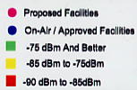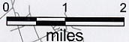

(AT&T 1, Q. 5)

FIGURE 9

AT&T EXISTING AND PROPOSED COVERAGE
3 EDMOND ROAD – 140 FEET

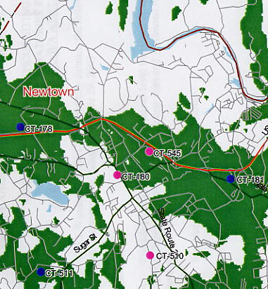
I-84
Rt. 6/25

CT-545 - 3 Edmond Road

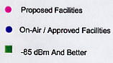

(AT&T 2, Q. 1)

