DOCKET NO. 236 - Sprint Spectrum L.P. application for a Certificate of Environmental Compatibility and Public Need for the construction, maintenance and operation of a wireless telecommunications facility off Great Hollow Road or at 103 Great Hollow Road, South Woodbury, Connecticut. | }  }  }  } | Connecticut  Siting  Council  June 19, 2003

Findings of Fact
Introduction

- Sprint Spectrum L.P., d/b/a Sprint PCS (Sprint), in accordance with provisions of General Statutes §§ 16-50g through 16-50aa, applied to the Connecticut Siting Council (Council) on November 27, 2002, for the construction, operation, and maintenance of a wireless telecommunications facility in Woodbury, Connecticut. The proposed facility would provide wireless coverage to existing coverage gaps in Woodbury and along Route 6. The metropolitan trading area (MTA) for proposed Site A and Site B is MTA 1, New York, and the basic trading area (BTA) is BTA 318, New Haven. Proposed Site A is located off of Great Hollow Road, Woodbury and Site B is located at 103 Great Hollow Road, Woodbury, Connecticut. (Sprint 1, p. 1, 5)

- Sprint is a wholly owned subsidiary of Wireless Co, L.P., licensed by the Federal Communications Commission (FCC) to provide wireless personal communication service (PCS). Sprint operates in 32 major trading areas within the United States, including Connecticut. (Sprint 1, p. 2, 3)

- The party in this proceeding is the applicant. Intervenors are AT&T Wireless (AT&T). (Tr. 1, 2:00 p.m., p. 5; Tr. 2, 7:00 p.m., p. 5)

- Pursuant to General Statutes § 16-50m, the Council, after giving due notice thereof, held a public hearing on January 30, 2003, beginning at 2:00 p.m., and continuing at 7:00 p.m. in the Old Town Hall, 5 Mountain Road, Woodbury, Connecticut. (Tr. 1, p. 3; Tr. 2, p. 3)

- The Council and its staff made inspections of the proposed sites on January 30, 2003. During the field inspection, the applicant flew a red balloon at proposed Site A to 110 feet above ground level (agl) and a black balloon at proposed Site B to 150 feet agl. (Sprint 1, p. 27; Tr. 1, p. 18)

- On March 22, 2000, Sprint filed an application with the Town of Woodbury Zoning Commission for the construction of a tower on Town of Woodbury owned property at 281 Main Street, Woodbury. The Woodbury Zoning Commission denied this application. The decision is currently under appeal. Following input from the Town, Sprint has decided to propose two towers to fill the coverage gap along Route 6, rather than one. On April 30, 2002, Sprint notified First Selectman Richard W. Crane of its intent to submit an application to the Council for the proposed monopole in southern Woodbury. The Woodbury Zoning Commission scheduled a public hearing on June 11, 2002 regarding the proposed structure. On June 26, 2002, the First Selectman provided Sprint with specific recommendations and concerns from the Town Zoning Commission. (Sprint 1, p. 6, 7)

- On November 27, 2002, Sprint notified First Selectman Richard W. Crane, and the Planner/Zoning Enforcement Officer of the Town of Woodbury, Christopher S. Wood, of its intent of constructing a telecommunications facility at proposed Site A, or Site B. Public notice of the application was published in Waterbury Republican American on November 14 and 21, 2002 and Voices Sunday – The Weekly Star on November 13 and 17, 2002. (Sprint 1, Tab 2, Tab 4)

- Pursuant to General Statutes § 16-50j (h), the following state agencies were notified of the project on December 20, 2002; Department of Environmental Protection (DEP), Department of Public Health (DPH), Council on Environmental Quality (CEQ), Department of Public Utility Control (DPUC), Office of Policy and Management (OPM), Department of Economic and Community Development (DECD), and the Department of Transportation (DOT). Comments were received from the DOT on January 14, 2003 and from the DEP on January 30, 2003. The following agencies did not offer comments on the application; DPH, CEQ, DPUC, OPM, and the DECD. (Letter from DOT dated January 14, 2003; Letter from DEP dated January 29, 2003)

Need

- Sprint located the proposed facility to facilitate the provision of wireless telecommunications service to Woodbury and along Route 6. (Sprint 1, p. 5)

- In issuing cellular licenses, the Federal government has preempted the determination of public need for cellular service by the states, and has established design standards to ensure technical integrity and nationwide compatibility among all systems. (Council Admin. Notice, no. 7, Telecom. Act 1996)

- In 1996, the United States Congress recognized a nationwide need for high quality wireless telecommunications services, including cellular telephone service. Through the Federal Telecommunications Act of 1996, Congress seeks to promote competition, encourage technical innovations, and foster lower prices for telecommunications services. (Council Admin. Notice, no. 7, Telecom Act 1996)

Site Search

- Sprint identified nine existing communications towers located within approximately five miles of the proposed sites: a 150-foot tower owned by AT&T, located at 478 Good Hill Road, Woodbury; a 160-foot tower owned by Sprint, located at 1440 North Main Street, Woodbury; a 230-foot tower owned by Bell Atlantic Mobile, located on Old Waterbury Road, Southbury; a 195-foot tower owned by Omnipoint, located at 231 Kettletown Road, Southbury; a 180-foot tower owned by the Department of Public Safety, located on Swamp Road, Southbury; a 150-foot tower owned by Cingular, located at 133 Horse Fence Hill Road, Southbury; a 180-foot tower owned by the Department of Public Safety, located at 11 Lakeside Road, Southbury; a 180-foot tower owned by Nextel, located on Lower County Road, Roxbury; and a 160-foot tower owned by the Department of Public Safety, located on I-84 at the South Avenue overpass, Middlebury. These towers would not provide adequate coverage to south Woodbury. Sprint is not aware of any plans by other telecommunications entities to construct a new telecommunication facility within two-miles of the search area. (Sprint 1, p. 11, Tab 13)

- Sprint identified and investigated twenty-seven potential sites, including proposed Site A and Site B, within the search ring in Woodbury. The potential sites investigated and rejected by Sprint due to inadequate coverage include 463 Goodhill Road, Goodhill Road, Orenaug Hill – 1, 785 Washington Road, Corner of Main Street and Washington Street, Corner of Main Street and Judson Avenue, Bacon Pond Road, St. Teresa Church, 1st Congregational Church, St. Paul’s Church, Church of Jesus Christ, Flagpole in Park, Water Tank, Look-out Tower, and Cable TV Tower. Potential sites that were investigated and rejected by Sprint due to real estate or property owner issues include Woodlake Condominium Complex, Mountain Road, Corner of Washington Street and School Street, Orenaug Hill – 2, Orenaug Park, Orenaug Hills – 3, Orenaug Hills – 4, 172 Great Hollow Road, and 128 Great Hollow Road. A tower was considered at the Woodbury Town Center but was rejected by the Woodbury Zoning Commission. (Sprint 1, p. 12)

Site and Equipment

- Proposed Site A and Site B would include a 100-foot by 100-foot leased parcel on which Sprint would develop a 75-foot by 75-foot equipment compound. Sprint proposes to place equipment cabinets on a 10-foot by 20-foot equipment pad. The proposed tower and equipment compound would be enclosed by an 8-foot high chain link fence. The proposed monopole would have a global positioning system (GPS) antenna at 75 feet agl, facing southwest. A gravel surface would be established within the tower compound and access road. Sprint would use a battery back up, which would operate for approximately four hours, during power outages. Sprint would consider bringing in a diesel powered electrical generator temporarily during a substantial power outage. (Sprint 1, p. 14 - 15, 14, Tab 7, Tab 8)

- AT&T has expressed an interest in using the proposed facility at the 100-foot level of proposed Site A and the 140-foot level of proposed Site B. Cingular and Nextel have expressed an interest in using the proposed facility. Sprint proposes to allow any local authority or emergency response system to use the proposed tower, provided it is consistent with the structural integrity of the tower. The Town of Woodbury has not indicated an interest in using the proposed site. (Sprint 1, p. 6; Sprint 2, Q. 18)

- The tower radius setback of the proposed tower would be contained within the lessor’s property. There are no existing or planned structures within the tower radius setback of the tower. (Sprint p. 13; Sprint 2, Q. 10)

- The approximate costs of construction for the proposed Site A and Site B are estimated as follows:

Site Work | $ 75,000
Tower | 40,000
Electrical & Telephone | 35,000
Foundation | 15,000
Compound | 25,000
Road | 60,000
Total Costs | $ 250,000
(Sprint 1, Tab 18)

Proposed Site A/ Site B

- Proposed Site A would be located on an approximately 210-acre parcel owned by O & G Industries, Inc. The elevation of Site A is 590 feet above mean sea level (amsl). Proposed Site B would be located on an approximately 7.91 acre parcel owned by David R. Smith. The elevation of Site B is 450 feet amsl. Vegetative cover in the area consists mainly of mixed deciduous hardwoods with an average estimated height of seventy-five feet agl. The surrounding topography consists of rolling hills. (Sprint 1, p. 4 – 5, 26 – 27, Tab 7, Tab 8 )

- According to the Town of Woodbury Plan of Conservation and Development, Site A is located within an area designated as “Vacant” and Site B is located within an area designated as “Residential”. Site A and Site B would be located within an Open Space Residence zone (OS-80). The Town’s Zoning Regulations express that the location of a tower greater than 80 feet in height within an open space residential zone is the least desirable option for the location of a new tower. (Sprint 1, p. 12, Tab 16; Sprint 2, Q. 2)

- There are 4 homes within a 1,000-foot radius of proposed Site A, the nearest of which is approximately 596 feet to the northeast. There are 7 homes within a 1,000-foot radius of proposed Site B, the nearest of which is approximately 177 feet to the northwest. (Sprint 2, Q. 6)

- Sprint proposes to construct a 110-foot monopole at Site A, which would be designed with the potential to expand to 150 feet agl and support up to five carriers with a 10-foot center-to-center vertical separation. Sprint proposes to construct a 150-foot monopole at Site B, which would be designed to accommodate two additional carriers with a 10-foot center-to-center vertical separation. (Sprint 1, p. 4, Tab 7, Tab 8)

- Access to Site A would be a twenty-five foot wide access road extending from Great Hollow Road along an existing access road for 890 feet, then an additional 170 feet would be needed to continue to the proposed site. Telephone and electrical utilities would be installed underground from an adjacent utility pole to the proposed compound at Site A. Access to Site B would be a 25-foot wide access road extending from Great Hollow Road along an existing access road for 520 feet. Telephone and electrical utilities currently run overhead along the access road. (Sprint 1, p. 13)

- A stealth tower could be constructed at Site A or Site B in place of the proposed monopole structure. A tree type tower would not result in a significant reduction in coverage. A pole type tower, such as a wood pole or a flagpole may result in a significant reduction in coverage because the antennas are internally mounted and, therefore, close together. The farther apart the antennas are the greater the chance that the tower can pick up the weak signal of the hand held unit, which results in an increase in receive signal strength. (Sprint 2, Q. 12)

Environmental Considerations

- Ten plant species and two wildlife species, which are listed as endangered and special concern species, were documented as occurring in proximity to the proposed sites. Sprint conducted a rare flora and fauna survey for each of the sites. The rare flora survey did not reveal any of the ten endangered or special concern plant species in proximity of the proposed sites. According to the wildlife survey, the two species of Special Concern, the Jefferson salamander “complex” and the Eastern box turtle, were not found within, or in close proximity to, either of the proposed sites. A vernal pool, located approximately 450 feet south/southwest of Site A may provide breeding habitat for the Jefferson salamander “complex”. (Sprint 1, p. 22 – 24)

- The proposed access road at Site A includes an existing dirt woods road that crosses a wetland corridor and is immediately adjacent to another wetland. Approximately 30 feet of the woods road crosses the wetland corridor. The proposed upgrading of the existing access road would result in a direct impact to approximately 2,275 square feet of the wetland. Sprint maintains that there is no other feasible alternative access to the proposed site. The proposed wetland crossing would incorporate a culvert to allow surface water to flow. The nearest wetland to Site B is about 125 feet to the southeast. (Sprint 1, p. 18 – 20; Tr. 1, p. 13)

- The Connecticut Historical Commission (CHC) has determined that construction of the proposed sites would have no effect on historic, architectural, or archaeological resources listed on or eligible for the National Register of Historic Places. (Sprint 1, p. 29, Tab 24)

- Clearing of approximately 80 trees with diameters of six inches or greater would be required for the construction of proposed Site A. Clearing of approximately 72 trees with diameters of six inches or greater be required for construction of proposed Site B. Sprint would remove approximately 302 cubic yards of material at proposed Site A, and proposed Site B would require approximately 81 cubic yards of fill. (Sprint 2, Q. 11)

- Erosion and sediment controls would be established as required by the State of Connecticut DEP Bulletin 34 “Connecticut Guidelines for Soil and Erosion and Sediment Control dated 2002”. Erosion and sediment controls would minimize soil exposure, control runoff, shield and bind the soils, and trap sediments. Silt fencing would be placed immediately down slope of the project area prior to construction. Following completion of construction of the proposed project, all disturbed areas would be permanently stabilized with seed and mulch. (Sprint 1, p. 18; Sprint 2, Q. 11)

- Analysis of the site performed by the Airspace Safety Analysis Corporation determined that the proposed site does not have to be registered with the Federal Aviation Administration (FAA). (Sprint 2, Q. 19)

- The electromagnetic radio frequency power densities, calculated using the FCC Office of Engineering and Technology Bulletin 65, using conservative worst-case approximation of radio frequency power density levels at the base of each tower, would be 7.797 percent of the American National Standards Institute (ANSI) Standard for proposed Site A and 3.738 percent at the Site B. (Sprint 1, p. 28)

Visibility

- A visibility analysis of the proposed facility was performed by Sprint using computer aided spatial analysis techniques and field studies. The study area is a total of 10,127 acres. Approximately 7,346 acres of the study area consist of forest cover with an average estimated tree height of 75 feet. The proposed towers would not be visible from forested areas. According to the viewshed analysis, Site A at 110 feet would be visible from approximately 105 acres of the study area, and approximately 198 acres at 150 feet. Site B would be visible from approximately 124 acres of the study area. (Sprint 1, Tab 20)

- Based on the visibility diagram (see Figure 1) generated from the computer model and field studies, the Site A tower at 110 feet would be visible from locations along Route 6, Route 64, Route 317, Sherman Hill Road, Hesseky Meadow Pond, and Rag Land. The Site B tower at 150 feet would be visible from locations along Route 6, Route 64, and Route 317. The visibility map is attached as Figure 1. (Sprint 1, Tab 20)

Coverage Needs

- Existing facilities in Woodbury, Southbury (to the south), and Middlebury (to the southeast) leave gaps in wireless coverage in the southern Woodbury area. Gaps are defined as areas receiving less than –94 dBm coverage. The minimum signal level threshold for Sprint is –94 dBm for rural areas and –79 dBm to –84 dBm for urban areas. The primary purpose of this application is to provide coverage to these gaps along Route 6 and local roads within southern Woodbury. (Sprint 1, p. 5; Sprint 2, Q. 13, 14)

- Existing wireless coverage, at 1900 MHz, leave gaps in coverage within a four mile radius of the proposed site is as follows:

Existing Coverage

(see Figure 2)

Route | Existing Gaps (miles)  < -94 dBm | Total Road Miles within a Four Mile Radius
6 | 0.5 | 7.2
64 | 1.6 | 3.7
317 | 0.5 | 4.4
Total | 2.6 miles | 15.3 miles
(Sprint 4, Re-opening Interrogatories, Q. 1)

- Existing coverage combined with antennas on the proposed towers at the listed height above ground level, both at 1900 mhz, would leave the following gaps within a four mile radius of the proposed Site A and Site B as follows:

Proposed Site A at 110-Feet AGL

(see Figure 3)

Route | Gaps (miles)  < -94 dBm | Total Road Miles within a Four Mile Radius
6 | 0.4 | 7.2
64 | 1.5 | 3.7
317 | 0.0 | 4.4
Total | 1.9 miles | 15.3 miles

(Sprint 4, Re-opening Interrogatories, Q. 1, 2)

Proposed Site B at 150-Feet AGL

(see Figure 4)

Route | Gaps (miles)  < -94 dBm | Total Road Miles within a Four Mile Radius
6 | 0.4 | 7.2
64 | 1.5 | 3.7
317 | 0.0 | 4.4
Total | 1.9 miles | 15.3 miles

(Sprint 4, Re-opening Interrogatories, Q. 1, 2)

AT&T Coverage

- The proposed towers would provide AT&T with coverage to Route 6, Route 64, Route 67, Route 317, and local roads. AT&T would locate antennas at the 100-foot level at Site A and the 140-foot level at Site B. Existing coverage combined with antennas on the proposed towers at the listed heights above ground level, both at 1900 MHz, would leave the following gaps within a four mile radius of the proposed sites as follows: (AT&T 1, Q. 1)

Proposed Site A at 100 Feet AGL

(see Figure 5)

Route | Gaps (miles)  < -90 dBm | Total Road Miles within a Four Mile Radius
6 | 3.7 | 7.2
64 | 2.6 | 3.7
317 | 0.4 | 4.4
Total | 6.7 miles | 15.3 miles

(AT&T 1, Q. 3)

Proposed Site B at 140-Feet AGL

(see Figure 6)

Route | Gaps (miles)  < -90 dBm | Total Road Miles within a Four Mile Radius
6 | 4.2 | 7.2
64 | 2.6 | 3.7
317 | 0.2 | 4.4
Total | 7.0 miles | 15.3 miles

(AT&T 1, Q. 3)

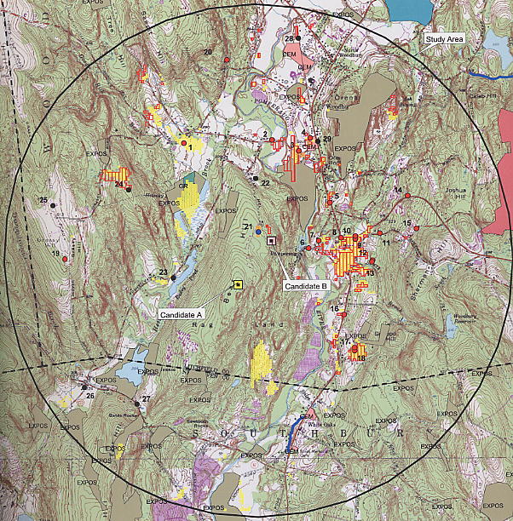

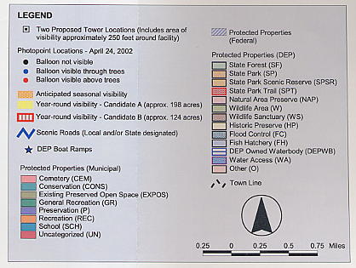

Figure 1. Visibility Analysis of the proposed sites. (Sprint 1, Tab 20)

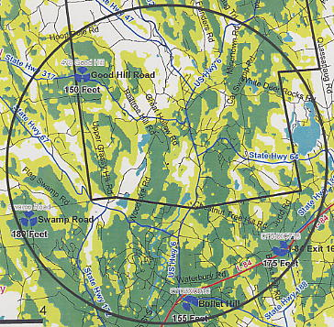

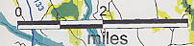

Figure 2. Existing Sprint coverage within a four-mile radius in the
Town of Woodbury. (Sprint Re-opening Interrogatories,
Q. 1)

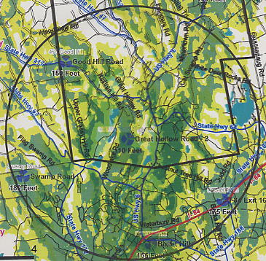

Figure 3. Existing Sprint coverage with coverage from proposed Site A at
110-feet AGL (1900 mhz). (Sprint Re-opening Interrogatories,
Q. 1, 2)

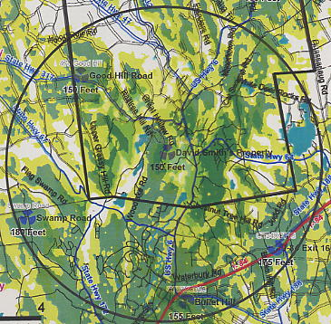

Figure 4. Existing Sprint coverage with coverage from proposed Site B at
150-feet AGL (1900 mhz). (Sprint Re-opening Interrogatories,
Q. 1, 2)

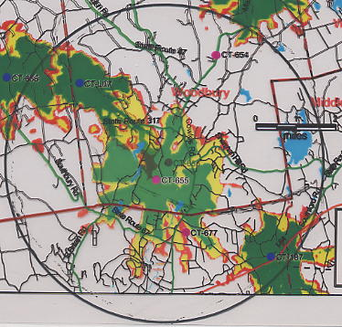

Figure 5. Existing AT&T coverage with coverage from proposed Site A at
100-feet AGL (1900 mhz). (AT&T 1, Q. 3)

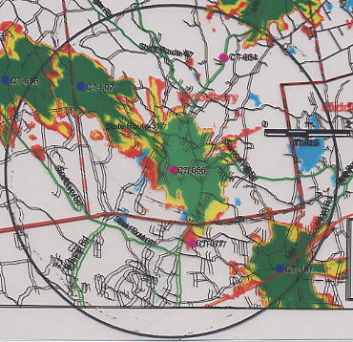

Figure 6. Existing AT&T coverage with coverage from proposed Site B at
140 feet AGL (1900 mhz). (AT&T 1, Q. 3)

