DOCKET NO. 229 – Sprint Spectrum, L. P. application for a Certificate of Environmental Compatibility and Public Need for the construction, maintenance and operation of a cellular telecommunications facility at Public Works Drive, East Hampton, Connecticut. | }  }  }  } | Connecticut  Siting  Council  November 21, 2002

Findings of Fact

Introduction

- Sprint Spectrum, L. P. (Sprint), in accordance with provisions of General Statutes § 16-50g through 16-50aa, applied to the Connecticut Siting Council (Council) on June 25, 2002 for the construction, operation, and maintenance of a 180-foot telecommunications facility in the Town of East Hampton, Connecticut. The proposed site is located at the Town of East Hampton’s Department of Public Works facility at 1 Public Works Drive in East Hampton, Connecticut. The purpose of the proposed facility is to provide wireless coverage to existing coverage gaps in the East Hampton area along Route 66 and Route 16, and local roads. (Sprint 1, pp. 1, 2, & 4)

2. Sprint is a wholly owned subsidiary of WirelessCo L.P., licensed by the Federal Communications Commission (FCC) to provide wireless personal communication service (PCS). Sprint operates in 32 major trading areas within the United States including Connecticut. (Sprint 1, pp. 1, 2)

- Pursuant to General Statute § 16-50m, the Council, after giving due notice thereof, held a public hearing on September 17, 2002, beginning at 3:00 p.m. and continued at 7:05 p.m. in the East Hampton Community Center, 105 Main Street, East Hampton, Connecticut. (Council's Hearing Notice dated August 7, 2002; Transcript, September 17, 2002, 3:00 p.m. [Tr. 1], p. 3; Transcript, September 17, 2002, 7:05 p.m. [Tr. 2], p. 3)

- The party in this proceeding is the applicant. AT&T Wireless PCS, LLC d/b/a AT&T Wireless (AT&T) is an intervenor in this proceeding. (Tr. 1, p. 5)

- The Council and its staff made an inspection of the proposed site on September 17, 2002. During the field inspection, the applicant flew a four-foot diameter balloon at the proposed site to simulate the height of the proposed 180-foot tower. (Tr. 1, pp. 86-87)

- Sprint notified the Town of East Hampton of its intent of constructing a telecommunications facility at the proposed site on March 18, 2002. Public notice of the application was published in The Hartford Courant and The Middletown Press on June 18 and June 20, 2002, and in the Rivereast News Bulletin on June 21, 2002. (Sprint 1, p. 3, Exhibit 12)

- On September 18, 2002, the following state agencies were notified of the project, pursuant to General Statutes § 16-50j (h): Department of Environmental Protection, Department of Public Health, Council on Environmental Quality, Department of Public Utility Control, Office of Policy and Management, Department of Economic and Community Development, and Department of Transportation. Written comments were received from the Department of Environmental Protection on September 12, 2002. (Record)
Wireless Service Design

- Sprint operates a digital personal communications service network using a 1900-megahertz (MHz) frequency signal allocated by the FCC. This high frequency signal is twice that of traditional cellular service in the 800 MHz range and degrades quickly in areas of hilly terrain and dense foliage. To ensure adequate service and to accommodate the needs of other carriers in the hilly terrain of the search area, Sprint proposes a 180-foot facility. (Sprint 1, pp. 17, 18)

9. Existing Sprint facilities that would hand off traffic with the proposed facility are as follows:

Location | Distance and Direction from the Proposed Site | Antenna Height (agl-ft)
Goodrich Lane, Portland | 3.91 miles northwest | 143
East High Street, East Hampton | 3.17 east miles east | 120
Saybrook Road, Middletown | 4.16 miles southwest | 150
(Sprint 1, Exhibits 8, 11)

- Use of alternative technologies like microcells or repeaters would be useful for filling coverage in small areas or providing service in buildings, but are limited as to coverage and capacity. These alternatives would not provide adequate coverage to the identified gaps. (Sprint 1, p. 17)

Site Selection and Alternatives

- The proposed site at the East Hampton Public Works facility represents a settlement of on-going litigation between Sprint and the Town of East Hampton. In 1999, the town denied a special permit application by Sprint to construct a telecommunications facility on Terp Road. Sprint appealed this decision. Sprint and the town agreed to settle the matter by proposing a tower at the town’s public works facility. After deciding on a suitable location at the public works facility, the town planning and zoning commission approved Sprint’s proposal at a public hearing on March 18, 2002. (Sprint 1, p. 16; Sprint 2, Q, 4; Tr. 1, pp. 37, 38)

12. The proposed site is one of two sites Sprint would require in order to satisfy the coverage requirements of the original search ring. The Council approved the second site, located on the roof of the NRG Energy, Inc. facility in Middletown, on July 11, 2002 as part of Petition 571. A third facility would be required to serve the travel corridors in southeast East Hampton; however, Sprint is not presently pursing a search ring in this area. (Sprint 2, Q. 11; Tr. 1, pp. 44, 45, 50, 60-62)

- Sprint investigated a total of seven potential sites in the East Hampton area, one of which was selected as the proposed site. Four sites, water towers located on Bevin Court and Watrus Court in East Hampton, and the steeple of the East Hampton Congregational Church, were rejected due to low elevation and minimal coverage. The St. Patrick’s Church steeple located on Route 66 in East Hampton was rejected due to poor coverage along Route 66 and Route 16. A site on Hog Hill Road was rejected after mutually agreeable lease terms could not be obtained from the landowner. (Sprint 1, pp. 18, 19; Sprint 2, Q. 5, Q. 13; Sprint 3, Q. 21)

- Propagation models indicate placing antennas at the 100-foot level of the existing 100-foot town tower would not provide adequate coverage to Route 66. The existing tower is not capable of supporting an additional antenna array without substantial reinforcement. In addition the existing tower is not located within the town’s public works parcel and is located on state property. (Sprint 1, Exhibit 7; Sprint 2, Q. 19, Q. 20; Tr. 1, pp. 20, 21)

15. Sprint determined an approved Crown Atlantic Company LLC (Crown) facility in Portland approximately 1.5 miles west of the proposed tower would not meet coverage objectives on Route 66. AT &T did not examine the Crown facility. (Sprint 2, Q. 1, Q. 11, Tr. 1, pp. 44, 105)
Proposed Site

16. An existing 100-foot telecommunications facility owned by the Town of East Hampton is located on state property approximately 30 feet north of the site parcel property boundary. The tower is currently used for the town’s public safety communications system. This existing tower would be removed by Sprint upon construction and operation of the proposed tower. (Sprint 1, p. 13, Exhibit 7; Tr. 1, pp. 20, 21, 63)

- The proposed site is located on an approximate 6.43-acre parcel owned by the Town of East Hampton. The parcel, located at 1 Public Works Drive, is developed as the town’s public works facility and contains sand, gravel and salt storage areas, vehicle storage and maintenance buildings. The proposed tower site is located in the northeast corner of the parcel in a level, cleared area used for the storage of snow removal equipment and other miscellaneous items. (Sprint 1, p. 13, Exhibit 7; DEP comments dated September 12, 2002)

- Access to the proposed site would be from an existing asphalt driveway extending from Public Works Drive to the sand and gravel storage areas at the public works facility. Sprint would install a gravel driveway extending 200 feet through the storage area to access the proposed tower compound. (Sprint 1, p. 4, Exhibit 7; Tr. 1, p. 88)

- Sprint would construct a 180-foot monopole, designed to support four platforms, on a 75-foot by 120- foot lease area at the proposed site. The tower would be designed in accordance with Electronic Industries Association Standard EIA/TIA 222-F, Structural Standards for Steel Antenna Towers and Support Structures. The final tower design has not been determined. Sprint would install twelve 4-foot panel type directional antennas at a centerline height of 177.5 feet agl. AT&T would install panel antennas at a centerline height of 170 feet. The Town of East Hampton’s fire, civil preparedness, and public work system antennas would be mounted on an antenna platform with a centerline height of 125 feet agl. A GPS antenna would be mounted at a height of 75 feet agl. The total height of the structure would be 180 feet agl. (Sprint 1, pp. 6, 7, Exhibit 7; Sprint 2, Q. 10; AT&T 1, Q. 3)

- The proposed tower would be located in the central portion of a 60-foot by 75-foot compound area at an elevation of 377 feet above mean sea level (amsl). The facility compound would contain a gravel surface and would be enclosed by a 6-foot high chain-link fence topped with barbed wire. Sprint would install seven equipment cabinets on an 8.5-foot by 20-foot concrete pad within the compound. AT&T would install up to four equipment cabinets on a concrete pad within the compound. Town communication equipment would be contained within an 8-foot by 16-foot shelter. No vegetative screening is proposed for the site. (Sprint 1, p. 7, Exhibit 7; AT&T 1, Q. 6)

- Topography surrounding the proposed site is characterized by rolling hills, ranging in elevation from approximately 100 feet to 750 feet amsl. (Sprint 1, p. 4, Exhibit 10)

- The proposed site is zoned R-2, single family residential. The Town’s Zoning Regulations permit telecommunication towers in any zone district, subject to issuance of a Special Permit. Adjacent property consists of a State of Connecticut Department of Transportation (DOT) Highway Maintenance Facility to the east, an abandoned railroad right of way to the north, Town of East Hampton property to the west and Route 66 and Gildersleeve Drive to the south. There are three residences within 1,000 feet of the site; the closest residence is located 950 feet south of the proposed site. (Sprint 1, Exhibit 7; Sprint 2, Q. 8; Tr. 1, pp. 40)

- The tower radius would extend beyond the site parcel to the west by 120 feet onto a storage yard portion of a DOT Highway Maintenance Facility and to the north by 70 feet onto an abandoned railroad right-of-way owned by the DOT. The railroad right-of-way is an undeveloped portion of the Air Line State Trail. Relocating the tower so that the tower radius is contained within the site property would hinder the use of the sand storage and staging areas of the town public works yard. (Sprint 1, Exhibit 7; Tr. 1, pp. 22, 23, 25, 74-76)

- The approximate cost of construction for the proposed facility is as follows:

Site work $50,000
Road installation 35,000
Electrical and telephone 55,000
Foundation 45,000
Compound 60,000
Town’s RF work 45,000

Total $290,000

(Sprint 1, Exhibit 17; Sprint 3, Q. 22)

Environmental, Historic, and Safety Concerns

- The State Historic Preservation Office has determined that construction of the proposed facility would have no effect on historic, architectural, or archaeological resources listed on or eligible for the National Register of Historic Places. Furthermore, the proposed facility would have no effect upon properties of traditional cultural importance to Connecticut’s Native American community. (Sprint 1, Exhibit 19)

- The proposed site is within the summer foraging habitat for the state endangered eastern timber rattlesnake (Crotalus horridus) which is known to occur in woodland habitat 1,200 feet north of the site. The State of Connecticut Department of Environmental Protection (DEP) recommends construction activities occur during the rattlesnake’s dormant period, October to March. There are no other known existing populations of federal or state endangered, threatened or special concern species occurring at the proposed site, based on a review of the Connecticut Department of Environmental Protection Natural Diversity Database. (Sprint 1, Exhibit 19; Sprint 2, Q. 18; DEP letter September 12, 2002)

- There are no town or state designated scenic roadways in the vicinity of the site or within the Town of East Hampton. (Sprint 2, Q. 17)

- The applicant performed an aeronautical study that determines the impact of the proposed facility on nearby airports in accordance with Federal Airspace Regulations. The analysis, performed by Airspace Safety Analysis Corporation, determined that the Salmon River Airfield is 4.76 nautical miles from the proposed facility and obstruction marking and lighting of the proposed tower would not be required. (Sprint 1, Exhibit 16)

- The proposed site is located in a cleared area and site development would not impact vegetation or wetlands. The nearest watercourse is an intermittent stream located along an abandoned railbed approximately 200 feet north of the site. Sprint would install erosion and sediment controls prior to site construction and would stabilize all disturbed areas with seed and mulch after construction is completed. (Sprint 1, pp. 11, 13, 15)

- The total electromagnetic radio-frequency (RF) power density, calculated using FCC Office of Engineering Bulletin 65, using conservative worst-case exposures at the base of the proposed tower, would not exceed the American National Standards Institute (ANSI) standard and is estimated as 10% of the ANSI standard. (Sprint 1, Exhibit 15; AT&T 1, Q. 8)

Visibility

- A visibility analysis of the proposed facility was performed by Sprint using computer aided spatial analysis techniques and field studies. The analysis concluded the facility would be visible from approximately 75 acres of an 8,042-acre study area including several homes in the Charles Mary Drive area and along the Route 66 and Route 16 travel corridors. Approximately 6,052 acres of the study area consists of forest cover with an estimated average tree height of 75 feet. The visibility of the proposed tower from select public roads within a two-mile radius of the site is presented in the following table and depicted on Figure 1.

Location Distance and Direction from Proposed Site
Middle Haddam Road, Portland 1.24 miles west
Coughlin Road, East Hampton 0.35 miles west
Long Hill Road/Rt. 66 intersection, East Hampton 0.12 miles south
Charles Mary Drive, East Hampton 0.25 miles southeast
Old West High Street, East Hampton 0.21 miles northeast
Route 16/66 intersection 0.19 miles east

(Sprint 1, Exhibit 10; Tr. 1, p. 67)

- The Shenipsit Hiking Trail is located approximately 1.1 miles north of the proposed site and extends along the ridgeline of Great Hill. The tower would be visible from viewpoints on the ridgeline. (Sprint 1, Exhibit 10; Tr. 1, pp. 77, 78)

33. An undeveloped section of the Air Line State Trail, located in an abandoned railroad right-of-way, is approximately 160 feet north of the tower site. The tower would not have an impact on the trail due to its location in a deep and narrow terrain cut. The surrounding trail topography would limit views of the tower to winter months. (Tr. 1, pp. 75, 81; DEP comments dated September 12, 2002)

Sprint - Existing and Proposed Wireless Coverage

34. Existing Sprint facilities in East Hampton and Portland leave gaps in wireless coverage in the east- central portion of East Hampton. The minimum signal level threshold Sprint is planning to use in this area is -94 dbm. Gaps in existing and proposed wireless coverage on select roads within a two mile radius of the proposed site is presented in the table below and on Figures 2 and 3.

Road | Existing Road Gaps *  (see Figure 2) | Gaps Remaining After Proposed Installation at 180 feet *  (see Figure 3)
Route 66 | 2.5 | 0.3
Route 16 | 1.8 | 0.2
Route 151 | 0.7 | 0.1
Total | 5.0 | 0.6
* approximate miles; signal strength -94 dbm
(Sprint 1, Exhibit 8)

35. Installing Sprint antennas at a lower height would result in a coverage gap on Route 66 at the Muddy Gutter Brook crossing and would not allow for a connection to Sprint’s Baker Hill facility in East Hampton. The number of dropped calls would increase in the coverage gap area. (Sprint 2, Q. 13; Tr. 1, pp. 40-42; Tr. 2, p. 30)

AT&T - Existing and Proposed Wireless Coverage

36. Existing AT&T facilities in Middletown and East Hampton leave gaps in wireless coverage in the east- central portion of East Hampton. The minimum signal level threshold AT&T is planning to use in this area is -85 dbm. Gaps in existing and proposed wireless coverage on select roads within a two mile radius of the proposed site is presented in the table below and on Figures 4 and 5.

Road | Existing Road Gaps *  (see Figure 4) | Gaps Remaining After Proposed Installation at 170 feet *  (see Figure 5)
Route 66 | 3.2 | 1.3
Route 16 | 1.8 | 0.7
Route 151 | 1.6 | 1.0
Total | 6.6 | 3.0
* approximate miles; signal strength -85 dbm
(AT&T 1, Q. 4, Q. 5)

- AT&T’s coverage objectives can be met using a minimum antenna height of 130 feet. (AT&T 1, Q. 5; Tr. 2, pp. 19, 32)

FIGURE 1

VISIBILITY OF PROPOSED 180-FOOT TOWER

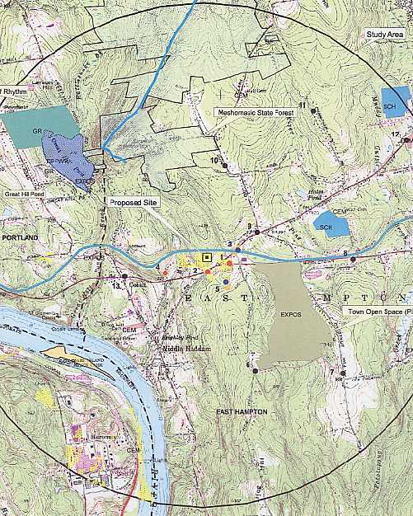

The areas highlighted in yellow on the above diagram denote visibility of the proposed tower within a two-mile radius of the site. (Sprint 1, Exhibit 10)

FIGURE 2

SPRINT EXISTING COVERAGE
(- 94 dbm)

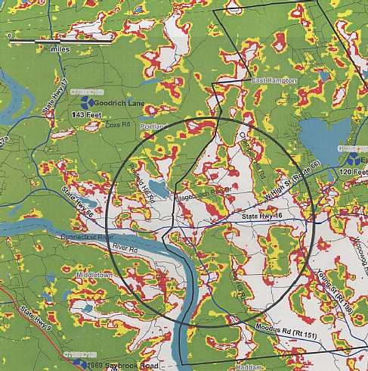
Two mile radius scale 1:67,400
(Sprint 1, Exhibit 8)
FIGURE 3

SPRINT EXISTING AND PROPOSED COVERAGE WITH ANTENNAS AT
180 FEET AGL
(- 94 dbm)

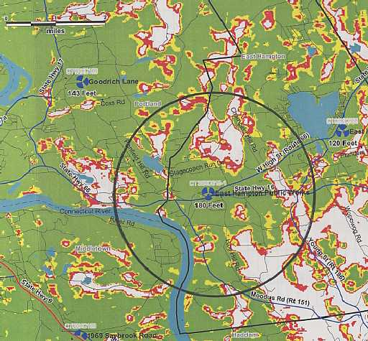
Two mile radius scale 1:67,400
(Sprint 1, Exhibit 8)
FIGURE 4

AT&T EXISTING COVERAGE
(- 85 dbm)

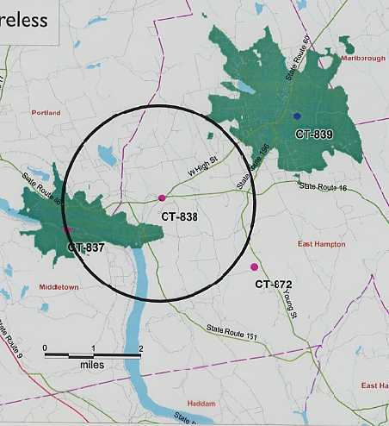
Two mile radius scale 1:75,000
(AT&T 1, Q. 4)
FIGURE 5

AT&T EXISTING AND PROPOSED COVERAGE WITH ANTENNAS AT
170 FEET AGL
(- 85 dbm)

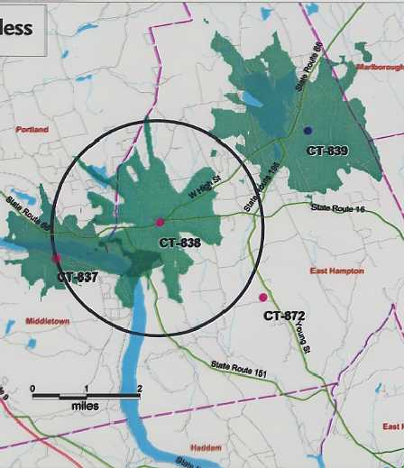
Two mile radius scale 1:75,000
(AT&T 1, Q. 5)

