DOCKET NO. 222 - James E. Dwyer Co., Inc. application for a Certificate of Environmental Compatibility and Public Need for the construction, maintenance, and operation of a cellular telecommunications facility at 459 Burr Road, Southbury, Connecticut. | }  }  }  } | Connecticut  Siting  Council  May 21, 2002

Findings of Fact

Introduction

- James E. Dwyer Co., Inc, (Dwyer) in accordance with provisions of General Statutes §§ 16-50g through 16-50aa applied to the Connecticut Siting Council (Council) on December 12, 2001 for the construction, operation, and maintenance of a cellular telecommunications facility in Southbury, Connecticut, to provide wireless coverage within Metropolitan Trading Area #1 (New York), and Basic Trading Area #318 (New Haven-Waterbury-Meriden). The proposed prime and alternate sites are located at 459 Burr Road, Southbury, Connecticut. (Dwyer 1, pp. 1 & 15)

2. The applicant does not hold a FCC license to operate as a wireless telecommunications carrier. Dwyer is acting in the capacity of a service provider to all wireless carriers which is consistent with the Federal Telecommunications Act of 1996 which promotes competition and technical innovation that results in higher quality consumer service and lower consumer costs. (Dwyer 1, pp. 2-3)

- The parties in this proceeding are the applicant and Michael Jeffers Ryer, James McQuillan, and Michael Schenk. (Tr. 1, pp. 4-5)

- Pursuant to General Statutes § 16-50m, the Council, after giving due notice thereof, held a public hearing on March 6, 2002, beginning at 3:05 p.m. and continuing at 7:05 p.m. in Room 205 of the Southbury Town Hall, 501 Main Street South, Southbury, Connecticut. (Tr. 1, p. 1; Tr. 2, p. 1)

- The Council and its staff conducted an inspection of the proposed prime and alternate sites on March 6, 2002. During the field inspection, the applicant flew balloons at each of the proposed sites to simulate the heights of the towers proposed at these locations. High winds caused several of the balloons to get tangled in the trees surrounding the proposed sites. (Tr. 1, pp. 37, 41, & 49)

6. Topographical descriptive information presented in the application narrative and the contour lines depicted on Attachment 4 of the application are incorrect. However, the coordinates and elevations of the proposed sites presented in the application are accurate and were determined by using a Global Positioning System identification device. The coordinates and site elevations were used to develop sight line graphs used in proposed tower visibility analysis. (Tr. 2, pp. 42-43, 46-50, & 135)

Need

- Dwyer located the proposed facility to facilitate the provision of wireless telecommunications service to northwest Oxford and southeast Southbury. Currently, there is not adequate coverage in this area for any of the five Personal Communication Service (PCS) providers licensed to serve this area. Dwyer investigated existing structures within an eight-mile search area and found that none of these structures would provide adequate coverage to the area. (Dwyer 1, pp. 1, 8, & 10, Attachment 1)

8. In 1996, the United States Congress recognized a nationwide need for high quality wireless telecommunication services, including cellular telephone service. The Federal Telecommunications Act of 1996 seeks to promote competition, encourage technical innovations, and foster lower prices for telecommunications services. Furthermore, the Federal government has preempted the determination of public need for wireless service by the states, and has established design standards to ensure technical integrity and nationwide compatibility among all systems. (Telecommunications Act of 1996, Definition of Act, Sections 256, and 704)

9. No carrier has committed to the proposed facility. AT&T Wireless has expressed interest in the facility. (Dwyer 6, Q. 9; Tr. 1, pp. 12-13, 24-25; Tr. 2, p. 134)

- As company policy, Dwyer stated it would only build a facility if commitments were obtained from at least two carriers. Dwyer has indicated a Council-imposed time limit of six months is sufficient to obtain a commitment from one carrier. Dwyer indicated a Council-imposed time limit of one year is sufficient to complete construction. (Dwyer 1, p. 4; Tr. 2, pp. 128-131)

Site Search

- Dwyer identified and investigated eight potential sites, including the prime and alternate, within a 3.5 mile wide and 2.0 mile long oval area in southeastern Southbury and northwestern Oxford. Two properties in the Holly Hill Lane/Georges Hill area of Southbury were rejected after the property owners did not respond to inquiries. Two sites located in the Mount Pisgah area of Oxford were rejected after mutually agreeable lease agreements could not be reached with the property owner. A site in the Bishop Road area of Oxford was rejected after access to the site was not considered reasonably feasible. A site located at 238 Maple Tree Hill Road in Oxford was rejected after the property owner could not agree on Dwyer’s proposal. Dwyer concluded the propagation plots from these alternative sites were inadequate to meet the needs of the identified coverage gap. (Dwyer 1, p. 10-12, Attachment 1; Dwyer 6, Q. 13)

- Dwyer identified thirteen existing and three proposed telecommunications towers located within approximately 8 miles of the site search area. These sites do not provide adequate coverage to the search area. The sites are summarized in the following table:

Tower Location | Tower Height (ft) | Approximate Direction and distance from proposed site | Number of Carriers
Willenbrock Rd., Oxford | 137 | 2.2 mi. northeast | 1
Old Waterbury Rd., Southbury | 230 | 3.2 mi. north | 6
Lakeside Rd., Southbury | 178 | 2.7 mi. east | 2
Kettletown Rd., Southbury | 185 | 2.2 mi. northwest | 2
Russian Village Rd., Southbury | 132 | 3.5 mi. east | 3
Route 34, Newtown | 185 | 5.1 mi. southwest | 7
South Main St., Newtown | - | 6.7 mi. southwest | 1
Main St., Newtown | 140 | 7.5 mi. southwest | 1
Shelton Rd., Orange | 92 | 3.7 mi. southeast | 2
Monroe Turnpike, Monroe | 195 | 5.0 mi. south | proposed
Osborn Hill Rd., Newtown | 150 | 4.0 mi. southwest | proposed
Horse Fence Hill Rd., Southbury | 150 | 3.4 mi. west | 1
338 Oxford Rd., Oxford | 150 | 4.0 mi. southeast | 2
691 Oxford Rd., Oxford | 150 | 2.0 mi. east | proposed
Great Oak Rd., Oxford | 150 | 2.5 mi. southeast | 1
Coppermine Rd., Oxford | 180 | 4.1 mi. south | under const.
(Dwyer 1, p. 8, Attachment 2, Attachment 5; Dwyer 7, Q. 34; Tr. 2, pp. 137-138)
Proposed Prime and Alternate Sites

- The proposed prime and alternate sites are located on an approximately 37.22-acre parcel, at 459 Burr Road, Southbury, Connecticut. The parcel is used as a private residence. Both proposed sites are located in the central portion of the parcel, in a wooded area with a tree canopy height of 60-75 feet above ground level (AGL). The parcel is generally rectangular in shape and ranges in elevation from approximately 650 to 773 feet above mean sea level (AMSL). Characteristics of the prime site include numerous boulders, possible rocky outcrops, and a forest cover of red, white, and chestnut oak. Characteristics of the alternate site include a sloping grade and a forest cover of oak, black birch, and red maple. (Dwyer 1, p. 15-16, Attachments 3 & 4; Dwyer 6, Q. 8; Tr. 2, p. 40; DEP letter dated March 5, 2002)

14. Abutting properties to the west include five residential homes on lots ranging in size from 4 to 16 acres and open space owned by the Town of Southbury. Abutting properties to the east include two farms of 45 and 57 acres, and two residential homes on lots of 2 to 4 acres in size. Abutting properties to the north include residential homes on 2 to 3 acre lots. Abutting properties to the south include two residential homes on 1 to 2 acre lots. (Dwyer 1, p. 16, Attachment 4)

- The proposed prime site is within a Residential District (R-60). The Town’s Zoning Regulations categorize the location of a tower above 60 feet in height, in a residential zone, as the least desirable on a ranked list of location preferences. (Dwyer 1, p. 17, Attachment 21 - Town of Southbury Zoning Regulations, Section 6.10.1)

- There are 4 residences and 13 properties within a 1,000-foot radius of the prime site. The nearest adjacent property boundary is approximately 330 feet to the east of the proposed compound. The nearest residential home is approximately 700 feet east of the proposed tower. (Dwyer 1, pp. 16-17, Attachment 4)

- There are 4 residences and 8 properties within a 1,000-foot radius of the alternate site. The nearest adjacent property boundary is approximately 170 feet to the east of the proposed compound. The nearest residential home is approximately 600 feet east of the proposed tower. (Dwyer 1, pp. 16-17, Attachment 4)

- Dwyer would construct a 150-foot monopole, designed to support eight platforms, at the proposed sites. The tower would be approximately 72 inches in width at the base and 20 inches in width at the top and would be designed in accordance with Electronic Industries Association Standard EIA/TIA 222-F, Structural Standards for Steel Antenna Towers and Support Structures. (Dwyer 1, pp. 1 & 18; Tr. 1, pp. 19-20)

- The base of the tower at the proposed prime site is 759.71 feet AMSL. The base of the tower at the proposed alternate site is 737.86 feet AMSL. (Dwyer 1, Attachment 4)

- The fall zone/tower radius of the proposed prime and alternate towers would not extend beyond the property boundaries. No structures other than the proposed telecommunications equipment would be within the tower radius. (Dwyer 6, Q. 16)

- Both the proposed prime and alternate sites would include a 100-foot by 100-foot leased parcel on which a 60-foot by 80-foot fenced equipment compound would be installed. Dwyer proposes to construct a 20-foot by 40-foot equipment shelter with enough space for four carriers. The exterior shelter walls will be eight feet high and constructed of split-face masonry block. The roof would be a wood framed gable structure with asphalt shingles. Two 10-foot by 15-foot equipment pads, a transformer pad, an electrical meter bank, and a telephone cabinet would also be installed. Compound equipment would be installed to support the needs of six carriers. The tower and facility compound would be enclosed by an 8-foot high chain-link fence topped with barbed wire. A crushed stone surface would be established within the facility compound. The compound will be screened by existing vegetation. The design of the equipment shelter and height of the chain link fence conforms to applicable sections of the town’s zoning regulations. (Dwyer 1, p. 18, Attachment 4, Attachment 21 - Town of Southbury Zoning Regulations, Sections 6.10.13 & 6.10.14; Dwyer 2, p. 5; Dwyer 6, Q. 11, Q. 12, & Q. 19)

- Access to the prime site and alternate sites would be from Burr Road along an existing driveway and a pre-existing dirt road. The dirt road would be improved by widening it to 12 feet and adding 12 inches of gravel. Some sections of the road may be narrower in order to minimize the amount of vegetative clearing. The improved road would extend 1455 feet from the existing drive to the prime site and 1320 feet to the alternate site. (Dwyer 1, pp. 1 & 16; Dwyer 6, Q. 7; Dwyer 7, Q. 26)

- The estimated cost to construct a tower at the parcel is as follows:

Item | Prime Site | Alternate Site
Compound Area Sitework | $21,000 | $21,000
150’ Monopole Tower & Foundation | $135,000 | $135,000
Equipment Shelters | $120,000 | $120,000
Access Road | $43,650 | $39,600
Fencing | $8,000 | $8,000
Utility Ductbank | $25,000 | $20,000
Electrical/Telephone Service | $48,000 | $45,000
Total Cost | $400,650 | $388,600
(Dwyer 1, Attachment 15)

Municipal Consultation

24. On January 8, 2002, the applicant attended a Town of Southbury Zoning Board of Appeals (ZBA) public meeting. The applicant reviewed the proposed facility and answered questions from the zoning board and public. (Dwyer 3, p. 1)

25. The ZBA submitted written comments to the Council that were generally not favorable to the siting of a facility at the proposed location, stating that the applicant did not provide enough analysis and proof demonstrating need for this facility. (Town of Southbury Letter dated February 27, 2002.)

26. The town accepted the applicant’s offer of free use of the proposed facility in order to improve public works and emergency communications; however, specific needs of these communication systems were not addressed. (Dwyer 7, Attachment 43)

Environmental Considerations

- The proposed prime and alternate sites contain no known existing populations of Federal or State Endangered, Threatened or Special Concern Species, according to the Connecticut Department of Environmental Protection Natural Diversity Database. According to the database, two abutting properties to the northeast contain state and federal listed species and/or significant natural communities. (Dwyer 6, Q. 1; CT DEP letter dated March 5, 2002; Tr. 2, pp. 77-78)

- According to the Town of Southbury Soils Inventory Map provided in the town’s Inland Wetlands and Watercourses Regulations, no wetlands or watercourses would be impacted during the construction of either of the proposed sites. The nearest wetland to any of the proposed telecommunication installations on the property is 475 southeast of the proposed alternate site. A field investigation to determine the presence of wetland soils was not conducted at the proposed sites. (Dwyer 1, Attachment 23; Dwyer 6, Q. 10; Tr. 2, pp. 77, 135-136)

- The proposed sites are within an area marked as locally high ground on the CT DEP Ridgeline and Summit Protection Policy Area maps. Field review of the parcel by CT DEP staff determined the proposed sites are not on a ridgeline, bluff, or notable promontory that provides a locally or regionally significant scenic vista. (CT DEP letter dated March 5, 2002)

- The State Historic Preservation Office (SHPO) has determined that construction of the proposed facilities would have no effect on historic, architectural, or archaeological resources listed on or eligible for the National Register of Historic Places. Furthermore, the proposed facility would have no effect upon properties of traditional cultural importance to Connecticut’s Native American community. (Dwyer 6, Attachment 39)

- There are no state or local designated scenic roads near the proposed sites. An application to the Town of Southbury was filed on January 28, 2002 requesting that Rocky Mountain Road, located approximately 0.2 miles east of the proposed sites, be designated a town scenic road. The proposed towers would be visible from this road. (Dwyer 6, Q. 20 & Q. 24)

- Approximately 31 trees of six inches or greater in diameter at breast height would be removed for the construction of the proposed prime site and upgrading the access road. This includes 12 trees along the access road. Approximately 18 trees of six inches or greater in diameter at breast height would be removed for construction of the proposed alternate site. (Dwyer 1, pp. 15-16; Dwyer 7, Q. 26)

- Dwyer would install erosion and sediment controls prior to construction in accordance with the Connecticut Department of Environmental Protection Erosion and Sediment Control Guidelines. Dwyer anticipates that blasting will be needed at the prime and alternate sites due to the presence of ledgerock. Dwyer estimates the maximum amount of rock blasting needed at either site is 300 yards. (Dwyer 1, p. 19; Dwyer 6, Q. 4; Dwyer 7, Q. 31)

- The proposed sites are located approximately 2.58 nautical miles from the nearest airport, Waterbury-Oxford Airport. According to an aeronautical study conducted by the Federal Aviation Administration (FAA), neither of the proposed towers in this application would require marking or lighting. (Dwyer 1, Attachment 17; Dwyer 6, Attachment 38)

- Dwyer estimated electromagnetic radio frequency power densities for the proposed facility assuming six carriers were located on the tower, operating at maximum capacity. Power densities were calculated using the FCC Office of Engineering and Technology Bulletin 65, August 1997, using conservative worst-case approximation of radio frequency power density levels at the base of each tower. The estimated power density with all assumed antennas transmitting simultaneously on all channels at full power would be 292.46 MW/cm² (29.24 percent of the American National Standards Institute Standard). (Dwyer 1, pp. 21-22; Dwyer 1, Attachment 7)

Visibility

- The visibility of the proposed tower from roads within a two-mile radius of the site is shown on Figure 1. (Dwyer 6, Q. 20)

- The proposed towers would be visible from the observation tower located in Southford Falls State Park. The park is approximately 1.1 miles east of the proposed sites. The towers may be visible from historic properties located on Sanford Road (approximately 0.88 miles north) and at 327 Hulls Hill Road (approximately 0.78 miles northeast) during non-foliage months. (Dwyer 1, p. 17, Attachment 1 & 10; Dwyer 6, Q. 6 & Q. 23; Dwyer 7, Q. 32; Tr. 2, p. 35)

38. The proposed towers would not be visible from the Pheasant Hill Development adjacent to and north of the proposed sites. (Dwyer 1, Attachment 4; Dwyer 10, Attachment 50; Tr. 1, pp. 42-44; Tr. 2, p. 94)

Coverage Needs

39. Existing facilities in Monroe, Newtown, Oxford, and Southbury leave gaps in PCS wireless coverage in the northwest Oxford and southeast Southbury area. Gaps were identified using the Longley-Rice propagation model. Parameters used in the model include a signal strength of –94 dbm and a frequency of 1900 MHz. A signal strength of –94 dbm would be sufficient to provide in-vehicle coverage to the area. (Dwyer 1, p. 8; Dwyer 6, Q. 5; Tr. 1, pp. 25-27)

40. Existing PCS wireless coverage, at 1900 MHz, on select roads within a three-mile radius of the proposed sites is as follows:

Existing Coverage

(see Figure 2)

Road | Existing Gaps (approx. miles)  < -94 dbm
Route 188 | 0.6
Route 487 | 2.2
Burr Road | 1.2
Georges Hill Road | 2.0
Hulls Hill Road | 0.4
Jacob Road | 1.0
Jeremy Swamp Road | 1.0
Mapletree Hill Road | 1.6
Total | 10.0 miles
(Dwyer 6, Q. 5; Tr. 2, p. 38)
41. Gaps in proposed wireless coverage within a three-mile radius of the prime site are presented in the following table and associated figure. Coverage gaps were determined by combining propagation models for existing coverage and proposed coverage from antennas mounted at select tower heights.

Proposed Prime Tower Coverage Gaps (Miles)

Signal Strength < -94 dbm

Frequency 1900 MHz

(see Figure 3)

Road | 150 Feet AGL | 130 Feet AGL | 110 Feet AGL
Route 188 | 0.0 | 0.0 | 0.0
Route 487 | 0.16 | 0.16 | 0.16
Burr Road | 0.0 | 0.0 | 0.0
Georges Hill Road | 0.28 | 0.28 | 0.28
Hulls Hill Road | 0.0 | 0.0 | 0.0
Jacob Road | 0.0 | 0.0 | 0.0
Jeremy Swamp Road | 0.0 | 0.0 | 0.0
Mapletree Hill Road | 0.20 | 0.20 | 0.20
Total | 0.64 | 0.64 | 0.64
(Dwyer 6, Q. 5; Tr. 2, p. 38)

42. Gaps in proposed coverage within a three-mile radius of the alternate site are presented in the following table and associated figure. Coverage gaps were determined by combining propagation models for existing coverage and proposed coverage from antennas mounted at select tower heights.

Proposed Alternate Tower Coverage Gaps (Miles)

Signal Strength < -94 dbm

Frequency 1900 MHz

(see Figure 3)

Road | 150 Feet AGL | 130 Feet AGL | 110 Feet AGL
Route 188 | 0.0 | 0.0 | 0.12
Route 487 | 0.40 | 0.40 | 0.40
Burr Road | 0.0 | 0.0 | 0.0
Georges Hill Road | 0.24 | 0.24 | 0.24
Hulls Hill Road | 0.0 | 0.0 | 0.0
Jacob Road | 0.0 | 0.0 | 0.0
Jeremy Swamp Road | 0.0 | 0.0 | 0.0
Mapletree Hill Road | 0.24 | 0.24 | 0.32
Total | 0.88 | 0.88 | 1.08
(Dwyer 6, Q. 5; Dwyer 7, Q. 33; Tr. 2, p. 38)

43. Proposed towers in Newtown (Osborn Hill Road) and Monroe (Marian Heights) would provide wireless coverage, at a signal strength of –94 dbm, to portions of the existing gap. However, gaps along roads in the area including Route 487 would remain. (Tr. 2, pp. 24-28 & 36)
44. The proposed tower location was selected to allow for integration into a PCS grid. However, Dwyer also provided propagation analysis information for cellular systems that demonstrate gaps in existing cellular coverage in the northwest Oxford and southeast Southbury area. (Dwyer 6, Q. 5; Dwyer 7, Q. 33; Tr. 1, p. 29)

45. Existing cellular coverage, at 880 MHz, on select roads within a three-mile radius of the proposed sites is as follows:

Existing Coverage

Frequency 880 MHz

Road | Existing Gaps (approx. miles)  < -75 dbm  (see Figure 4) | Existing Gaps (approx. miles)  < -90 dbm  (see Figure 5)
Route 188 | 0.20 | 0.44
Route 487 | 2.12 | 2.12
Burr Road | 0.60 | 0.96
Georges Hill Road | 1.20 | 1.20
Hulls Hill Road | 0.44 | 0.44
Jacob Road | 0.76 | 1.04
Jeremy Swamp Road | 0.20 | 0.48
Mapletree Hill Road | 1.72 | 1.72
Total | 7.24 | 8.40

(Dwyer 7, Q. 34)

46. Gaps in proposed cellular coverage within a three-mile radius of the prime site are presented in the following tables and associated figures. Coverage gaps were determined by combining propagation models for existing coverage and proposed coverage from antennas mounted at select tower heights.

Proposed Prime Tower Coverage Gaps (Miles)

Signal Strength < -75 dbm

Frequency 880 MHz

(see Figure 6)

Road | 150 Feet AGL | 130 Feet AGL | 110 Feet AGL
Route 188 | 0.00 | 0.00 | 0.00
Route 487 | 0.12 | 0.16 | 0.16
Burr Road | 0.00 | 0.00 | 0.00
Georges Hill Road | 0.16 | 0.16 | 0.16
Hulls Hill Road | 0.00 | 0.00 | 0.00
Jacob Road | 0.00 | 0.00 | 0.00
Jeremy Swamp Road | 0.00 | 0.00 | 0.00
Mapletree Hill Road | 0.20 | 0.20 | 0.20
Total | 0.48 | 0.52 | 0.52

(Dwyer 6, Q. 5; Dwyer 7, Q. 34)

Proposed Alternate Tower Coverage Gaps (Miles)

Signal Strength < -75 dbm

Frequency 880 MHz

(see Figure 6)

Road | 150 Feet AGL | 130 Feet AGL | 110 Feet AGL
Route 188 | 0.00 | 0.00 | 0.08
Route 487 | 0.32 | 0.32 | 0.32
Burr Road | 0.00 | 0.00 | 0.00
Georges Hill Road | 0.16 | 0.16 | 0.16
Hulls Hill Road | 0.00 | 0.00 | 0.00
Jacob Road | 0.00 | 0.00 | 0.00
Jeremy Swamp Road | 0.00 | 0.00 | 0.00
Mapletree Hill Road | 0.28 | 0.28 | 0.28
Total | 0.76 | 0.76 | 0.84

(Dwyer 6, Q. 5; Dwyer 7, Q. 33, Q. 34)

Proposed Prime Tower Coverage Gaps (Miles)

Signal Strength < -90 dbm

Frequency 880 MHz

(see Figure 7)

Road | 150 Feet AGL | 130 Feet AGL | 110 Feet AGL
Route 188 | 0.00 | 0.00 | 0.00
Route 487 | 0.00 | 0.00 | 0.12
Burr Road | 0.00 | 0.00 | 0.00
Georges Hill Road | 0.16 | 0.16 | 0.16
Hulls Hill Road | 0.00 | 0.00 | 0.00
Jacob Road | 0.00 | 0.00 | 0.00
Jeremy Swamp Road | 0.00 | 0.00 | 0.00
Mapletree Hill Road | 0.20 | 0.20 | 0.20
Total | 0.36 | 0.36 | 0.48

(Dwyer 6, Q. 5; Dwyer 7, Q. 34)

Proposed Alternate Tower Coverage Gaps (Miles)

Signal Strength < -90 dbm

Frequency 880 MHz

(see Figure 7)

Road | 150 Feet AGL | 130 Feet AGL | 110 Feet AGL
Route 188 | 0.00 | 0.00 | 0.00
Route 487 | 0.08 | 0.24 | 0.40
Burr Road | 0.00 | 0.00 | 0.00
Georges Hill Road | 0.08 | 0.00 | 0.08
Hulls Hill Road | 0.00 | 0.00 | 0.00
Jacob Road | 0.00 | 0.00 | 0.00
Jeremy Swamp Road | 0.00 | 0.00 | 0.00
Mapletree Hill Road | 0.12 | 0.20 | 0.20
Total | 0.28 | 0.44 | 0.68
(Dwyer 6, Q. 5; Dwyer 7, Q. 33, Q. 34)

FIGURE 1

Visibility of Proposed 150-foot Tower

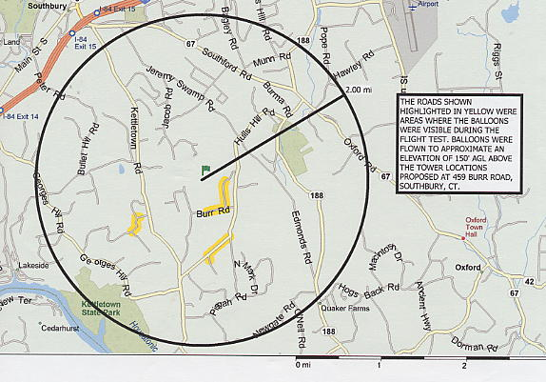

The above diagram denotes visibility from the following roads:

Location Approximate Distance/Direction to Proposed Sites
Burr Road, Southbury 0.3 miles south
Rocky Mountain Road, Southbury 0.2 miles east
Cobbler Lane, Southbury 0.8 miles west
Stonegate Drive, Southbury 0.8 miles west
Britiani Road, Southbury 1.0 miles southwest
Maple Tree Hill Road, Oxford 0.7 miles south
Toppenfjel Lane, Oxford 0.9 miles south

(Dwyer 6, Q. 20)

FIGURE 2
EXISTING PCS WIRELESS COVERAGE
-94 dbm, 1900 MHz

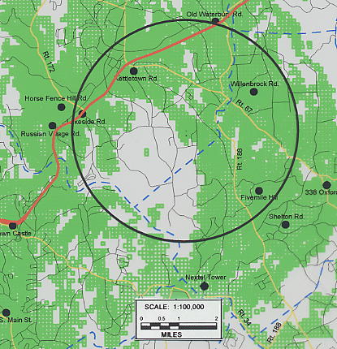
Rt. 487
(Dwyer 7, Q. 34)

FIGURE 3
EXISTING COVERAGE WITH COVERAGE FROM THE PROPOSED PRIME SITE AT 130 FEET AGL
-94 dbm, 1900 MHz

(There is no significant difference in coverage between the prime and alternate sites and from proposed antenna heights of 150, 130 and 110 feet AGL)

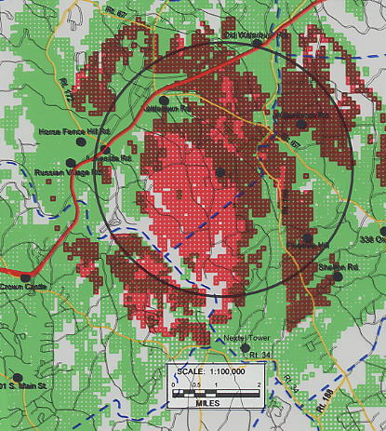
Rt. 487
(Dwyer 6, Q. 5; Dwyer 7, Q. 34)
FIGURE 4
EXISTING CELLULAR COVERAGE
-75 dbm, 880 MHz

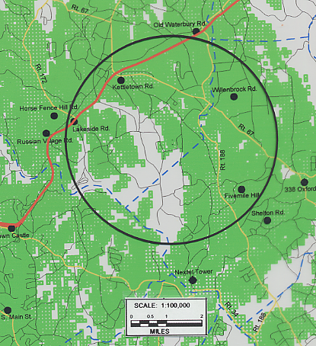
Rt. 487
(Dwyer 7, Q. 34)
FIGURE 5
EXISTING CELLULAR COVERAGE
-90 dbm, 880 MHz

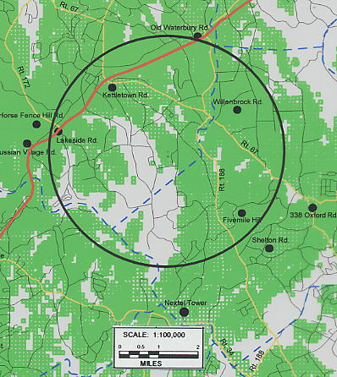
Rt. 487
(Dwyer 7, Q. 34)
FIGURE 6
EXISTING COVERAGE WITH COVERAGE FROM THE PROPOSED PRIME SITE AT 150 FEET AGL
-75 dbm, 880 MHz

(There is no significant difference in coverage between the prime and alternate sites and from proposed antenna heights of 150, 130, and 110 feet AGL)

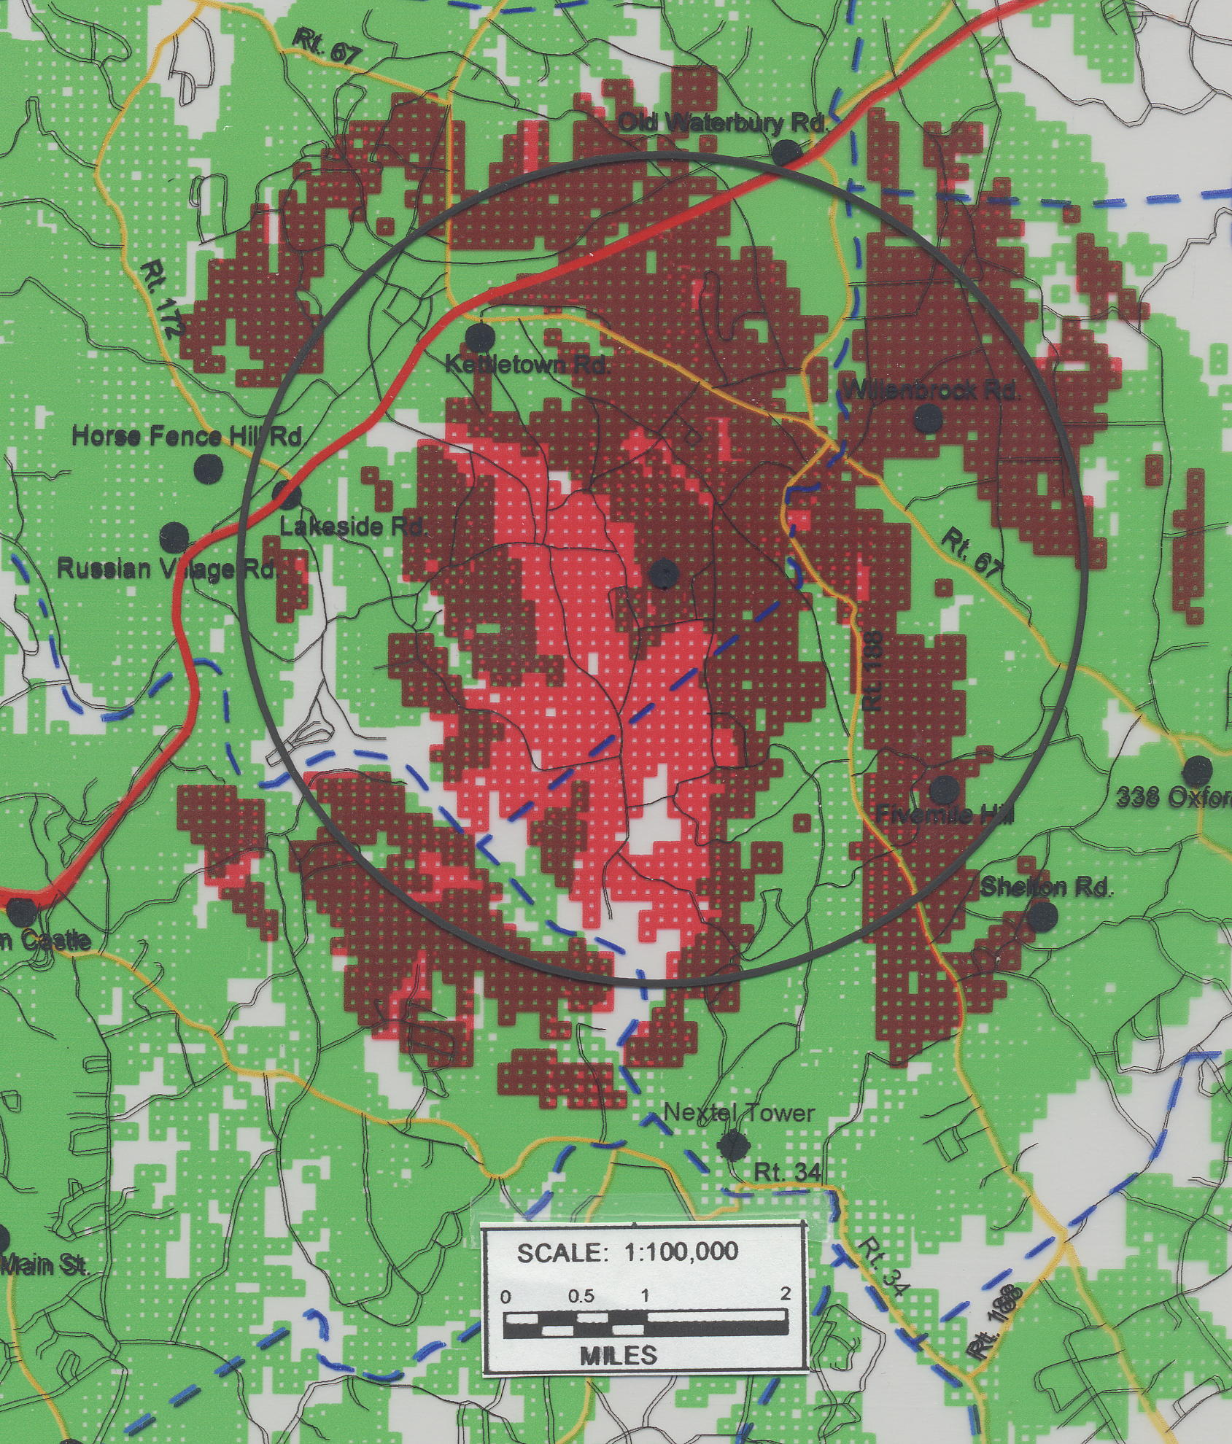
Rt. 487
(Dwyer 6, Q. 5; Dwyer 7, Q. 34)
FIGURE 7
EXISTING COVERAGE WITH COVERAGE FROM THE PROPOSED PRIME SITE AT 150 FEET AGL
-90 dbm, 880 MHz

(There is no significant difference in coverage between the prime and alternate sites and from proposed antenna heights of 150, 130, and 110 feet AGL)

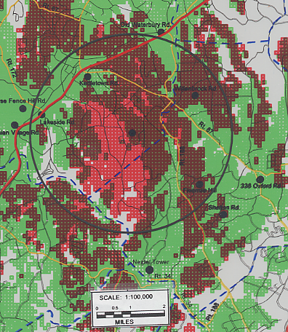
Rt. 487
(Dwyer 6, Q. 5; Dwyer 7, Q. 34)

