DOCKET NO. 206 - Crown Atlantic Company LLC and Cellco Partnership d/b/a Verizon Wireless application for a Certificate of Environmental Compatibility and Public Need for the construction, maintenance and operation of a cellular telecommunications facility at 191 Middle Haddam Road, Portland, Connecticut. | }  }  } | Connecticut  Siting  Council  July 11, 2002

Findings of Fact

Introduction

- Crown Atlantic Company LLC (Crown) and Cellco Partnership (Cellco) d/b/a Verizon Wireless (Verizon) in accordance with provisions of General Statutes §§ 16-50g through 16-50aa applied to the Connecticut Siting Council (Council) on June, 8, 2001, for the construction, operation, and maintenance of a cellular telecommunications facility in Portland, Connecticut, to provide cellular coverage within the Hartford New England County Metropolitan Area (NECMA). Both the proposed prime site and alternate site are located at 191 Middle Haddam Road, Portland, Connecticut. (Crown/Cellco 1, pp. 1-3)

- The party in this proceeding is the applicant. Sprint Spectrum L.P. (Sprint) was granted intervenor status by the Council on October 18, 2001. On April 11, 2002, Sprint withdrew as an intervenor as not having a need for Crown’s proposed tower in Portland because Sprint would be collocating on the NRG Generating facility building in Middletown. (Crown/Cellco 13, Q. 26; Transcript August 9, 2001 3:00 p.m. (Tr. 1), pp. 1-4)

- Pursuant to General Statutes § 16-50m, the Council, after giving due notice thereof, held a public hearing on August 9, 2001, beginning at 3:00 p.m. and continuing at 7:00 p.m. in the Portland High School Auditorium, 95 High Street, Portland, Connecticut. The Council continued hearings on November 7, 2001, and April 18, 2002 at the Council’s offices 10, Franklin Square, New Britain, Connecticut.(Tr. 1, p. 2, Transcript November 7, 2001, 3:00 p.m. (Tr. 3) p. 1; Transcript April 18, 2002, 3:00 p.m. (Tr. 4 p. 1 )

- The Council and its staff made inspections of the proposed prime and alternate sites both located at 191 Middle Haddam Road on August 9, 2001. During the field inspection, the applicant flew a balloon at each of the proposed prime and alternate site to simulate the heights of the towers proposed at these locations. The balloons were flown on a 180-foot tether at both sites, and winds caused the tethered balloons to fly at an angle less than 90 degrees. (Tr. 1, p. 79)

Municipal Consultation

- Pursuant to CGS § 16-50l(e), Crown met with Town of Portland’s First Selectman and Director of Planning to discuss plans for development of a cell site in the Town of Portland. The Town of Portland’s Planning Director responded to Crown’s technical report dated March 28, 2001 raising issues regarding the use of existing electric transmission line structures and the NRG electric generating facility stack in Middletown; minimum height necessary for the proposed towers, future changes to technology that may reduce tower height or removal of tower, health risks, public field review of balloon flying, minimum setback for tower, and sightlines from sensitive receptors. Crown provided information to the Town on each issue. (Crown/Cellco 1, p. 19, 1d, Crown/Cellco 2; Tr. 1, p.6 and 7)

- Crown also provided technical information to the City of Middletown pursuant to CGS § 16-50l(e) because the proposed prime and alternate site are within 2,500 feet of the town boundary. The City of Middletown’s Department of Planning, Conservation, and Development - Design Review and Preservation Board oppose the proposed prime and alternate sites. City of Middletown’s sewage treatment plant that is located along the Connecticut River is being planned to be removed and relocated to the Mattabesset River plant in Cromwell including environemental cleanup of several industrial sites ‘to make room for development of 85 acres of water-dependent and water-oriented uses and recreation.” Furthermore, the Connecticut River has been recently designated a National Hertiage River. (Crown/Cellco 1, p. 19; Crown /Cellco 2; City of Middletown letter from Jeff Bianco to Robert Stanford dated July 9, 2001)

Site Search

- Cellco identified six existing structures located within approximately five miles of the site search area: a 160-foot tower owned by Crown, located on Goodrich Lane, Portland; an 80-foot tower owned by the Town of Portland, located at the Portland High School on 95 High Street, Portland; a building mounted facility at a height of 207 feet owned by the Middlesex Mutual Insurance Company located on Court Street Middletown; a 118-foot tower owned by Sprint Sites USA located on 94 East High Street, East Hampton; a 498-foot stack owned by NRG located on River Road, Middletown; and a tower located at Pratt and Whitney, Airport Road, Middletown . These structures would not provide adequate coverage to areas in the Portland area because they are either located too far from existing coverage gaps or do not offer adequate height or maintain characteristics unsuitable for use by Cellco. (Crown/Cellco 1, Section 2, pp. 1-2; Crown/Cellco 5, Q. 10; Tr. 1, p. 14)

- Cellco identified and investigated five potential sites, including the prime and alternate, between approximately 1,050 feet and 3,700 feet from the center of the preliminary search area located approximately 1,000 feet west of the intersection of Penfield Hill Pond Road and Middle Haddam Road in Portland. Three of the sites were rejected due to less coverage provided compared to the proposed prime/alternate sites. (Crown/Cellco 1, Section 2, pp. 2-3)

- The NRG electric generating facility is located approximately 3,000 feet southwest of the proposed Portland site. The tallest stack at this facility is 498 feet above ground level (AGL) and the base of the stack is at 19 feet amsl. Initially, NRG leased space to Sprint to attach antennas to its existing generator building. Subsequent to Crown filing an application for the proposed Portland tower to the Council, NRG retracted its lease contract with Sprint and contended it could not share space for telecommunications purposes pursuant to the federal Public Utility Company Holding Act (PUCHA) of 1935. However, in the spirit of community citizenship, NRG applied for and was granted as an “exempt telecommunications company” pursuant to section 34 of the PUCHA and amended by section 10 of the Telecommunications Act of 1996. Cellco contends coverage from the top of the existing stack would be less than the proposed Portland site. Other reasons Cellco rejected use of the stack include emissions from four stacks at the facility could cause corrosion to antennas and brackets, and cause concern for exposure to workers, long runs of transmission cable result in loss of power, limited access, and scheduling work on the stack while any one of the generators is operating. (Crown/Cellco 13, Q. 27; Federal Communications Commission NSD file No. ETC 01-23, NRG Comlease LLC seeks Commission Determination of “Exempt Telecommunications Company” status under the Public Utility Holding Act, and Email from Jon Minkoff of the FCC to Robert J. Golden AAG dated March 27, 2002, 2:37 p.m.; Tr. 1, pp. 24-27)

- Sprint is proposing a 180-foot tower at the East Hampton Public Works Garage on Gildersleeve Drive, East Hampton. This site is located approximately 1.5 miles east of the proposed Portland site. Sprint expects to commence the 60-day municipal review period prior to Council application on or about May 8, 2002. Cellco rejected this site because it would leave gaps in coverage along Route 66 west into Portland. (Crown/Cellco 13, Q. 28)

- Cellco has a masterlease agreement with Northeast Utilities to share existing electric transmission line support structures for wireless telecommunications facilities. Cellco has investigated and rejected use of existing transmission line structures (100 feet in height) located adjacent to the proposed Portland site and structures (65 feet in height) located on a hill south of the NRG facility because the height and location of the structures would not meet Cellco coverage needs. Furthermore, access to the transmission line structures adjacent to the proposed Portland site would require access through a substation which CL&P would not likely grant, and access around the substation would cross through inland wetlands. (Crown/Cellco 12, Q. 24; Tr. 4, p. 27)

- Crown has publicized the shared use of the proposed tower in Portland. No other carriers have notified Crown of its intention to share the proposed tower. (Crown/Cellco 5, Q. 4; Crown/Cellco 13, Q. 26)

Need and Coverage

- In 1981, the Federal Communications Commission (FCC) recognized a public need for technical improvement, wide-area coverage, high-quality service, and competition in the provision of mobile telephone service. This included the issuance of two licenses for the provision of cellular service at the wholesale level in each market area. Cellco is the non-wireline provider for cellular service in the Portland area. (Crown/Cellco 1, p. 6)

- In 1996, the United States Congress recognized a nationwide need for high quality wireless telecommunications services, including cellular telephone service. The Federal Telecommunications Act of 1996 seeks to promote competition, encourage technical innovations, and foster lower prices for telecommunications services. Furthermore, the Federal government has preempted the determination of public need for wireless service by the states, and has established design standards to ensure technical integrity and nationwide compatibility among all systems. (Crown/Cellco 1, pp. 6-7)

- Existing coverage comes from facilities in East Hampton, Middletown, and Portland. Existing Cellco coverage within a three mile radius of the intersection of Route 66 and Route 151 indicates the following coverage gaps. Gaps are defined as areas receiving less than -90 dbm coverage. The primary purpose of this application is to provide coverage to these gaps in coverage and provide additional traffic handling capacity to the Route 66 and surrounding areas in Portland.

Existing Coverage
(see Appendix A)

Route | Gaps (miles)  < -90 dbm | Total Road  Miles
Route 66 | 2.0 | 6.8
Route 151 | 3.5 | 3.5
Route 16 | 0.1 | 2.4
Total | 5.6 | 12.7

(Crown/Cellco 1, p. 8, and Tab 1)

- Existing coverage combined with Cellco antennas on the proposed 180-foot prime site tower at 130 feet AGL (390 feet amsl) or the proposed 180-foot alternate site tower at 160 feet AGL (390 amsl) would leave the following coverage gaps within a three mile radius of the intersection of Route 66 and Route 151 as follows:

Proposed 180- foot Prime Site Tower with antennas at 130 AGL (390 feet amsl)
Proposed 180-foot Alternate Tower with antennas at 160 feet AGL (390 feet amsl)
(see Appendix B)

Route | Gaps (miles)  < -90 dbm | Total Road  Miles
Route 66 | 0.0 | 6.8
Route 151 | 0.8 | 3.5
Route 16 | 0.1 | 2.4
Total | 0.9 | 12.7

Coverage at heights less than 390 feet amsl begin to develop gaps in coverage to Route 66 and Route 151 east of the proposed site. (Crown/Cellco 1, p. 8, Tab 1; Crown/Cellco 5, Q. 9)

- Existing coverage combined with Cellco antennas on the NRG facility stack at 498 feet AGL (517 feet amsl) would leave the following coverage gaps within a three mile radius of the intersection of Route 66 and Route 151 as follows:

NRG facility stack with antennas at 495 feet AGL (517 feet amsl)
(see Appendix C)

Route | Gaps (miles)  < -90 dbm | Total Road  Miles
Route 66 | 0.0 | 6.8
Route 151 | 0.5 | 3.5
Route 16 | 0.1 | 2.4
Total | 0.6 | 12.7

A gap in coverage exists between 0.2 mile and 0.4 mile south of the intersection of Route 66 and Route 151 because of topography. Placing antennas at the 450- or 400-foot level of the stack would increase gaps in coverage to Route 151. (Crown/Cellco 13, Q. 27)

- Existing coverage combined with Cellco antennas on an existing Connecticut Light and Power Company electric transmission line structure at 100 feet AGL and at 160 feet AGL on an existing Pratt and Whitney Company tower would leave the following coverage gaps within a three mile radius of the intersection of Route 66 and Route 151 as follows:

Antennas at 100- feet AGL on a CL&P transmission structure combined
with antennas at 160 feet on a Pratt & Whitney tower
(see Appendix D)

Route | Gaps (miles)  < -90 dbm | Total Road  Miles
Route 66 | 0.0 | 6.8
Route 151 | 0.4 | 3.5
Route 16 | 0.1 | 2.4
Total | 0.5 | 12.7

The gap in coverage to Route 151 is located over three miles south of the Route 6 and Route 151 intersection. (Crown/Cellco 7, Q. 20)

- Existing coverage combined with Cellco antennas on an existing Connecticut Light and Power Company electric transmission line structure at 100 feet AGL and at 170 feet AGL on a proposed Sprint tower would leave the following coverage gaps within a three mile radius of the intersection of Route 66 and Route 151 as follows:

Antennas on a 100- foot CL&P transmission structure combined
with antennas at 170 feet on a proposed Sprint tower
(see Appendix E)

Route | Gaps (miles)  < -90 dbm | Total Road  Miles
Route 66 | 0.0 | 6.8
Route 151 | 0.4 | 3.5
Route 16 | 0.0 | 2.4
Total | 0.4 | 12.7

The gap in coverage to Route 151 is located over three miles south of the Route 6 and Route 151 intersection. (Crown/Cellco 13, Q. 28)

Cellular Service Design

- The cellular system design provides for frequency reuse and handoff, is capable of orderly expansion, and is compatible with other cellular systems, and is in conformity with Code of Federal Regulations 47 C.F.R. Part 22, Subpart K. (Crown/Cellco 1, p. 9)

- Cellco would provide only digital service from its proposed Portland site. (Crown/Cellco 5, Q. 2)

- Adjacent Cellco facilities that would hand off traffic with the proposed facility are as follows:

Location | Distance and Direction from proposed facility | Status
Goodrich Lane, Portland | 3.2 miles north | Existing tower – operating
Court Street, Middletown | 3.5 miles west | Existing building facility – operating
94 High Street, East Hampton | 4.6 miles east northeast | Existing tower – operating
Airport Road exit on Route 9 | 3.7 miles south | Existing tower – proposed mid-2002
East Haddam | 4.6 miles southeast | Planned site no date certain

(Crown/Cellco 1, Tab 1; Crown/Cellco 5, Q. 5; Tr. 1, pp. 54-55)

- Cellco currently uses signal level thresholds of -90 dbm and -75 dbm for acceptable mobile and hand-held unit coverage, respectively. Cellco finds -90 dbm coverage generally acceptable for mobile (in-vehicle) units, but inadequate for hand-held units. Cellco determined its coverage gaps based on a -90 dbm signal strength level. (Crown/Cellco 1, Tab 1; Crown/Cellco 5, Q. 2)

Proposed Prime/Alternate Site

- The proposed prime/alternate site would be located on an approximate 15-acre parcel south of Middle Haddam Road owned by Tina and Philip Knowlton. The parcel consists of meadow and woodland and developed with the owner’s residence and barn. Adjacent land uses include undeveloped wooded land to the east, an abandon railroad right-of-way and Route 66 to the south, a CL&P substation and high voltage transmission lines to the west and sparse residential development to the north and east along Middle Haddam Road. (Crown/Cellco 1, p. 2, Sections 3 and 4, pp. 3, 6 and; 21; Crown/Cellco 10; Crown/Cellco 11; Crown/Cellco 5, Q. 2; DEP Comments dated January 19, 2001; Tr. 1, p.10)

- The proposed prime site is located near the southeast corner of the 15 acre parcel and approximately 920 feet due south of Middle Haddam Road. The proposed prime site elevation is 260 feet above mean sea level (amsl). The proposed alternate site is located approximately 300 feet northwest of the proposed prime site toward the center of the lessor’s property at an elevation of 230 feet amsl. (Crown/Cellco 1, p. 2, Sections 3 and 4, pp. 4 and; 21; Crown/Cellco 10; Crown/Cellco 11; Crown/Cellco 5, Q. 2; DEP Comments dated August 3, 2001; Tr. 1, p.10)

- The proposed prime/alternate site is within a rural residential zone (RR). The Town’s Zoning Regulations do not permit communication towers in residential zones; however, radio and television towers are allowed in residential zones by special permit. Communication towers are permitted in Industrial zones and B-1 and B-2 Business zones by special permit. The nearest B-1 zone is located approximately 1,500 feet south of the proposed site. The minimum setback distance from any property line shall be equal to the height of the tower. (Crown/Cellco 1, p. 14, Sections 3 and 4, p. 6)

- The proposed prime tower radius would extend approximately 130 feet across the east property boundary. The proposed alternate tower radius would extend 70 feet across the west property boundary and 10 feet south across the south property boundary. Crown could adjust the leased parcel to keep a 180-foot tower radius within the lessor’s property, and would be equidistant to both the east and south property boundaries. Movement of the leased parcel would cause a change in elevation of less than ten feet. (Crown/Cellco 1, Tabs 3 and 4 p. 20; Crown/Cellco5, Q. 1; Tr. 2 p. 25)

- There are three homes within a 1000-foot radius of the prime site, the nearest of which belongs to the lessor approximately 660 feet to the north. There are three homes within a 1000-foot radius of the alternate site, the nearest of which belongs to the lessor located approximately 470 feet to the east. (Crown/Cellco 1, pp. 14-15, Sections 3 and 4)

- The proposed prime/alternate site would include a 100-foot by 100-foot leased parcel on which Crown would develop a 56-foot by 64-foot facility compound. The proposed tower and equipment compound would be enclosed by an 8-foot high security fence and gate. A crushed stone surface would be established within the tower compound. A 12-foot by 30-foot equipment building would be constructed to house Cellco’s telecommunications equipment and three additional 12-foot by 20-foot foundations would be constructed for other wireless carriers. (Crown/Cellco 1, pp. 2 and 3, Sections 3 and 4, p. 5; Tr. 2, p. 35)

- An abandoned railroad right-of-way abuts the proposed site. The Town of Portland, CL&P, and the Department of Environmental Protection have identified this right-of-way to be developed as a rails-to-trails path which would connect to the State of Connecticut Designated Greenway which runs from Willimantic to East Hampton known as the “Airline Trail.” No final local or state plans have been approved. (Crown/Cellco 5 Q. 16; Tr. 1, p. 8)

- A 40-kilowatt diesel-fueled emergency generator would be installed inside Cellco’s equipment building. The generator would have a 275-gallon belly tank that would be double-walled and contain leak detection alarms. Use of propane as an alternate fuel would require the installation of a storage tank either above ground or below ground, located anywhere from 10 to 25 feet from any building. Cellco would need to obtain a permit from the Department of Environmental Protection for the operation of the emergency generator. (Crown/Cellco 1, pp. 11, 12, and 20, Sections 3 and 4 pp. 1 and 10; Crown/Cellco 5, Q. 12; Tr. 1, pp. 30, 33, and 35)

- Crown would construct a 180-foot monopole at the proposed prime site, and a 160-foot monopole at the alternate site. The tower would be approximately six feet in width at the base and three feet in width at the top and designed to withstand pressures equivalent to a 90 mph wind with one-half inch solid ice accumulation in accordance with Electronic Industries Association Standard EIA/TIA 222-F, Structural Standards for Steel Antenna Towers and Support Structures. (Crown/Cellco 1, Tab 3 and Tab 4, p. 8)

- Cellco would attach 9 cellular panel antennas configured in a three-sector array on a triangular platform to the monopole at approximately 130 feet above ground level AGL on the proposed 180-foot prime tower and at the top of the proposed 160-foot alternate tower. A global positioning system (GPS) antenna would be attached at approximately 70 feet AGL. (Crown/Cellco 1, Tab 3 and 4, p. 8)

- A new 1,000-foot long gravel drive would be constructed from Middle Haddam Road to the proposed prime site. A new 12-foot wide by 700-foot long gravel drive would be constructed from Middle Haddam Road to the proposed alternate site. Construction of the access drive would follow an existing cleared area that would limit the amount of tree clearing and grading. Electric and telephone utilities would be placed underground within the 20-foot wide utility/access easement. (Crown/Cellco 1, p. 2; Sections 3 and 4, pp. 1, 4, and 7; Crown/Cellco 10; Crown/Cellco 11)

- The approximate costs of construction to Crown and Cellco for the proposed prime/alternate site are estimated as follows:

 | Prime | Alternate
Cell site radio equipment | $ 650,000 | $ 650,000
Tower and antennas | 110,000 | 110,000
Power Systems | 45,000 | 45,000
Building Costs | 65,000 | 65,000
Miscellaneous Costs (including site preparation and installation) | 80,000 | 68,000
Total Costs | $950,000 | $938,000

Costs for developing a two-site scenario would be about twice that of a single site.

(Crown/Cellco 1, p. 21; Crown/Cellco 13, Q. 28)

Environmental Considerations

- The proposed prime/alternate site contains no known existing populations of Federal or State Endangered, Threatened or Special Concern Species. (Crown/Cellco 1, Section 5)

- No wetlands or watercourses were identified in the area of the proposed prime/alternate access drive or site. (Crown/Cellco 1, p. 18, Sections 3 and 4, p. 6 and 10;)

- Crown conducted an archaeological reconnaissance survey for the proposed prime and alternate sites based on a recommendation of the State Historic Preservation Office (SHPO). The SHPO has reviewed the archaeological reconnaissance survey and has determined that construction of the proposed prime or alternate facility would have no effect on the state’s archaeological heritage. There are no sites listed on the National Register of Historic Places or any National Historic Districts in the vicinity of the proposed prime or alternate site. (Crown/Cellco 1, pp. 15 and 20, and Section 5; Crown/Cellco 3; Crown/Cellco 4)

- Crown would install silt fence and/or hay bales along the down-gradient side of all construction in accordance with the Connecticut Guidelines for Soil Erosion and Sediment Control. (Crown/Cellco 1, p. 18)

- It is uncertain as to whether blasting would be required during the construction of either of the proposed facilities. (Crown/Cellco 5, Q. 13)

- Crown used an airspace program to determine if a proposed tower would be a hazard to air navigation. No obstruction or notice standards were exceeded in this analysis; therefore notification to the Federal Aviation Administration (FAA) is not required. Neither the prime or alternate tower would require air-navigation marking and/or lighting. (Crown/Cellco 1, pp. 19-20; Crown/Cellco 5, Q. 14; Crown/Cellco 6; Crown /Cellco 7, Q. 21)

- The electromagnetic radiofrequency power densities, calculated using the FCC Office of Engineering and Technology Bulletin 65, August 1997, using conservative worst-case approximation of radiofrequency power density levels at the base of each tower, with all Cellco antennas transmitting simultaneously on all channels at full power would be 6.9 percent of the American National Standards Institute (ANSI) Standard for the proposed prime site with antennas at 130 feet agl and 4.6 percent at the alternate tower site with antennas at 160 feet agl. (Crown/Cellco 1, pp. 16-17;)
Visibility

- The visibility of the proposed prime tower from various locations in the area would be as follows:

Visibility of Proposed 180-foot Prime Tower

Location | Visible | Distance and Direction to Tower
Cobalt Road (Route 66) | No | 300 feet north
Cobalt Road and Middle Haddam Road intersection | Yes | 4,200 feet east
Jobs Pond east shore | Partially obscured | 4,200 feet southeast
Middle of Jobs Pond | No | 5,200 feet southeast
Breezy Corner Road and Jobs Pond Road intersection | No | 2,200 feet south
Great Hill Pond east shore and Penfield Drive | No | Between 3,600 and 4,600 feet southwest
Middle Haddam Road and Penfield Road intersection | No | 3,200 feet west
St. Clements Castle | No | 2,400 feet east-northeast
Connecticut River | Partially obscured | Between 1,100 and 2,500 feet south
Dart Island State Park | Yes | 3,600 feet north
Shenipsit Trail overlook at 700-foot elevation on Great Hill | Partially obscured | 6,800 feet south

Tree heights depicted in the sight line graphs range from 60 feet to 65 feet and consist of a deciduous/conifer mix. (Crown/Cellco 1, Tab 3, pp. 11-21; Crown/Cellco 5, Q. 11; Tr. 1, p.81)

- The visibility of the proposed alternate tower from various locations in the area would be as follows:

Visibility of Proposed 160-foot Alternate Tower

Location | Visible | Distance and Direction to Tower
Cobalt Road (Route 66) | No | 500 feet north
Cobalt Road and Middle Haddam Road intersection | Yes | 4,400 feet east
Jobs Pond east shore | No | 4,600 feet southeast
Middle of Jobs Pond | No | 5,400 feet southeast
Breezy Corner Road and Jobs Pond Road intersection | No | 2,000 feet south
Great Hill Pond east shore and Penfield Drive | No | Between 3,200 and 4,400 feet southwest
Middle Haddam Road and Penfield Road intersection | No | 3,200 feet west
St. Clements Castle | No | 2,800 feet east-northeast
Connecticut River | Partially obscured | Between 1,250 and 2,750 feet south
Dart Island State Park | Yes | 3,800 feet south
Shenipsit Trail overlook at 700-foot elevation on Great Hill | Partially obscured | 6,800 feet south

Tree heights depicted in the sight line graphs range from 60 feet to 65 feet and consist of a deciduous/conifer mix. (Crown/Cellco 1, Tab 4, pp. 11-20; Crown/Cellco 5, Q. 11)
Appendix A
(Cellco existing coverage)

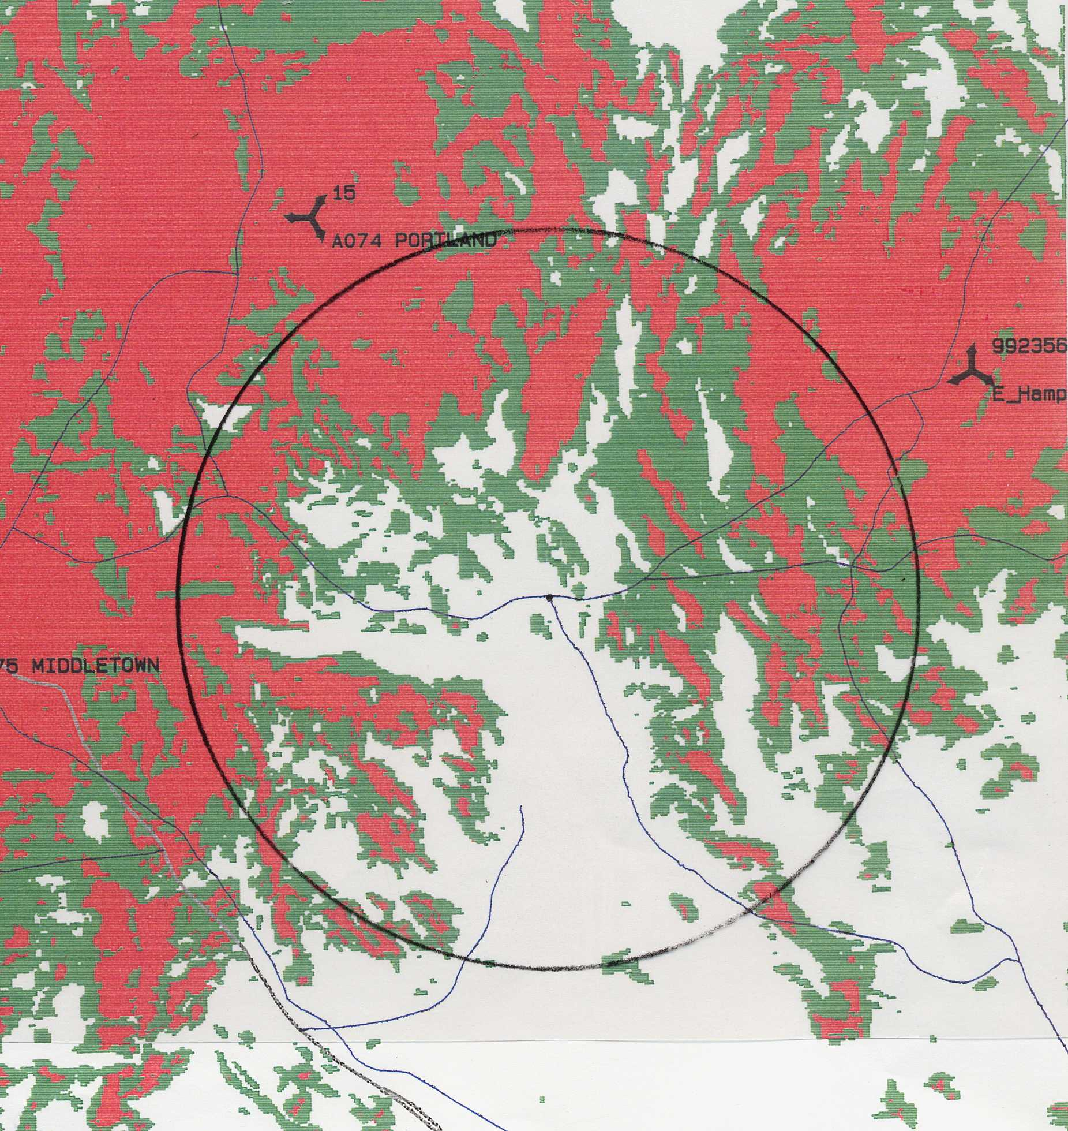

(Crown/Cellco 1, Tab 1)
Note: use scale from Appendix E

Appendix B
(Cellco existing coverage with proposed prime tower or alternate site tower with antennas at 390 feet amsl)

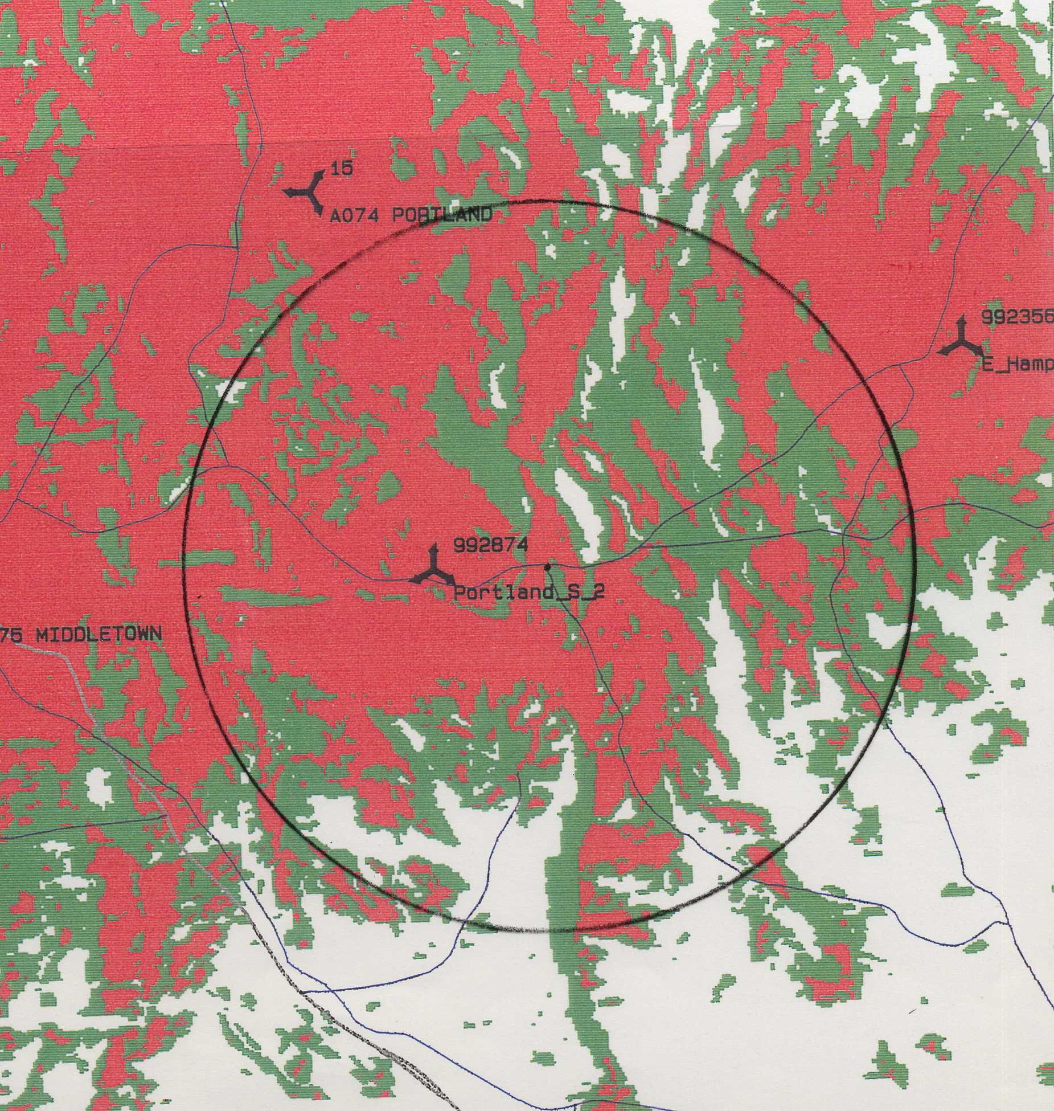

(Crown/Cellco 1, Tab 1)
Note: use scale from Appendix E

Appendix C
(Cellco existing coverage with antennas at the 495-foot level of the NRG facility stack - 517 feet amsl)

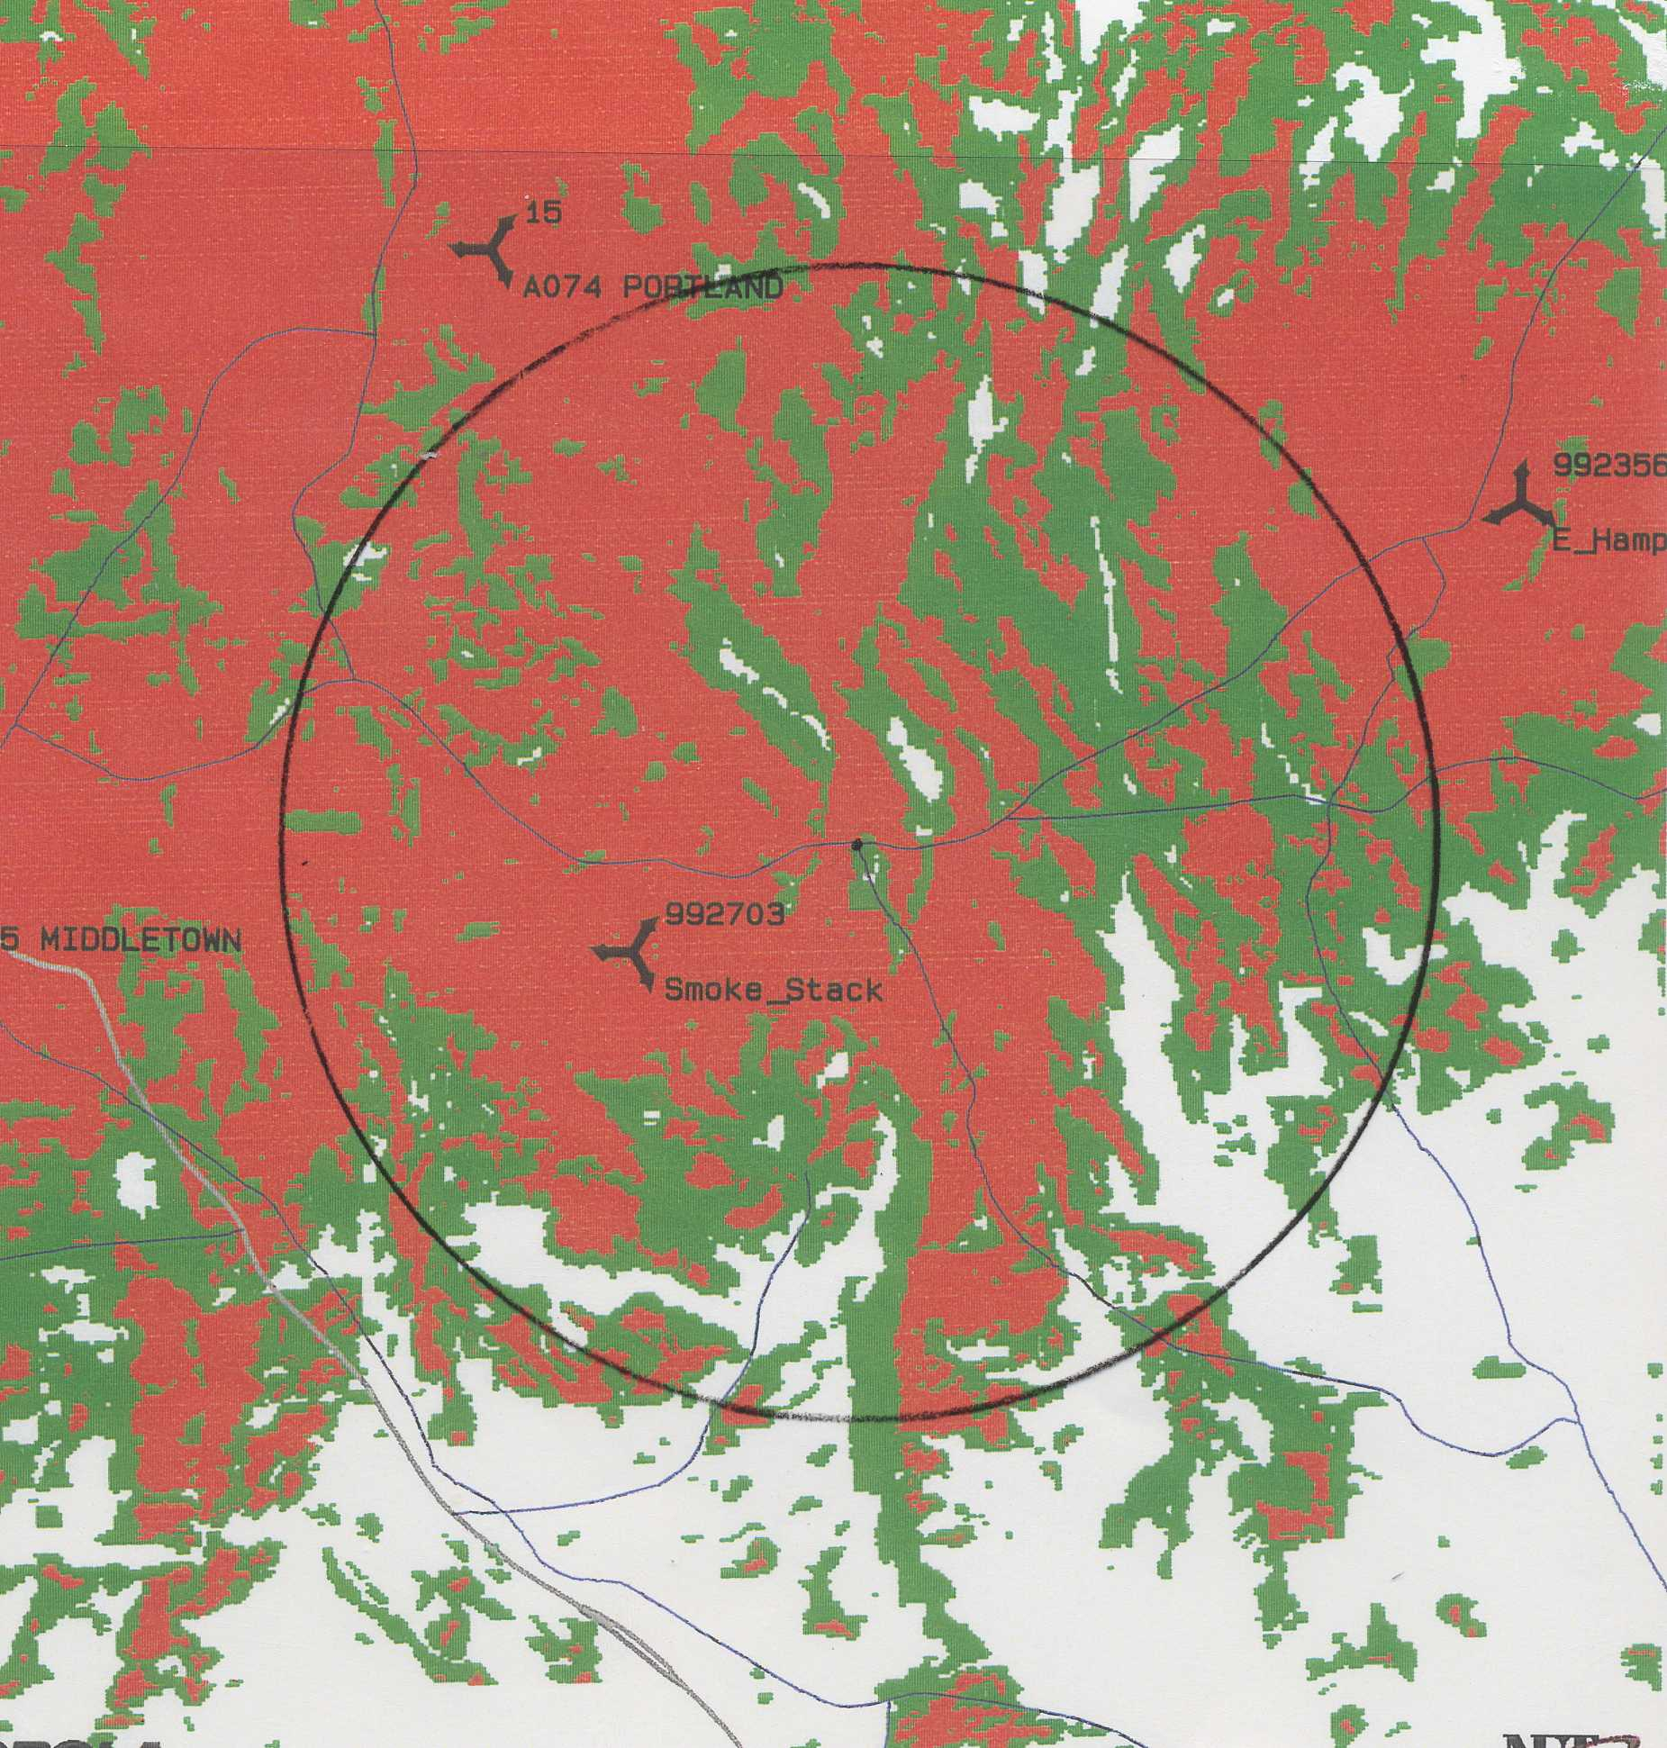

(Crown/Cellco 13, Q. 27)
Note: use scale from Appendix E

Appendix D
(Cellco existing coverage with antennas at the 100-foot level on an existing CL&P transmission structure combined with antennas at 160 feet on a Pratt and Whitney Tower)

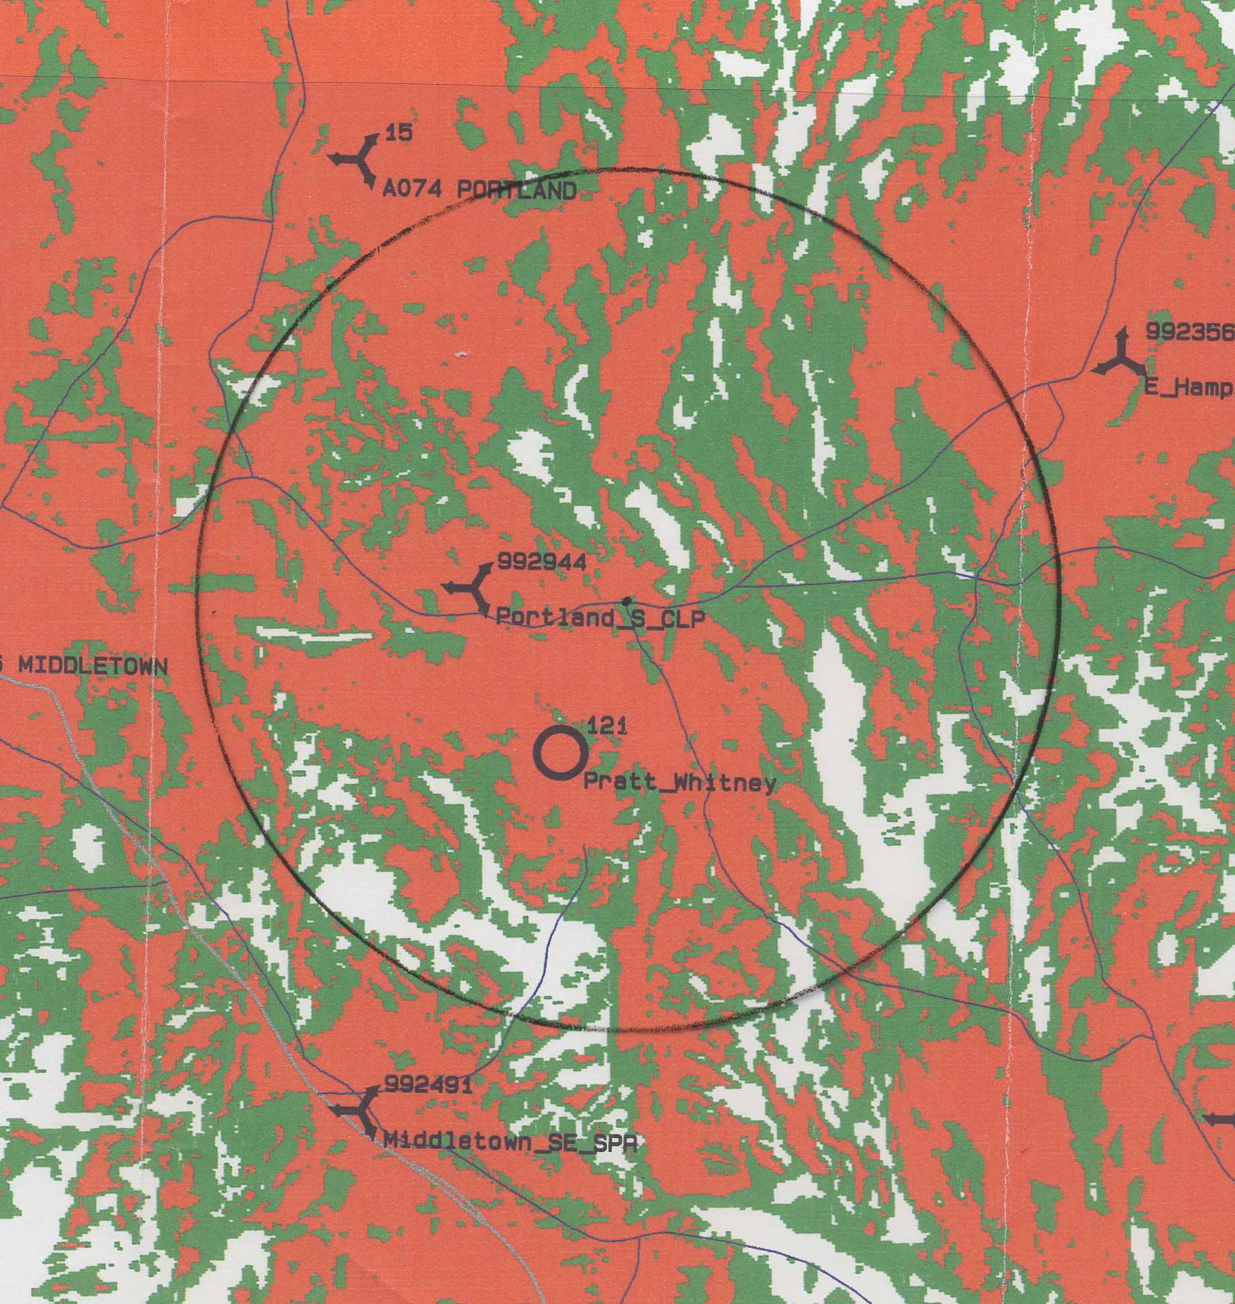

(Crown/Cellco 7, Q. 20)
Note: use scale from Appendix E

Appendix E
(Cellco existing coverage with antennas on a 100- foot CL&P transmission structure combined
with antennas at 170 feet on a proposed Sprint tower)

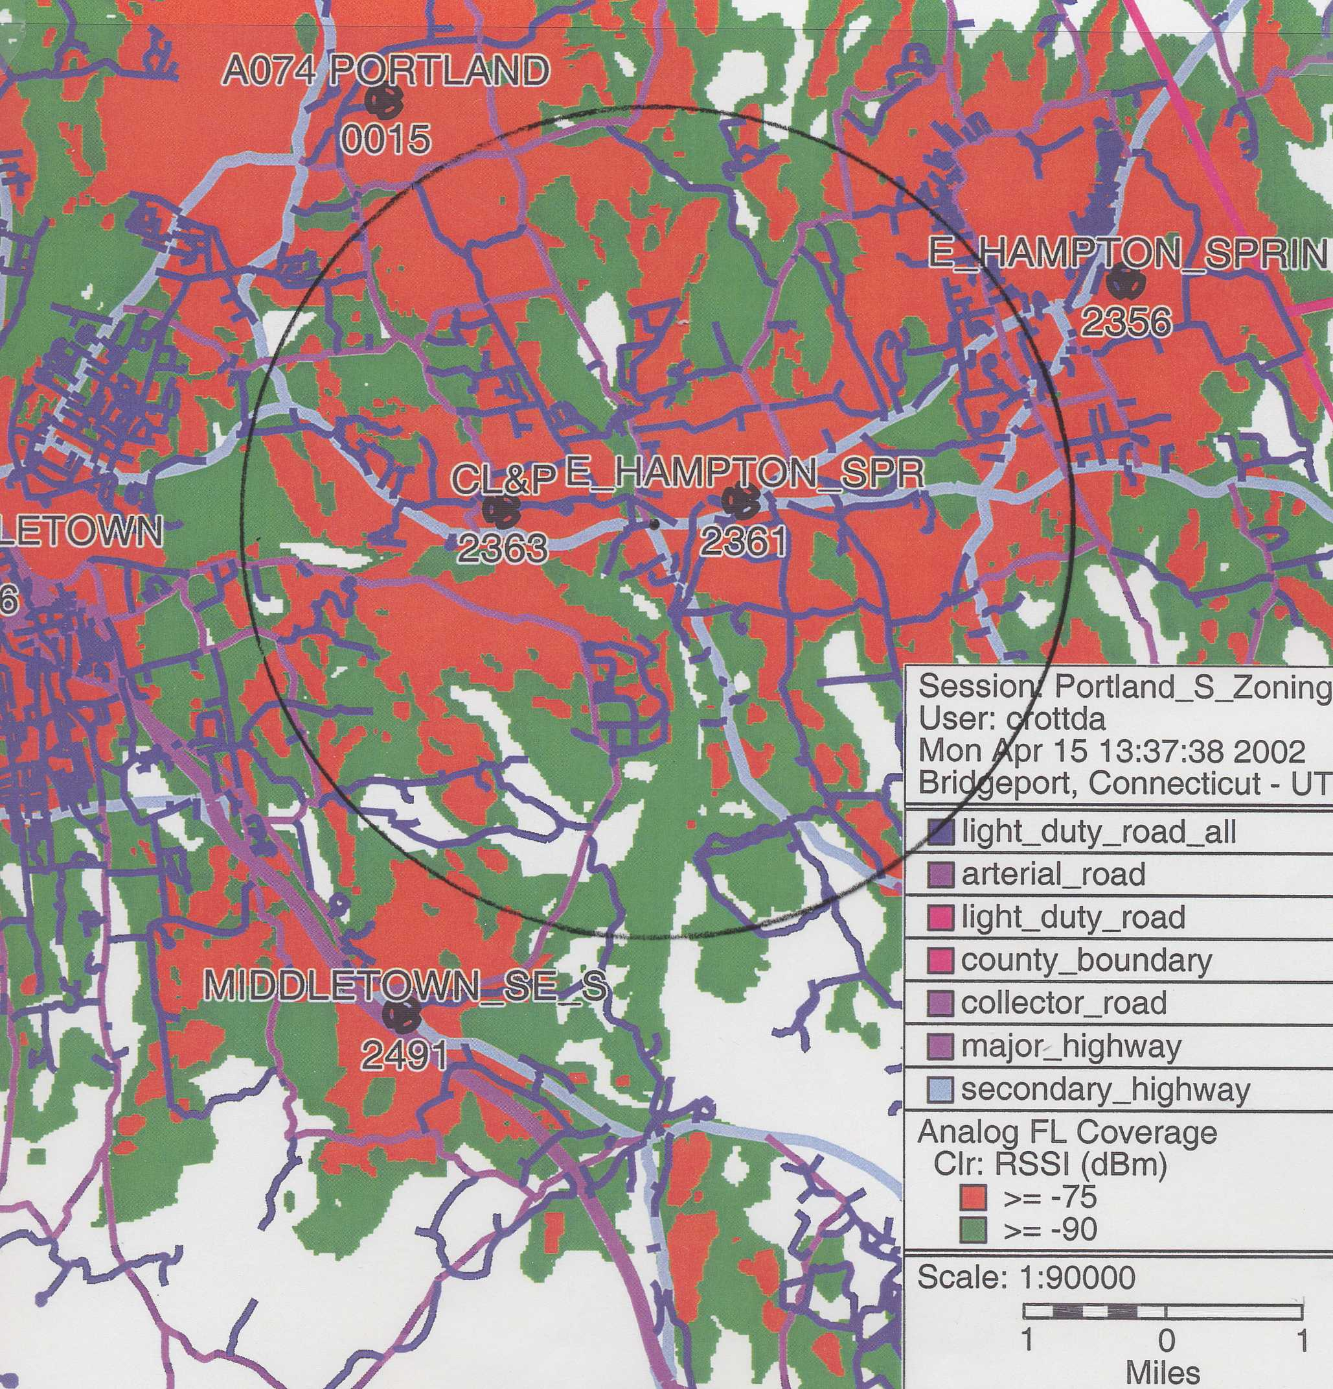

(Crown/Cellco 13, Q. 28)

