Petition No. 1407
Torrington Solar One, LLC and VCP, LLC d/b/a Verogy
East Pearl Road, Torrington
DRAFT Staff Report
August 7, 2020

Introduction

On May 29, 2020, Torrington Solar One, LLC and VCP, LLC d/b/a Verogy (Petitioner) submitted a petition to the Connecticut Siting Council (Council) for a declaratory ruling pursuant to Connecticut General Statutes (CGS) §4-176 and §16-50k for the construction, operation and maintenance of a 1.975-megawatt (MW) alternating current (AC) solar photovoltaic electric generating facility located generally south of East Pearl Road and east of Torringford Street (Route 183) in Torrington, Connecticut.

Pursuant to Regulations of Connecticut State Agencies (RCSA) §16-50j-40, on or about May 28, 2020, the Petitioner notified City of Torrington officials, Town of New Hartford officials, state officials and agencies, the property owner, and abutting property owners of the proposed project.

On June 2, 2020, the Council sent correspondence to the Petitioner noting a deficiency in the completeness of the Petition. Specifically, pursuant to RCSA §16-50j-40, the Petition did not provide evidence of notice to the Department of Consumer Protection (DCP), the Department of Administrative Services (DAS), Department of Labor (DOL), the City of Torrington Conservation Commission, and the Town of New Hartford Conservation Commission. The Council recommended that the Petitioner provide such information on or before July 2, 2020. The Council received such correspondence from the Petitioner on June 3, 2020 demonstrating notice. Accordingly, by letter dated June 4, 2020, the Council rendered the Petition complete.

Pursuant to CGS §4-176(e) of the Uniform Administrative Procedure Act, an administrative agency is required to take action on a petition within 60 days of receipt. July 28, 2020 was the deadline for this petition under CGS §4-176(e). In response to the Coronavirus pandemic, on March 25, 2020, Governor Lamont issued Executive Order No. 7M that provides for a 90-day extension of statutory and regulatory deadlines for administrative agencies thus extending the deadline to October 26, 2020.

The Council issued interrogatories to the Petitioner on June 22, 2020, which include photographic documentation of site-specific features intended to serve as a virtual field review of the project. On July 9, 2020, the Petitioner submitted responses to the Council’s interrogatories. On August 5, 2020 Council staff member, Michael Perrone, visited the site.

Municipal Consultation

In December 2019, the Petitioner informed municipal officials in the City of Torrington and the Town of New Hartford of its plans to develop the project. In March 2020, the Mayor of Torrington asked the Petitioner to reach out to the adjoining property owners along the north side of the East Pearl Road, near the proposed site access drive. The Petitioners met with property owners, via Zoom teleconference, to discuss the project. The primary concern raised by the residents were potential visual impacts. In an effort to address the property owners’ visibility concerns, the Petitioner agreed to:

- Increase the setback of the northern solar array from 50 feet to 70 feet;
- Increase the height of the perimeter fence along East Pearl Road from six feet to eight feet;
- Install privacy slats on the fence along East Pearl Road;
- Relocate the project access drive to the eastern edge of the project area;
- Reorient the access drive to minimize any direct views into the project area; and
- Install a landscaped buffer along the northern fence line and between the fence and East Pearl Road to the west side of the access drive.

In April 2020, the Petitioner began public outreach to local residents, neighboring landowners and members of the greater Torrington and New Hartford communities by launching a project website and mailing letters on April 21, 2020 to abutting property owners regarding the project.

The Petitioner also hosted Virtual Public Information Meetings on May 18, 2020 and May 20, 2020. These meetings were attended by abutting property owners along the north side of East Pearl Road.

The Petitioner also gave a virtual presentation to the Torrington Planning and Zoning Commission on May 27, 2020 and attended the virtual Torrington City Council meeting on June 15, 2020 to provide the City Council with information on the project.

On June 1, 2020, the Council sent correspondence to the City of Torrington and the Town of New Hartford stating that the Council has received the Petition and invited the municipalities to contact the Council with any questions or comments by June 28, 2020. No comments were received from the Town of New Hartford. Comments were received from the City of Torrington as noted below.

By letter dated June 26, 2020, Mayor Carbone noted that the City Council had met on June 15, 2020; a number of neighbors expressed objections to the location of the proposed facility; and members of the City Council expressed the following concerns about the project:

- Proximity to residential homes on East Pearl Road and Gaylord Lane;
- Impact of the facility on abutting Bishop Donnelly Field;
- Conflicts with the City of Torrington’s Plan for Conservation and Development (Farmland Plan); and
- Location of the property within a historic district.

The City Council also expressed opposition to the project at this location and recommended that the City Council work with the Petitioner to identify and investigate other City-owned alternative sites.

By letter dated June 30, 2020, the Petitioner responded to the concerns of the City Council and noted the following:

- Petitioner met with municipal officials and submitted notice to all abutting property owners. Three abutting property owners on the north side of East Pearl Road and City Councilwoman Ruwet expressed concerns. In response to these concerns, the Petitioner made site layout changes including, but not limited to, the increase in fence height from six feet to eight feet on the north side and the use of privacy slats;
- The eight-foot tall fencing with privacy slats would also be utilized in the vicinity of Bishop Donnelly Field;
- The Farmland Plan includes a “farmland cluster” of ten parcels (including the subject parcel) totaling approximately 319 acres. The proposed project area of approximately 11.15 acres represents about 3.5 percent of the 319 acres of this “farmland cluster;”
- The State Historic Preservation Office (SHPO) determined that, with the revised site plans that include vegetative screening on the west side of the solar facility, the proposed project would not have an adverse effect on historic resources; and
- Upon request by the City Council, the Petitioner performed a preliminary feasibility analysis of the municipal landfill as an alternative site. A majority of the landfill has grades in excess of 20 percent, which leaves only a small area available for development. Installation on steep (i.e. more than 20 percent) slopes and on a capped landfill would add significantly to cost. Further, development on such steep slopes would likely be inconsistent with Department of Energy and Environmental Protection (DEEP) Stormwater Permit requirements.

State Official Comments

By letter dated June 26, 2020, State Representative Jay Case and State Senator Kevin Witkos expressed concerns about the proposed project relative to loss of farmland, neighbor concerns, wildlife impacts, and alternative sites.

State Agency Comments

On June 1, 2020, the Council sent correspondence requesting comments on the proposed project from the following state agencies by June 28, 2020: DEEP; Department of Agriculture (DOAg); Department of Public Health (DPH); Council on Environmental Quality (CEQ); Public Utilities Regulatory Authority (PURA); Office of Policy and Management (OPM); Department of Economic and Community Development (DECD); Department of Emergency Services and Public Protection (DESPP); DCP; DOL; DAS; Department of Transportation (DOT); the Connecticut Airport Authority (CAA); and SHPO.

DOT and DEEP submitted comments on June 23, and June 30, 2020, respectively. These comments are attached as Appendix A. No other state agencies provided written comments on this project.

While the Council is obligated to consult with and solicit comments from state agencies by statute, the Council is not required to abide by the comments from state agencies.

Public Act 17-218

Effective July 1, 2017, Public Act 17-218 requires, “for a solar photovoltaic facility with a capacity of two or more megawatts, to be located on prime farmland or forestland, excluding any such facility that was selected by DEEP in any solicitation issued prior to July 1, 2017, pursuant to section 16a-3f, 16a-3g or 16a-3j, the DOAg represents, in writing, to the Council that such project will not materially affect the status of such land as prime farmland or DEEP represents, in writing, to the Council that such project will not materially affect the status of land as core forest.” The proposed facility has a generating capacity of 1.975 MW. Therefore, it is exempt from the provisions of Public Act 17-218.

Public Benefit

The project would be a distributed energy resource facility as defined in CGS § 16-1(a)(49). CGS § 16a-35k establishes the State’s energy policy, including the goal to “develop and utilize renewable energy resources, such as solar and wind energy, to the maximum practicable extent.” The 2018 Comprehensive Energy Strategy (2018 CES) highlights eight key strategies to guide administrative and legislative action over the next several years. Specifically, Strategy No. 3 is “Grow and sustain renewable and zero-carbon generation in the state and region.” Furthermore, on September 3, 2019, Governor Lamont issued Executive Order No. 3, which calls for the complete decarbonization of the electric sector by 2040. The proposed facility will contribute to fulfilling the State’s Renewable Portfolio Standard and Global Warming Solutions Act as a zero emission Class I renewable energy source.

Energy produced by the project would be sold to The Connecticut Light and Power Company d/b/a Eversource Energy (Eversource) at market rates specified in the applicable utility tariff with Eversource for a self-generating facility. The Petitioner would sell renewable energy certificates (RECs) to Eversource via a 15-year Low Emission Renewable Energy Certificate (LREC) contract (executed in August 2019) under the state’s Low and Zero Emissions Renewable Energy Credit Programs (LREC/ZREC Program). The LREC/ZREC Program was developed as part of Public Act 11-80, “An Act Concerning the Establishment of the [DEEP] and Planning for Connecticut’s Energy Future.” The LREC/ZREC Program is not among the competitive energy procurement programs that are exempt from Public Act 17-218.

The LREC/ZREC Program creates a market-driven bidding process for renewable energy projects ranging from rooftop solar panels to fuel cells to compete to obtain a 15-year revenue stream from the sale of renewable energy credits (RECs) to the electric utilities. It requires Eversource and the United Illuminating Company (UI) to procure Class I RECs under 15-year contracts with owners or developers of renewable energy projects in the state.

The Petitioner would participate in the ISO-New England, Inc. Forward Capacity Auction #15 in 2021 for the 2024 to 2025 Capacity Commitment Period.

Proposed Site

The proposed facility would be located on an approximately 11.15-acre portion of a 66.4-acre parcel owned by the Catholic Cemeteries Association of the Archdiocese of Hartford within the City of Torrington’s Residential Water Protection (R-WP) and Residential Single Family (R-15S) zoning districts. The subject property is bounded by East Pearl Road to the north; by Torringford Street (Route 183) to the west; by Harrison Road to the east; and by agricultural and residential land off of Gaylord Lane to the south. The easterly portion of the subject property is developed and occupied by Saint Peter’s Cemetery and undeveloped woodland areas. The westerly portion of the subject property is largely undeveloped and contains a wooded wetland area, a vernal pool and intermittent watercourses. The central portion of the subject property (including the proposed project development area) is currently used for agricultural and recreational purposes (Bishop Donnelly field.)

Considerations in Petitioner’s site selection process include, but are not limited to, the following:

- parcel size, grade, and surrounding topography;
- availability of land for lease or purchase;
- proximity to the electrical infrastructure; and
- potential environmental effects.

Proposed Project

The proposed solar field is made up of two arrays separated by the proposed access drive and totaling 1.975 MW AC. The entire project would be located on the host property.

The solar field would include a total of 7,150 solar photovoltaic modules: 5,876 modules at 390 Watts direct current (DC) each and 1,274 modules at 380 Watts DC each. The modules would be installed on a fixed-tilt racking system and oriented to the south at a 30 degree angle. The modules would be mounted to a ground-mounted racking system. The modules would be installed with a ground clearance of approximately three feet. The maximum height to the tops of the solar panels would be approximately 10 feet.

The racking system would be supported by driven beams (about eight to ten feet deep) and/or drilled piers to be installed using a pile driver. If refusals are encountered due to dense subsurface conditions, a ground screw option would be utilized. If ledge is encountered, drilling of holes backfilled with grout would be performed.

The Petitioner would install 16 inverters. The AC power output from the inverters would feed into two step-up transformers (each to be located on a concrete pad) to raise the voltage to the level of the existing electric distribution.

The efficiency of the proposed solar panels would be approximately 19.5 to 20.2 percent. The maximum annual power degradation (as the panels age) would be 0.5 percent per year.

Fencing would consist of an eight-foot tall chain-link fence with privacy slats to be located on the north side along East Pearl Road and adjacent to Bishop Donnelly Field. The remainder of the fencing would be six-foot tall chain link fence.

A new 12-foot wide gravel access drive would extend from East Pearl Street south to serve the proposed facility and would include two turn-arounds. A total of approximately 0.28-mile of new access would be constructed.

The Petitioner executed an interconnection agreement with Eversource in February 2020. The electrical interconnection would run overhead on approximately ten new distribution poles approximately 45 feet tall for about 720 feet from the equipment pads on the southwest corner of the site to Torringford Street to connect to Eversource’s 23-kilovolt distribution system. Four new distribution poles would be installed within Wetland 1 in the southwest portion of the site to construct this electrical interconnection route.

While the Petitioner could run its electrical interconnection route to the north to East Pearl Street to avoid impacts to Wetland 1, the Petitioner has been working to limit the visual impact of the project on neighbors to the north. Additionally, relocating the electrical interconnection would result in about $150,000 to $165,000 in additional costs due to required reconductoring and adding a radial recloser. This would increase the costs of the interconnection by about 76 percent.

No trees would be removed to construct the project. Existing slopes within the project footprint are suitable for the arrays and would not require alteration. Approximately 245 cubic yards of material would be removed for the development of the access drive entrance, and approximately 660 cubic yards of material would be excavated for the three water quality basins around the site perimeter. Any material that cannot be reused on-site would be removed and disposed of in accordance with applicable regulations.

Construction of the project would commence in the third quarter of 2020. Final site stabilization, testing and commissioning would be completed by approximately year-end 2020. Work hours would typically be 7:00 a.m. to 7:00 p.m., Monday through Saturday.

Public Safety

The proposed project would comply with the National Electric Code, National Electric Safety Code and National Fire Protection Association Codes and Standards, as applicable. If one section of the solar array experiences an abnormal operation, that section can shut down while the remaining sections (on separate inverters) can remain active. The facility would be remotely monitored and would have the ability to be remotely de-energized in case of an emergency.

Prior to operation, the Petitioner would meet with the City of Torrington first responders to provide them with information regarding responses to emergencies at solar facilities, discuss industry best practices and provide a tour of the facility. All City of Torrington emergency response personnel would be provided access via a Knox pad lock.

The nearest federally-obligated airport to the proposed facility is Bradley International Airport in Windsor Locks, which is approximately 21 miles to the north-northeast of the proposed site. By letters dated April 22, 2020, the Federal Aviation Administration (FAA) issued a Determination of No Hazard to Air Navigation. The solar modules are designed to absorb incoming solar radiation and minimize reflectivity; thus, only a small percentage of incidental light would be reflected off the panels. Such incidental light is significantly less reflective than common building materials or the surface of a smooth water body.

Any noise associated with the construction of this project would be temporary in nature and exempt per DEEP Noise Control Regulations. The proposed project is expected to meet the DEEP noise standards at the property boundaries.​

Environmental Effects and Mitigation Measures

Historic and Recreational Resources

Heritage Consultants (Heritage) prepared a Phase 1A Cultural Resources Assessment Survey dated February 2020 (Phase 1A Report). According to the Phase IA Report, the proposed solar facility is located within the Torringford Street Historic District, which is listed on the National Register of Historic Places. Two properties listed on the State Register of Historic Places are located within one-mile of the proposed project: a federal farmhouse located at the northeast corner of Gaylord Lane and Torringford Street and a colonial farmhouse located at 1280 Torringford Street. Heritage noted that the proposed project has the potential to impact the viewshed of built resources within the historic district and based on the landscape type, proximity to freshwater, and the presence of well-drained loamy soils, the entire project area appears to retain a moderate/high sensitivity for yielding archaeological deposits. Heritage recommended that the Petitioner consult with SHPO and conduct a Phase 1B Survey.

Heritage prepared a Phase 1B Cultural Resources Reconnaissance Survey Report dated April 2020 (Phase 1B Report). Heritage noted that a total of 136 shovel tests were excavated within the project area. No cultural materials, cultural features, or soil anomalies were identified. Thus, Heritage determined that no impacts to significant cultural resources would be expected to result from the construction of the proposed facility. Therefore, no additional archaeological examination of the subject property is recommended.

By letter dated June 29, 2020, SHPO concurs that no additional archaeological investigations are warranted. SHPO also notes that it received revised plans that include vegetative screening to be installed along the western portion of the solar field, facing Torringford Street. See attached drawing “Proposed Site Layout.” SHPO determined that the proposed project would have no adverse effect on historic resources with the employment of the mitigation measures.

Bishop Donnelly Field is an on-site athletic field, located in the north-central portion of the subject property. Year-round views of the proposed facility from Bishop Donnelly Field would be expected. However, the proposed eight-foot tall fence with privacy slats in the vicinity of Bishop Donnelly Field would provide screening of the facility.

The nearest off-site recreational area is Pleasant View Park located 0.8-mile to the southwest of the site. The proposed facility is not expected to be visible from Pleasant View Park.

Visibility

Predicted year-round visibility of the proposed facility would be confined to areas within the immediate vicinity of the facility, primarily from residential properties on East Pearl Road located north of the site. Predicted year-round visibility would also be experienced from open fields north of East Pearl Road and to the south of the site. In order to minimize the visual impacts on East Pearl Road, the Petitioner would install an eight-foot chain link fence with black vinyl covering and black privacy slats along the north and northwest fence lines, including the fence opposite the athletic field. Additionally, vegetative screening consisting of arborvitae would be installed along the northern fence line and west side of the access drive between East Pearl Road and the fence.

Limited seasonal (or “leaf off”) views could extend beyond the site approximately 0.25-mile to the south and west and between 0.25 and 0.50 mile to the north. Potential views from nearby locations to the west within the Torringford Street Historic District would be limited by existing mature vegetation, existing development and landscaping to be installed on the west side of the facility. In general, views beyond the immediate area would be minimized by a combination of the facility’s low height and the presence of intervening vegetation.

Agriculture

The proposed site contains approximately 33 acres of Prime Farmland Soils. Of that acreage, approximately 11.1 acres are located within the limits of the project area. The Petitioner proposes using minimally intrusive methods for constructing the facility. Specifically, the use of pile-driven posts for the installation of the solar panel racks and other equipment would minimize the need for substantial grading. Outside of the facility’s southern and southeastern fence lines, the installation of three stormwater basins would require soil disturbance. Any excavated material would be either spread as top dressing for reestablishing vegetation or removed from the site. No topsoil would leave the site. Thus, the proposed project would not materially affect Prime Farmland Soils.

No portion of the project area is currently in use for agricultural purposes. In prior years, the project area was leased to a third party (Ruwet Family) for agricultural use. The lease agreement granting the Ruwet Family the right to use the property expired and was not renewed.

Wetlands and Watercourses

The topography of the site gently slopes down from north to south. Wetland 1 is located west of the proposed project area and consists of a complex of forested and agricultural wet meadow habitats that have been significantly disturbed by historic agricultural use and residential development. An intermittent watercourse, identified as IWC-1, is located within Wetland 1 and drains north to south. Wetland 2 is located southwest of the project area along the southern limits of the subject property. Wetland 2 consists of primarily forested habitat that has been significantly disturbed by historic agricultural activities. Another intermittent watercourse, identified as IWC-2 is located around the western edge of the mixed hardwood forest habitat area, northeast of the project area.
There would be no direct impacts to Wetland 2 or the watercourses. However, the proposed electrical interconnection would result in direct permanent and temporary impacts to the southern portion of Wetland 1. Specifically, four new poles would be installed within Wetland 1 and would result in approximately 28 square feet of permanent impacts due to associated excavation/backfill work and pole installations. Temporary direct impacts would be due to the access required to install the poles. Minor clearing of vegetation would be required to facilitate the placement of construction matting. Temporary impacts would be minimized by limiting clearing for the placement of such construction matting. The Petitioner would restore any disturbed soils within wetlands areas due to the use of construction matting.

Wetland impact areas and associated buffer distances to wetlands and watercourses are identified in the table below.
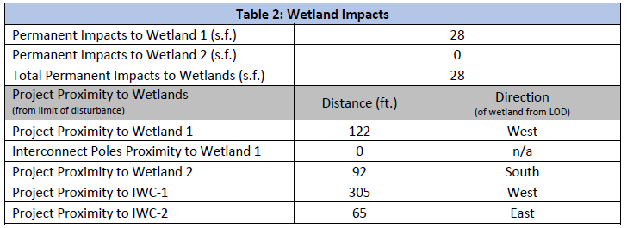
Vernal pool surveys were conducted on the site on March 18, 2020; April 7, 2020; and April 14, 2020. One vernal pool was identified in Wetland 1. See Vernal Pool Map. Indicator species and egg mass totals are identified in the table below.

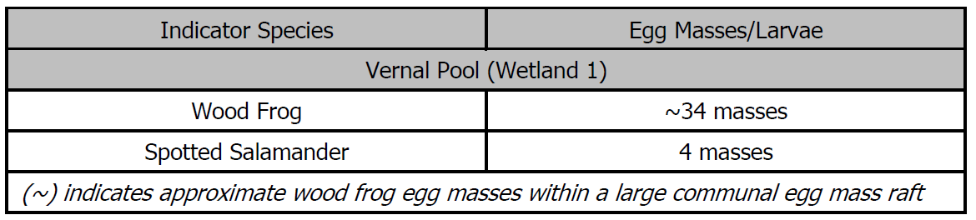

The proposed project would be consistent with U.S. Army Corps Vernal Pool Best Management Practices (ACOE BMPs). The 100-foot vernal pool envelope (VPE) would not be impacted. The pre-construction percent developed area of the 100-foot to 750-foot Critical Terrestrial Habitat (CTH) is approximately 32 percent. Post-construction, the percent developed area of the CTH would be approximately 50 percent. Areas proposed to be converted from agricultural field to development within the CTH are suboptimal for herpetofauna using the vernal pool and provide no substantive cover; thus, the proposed project would not significantly alter important vernal pool habitat. The Petitioner proposes to establish a Habitat Enhancement Area to improve the quality of the habitat peripheral to the facility and the vernal pool and Wetland 2 to the south and the larger forested habitat east of the project area.

To further protect wetlands and watercourses during construction, a project-specific Wetland and Vernal Pool Protection Plan and an erosion and sedimentation control plan consistent with the 2002 Connecticut Guidelines for Soil Erosion and Sediment Control would be implemented to mitigate potential impacts to wetland resources.

Wildlife

The proposed project is not located within 0.25-mile of the buffered area of the DEEP Natural Diversity Database (NDDB). The nearest NDDB area is located approximately 1.8-miles southeast of the subject property.

The northern long-eared bat (NLEB), a state-listed Endangered Species and federally-listed Threatened Species, is known to occur in Connecticut. However, the nearest known NLEB habitat resource in Connecticut is located approximately 5.9 miles to the northwest in Winchester. There are no known NLEB maternity roost trees in Connecticut. Additionally, the proposed project does not require tree clearing; thus, there would be no impact to NLEB habitat.

Forest

Under PA 17-218, “core forest” means unfragmented forest land that is three hundred feet or greater from the boundary between forest land and nonforest land, as determined by the Commissioner of DEEP. UCONN’s Center for Land Use Education and Research (CLEAR) defines “core forest” as forested areas that are essentially surrounded by more forested areas and fall into three classes – small core forest, medium core forest and large core forest. Small core forest is comprised of core forest patches that are less than 250 acres. Medium core forest is comprised of core forest patches that are between 250-500 acres. Large core forest is comprised of core forest patches that are greater than 500 acres.

UCONN CLEAR utilizes the concept of “edge width” to capture the influence of a non-forest feature as it extends into the forest. Research found that the “edge influence” of a clearing will typically extend about 300 feet into the forest.

The proposed project area does not contain any “core forest,” and no tree clearing is proposed for this project.

Air Quality

The project would not produce air or water emissions as a result of operation. The solar project would not produce air emissions of regulated air pollutants or greenhouse gases during operation.

Water Quality

The site is not located within a Federal Emergency Management Agency designated 100-year or 500-year flood zone. The site parcel is also not located within a DEEP-designated Aquifer Protection Area.

There are wells on the subject property associated with St. Peter’s Cemetery and off-site wells on properties to the north of the site. However, no groundwater impacts are anticipated to result from the construction of the project. Vibrations from the installation of the racking system are not expected to cause sediment releases, and no disruption to well water flow or quality is anticipated.

Stormwater

Pursuant to CGS Section 22a-430b, DEEP retains final jurisdiction over stormwater management and administers permit programs to regulate stormwater pollution. DEEP regulations and guidelines set forth standards for erosion and sedimentation control, stormwater pollution control and best engineering practices. The DEEP Individual and General Permits for the Discharge of Stormwater and Dewatering Wastewaters from Construction Activities (Stormwater Permit) requires implementation of a Stormwater Pollution Control Plan to prevent the movement of sediments off construction sites into nearby water bodies and to address the impacts of stormwater discharges from a project after construction is complete. A DEEP-issued Stormwater Permit is required prior to commencement of construction.

The Petitioner met with representatives of the DEEP Stormwater Division in January 2020. At that meeting, the Petitioner received recommendations to follow the DEEP’s draft Appendix I – Stormwater Management at Solar Array Construction Projects, and no concerns were raised.

The Petitioner applied for a DEEP Stormwater Permit on June 9, 2020.

Decommissioning Plan

A Decommissioning Plan was included in the Petition and has provisions for project removal after a useful life of at least 30 years. Following the removal of project related equipment, the site would be restored, and a seed mix would be applied to match existing on-site ground cover.

Conclusion

The project is a grid-side distributed resource with a capacity of not more than sixty-five megawatts, meets air and water quality standards of the DEEP, and would not have a substantial adverse environmental effect. The proposed project will not produce air emissions, will not utilize water to produce electricity, was designed to minimize environmental impacts, and furthers the State’s energy policy by developing and utilizing renewable energy resources and distributed energy resources. Furthermore, the project was selected under the State’s LREC/ZREC Program.

Recommendations

Staff recommends inclusion of the following conditions:
- Approval of any project changes be delegated to Council staff;
- Submit a copy of a DEEP Stormwater Permit prior to commencement of construction;
- Submit the final fence design in compliance with the National Electrical Code prior to the commencement of construction; and
- Submit the final electrical design plans and interconnection route on the subject property prior to commencement of construction.

Proposed Site Layout – with additional vegetative screening along Torringford Street

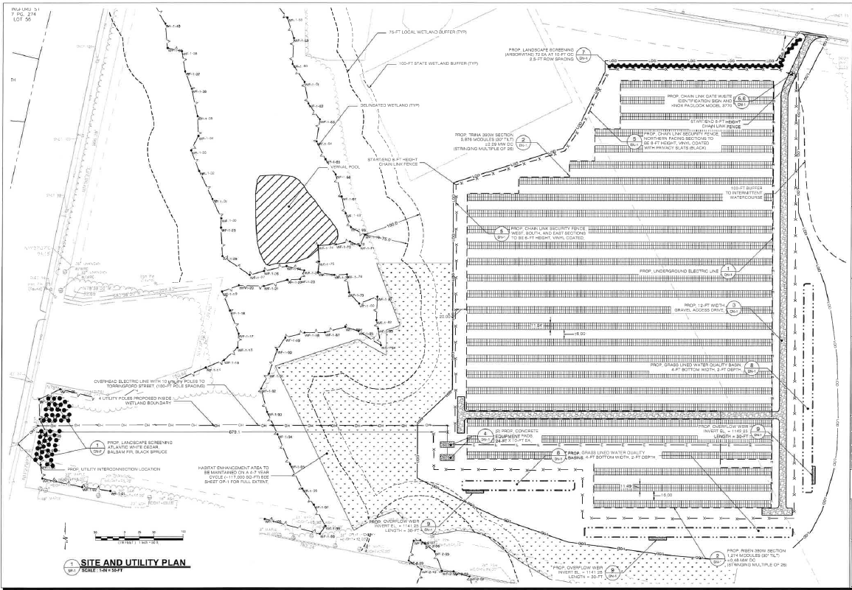

Aerial Site Plan

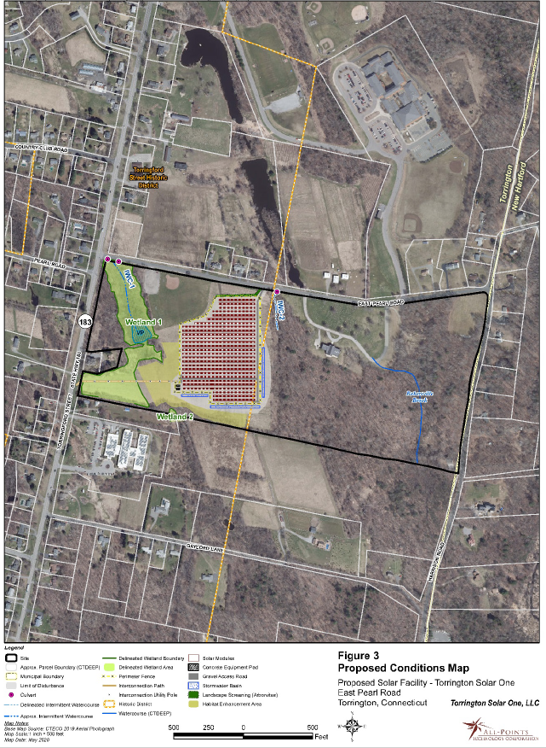

Vernal Pool Map

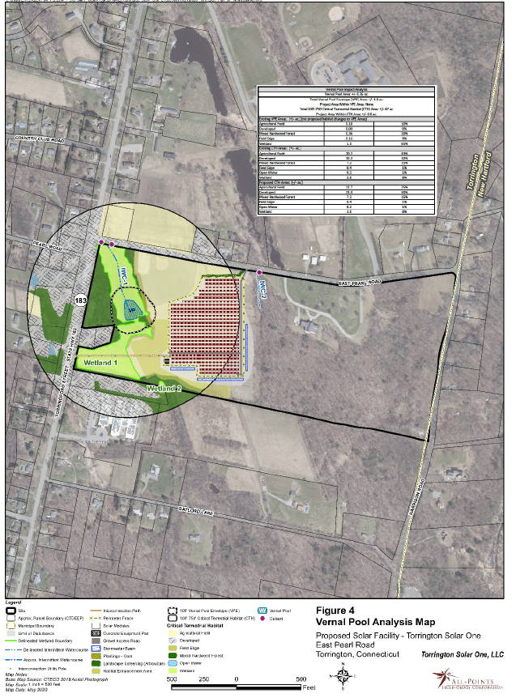

Viewshed Map

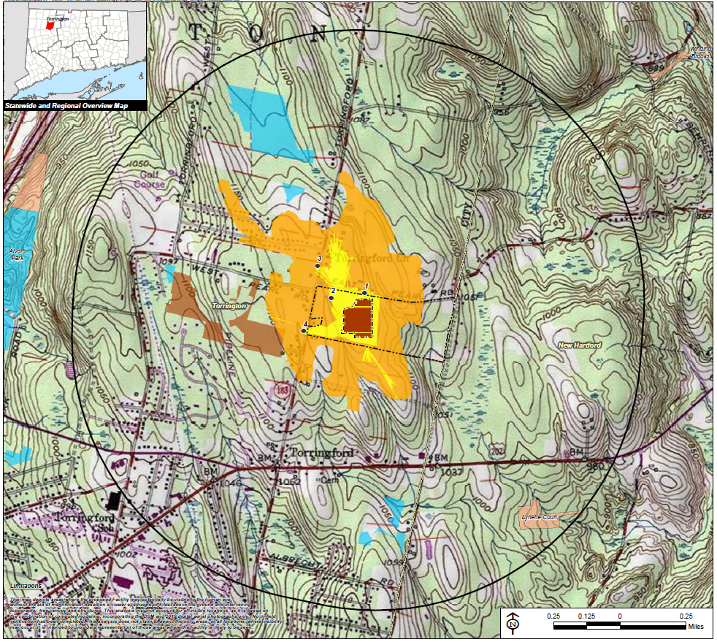
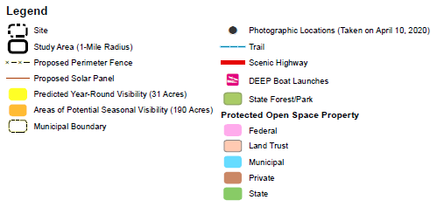

Appendix A - State Agency Comments

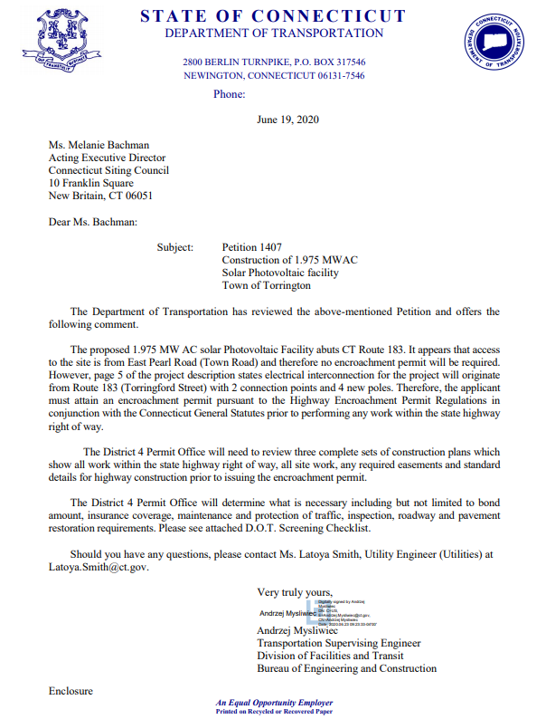



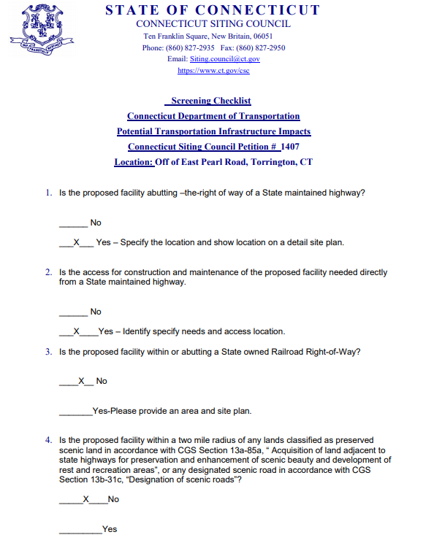

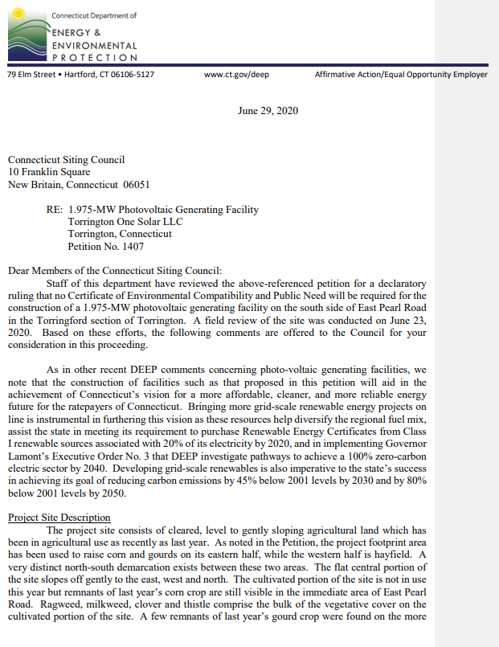

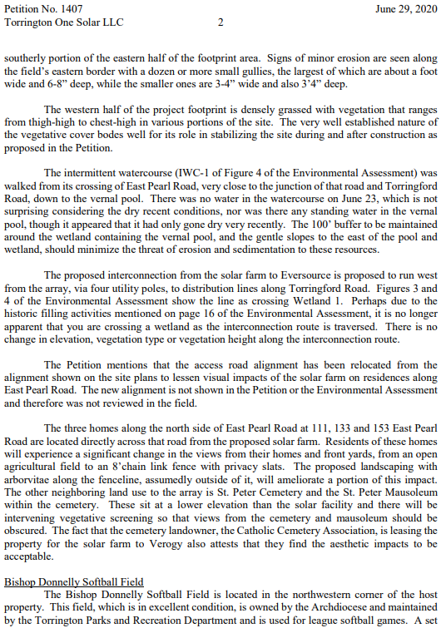

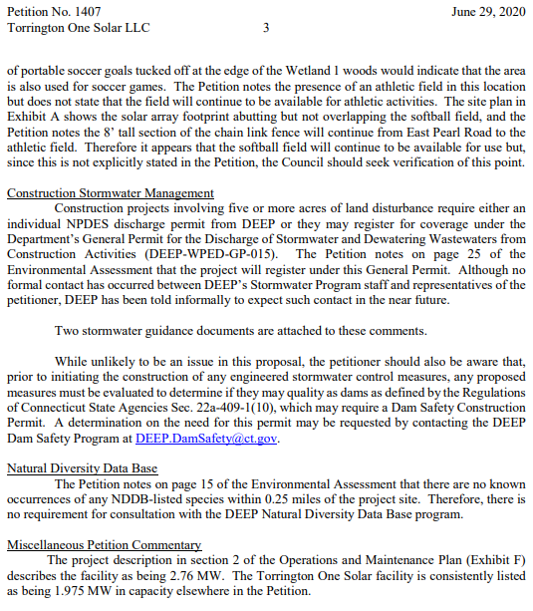

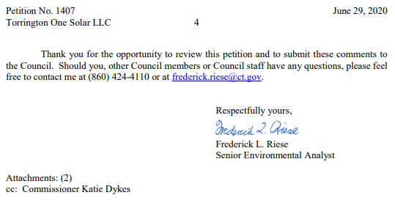

The Town of New Hartford is located within 2,500 feet of the proposed facility.
Corcoran v. Connecticut Siting Council, 284 Conn. 455 (2007)
Alternatively, in the event that virtual net metering capacity becomes available, energy produced by the project may be delivered to Eversource through the Virtual Net Metering (VNM) Rider or any successor rider thereto.
Section 691.4(2) of the National Electrical Code (NEC), 2020 Edition notes that, “Access to PV electric supply stations shall be restricted by fencing or other adequate means in accordance with 110.31…” Section 110.31 notes that for over 1,000 Volts, “…a wall, screen, or fence shall be used…A fence shall not be less than 7 feet in height or a combination of 6 feet or more of fence fabric and a 1 foot or more…utilizing barbed wire or equivalent.”

