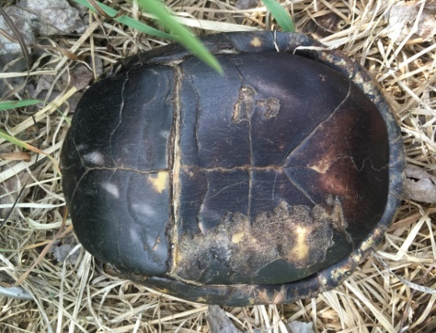
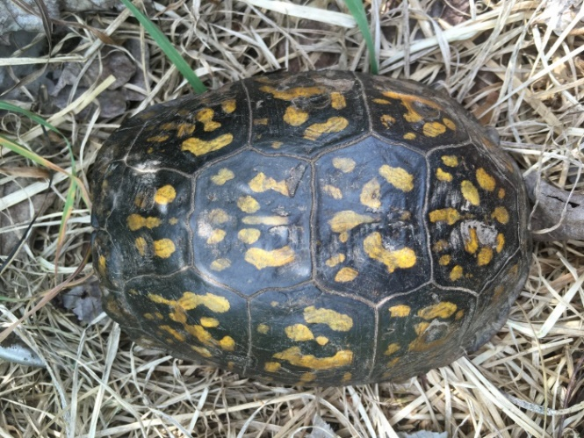
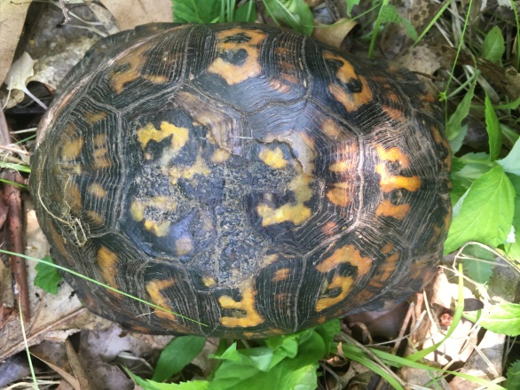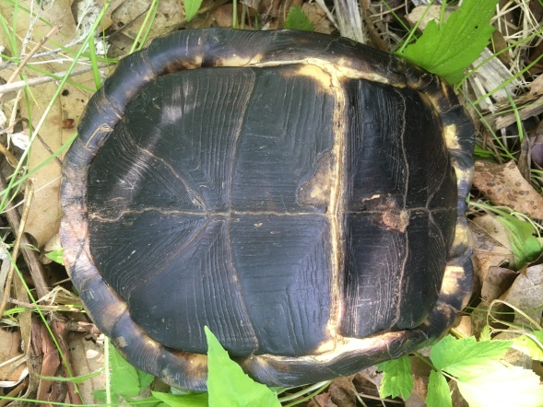
- Adult Female. 14 annuli, 60% worn.
- Captured 6/3/20
- On edge of early/ late successional vegetation between forest and hayfield.
- Marked L-1
- Mass: 540g, SLC: 134mm, SLP- ATL: 55.5mm; PL: 78.5mm
- 41.7290, -72.9366

- Adult Female, 0 annuli, 100% worn
- Captured 6/3/20
- 30ft into hayfield off herb/shrub soft edge & forest
- Marked L-2
- Mass: 610g, SLC: 143mm, SLP- ATL: 57mm; PL: 86mm
- 41.7288, -72.9367

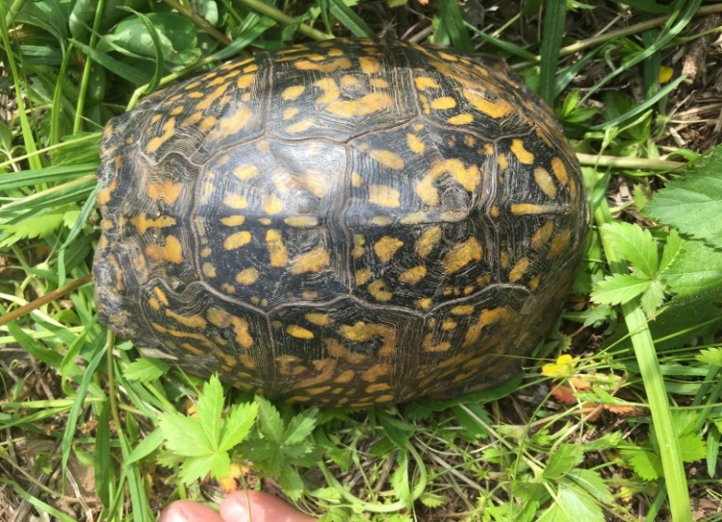
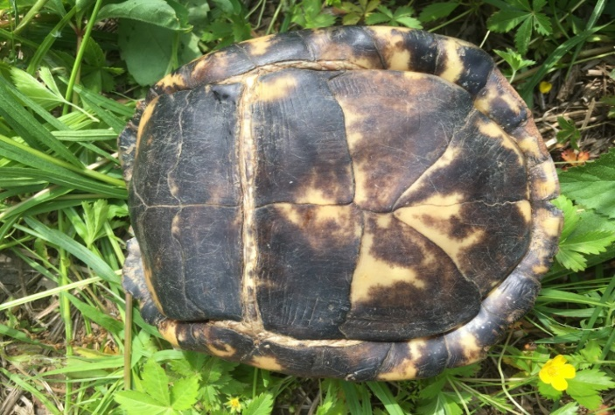
- Adult Female, 0 annuli, 100% worn
- Captured 6/3/20
- Edge of active mine, on shrub/herb edge.
- Marked R1
- Mass: 830g, SLC: 146mm, SLP- ATL: 60mm; PL: 90mm
- 41.7298, -72.9373

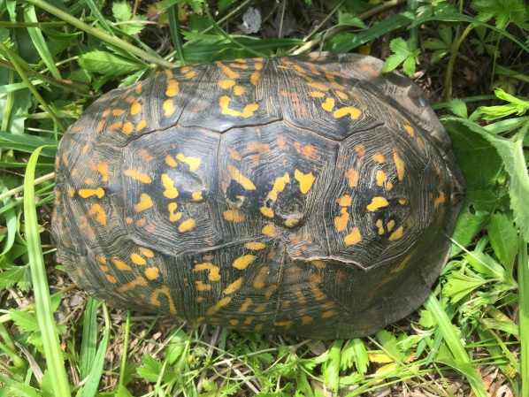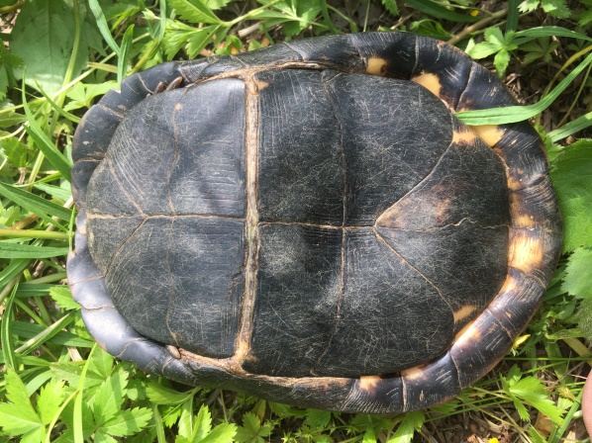
- Adult Male, 0 annuli, 100% worn
- Captured 6/3/20
- Edge of active mine, on shrub/herb edge
- Marked L-3
- Mass: 740g, SLC: 162mm, SLP- ATL: 59mm; PL: 87mm
- 41.7298, -72.9374

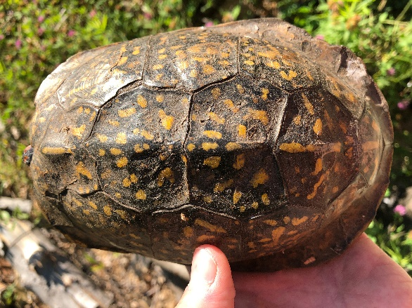
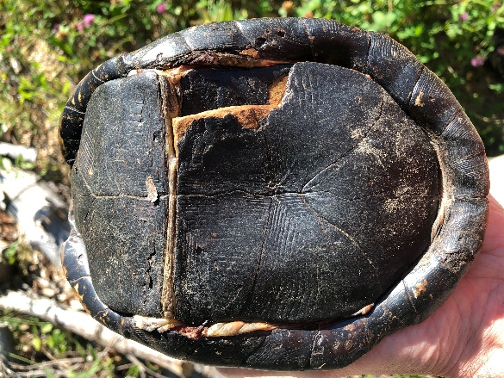
- Adult Male, 21+ annuli, 80% worn
- Captured 6/17/20
- Edge of active mine, under log pile
- Not marked (plastral damage will be used for re-identification)
- Morphometrics not recorded
- 41°43'50.23"N, 72°56'15.02"W
ACTIVE/81198.3/AGURREN/9136644v1

