56 Prospect Street
P.O. Box 270
Hartford, CT 06103

Deborah Denfeld
Team Lead - Transmission Siting
Tel: (860) 728-4654
Tel: (860) 205-9368
August 16, 2023

Melanie Bachman, Esq. Executive Director Connecticut Siting Council Ten Franklin Square
New Britain, CT 06051

Re: SUB-PETITION NO. 1293-OX-03 (Oxford) Eversource Energy declaratory ruling that no Certificate of Environmental Compatibility and Public Need is required for all transmission facility asset condition maintenance improvements statewide to comply with the updated National Electrical Safety Code clearance requirements.

Dear Attorney Bachman:

On October 25, 2022, Eversource Energy (“Eversource”) received an acknowledgement from the Connecticut Siting Council (“Council”) of Eversource’s notice to replace 4 transmission structures and install one new transmission structure on the 1319/1619 Lines in the Eversource transmission right-of-way in the Town of Oxford subject to conditions. Among other conditions of the acknowledgement, the Council required that Eversource submit the following item:

- Not less than 45 days after completion of the transmission line maintenance activity, the Council shall be notified in writing that construction has been completed.

Construction was completed on August 10, 2023.

Additionally, a representative photograph of the completed modification(s) to the existing energy facility, is included as Attachment A.

Eversource will be providing one original and two hard copies of this notice in the mail for the Council’s records.

Sincerely,
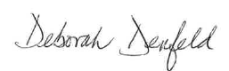
Deborah Denfeld
Team Lead – Transmission Siting

Attachment A – Photograph

Attachment A
Structure Access is off Commerce Drive.

Where does the 160 Christian St address come into play?
Representative Photograph
Completed Asset Condition Maintenance Improvements

Site: Structure 11156, Eversource 1619 Transmission Line ROW
160 Christian Street, Oxford, Connecticut

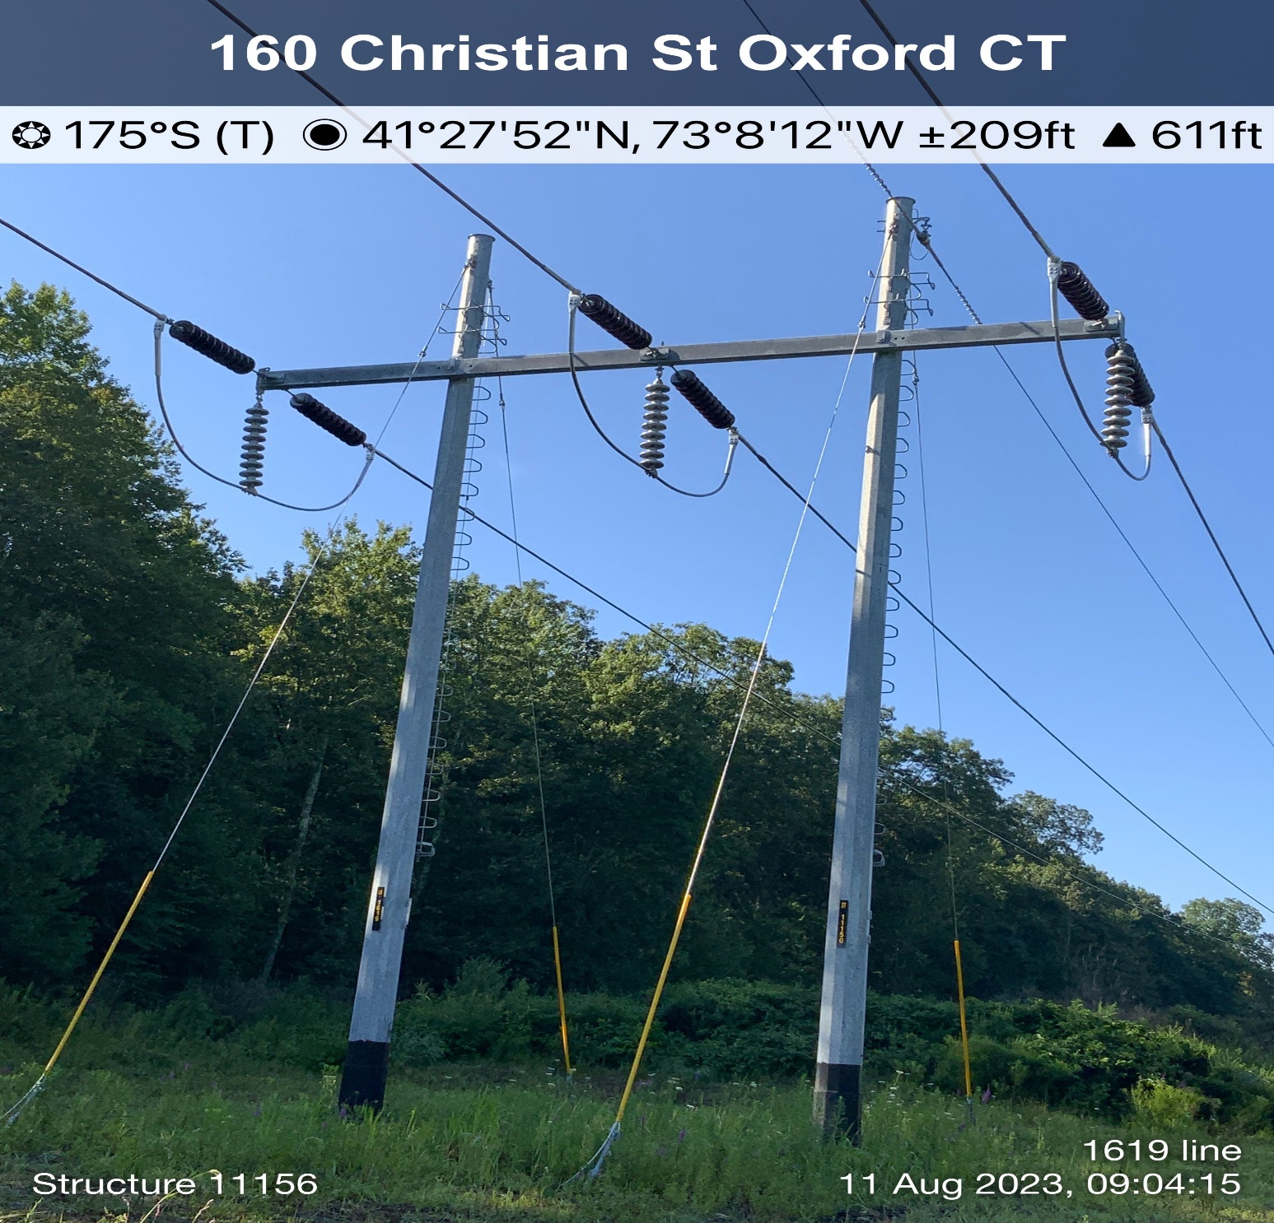

REPRESENTITIVE PHOTO
May 17, 2023

