Petition No. 981
New Cingular Wireless PCS
Milford, Connecticut
Staff Report
December 22, 2010

On November 22, 2010, the Connecticut Siting Council (Council) received a petition from New Cingular Wireless PCS (AT&T) for a declaratory ruling that no Certificate of Environmental Compatibility and Public Need is required for the modification of an existing transmission line tower located at 945 North Street (Route 121) in Milford, Connecticut. Council member Larry Levesque and staff member David Martin visited the site on December 22, 2010 to review the proposal. Daniel Laub of Cuddy & Feder and Andrew Thompson of Centerline Communications represented AT&T at the field review.

AT&T seeks to install six panel antennas (two per sector) on T-arm mounts at a centerline height of 127 feet above ground level on a 140-foot monopole transmission line tower (CL&P #24032). T-Mobile currently has three flush-mounted antennas installed on the tower at a centerline height of 137 feet above ground level. T-Mobile’s antennas were originally installed under Petition 635, which was approved in July of 2003. This original approval allowed T-Mobile to add a 15-foot pipe mast extension to an 80-foot tall tower. This tower was replaced by the current, taller tower as part of the upgrade of the Middletown – Norwalk transmission line that was the subject of Docket 272.

AT&T would place its ground equipment inside a 12-foot by 20-foot shelter that would be located adjacent to T-Mobile’s existing 11-foot by 22-foot compound. T-Mobile’s compound is enclosed with a wooden stockade fence; AT&T would not erect a fence around its shelter.

The transmission line tower on which AT&T seeks to install its antennas is located on a 5.49-acre parcel used as a garden center and by a landscaping business. Other than this commercial property, most of the development in the near vicinity is residential. However, AT&T’s proposed antenna installation should have little visual impact within the surrounding area as it will not increase the height of the existing tower, and there are many other similar towers that carry the Middletown to Norwalk transmission line along its path.

A structural engineer, duly licensed in the State of Connecticut, has certified that the existing transmission line tower and foundation are structurally capable of accommodating AT&T’s proposed antennas.

Council staff calculates that the proposed antennas, when added to the other antennas in place, would result in a power density equal to approximately 12.8% of the FCC’s applicable limit.

The proposed antenna installation on the transmission line tower is not expected to have any substantial adverse environmental effects.
View of existing transmission line tower
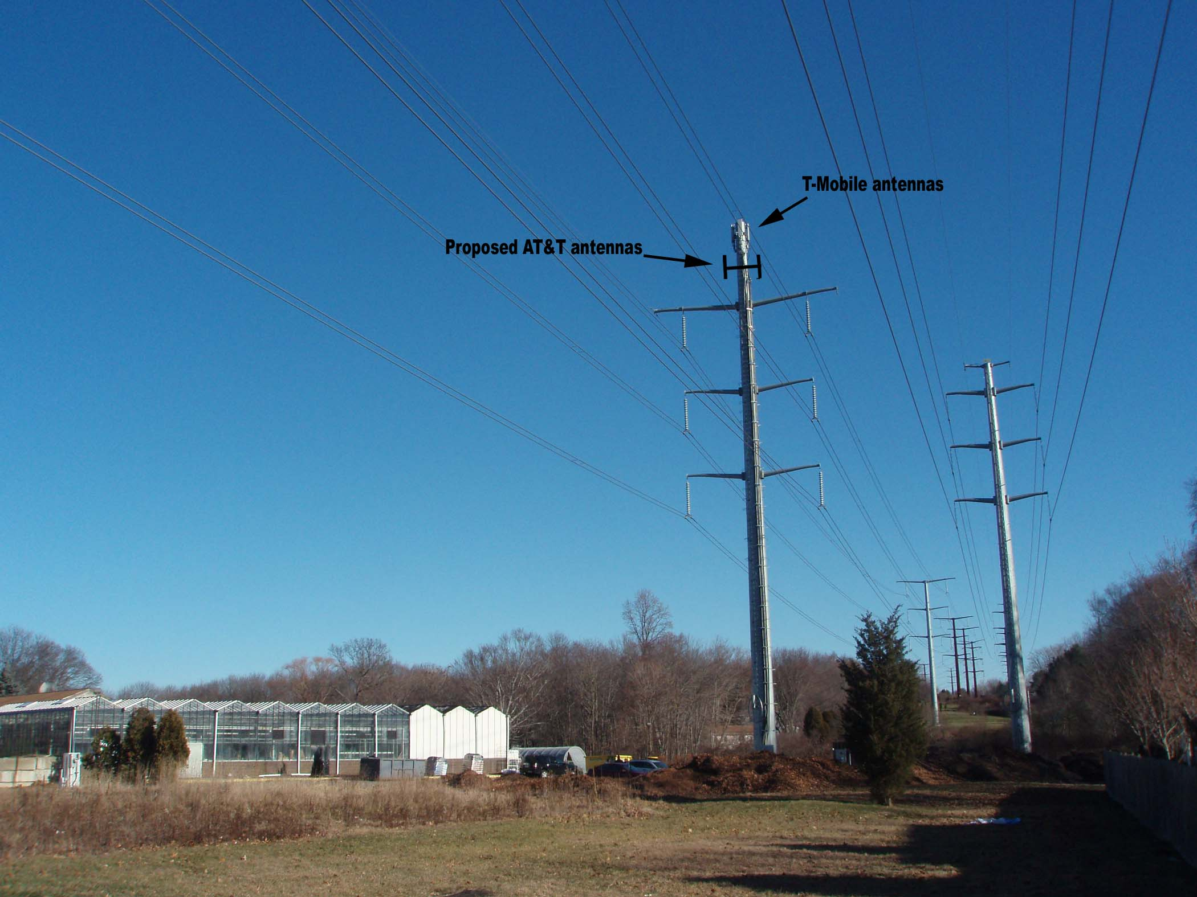

View of T-Mobile compound at base of transmission line tower
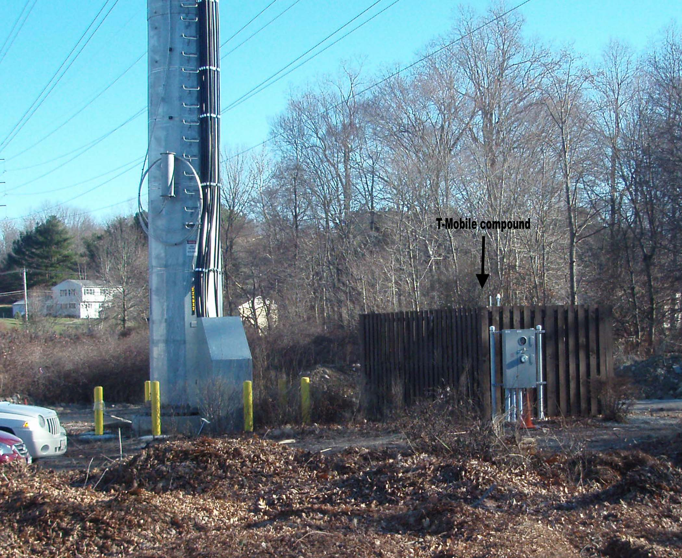

Cable mounts installed on existing tower


