Petition No. 974
T-Mobile Northeast, LLC
Norwalk, Connecticut
Staff Report
November 29, 2010

On October 25, 2010, the Connecticut Siting Council (Council) received a petition from T-Mobile Northeast, LLC (T-Mobile) for a declaratory ruling that no Certificate of Environmental Compatibility and Public Need is required for the modification of an existing transmission line tower located on the Oak Hills Golf Course owned by the City of Norwalk, Connecticut. Council member Dr. Barbara Bell and staff member David Martin visited the site on November 24, 2010 to review the proposal. Jennifer Gaudet represented T-Mobile at the field review.

The Oak Hills Golf Course is located in the west central area of Norwalk and is bisected by a CL&P transmission line. The towers for this transmission line are H-type lattice towers. One of these towers is located at the end of a paved area used to stage maintenance equipment and materials off of Charles Marshall Drive. Under Petition 459, Sprint received approval to install three antennas at centerline height of 103.5 feet on a pipe mast extension at the top of one side of this 95-foot tall tower. This approval was granted on May 17, 2000. T-Mobile now seeks to install antennas at a centerline height of 113.5 feet on a pipe mast extension to be installed on the other side of the same tower.

Sprint’s ground equipment was installed within a 17-foot by 30-foot compound that is enclosed by a wooden slat fence. T-Mobile would install a concrete pad next to Sprint’s existing compound and would enclose its own 18-foot by 14-foot compound area with a matching wooden slat fence. Cables from T-Mobile’s equipment cabinets would be extended underground to the base of the tower on which its antennas would be located and then up the side of the tower.

The Oak Hills Golf Course is surrounded by residences. But topography and mature vegetation make the tower on which T-Mobile’s antennas would be located difficult to see except for short distances on Fillow Street, which passes the golf course to the north, and from the nearest residential properties on Chipping Lane. The addition of the proposed antennas on the pipe mast extension is unlikely to increase the visibility of the transmission line tower beyond those areas that currently have views of it.

A structural engineer, duly licensed in the State of Connecticut, has certified that the existing lattice transmission line tower and foundation are structurally capable of accommodating T-Mobile’s proposed antennas.

Council staff calculates that the proposed antennas, when added to the other antennas in place, would result in a power density equal to approximately 18.3% of the FCC’s applicable limit.

The proposed antenna installation on the transmission line tower is not expected to have any substantial adverse environmental effects.
View of existing lattice transmission line tower; Sprint antennas on right
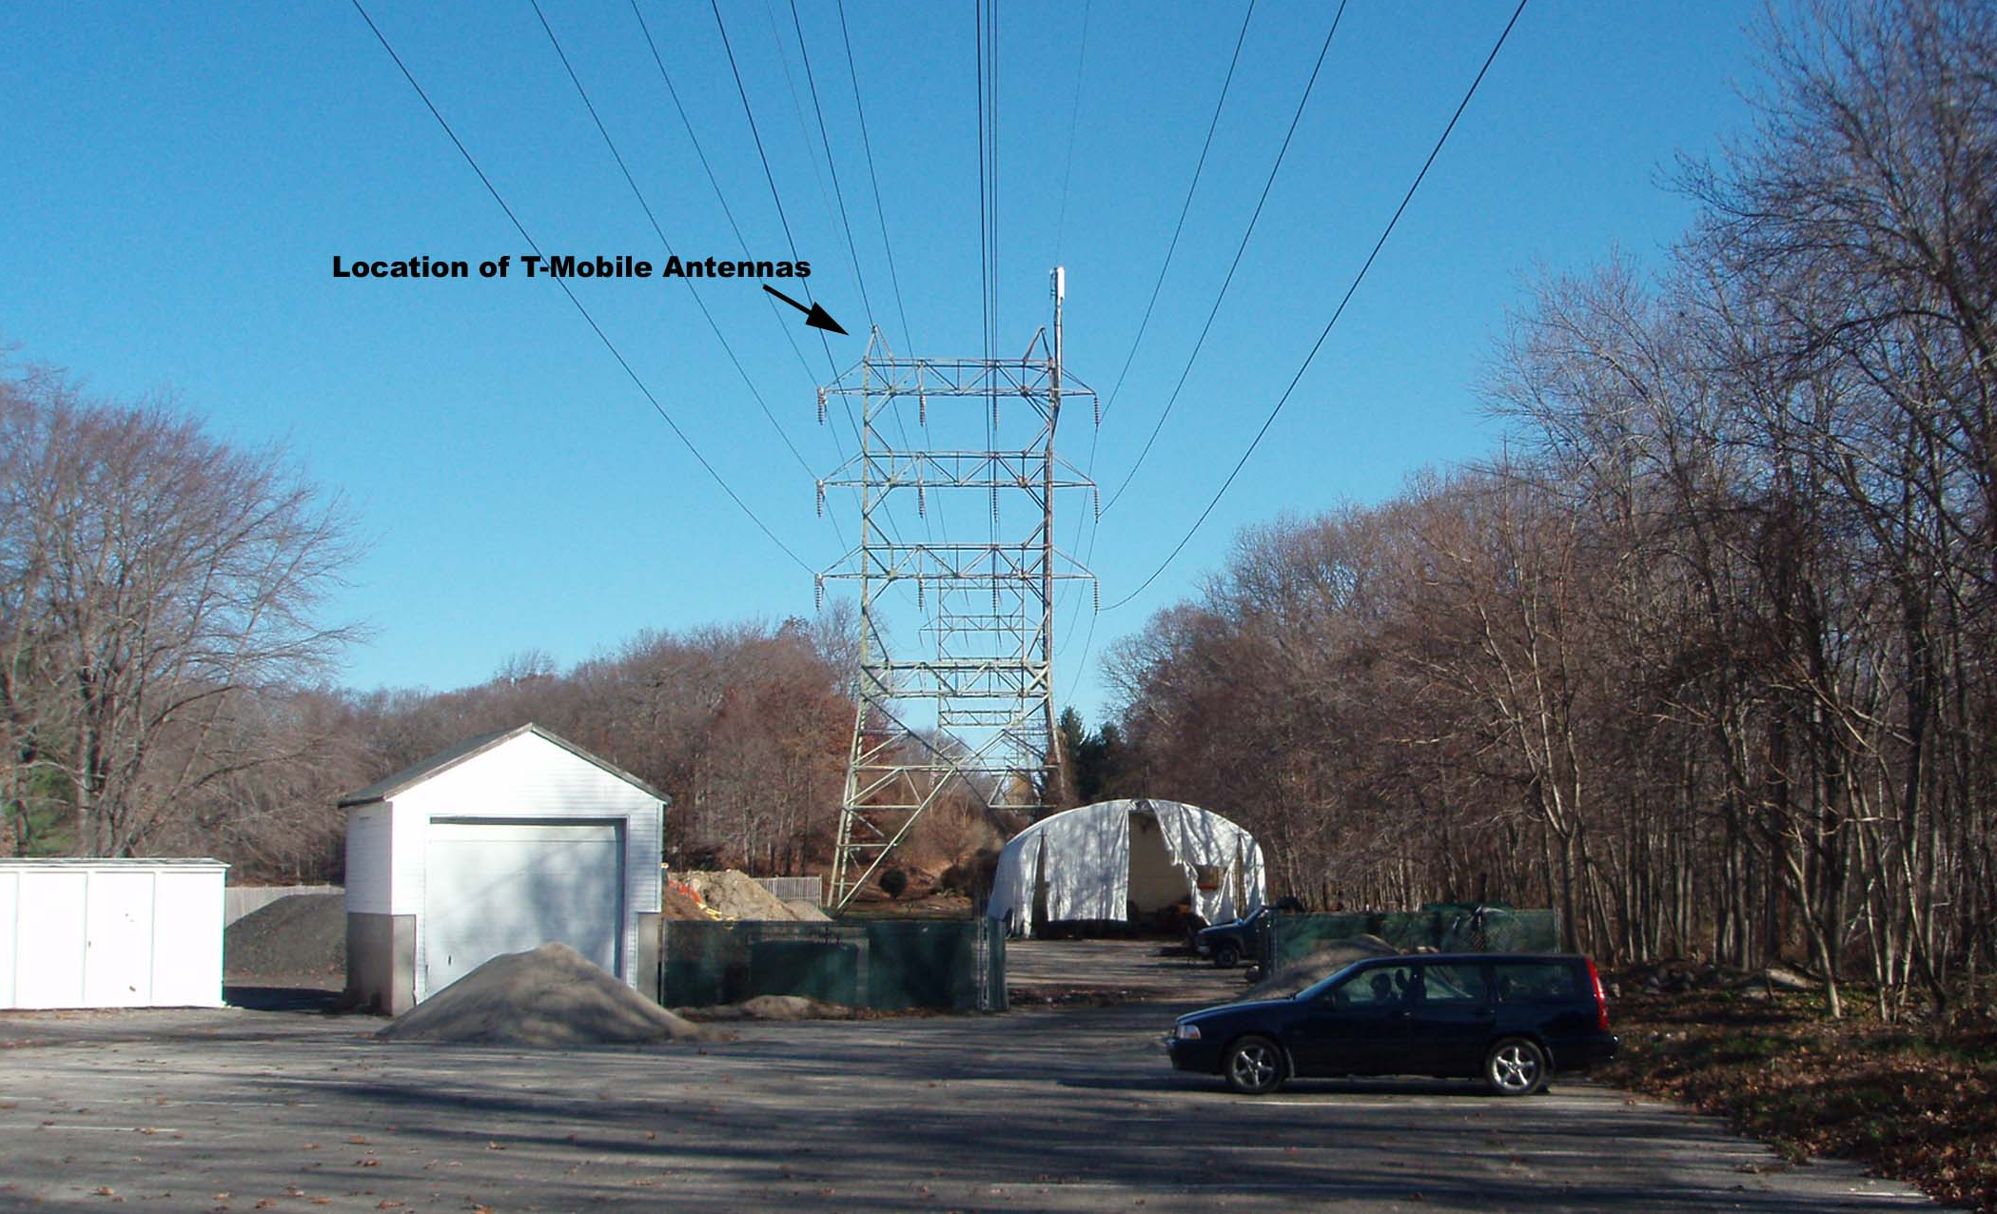

View of Sprint compound at base of transmission line tower
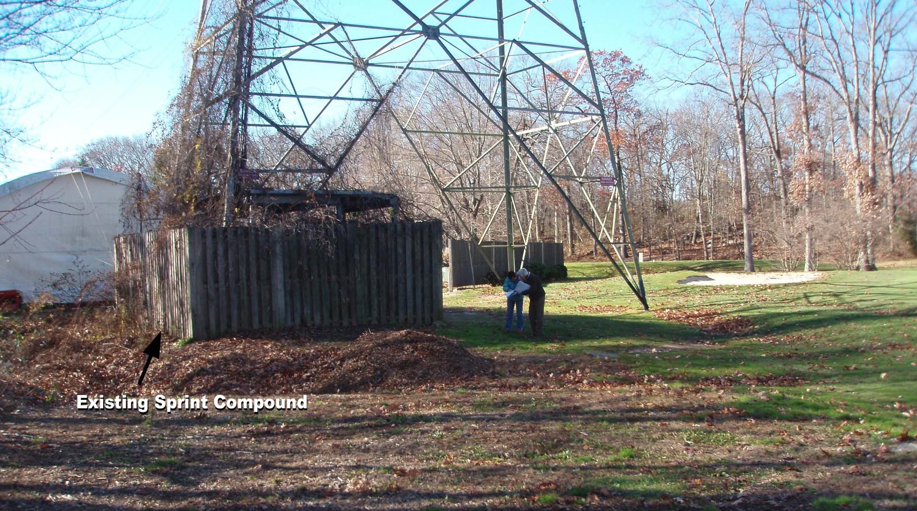

View of tower with Sprint antennas from nearest residence on Chipping Lane


