Petition No. 964
Cellco Partnership d/b/a Verizon Wireless
Lebanon, Connecticut
Staff Report
October 7, 2010

On August 27, 2010, the Connecticut Siting Council (Council) received a petition from Cellco Partnership d/b/a Verizon Wireless (Verizon) for a declaratory ruling that no Certificate of Environmental Compatibility and Public Need is required to extend the height of an existing 120-foot tower an additional 30 feet to a height of 150 feet. Council member Brian Golembiewski, Executive Director Linda Roberts, and staff member David Martin visited the site on September 16, 2010 to review the proposal. Ken Baldwin of Robinson & Cole, Sandy Carter of Verizon, and Michael Libertine of Vanasse Hangen Brustlin (VHB) represented Verizon at the field review.

The existing tower is owned by AT&T Wireless PCS, LLC (AT&T) and is located at 1699 Exeter Road in Lebanon. The tower was certificated by the Council on October 29, 2008 under Docket 257. In its certificate application, AT&T originally sought permission to erect a 150-foot tower at this site and flew a balloon at this height during the Council’s field review. In its deliberations on this application, the Council concluded that AT&T could achieve its coverage objectives with its antennas at 120 feet and directed AT&T to build its tower at this height. However, the Council further directed AT&T to design the tower and foundation to be able to accommodate an extension to the originally proposed height in case another carrier would want to go on the tower at a higher location in the future.

Now Verizon seeks to install antennas on the tower to fill coverage gaps it is experiencing along portions of Routes 207 and 16. Verizon’s RF engineers have determined that it needs to place its antennas at a centerline height of 150 feet in order achieve its coverage objectives. Verizon’s antennas would be mounted on T-arms in accordance with the Council’s Decision and Order for this docket and would extend to an overall height of approximately 153 feet.

A professional engineer licensed in Connecticut has determined that the existing tower is structurally capable of accommodating the extension and antenna loading proposed by Verizon. Staff calculates that the addition of Verizon’s antennas would result in an overall power density equal to 28.6% of the FCC’s applicable limit.

The tower is surrounded by thick stands of mature, deciduous trees that limit near views to fleeting glimpses from a few scattered locations along Route 207 (Exeter Road). VHB performed a visual analysis for the proposed tower extension that concluded the extension would increase the tower’s year-round visibility approximately 31 acres from 165 acres to 196 acres within a two-mile radius of the site. This additional acreage would represent expansions of areas from which the tower is visible now. The extended tower would be visible from very few new areas.

In addition to notifying town officials and the underlying property owner of its proposed extension, Verizon also sent letters to abutting property owners. Town officials did not report any concerns about the extension and no inquiries were received from neighbors.

The proposed extension of this existing tower is not expected to have any substantial adverse environmental effects.

Close up view of existing tower
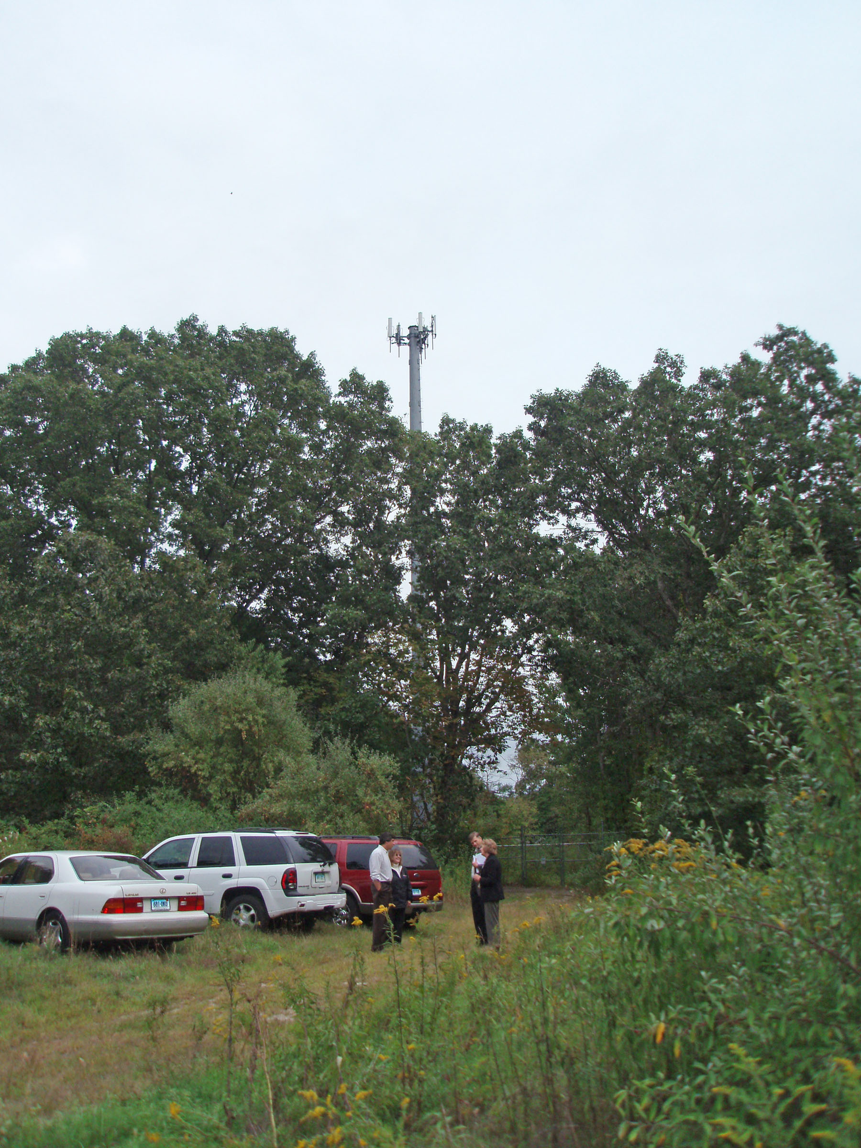

View from Lake Williams boat launch, approximately 1,500 feet to west of tower


