Petition No. 908
Pocket Communications
New Haven, Connecticut
Staff Report
July 22, 2009

On June 24, 2009, the Connecticut Siting Council (Council) received a petition from Youghiogheny Communications-Northeast, LLC d/b/a Pocket Communications (Pocket) for a declaratory ruling that no Certificate of Environmental Compatibility and Public Need is required for a ten-foot extension of an existing 66.5 foot monopole telecommunications tower at 389 Forbes Avenue in New Haven, Connecticut. Council member Phil Ashton and staff member David Martin visited the property on July 14, 2009 to review the proposal. Attorney Carrie Larson and Eric Dahl represented Pocket at the field review.

The existing tower was approved under Docket 298. It replaced a billboard on which Sprint had mounted antennas on an adjacent property at 401-411 Forbes Avenue. The replacement was necessitated by the reconstruction of I-95, a project that resulted in the condemnation of the 401-411 Forbes Avenue property. There are two carriers on the existing tower: Sprint at 62.5 feet and T-Mobile at 55 feet. Pocket would install three flush mounted antennas at a centerline height of 72 feet.

The existing tower is located towards the rear of its host property, approximately 70 feet from Forbes Avenue (Route 1). The rear of the property overlooks the I-95 right-of-way. The immediate vicinity of the site consists mostly of commercial and industrial uses, although there is a small side street with four residences directly across Forbes Avenue from the tower site. Pocket did send certified mail notices to surrounding property owners and did not receive any adverse comments. There are a number of tall 345 kV transmission towers nearby and an industrial smoke stack across I-95, so this tower would not be a singular vertical intrusion on the heavily urbanized viewscape.

A structural analysis concluded that the existing tower and foundation would be capable of accommodating the proposed extension. The addition of Pocket’s antennas would bring the aggregate power density at the tower to 54.73% of the FCC’s Maximum Permissible Emission.

Addendum: On July 17, 2009, Council member Phil Ashton and staff member David Martin returned to the site of the petition to inspect a retaining wall, about which the owner of the property next to the wall had expressed some concerns in a letter submitted by his lawyer. The wall was built as part of the reconstruction of I-95 and runs along two sides of the 389 Forbes Avenue property, the side that abuts the I-95 right-of-way and the side next to a commercial building housing a package store on the complaining neighbor’s property.

The retaining wall appeared to be in excellent condition, and there was no sign of subsidence in the tower’s compound. Based on this inspection, and the structural analysis submitted with the petition, there is no apparent basis for concern about the retaining wall.

View of Existing Tower
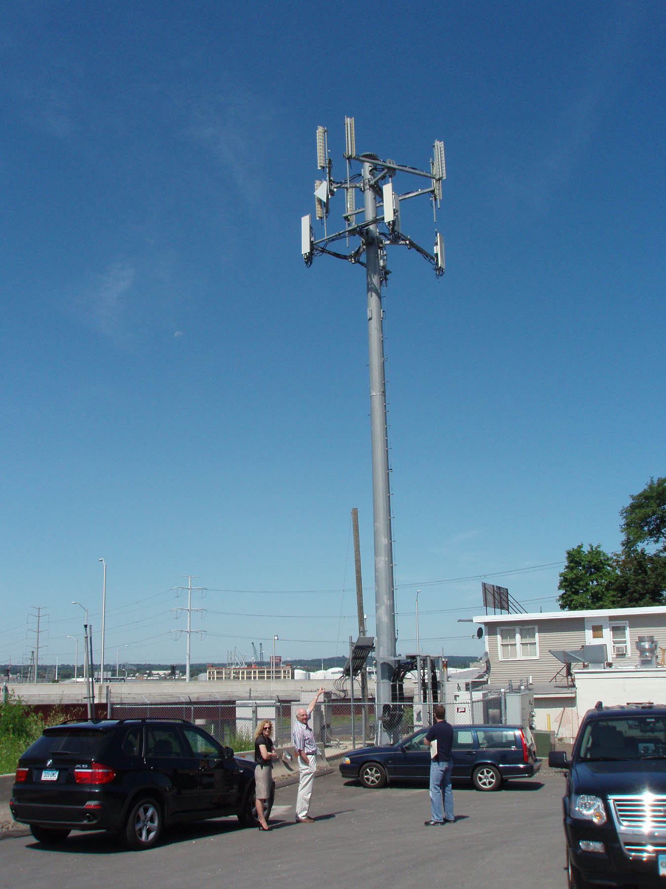

View of compound – neighboring property to right
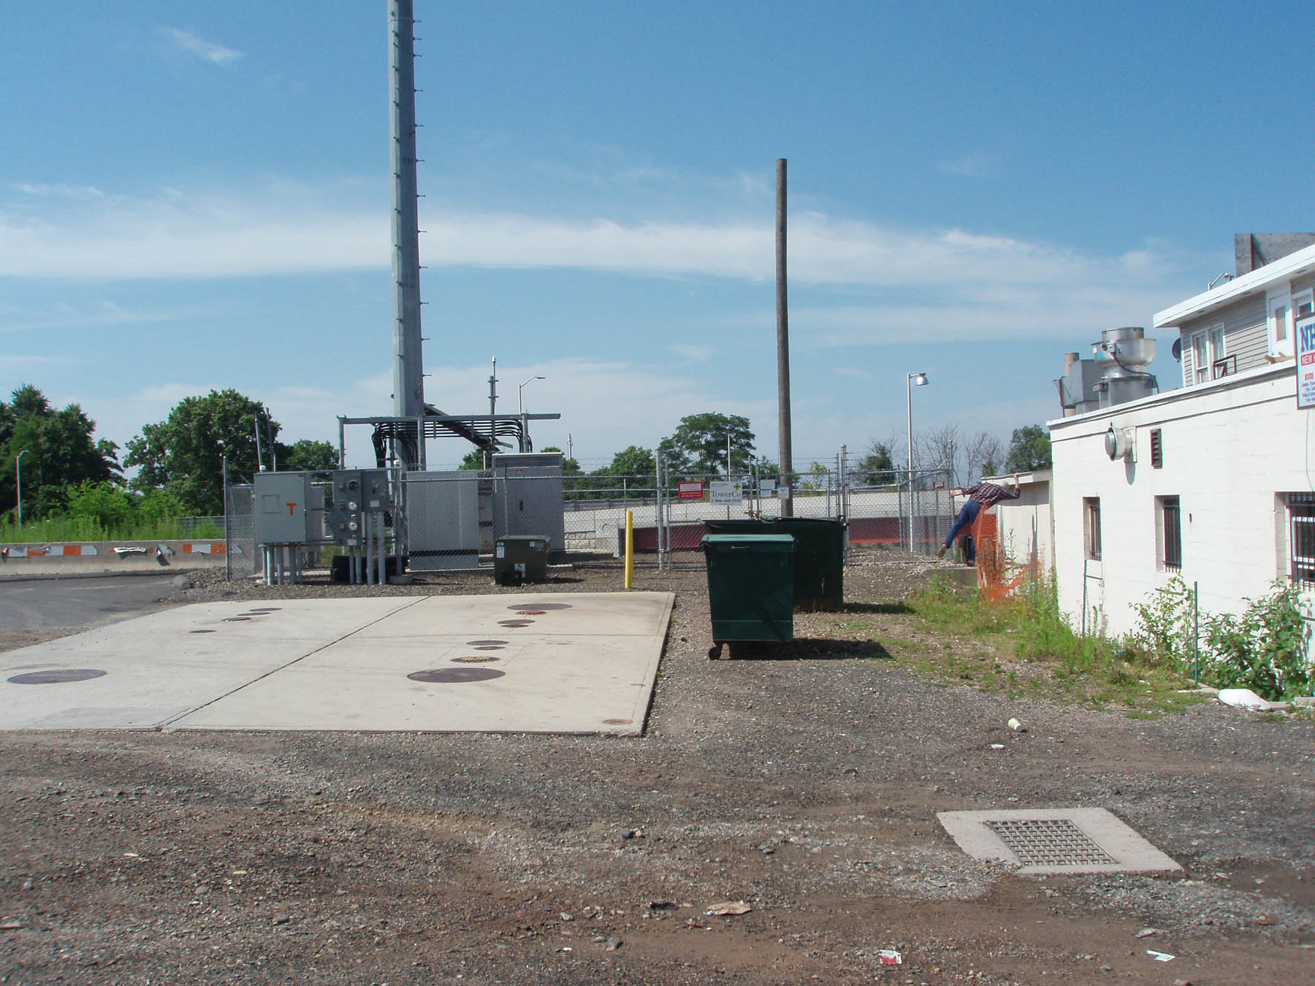

View of retaining wall between properties
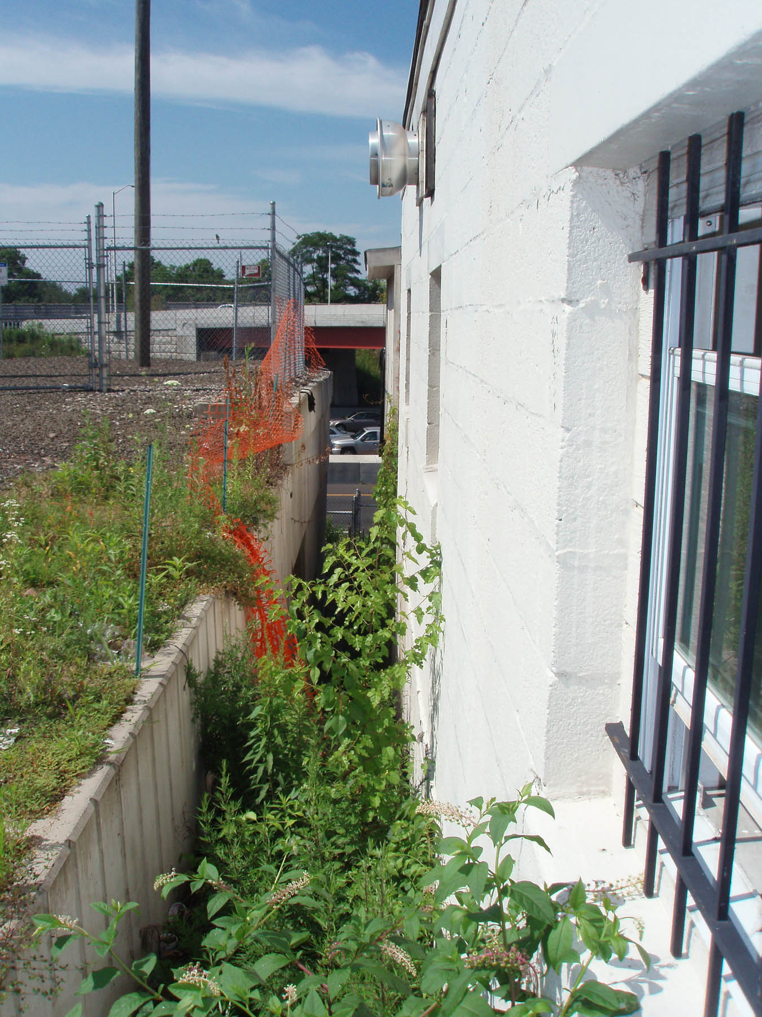

View of retaining wall from near bottom of wall
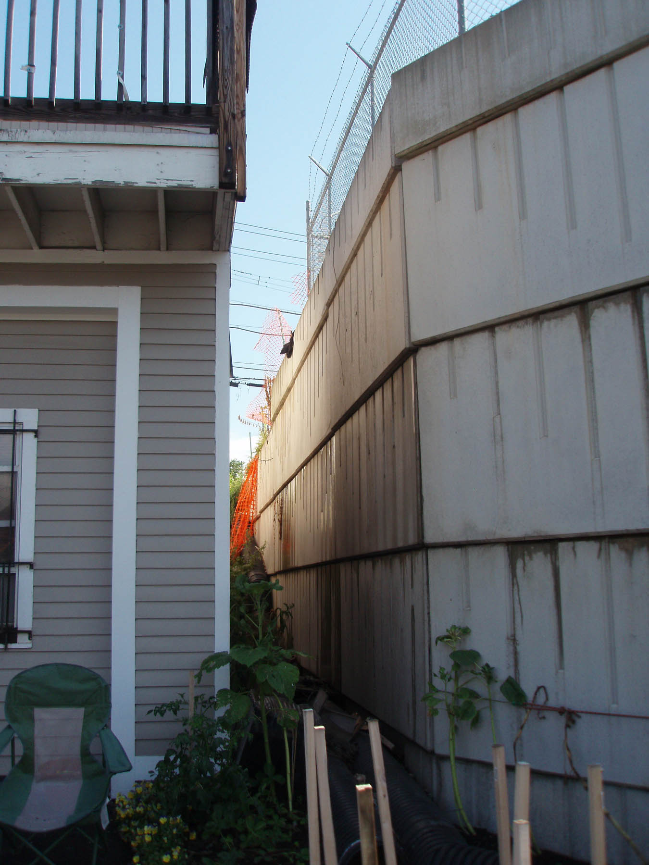

Retaining on I-95 side of property


