Petition No. 835
Cellco Partnership (Verizon)
Groton, Connecticut
Staff Report
December 6, 2007

On November 20, 2007, the Connecticut Siting Council (Council) received a petition from Cellco Partnership d/b/a Verizon Wireless (Verizon) for a declaratory ruling that no Certificate of Environmental Compatibility and Public Need is required for the ten-foot extension of a telecommunications tower located at 1294 Pleasant Valley Road North in Groton. The petition was field reviewed by Council member Jerry Murphy and Council staff member David Martin on December 5, 2007. Rachel Mayo, of Robinson & Cole, attended the field review representing Verizon. Town officials, Optasite, and abutting landowners were notified of the proposal.

Verizon seeks to add ten feet onto a newly built 140-foot monopole tower that was recently approved as Docket 330. Verizon would install twelve panel antennas at a center line height of 147 feet on a low profile platform. It would locate its ground equipment within a 12-foot by 30 equipment shelter to be erected within the facility’s compound.

The proposed facility would enable Verizon to provide service along portions of Route 12 in Groton and Route 32 in New London that are not currently covered. It would also provide service to the U.S. Naval Submarine Base in Groton and help off-load calls from Verizon’s adjacent sites. Verizon’s RF engineers have concluded that Verizon’s antennas could not satisfy the company’s coverage objectives from 127 feet, the next highest available elevation on the existing tower.

The combined power density of Verizon’s proposed antennas and T-Mobile’s existing antennas would represent 10.08% of the FCC maximum exposure limit.

The area around the tower is characterized by scattered residential development on the east side of Route 12. The Groton submarine base is located on the west side of Route 12 and is clearly visible from the facility.

The existing tower is not readily visible from Route 12, even with leaves off the trees. Views of the tower from Pleasant Valley Road North are generally restricted to the immediate vicinity of the tower. Because the tower is set down in a lower elevation on its host property, it does not appear high above the tree line but more at eye level of drivers traveling on Pleasant Valley Road North. An extra ten feet of height should not make a significant difference in the tower’s visibility in the surrounding area.

Verizon’s extension would have minimal impact on the surrounding vicinity and would enable the company to fill a significant existing coverage gap. Staff recommends approval.

Existing tower
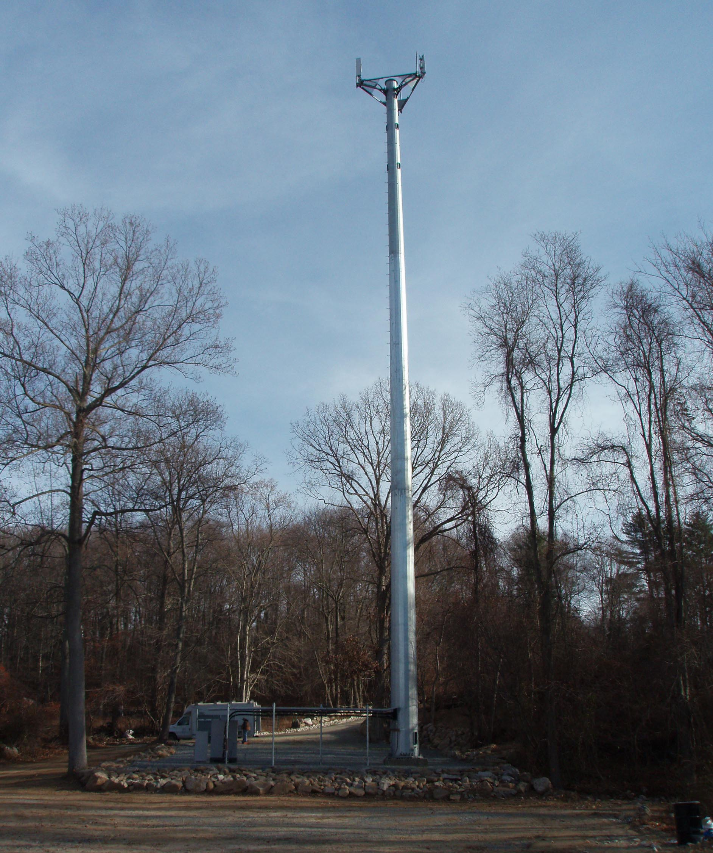

View of tower from Pleasant Valley Road North


