PETITION NO. 834 – Watertown Renewable Power, LLC petition for a declaratory ruling that no Certificate of Environmental Compatibility and Public Need is required for the construction, maintenance, an operation of a 30 MW biomass gasification generating project located at Echo Lake Road, Watertown, Connecticut.  . | }  }  } | Connecticut  Siting  Council  April 24, 2008

Findings of Fact

Introduction

1. On November 14, 2007, Watertown Renewable Power, LLC (WRP or Petitioner) pursuant to Connecticut General Statutes (CGS) §16-50k as amended by Section 18 of Public Act 05-1, submitted a petition (Petition) to the Connecticut Siting Council (Council) for a declaratory ruling that no Certificate of Environmental Compatibility and Public Need (Certificate) is required for the construction, maintenance, and operation of a 30 MW biomass gasification generating facility in the Town of Watertown, Connecticut. (WRP 1, p. 12-13)

2. WRP is a Connecticut limited liability company and a subsidiary of Tamarack Energy, Inc. (Tamarack). Tamarack is a Delaware corporation and an independently operated, wholly-owned subsidiary of Haley & Aldrich, Inc. (Sprint 1, pp. 4-5)

3. The proposed generating facility qualifies as a Class I renewable resource as defined by CGS § 16-1(a)(26). (WRP 1, p. 6; Administrative Notice Item No. 22)

4. The parties in this proceeding are WRP and the Town of Watertown (Town). The Connecticut Light and Power Company (CL&P) is an intervenor. (Transcript 1 – February 5, 2008, 3:00 p.m. [Tr. 1], pp. 1-2 ; Transcript 2 – February 5, 2008, 7:05 p.m. [Tr. 2], pp. 1-2)

5. Notice of the Petition was provided to all abutting property owners by First Class Mail. (WRP 2, response 1)

6. Notice of the Petition was published in local newspapers. (WRP 1, p. 91)

7. Pursuant to CGS § 16-50l (b), WRP provided notice to all federal, state and local officials and agencies listed therein. (WRP 1, p. 93)

8. On January 26, 2008, WRP placed a sign at the entrance to the site stating the name of the Petitioner, and the date, time and location for the Council’s public hearing on the Petition. (Tr. 1, p. 20)

9. Pursuant to Section 16-50j-21 and 16-50j-40 of the Regulations of Connecticut State Agencies, the Council, after giving due notice thereof, held a public hearing on February 5, 2008 beginning at 3:00 p.m. and continuing at 7:05 p.m. at the Watertown High School, 324 French Street, Watertown, Connecticut. (Tr. 1, pp. 2, 3; Tr. 2, pp. 2, 3)

10. The Council and its staff conducted an inspection of the proposed site on February 5, 2008. During the field inspection, the Petitioner flew a red balloon at proposed site to simulate the height of the proposed smokestack. Weather conditions during the field review were rainy, foggy, and calm. During the field review, the balloon reached a height of 170 feet above ground level (agl). The balloon was aloft from 8:00 a.m. to 5:00 p.m. for the convenience of the public. (Council’s Hearing Notice dated January 10, 2008; Tr. 1, pp. 19-20; Tr. 2, p.42)

State Agency Comment

11. Pursuant to CGS § 16-50j (h), on January 10, 2008 and February 8, 2008, the following State agencies were solicited by the Council to submit written comments regarding the proposed facility: Department of Environmental Protection (DEP), Department of Public Health (DPH), Council on Environmental Quality (CEQ), Department of Public Utility Control (DPUC), Office of Policy and Management (OPM), Department of Economic and Community Development (DECD), and the Department of Transportation (DOT). (Record)

12. The DPH Drinking Water Section responded to the Council’s solicitation, but had no comments. (DPH Comments dated January 15, 2008)

13. The DOT’s Bureau of Engineering and Highway Operations responded to the Council’s solicitation, but had no comments. (DOT Comments dated February 4, 2008)

14. The DEP submitted comments dated February 1, 2008. (DEP Comments dated February 1, 2008)

15. In its comments, DEP notes that the proposed facility would be consistent with the Connecticut Solid Waste Management Plan, as it diverts clean wood waste material, such as land clearing debris, pallets, spools, silvicultural thinnings and mill residues, from the waste stream and puts them to a beneficial use. (DEP Comments dated February 1, 2008)

16. DEP also notes that the ability of the facility to provide a market for low value forestry products is beneficial. This will improve the quality of forest stands by removing trees of poor form and health. (DEP Comments dated February 1, 2008)

17. DEP has not sampled Turkey Brook for fisheries population data. However, Turkey Brook would likely support a native brook trout population. To protect the water quality and fisheries resources, DEP recommends that a 100-foot wide riparian buffer be maintained along both sides of Turkey Brook. (DEP Comments dated February 1, 2008)

18. The DEP is willing to enter into an overhead easement agreement with WRP for the right of way (ROW) necessary to connect the proposed power plant with one of the two 115-kV transmission lines running through the Mattatuck State Forest just north of the site. This agreement includes the following conditions:

- Any cleared areas beyond the existing trail must be replanted with a species that is beneficial to wildlife.

- The state would require an annual payment and/or another form of compensation for the ROW. The compensation must be equal to or greater than the value of the ROW easement. The terms of the compensation will be negotiated prior to granting of the easement.

- The state must be compensated for the value of the timber removed.

- All costs associated with granting the ROW easement including, but not limited to, site surveys, appraisals, title work, etc. will be borne by Tamarack. (DEP Comments dated March 26, 2008; WRP 1, Appendix F)

19. The DEP notes that an application for a New Source Review Permit has been received and is undergoing technical review and modeling. The required emissions reduction credits for nitrogen oxides (NOx) must be acquired by the Petitioner before the issuance of the New Source Review Permit. DEP also notes that a Solid Waste Facility Permit will not be required as long as clean, untreated wood is used to fuel the plant. (DEP Comments dated February 1, 2008)

20. DEP recommends that the proposed retaining wall shown as being directly on the Mattatuck State Forest / Tamarack property line be pulled back off the property boundary by 20 to 30 feet in order to minimize damage to trees and root systems and to provide a minimal buffer. (DEP Comments dated February 1, 2008)

Municipal Consultation

21. WRP met with the former Town Manager, Meredith Robson, and other Town staff in March 2005 to introduce the project. Several meetings were held with Town officials during 2006 and 2007. (WRP 1, p. 91 and Appendix L).

22. In August 2007, WRP submitted a technical report to the chief elected official of the Town of Watertown. (WRP 1, p. 91 and Appendix L)

23. WRP held a community open house on October 4, 2007. A public notice with the date, time and location of the open house was published in local newspapers. Approximately 13 members of the Watertown community attended the open house. (WRP 1, p. 91 and Appendix L)

24. Charles Frigon, Town Manager of Watertown, made a limited appearance statement into the record at the February 5, 2008 public hearing in which he expressed support for the proposed project and praised Tamarack for their professionalism during the process. (Tr. 1, pp. 6-7)

25. Elaine Adams, Chairwoman of the Watertown Town Council, made a limited appearance statement into the record at the February 5, 2008 public hearing in which she expressed support for the proposed project and indicated that the project was well planned and thought out. (Tr. 2, pp. 6-8)

26. The Watertown Economic Development Commission and the Watertown Oakville Chamber of Commerce submitted letters of support for the proposed project on November 16, 2007 and January 3, 2008, respectively. (WRP 8 and 14)

Site Description

27. The site is a 33-acre parcel owned by Industrial Development Group and located off Echo Lake Road in Watertown, Connecticut. The site is located in an industrial zone (General Industrial, I G-80). It is bordered by industrial-zoned (I G-80) land to the west and south. To the north and east of the site is the Mattatuck State Forest. (WRP 1, pp. 18-20; WRP 2, response 2)

28. The site is located approximately one mile west of Route 8. (WRP 1, p. 18)

29. The Town Zoning Regulations allow the installation of public utility buildings and facilities within the I G-80 zone. (WRP 1, p. 19)

30. The site is undeveloped and was cleared approximately 10 years ago. The site is reverting to woodland. Grey birch and goldenrod are the dominant species, with lesser amounts of red oak, red maple, black locust, black oak, and white pine. (WRP 1, Appendix 1; WRP 2, response 8; DEP Comments dated February 1, 2008)

31. Turkey Brook and associated wetlands occupy the central portion of the property. (WRP 1, p. 19)

32. There are no residences within 1,000 feet of the site. (WRP 1, p. 19)

33. The nearest residence is located in an industrial-zoned area approximately 1,300 feet to the west of the subject property boundary. (WRP 1, p. 19)

34. The nearest residential zone is approximately three-quarters of a mile from the site. (WRP 1, p. 19)

35. Other nearby properties along Echo Lake Road include a Connecticut Resource Recovery Authority waste transfer facility, an automotive scrap yard, UPS and FedEx distribution centers, and several light manufacturing industries. (WRP 1, p. 19)

Power Plant Description

36. The WRP project will utilize a wood fuel receiving, storage and conveyance system to deliver chipped wood fuel to a fluidized bed gasification system, heating a steam boiler to drive a conventional condensing steam turbine with a nominal output of 30 MW. (WRP 1, p. 26)

37. The facility would include a 115-foot by 477-foot wood storage area, two truck dumpers, an 88-foot by 187-foot by 137-foot high boiler building, a 170-foot exhaust stack, an 82-foot by 144-foot by 59-foot high plant building, a baghouse, cooling tower, and a fenced substation (approximately 30 feet by 40 feet) to boost the output voltage to 115-kV. (WRP 1, Attachment D)

38. Access to the site would begin at Echo Lake Road (at a width of 30 feet), continue for about 215 feet, and then fork into two access drives (approximately 1,050 feet long and 15 to 20 feet wide each) to allow trucks to enter and exit the site. (WRP 1, Attachment L; Tr. 1, p. 23)

39. The facility would utilize clean wood chips derived from whole trees, chipped clean pallets, urban wood waste and mill residue. The facility would not use wood chips derived from painted or treated materials. (WRP 1, pp. 21-22)

40. Approximately 40 to 50 truck loads of fuel would be delivered each day and unloaded by two truck dumpers into a receiving hopper, then moved by conveyor to an outside storage pile capable of holding enough fuel for 17 to 20 days of operation. (WRP 1, pp. 26 and 74-75)

41. Wood fuel would be delivered from the storage pile to the fluidized bed boiler using a series of conveyors. (WRP 1, pp. 26-28)

42. Natural gas would be the start-up fuel for the fluidized bed boiler prior to introducing wood fuel into the furnace. (WRP 1, Exhibit 25)

43. The facility would have the capability to maintain 40 percent of its total capacity on natural gas in the event of a wood fuel handling system failure during critical grid load periods. (WRP 1, p. 25)

44. A new distribution gas line branch would be routed to the proposed site by Yankee Gas. (WRP 1, p. 25)

45. The plant would have one exhaust stack, 170 feet tall. (WRP 1, p. 40)

46. The facility would produce baseload power and would have an annual capacity factor of approximately 92 percent. (WRP 1, p. 20)

47. 15 MW of power output would be sold to CL&P under the terms of a 15-year electricity purchase agreement that resulted from the Connecticut Clean Energy Fund’s Project 100 Solicitation. Approximately 3 MW would be used to supply internal plant loads. The remaining power would be sold directly to ISO New England, Inc., (ISO-NE) or to other customers via separate, long-term contracts. (WRP 1, pp. 6, 28)

48. The facility is expected to have a service life of more than 30 years. (WRP 1, p. 20)

49. The facility would not have black start capability. (WRP 2, response 3)

50. The total installed cost of the project is expected to be between $100 million and $105 million. This includes approximately $90 million to $95 million for the plant plus $10 million for financing costs. (WRP 1, p. 38)

51. If approved, WRP anticipates commencement of construction in the third quarter of 2008. The construction process would take approximately 18 months. The commissioning and start-up of the plant is anticipated in November 2010. (WRP 1, p. 12; Tr. 1, p. 11)

52. Pursuant to the Standard Electricity Purchase Agreement (SEPA), the original scheduled operation date for the facility would be December 31, 2009 (but may be extended up to two years if necessary for permitting and construction). Penalties may be incurred if the Petitioner is unable to meet such deadline. (WRP 10, pp. 1 and 6)

Transmission Interconnection

53. WRP filed a revised Large Generator Interconnection Application with ISO-NE on December 22, 2006 requesting to connect to either CL&P’s 115-kV Frost Bridge to Campville Line No. 1191 and/or the 115-kV Frost Bridge to Carmel Hill Line No. 1238, both of which occupy an ROW between 500 and 1,000 feet north of the proposed WRP facility. (WRP 1, p. 37; WRP 13)

54. On February 29, 2008, ISO-NE issued an interconnection feasibility study concluding that the proposed interconnection would have no significant adverse impacts on the transmission system that might require transmission upgrades or system reinforcements. (WRP 17, p. viii)

55. The DEP had initially indicated a preference for an underground transmission line connection in the Mattatuck State Forest. (DEP Comments dated February 1, 2008; WRP 1, Appendix F)

56. On January 14, 2008, based on discussions with ISO-NE and CL&P and their concerns about the reliability of an underground connection, WRP requested that DEP consider granting an easement for an overhead interconnection, rather than underground as proposed. (Tr. 1, pp. 31-32; WRP 13)

57. Overhead transmission lines are strongly preferred by CL&P because a fault in a buried line takes much longer to locate and repair than a similar fault in an overhead line. A fault in an underground cable would impact the long-term reliability of the project as well as the CL&P transmission circuit. (WRP 13)

58. To minimize the impact on the Mattatuck State Forest, CL&P is willing to allow a configuration that utilizes a single line of poles with an ROW width of 90 feet, as opposed to the double pole configuration, with an ROW width of 110 feet. Also, the orientation of the interconnected route has been adjusted to reduce the total length of the ROW to approximately 500 feet, rather than 1000 feet. (WRP 13)

59. The existing CL&P ROW carrying circuits Nos. 1191 and 1238 is 350 feet wide. (Tr. 1, p. 81)

60. According to CL&P design standards, a suitable switchyard housing the circuit breakers and switches necessary to complete the interconnection would require an approximately 210-foot by 160-foot fenced area located within the state forest and adjacent to the existing CL&P ROW. For safety reasons, an approximately 30-foot wide zone outside the fence would be cleared and maintained. This fenced area is required regardless of whether the transmission line is overhead or underground. (WRP 13)

61. If the switchyard were placed on the subject property, it would result in a net increase of impact to state land, because separate lines coming into and out of the facility would require a wider ROW. (Tr. 1, p. 28)

62. CL&P would not recommend placing the switchyard within its existing ROW because it could interfere with future development of the ROW. However, the switchyard could abut the CL&P ROW. (Tr. 1, p. 82)

63. The overhead configuration would require two or three poles along its route, plus two at the switchyard termination. The poles would probably not be taller than the existing tree line height of 60 to 70 feet. (Tr. 1, pp. 41-42)

64. An underground configuration would use a solid dielectric cable. (Tr. 1, p. 81)

65. An underground ROW would be approximately 50 feet wide. (Tr. 1, p. 47)

66. An underground configuration would require two transition structures at the switchyard. (Tr. 1, p. 85-86)

67. The total impacted area of an overhead interconnection would be 1.7 acres, versus 1.5 acres for an underground interconnection. (WRP 13)

68. The interconnection cost for an overhead configuration, including the switchyard, substation, and the 500 feet of transmission line, would be about $6 million. (Tr. 1, p. 30)

69. CL&P estimates that the cost of installing an underground cable is eight to ten times as much as an overhead connection. (Tr. 1, p. 87)

70. CL&P has provided WRP with its standard conditions for transmission easements. Under these conditions, CL&P requests that the Petitioner provide the Council with a certification from CL&P to the effect that CL&P is satisfied as to the following conditions:

a) The transmission line design and studies of potential electric effects shall be completed by the Petitioner’s qualified consultant, by CL&P’s consultant, or by CL&P employees, and comply with applicable engineering, safety and other related laws, rules, regulations, standards and practices.

b) The Petitioner has demonstrated to CL&P’s satisfaction that the Petitioner has acquired all rights necessary to enable CL&P to access, construct, operate, repair, replace and maintain the transmission line.

c) There are no underlying encumbrances, environmental impairments or other obstacles to the construction and maintenance of the transmission line.

d) All such necessary rights are assignable to CL&P.

e) The Petitioner has undertaken, by agreement satisfactory to CL&P, to indemnify and protect CL&P against any expenses resulting from the exercise of the property owner (i.e. the State of Connecticut, acting through DEP) of any right to require relocation of the line. (CL&P 1, p. 4)

71. WRP indicated that it would accept, as a condition of approval, a requirement to provide the Council with a certificate indicating CL&P’s approval of any easement obtained from DEP. (CL&P 1, p. 4; Tr. 1, pp 32-33)

Wood Fuel Supply

72. The WRP plant would consume 310,000 tons per year of clean chipped wood with an average moisture content of 40 percent. (WRP 1, p. 21)

73. Several independent studies have concluded that between 500,000 and 1,000,000 tons of clean waste wood is currently available each year in Connecticut. (WRP 1, pp. 23-24)

74. A project-specific study for WRP has confirmed that a sufficient long-term supply of wood is available for the project. (WRP 1, pp. 23-24).

75. Most of the wood fuel would be supplied by sources within a 50-mile radius of the site. (Tr. 1, p. 51)

76. WRP would enter into a long-term contract for the supply of wood fuel with a company that would act as a procurer of fuel from hundreds of sources. (WRP 1, p. 46; Tr. 1, p. 58-59)

77. WRP would qualify each supplier to determine the source of the wood fuel and to ensure it meets the specifications required for the power plant. This may include field inspections to verify the source. (Tr. 1, p. 60)

78. The wood fuel supply for the project is expected to consist of approximately 44 percent whole tree chips, 39 percent pallet waste, 16 percent urban wood waste, and 1 percent mill residue. (WRP 1, p. 24)

79. Wood fuel deliveries would occur between the hours of 7:00 a.m. and 7:00 p.m. on weekdays and Saturdays as needed. (Tr. 1, p. 50)

80. Once the wood fuel is received at the power plant, testing would be performed on various truckloads of wood fuel to further verify the quality of the material sent by each supplier. (Tr. 1, p. 61)

Water Requirements

81. The project would utilize a conventional wet cooling tower for the purposes of condensing the steam from the turbine generator. (WRP 1, p. 33)

82. The WRP project would require 500,000 to 600,000 gallons of water per day to support its steam turbine cooling system, boiler water make-up, fire protection and other domestic uses. (WRP 1, p. 35)

83. Water for this project would be provided by the Watertown Municipal Water System subject to the terms of a Water Connection and Service Agreement dated January 24, 2008. (WRP 1, p. 35; WRP 16)

84. The Watertown Water and Sewer Authority has a long-term agreement with the City of Waterbury for the supply of 3 million gallons per day, while the average daily water consumption for the Watertown Municipal Water System has been just over 1 million gallons per day. (WRP 1, p. 35)

85. A 12-inch water main that terminates 1,200 feet west of the proposed site along Echo Lake Road would be extended to the facility. (WRP 1, p. 36)

Waste Generation

86. Fly ash would be generated at a rate of approximately 1.5 tons per hour. Fly ash is non-hazardous and can be used as a soil additive (fertilizer) or an ingredient in concrete. Excess sand captured from the fuel would be periodically removed from the sand hopper and may be used as a building material. All residues would be handled, stored and disposed of in accordance with all applicable laws and regulations. (WRP 1, pp. 36-37; Tr. 1, pp. 51-52)

Environmental Considerations

Wetland Impacts

87. The site contains one wetland area. It occupies 6.96 acres in the central portion of the site and consists of Turkey Brook, associated riparian wetlands, and a narrow and shallow swale that extends into the southeastern portion of the site. (WRP 1, p. 80)

88. Wetland impacts are limited to filling in 4,000 square feet of shallow swale. (WRP 1, p. 81)

89. WRP applied for and received a permit to conduct the proposed wetland activities from the Watertown Conservation Commission. (WRP 1, p. 81; WRP 2, response 5).

90. The project would maintain an existing natural riparian buffer along both sides of Turkey Brook equal to or greater than the 100 feet recommended by DEP, except in two areas where the buffer would be 75 to 80 feet wide. (Tr. 1, p. 24)
91. It is feasible to move the retaining wall proposed to be built along the state forest/Tamarack property line away from the property line to minimize damage to trees and their root systems. How far the retaining wall could be moved would depend on the results of a geotechnical evaluation. (Tr. 1, p. 25)

92. To minimize the potential for erosion and sedimentation during construction, mitigation measures, including hay bales and silt fence, would be placed in appropriate locations on the site to both protect the wetlands and to minimize the erosion of soil from stockpiles on the site. (WRP 1, Attachment I, p. 36)

93. To mitigate the wetland filling, two forebay sediment traps and a water quality basin are proposed that would cleanse drainage from the site. (WRP 1, Attachment I, p. 34)

94. The use of selected native plants for re-vegetation and other mitigating measures are also proposed. Specifically, New England Roadside Matrix Upland Seed Mix is proposed to re-vegetate all upland areas with exposed soils. (WRP 1, p. 81)

95. Also, the addition of woody vegetation to the wetland buffer zone would serve to dissipate the energy of overland sheet flow entering the Turkey Brook wetlands through increased surface area. The vegetation would have a filtering effect, thereby removing water-borne suspended solids and maintaining Turkey Brook water quality. (WRP 1, Attachment I, p. 36)

Site Clearing

96. No trees with a diameter at breast height (dbh) of six-inches or greater would be removed during the construction of the facility and access. The majority of the trees at the site are one to two inch dbh. (WRP 2, response 8)

97. Approximately 77,000 cubic feet of cut and 70,000 cubic feet of fill would be required to develop the proposed site. (WRP 2, response 7)

98. Due to the presence of shallow or outcropping bedrock, it is likely that some blasting would be necessary for the construction of the project. The extent of the blasting required is not known at this time. Any blasting would be performed according to best management practices. (WRP 2, response 9)

Air Emissions

99. The project would utilize an advanced fluidized bed gasification system designed to operate at low temperatures and low excess air to minimize the formation of nitrogen oxide (NO_{x}) emissions. (WRP 1, p. 29)

100. The fluidized bed gasification system ensures efficient combustion of fuel in order to minimize the formation of carbon monoxide (CO), unburned hydrocarbons or volatile organic compounds (VOC). (WRP 1, p. 29)

101. The addition of alkaline materials such as limestone, lime or dolomite to the fluidized bed would control sulfur and other acid gas constituents. (WRP 1, p. 29)

102. The project would utilize selective catalytic reduction (SCR) technology to control NO_{x} emissions. (WRP 1, p. 30)

103. The project would utilize a fabric filter baghouse to control the emission of particulates and trace metals. (WRP 1, p. 30)

104. The project would utilize a Continuous Emissions Monitoring System to demonstrate compliance with emissions limits. (WRP 1, p. 30)

105. Notwithstanding its emission control features, the project is considered a major stationary source of air pollutants due to its emissions of NO_{x} and CO, and is subject to the New Source Review requirements of the Clean Air Act, including the Prevention of Significant Deterioration (PSD) program and the non-attainment New Source Review programs (NNSR). (WRP 1, p. 67) (WRP 1, p. 64)

106. On September 27, 2007, WRP submitted an application to DEP for a permit to construct and operate the plant and demonstrating compliance with the Best Available Control Technology, Lowest Achievable Emissions Rates control technology requirements, and Maximum Allowable Stack Concentrations for DEP regulated hazardous air pollutants. (WRP 1, p. 63)

107. On October 31, 2007, WRP submitted to DEP an air quality impact analysis using analytical dispersion models that demonstrate compliance with state and federal Ambient Air Quality Standards and applicable Prevention of Significant Deterioration increments. (WRP 1, pp. 64-65)

108. To comply with NNSR requirements, WRP would be required to acquire 176 tons of NO_{x} Emission Reduction Credits to offset the potential NO_{x} emission by a ratio of 1.2:1 prior to the DEP’s issuance of a permit to construct and operate. (WRP 1, p. 69)

109. The project would be subject to DEP’s Title V Operating Permit regulations requiring that a Title V permit application be submitted to the DEP at least twelve months before the commencement of operation or within 90 days of receiving notice from DEP that an application is required. (WRP 1, p. 72)

110. The project would be subject to DEP’s Acid Rain program and would require an acid rain permit, continuous emissions monitoring, and the acquisition of sufficient sulfur dioxide (SO₂) allowances. (WRP 1, p. 72)

111. Potential annual air emissions and applicable regulatory criteria are provided in the tables below:

Pollutant | PM/PM₁₀ | NO_{x} | SO_{x} | CO | VOC | Lead | hcl | MERCURY
Emissions from Project (tpy) | 38.45 | 146.66 | 66.77 | 191.58 | 19.24 | 0.19 | 9.54 | 0.014
Major Source thresholds (tpy) | 100 | 50 | 100 | 100 | 50 | 10 | 10 | 10
PSD Significant Emission Rate Thresholds (tpy) | 25/15 | 40 | 40 | 100 | 25 | 0.6 | - | 0.1

Pollutant | PM2.5 filterable | pM2.5 cONDENSIBLE | pm2.5 tOTAL | sulfuric acid | AMMONIA | diOXINS
Emissions from Project (tpy) | 38.43 | 32.44 | 70.87 | 5.34 | 24.29 | 1.4E-07
Major Source thresholds (tpy) | - | - | 100 | 100 | - | 10
PSD Significant Emission Rate Thresholds (tpy) | - | - | 15 | 7 | - | 3.5E-06
(WRP 1, p. 64)

Wildlife Impacts

112. DEP’s Natural Diversity Database maps do not indicate the presence of any state or federally recognized endangered or threatened species, or any state species of special concern at the proposed site. However, DEP indicated in a letter to WRP that a threatened species, the American Kestrel, occurs in the vicinity of the site, approximately 1.25 miles to the northeast. However, based on a site-specific analysis of habitat at the site, suitable habitat for the American Kestrel is not present. (WRP 1, Appendix I)

Cultural Resources

113. The proposed facility would have no effect upon historic, architectural, or archaeological resources listed on or eligible for the National Register of Historic Places or upon properties of traditional cultural importance to Connecticut’s Native American community. (WRP 1, p. 82 and Appendix J; WRP 12)

Odors

114. No burning wood odor would emanate from the exhaust stack, due to the complete combustion of the fuel and the air pollution controls. (Tr. 2, pp. 44-46)

Noise

115. The nearest and most sensitive noise receptor is the Mattatuck State Forest, a Class B receptor under the state noise regulations. The worst-case projection for noise levels from the plant with appropriate mitigation measures was 62 dBA, which is below the 66 dBA noise limit for Class B receptors. (WRP Exhibit 1, pp. 75-77)

Magnetic Fields

116. The design and operation of the project would be consistent with the Council’s Best Management Practices for Electric and Magnetic Fields (EMF). (WRP 1, p. 82)

117. An EMF profile for the project has not yet been completed because the final configuration of the transmission interconnection is not yet known. (Tr. 1, p. 27)

118. The dominant source of magnetic fields would be from the existing CL&P transmission lines and the transmission interconnection. (Tr. 1, p. 27)

119. As a condition of Council approval, WRP would provide an EMF profile with its Development and Management Plan. (Tr. 1, p. 28)
Visibility

120. The site is in a natural depression and surrounded by dense forest, so that views from nearby properties are screened. (WRP 1, p. 19)

121. The 170-foot exhaust stack would be partially visible year-round from the nearest residence located in an industrial zone at 1020 Echo Lake Road. (WRP 1, Attachment H)

122. The exhaust stack would also be partially visible year-round from the nearest residence located in a residential zone approximately three-quarters of a mile from the site. (WRP 1, Attachment H)

Environmental Permits and Approvals

123. This project would require the following permits and approvals:

a) DEP Permit to Construct and Operate
b) DEP Title V Operating Permit
c) Title IV Acid Rain Permit
d) DEP Wastewater Discharge Permit
e) DEP General Permit for the Discharge of Stormwater Associated with Construction Activities
f) DEP General Permit for the Discharge of Stormwater Associated with Industrial Activities
(WRP 1, pp. 89-91)

Safety and Reliability

124. The 170-foot exhaust stack does not require notification to the Federal Aviation Administration nor would it require any marking or lighting. (WRP 1, p. 40)

125. A distributed control system would allow WRP staff to monitor and control virtually all power plant and fuel yard systems from the control room. (WRP 1, p. 48)

126. The plant control system would function to notify the WRP staff of any issues and automatically shut down the gasifier in the event of an emergency. (WRP 1, p. 48)

127. Prior to commercial operation, WRP would invite members of local emergency management and response agencies to the plant to allow them to become familiar with the plant, its operations, and procedures for dealing with emergencies. (WRP 1, p. 48)

128. A diesel-fueled emergency boiler feed pump would be provided to comply with the National Fire Protection Association requirements. The pump would continue to supply water to the boiler after a power failure so that the boiler would not be exposed to excessive heat due to poor water circulation. (WRP 1, p. 49)

129. The facility would employ both automatic and manual fire protection systems, with targeted systems and emergency procedures for the gasifier, steam turbine, electrical systems, fuel handing systems, and the wood storage area. (WRP 1, p. 52)

130. An eight-foot fence would surround the north portion of the subject property. (Tr. 1, p. 26)

131. A professional traffic study concluded that site distances are not sufficient at the intersection of the property access and Echo Lake Road to permit trucks to safely enter and exit the property. This is largely due to the fact that observed traffic speeds are in excess of the 25 mph speed limit. (WRP 1, p. 87)

132. The Petitioner and the Town of Watertown are continuing to cooperate in an effort to find an acceptable resolution to the traffic and sight line issues at the site. (WRP 1, p. 87)

Site Location
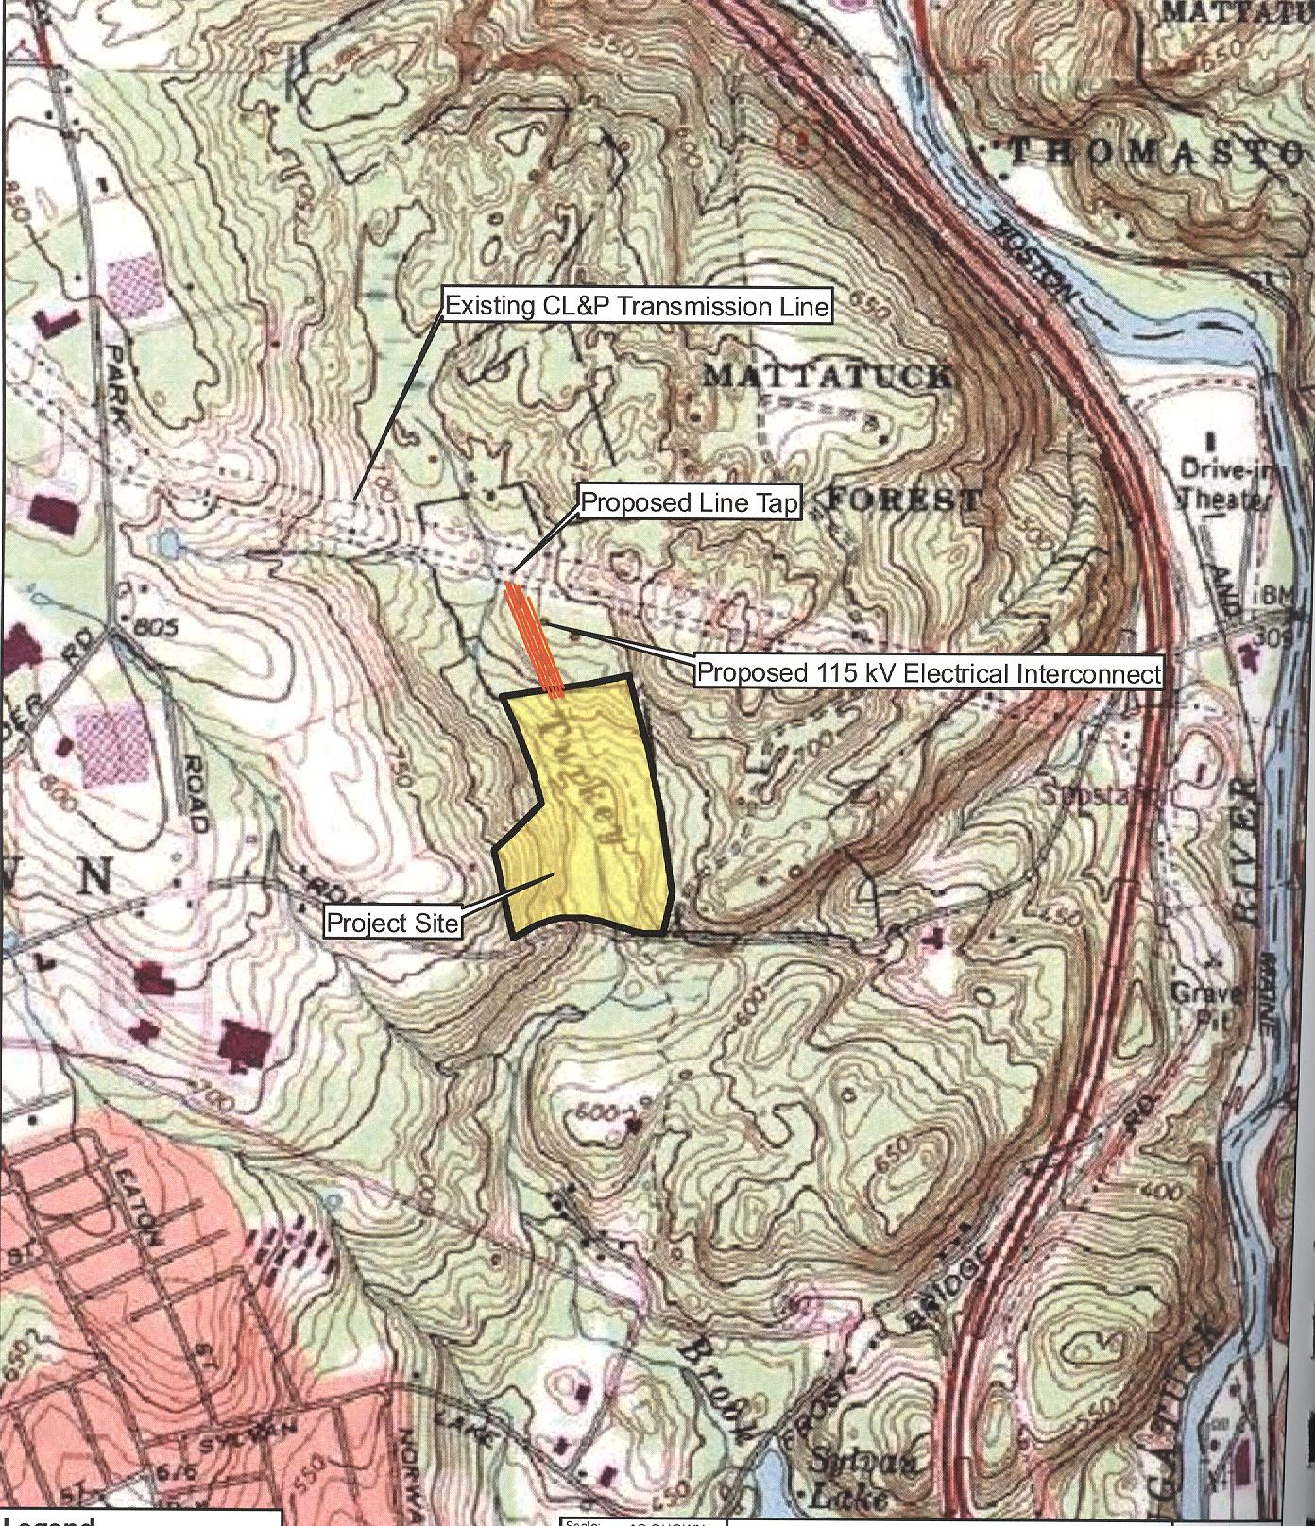
(WRP 1, Attachment I)

Site Plan
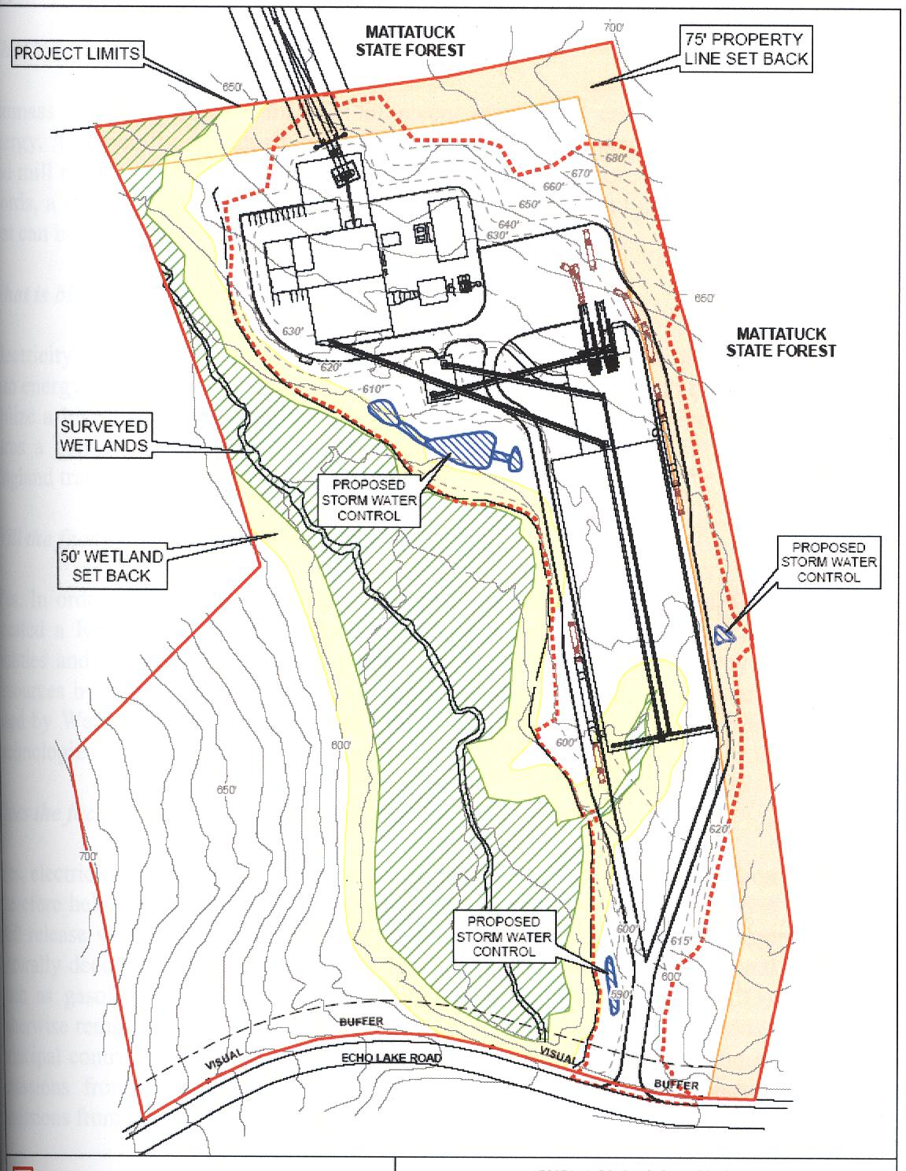
(WRP 1, Attachment L)

View from Echo Lake Road
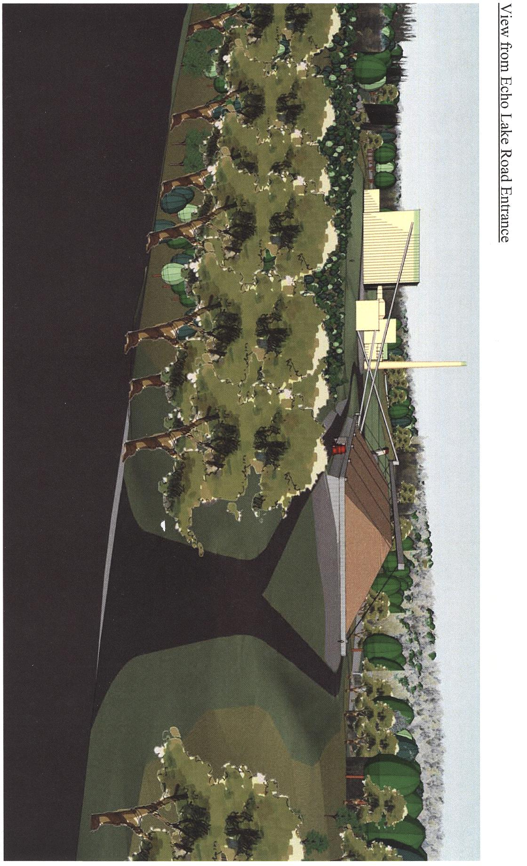
(WRP 1, Attachment B)

