PETITION NO. 535 - AT&T Wireless PCS, LLC and Crown Atlantic Company LLC petition for a declaratory ruling that no Certificate of Environmental Compatibility and Public Need is required for proposed modification of an existing telecommunications tower located at 1455 Forbes Street, East Hartford, Connecticut. | }  }  } | Connecticut  Siting  Council  May 21, 2002

Findings of Fact

Introduction

- On December 4, 2001, Crown Atlantic Company LLC (Crown) and AT&T Wireless PCS, LLC (AT&T) petitioned the Connecticut Siting Council (Council) for a declaratory ruling that no Certificate of Environmental Compatibility and Public Need (Certificate) would be required for the proposed placement of a 20-foot extension on an existing 110-foot telecommunications tower located at 1455 Forbes Street in East Hartford, Connecticut. (Crown/AT&T 1, pp. 1-2)

- On January 8, 2002, the Council provided a public hearing notice to The East Hartford Gazette and The Hartford Courant for publication. The Council held a public hearing on this petition on January 29, 2002, beginning at 3:15 p.m. and continuing at 7:00 p.m. in the East Hartford Town Hall, 740 Main Street, East Hartford, Connecticut. (Tr. 1, p. 3; Council Hearing Notice of January 8, 2002)

- The Council and its staff conducted a publicly noticed field inspection of the existing tower site on January 29, 2002, beginning at 2:00 p.m. (Council Hearing Notice of January 8, 2002)

History of the Site

- On September 18, 1991 the Council issued a Certificate in Docket No. 139 to Metro Mobile CTS of Hartford, Inc. (Metro Mobile) for the construction, operation, and maintenance for a cellular telephone tower with a height not to exceed 123 feet above ground level (AGL), with antennas and appurtenances. The Certificate allowed Metro Mobile to construct a 110-foot tower and 14-foot by 40-foot equipment building within the approximately 30-foot by 50-foot site compound on a 25.4-acre parcel located at 1455 Forbes Street, East Hartford. (Crown/AT&T 1, p. 1; Docket 139 Decision and Order of February 17, 1988; Docket 139 Findings of Fact, p. 11)

- On March 24, 1999, the Council approved the transfer of the Certificate issued in Docket No. 139 from Cellco (a.k.a. Metro Mobile) to Crown. (Crown/AT&T 1, p. 1)

- On December 14, 2000, the Council acknowledged an exempt modification filed by Crown to allow XM Satellite Radio to install an antenna and related equipment at the facility. The antenna would be mounted on a pipe mount with a centerline height of 120 feet with the top of the antenna extending to the 122-foot, 8-inch level. However, XM Radio has not yet installed equipment at the facility. (Acknowledgement of Exempt Modification – EM-XM-043-001130; Tr. 1 p. 1)

Tower and Equipment

- The existing 110-foot tower supports antennas for three carriers: Verizon at 110 feet AGL, Voicestream at 100 feet AGL, and Sprint PCS at 90 feet AGL. (Crown/AT&T 1, Exhibit A & B; Tr. 1, p. 8)

- Crown proposes to install a twenty-foot extension on top of the tower. The proposed extension would have a base diameter of 15.52 inches and a top diameter of 10.52 inches. The top of the existing tower has a diameter of 15.52 inches. (Crown/AT&T 2, Q. 3; Crown/AT&T 3, p. 2; Tr. 1, p. 47)

- AT&T proposes to install three panel antennas, each measuring approximately 60 inches tall by 8 inches wide by 3 inches deep, at a centerline level of 120 feet AGL. The proposed antennas would be flush mounted. (Crown/AT&T 1, p. 2; Crown/AT&T 2, Q. 2; Crown/AT&T 3, p. 2)

- XM Radio proposes to install a single omni-directional antenna at a centerline height of 130 feet AGL, instead of 120 feet AGL previously acknowledged in EM-XM-043-001130. The antenna would be 64 inches in length and have a diameter of 8 inches. The top of the antenna would extend to approximately 132 feet, 8 inches AGL. (Crown/AT&T 1, p. 2; Crown/AT&T 3, p. 1, Attachment)

- AT&T proposes to install radio equipment within weatherproof cabinets on an 8-foot by 15-foot concrete pad within the existing fenced compound. A battery would be installed on-site to provide emergency power, if needed. An emergency generator exists at the facility and would be available to AT&T. (Crown/AT&T 1, p. 2; Crown/AT&T 2, Q. 2; Tr. 1, pp. 51-53)

- The minimum mounting separation distance required between the proposed AT&T antennas and the existing Verizon antennas at the top of the existing tower is ten feet. The minimum separation distance required between the proposed AT&T antennas and the proposed XM Radio antenna at the top of the proposed extension is ten feet. (Tr. 1, pp. 47-51)

Environmental Concerns

- Extension of the existing tower would have no effect on historic, architectural, or archaeological sites listed on or eligible for the National Register of Historic Places, or on properties of traditional cultural importance to the Connecticut Native American Community. (Crown/AT&T 4, Q. 9)

- Properties to the north, east, and south of the tower site are residentially developed. The tower and proposed extension would be visible from Maple Street, Forbes Avenue, Linwood Drive, Heritage Lane, and Montclair Street. (Crown/AT&T 4, Q. 11; Crown/AT&T 6, p. 1)

15. The cumulative electromagnetic radio-frequency (RF) power density, calculated using FCC Office of Engineering Bulletin 65, using conservative worst-case exposures at the base of the proposed tower would not exceed the American National Standards Institute (ANSI) standard, and is calculated to be 38.63% of the ANSI standard. (Crown/AT&T 1, Exhibit B)

Coverage and Design Needs

AT&T

16. AT&T requires a signal level threshold of –85 dbm to satisfy their minimum design criteria in this area. AT&T seeks to provide coverage along Route 2, Route 3, and residential areas northeast of the site. (Tr. 1, pp. 26, 28-30)

- Existing and proposed wireless coverage, at a signal strength of –85 dbm and a frequency of 1900 MHz, within a three mile radius of the proposed site is as follows:

Road* | Existing Coverage Gaps (approx. miles)  < -85 dbm  (see Figure 1) | Coverage Gaps with Proposed Antennas at 80 feet AGL  (approx. miles)  < -85 dbm  (see Figure 2) | Coverage Gaps with Proposed Antennas at 120 feet AGL  (approx. miles)  < -85 dbm  (see Figure 3)
Route 2 (EH, Glast.) | 2.8 | 1.7 | 1.2
Route 3 (Glast.) | 0.4 | 0.2 | 0.2
Brewer Street (EH) | 1.6 | 1.6 | 1.0
Forbes Street (EH) | 3.2 | 2.2 | 1.4
Maple Street (EH) | 1.4 | 0.5 | 0.0
Griswold Street (Glast.) | 1.4 | 0.5 | 0.0
Total | 10.8 | 6.7 | 3.8

* EH – East Hartford

Glast. - Glastonbury

(Crown/AT&T Late File Exhibit)

FIGURE 1

AT&T EXISTING COVERAGE

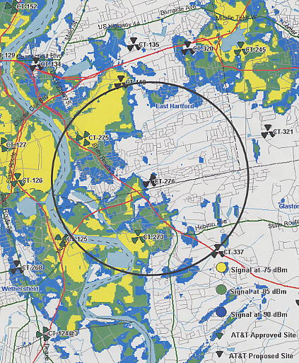
Rt. 3
Brewer St.

Scale 1:100,000

FIGURE 2

AT&T EXISTING AND PROPOSED COVERAGE WITH ANTENNAS AT
80 FEET AGL

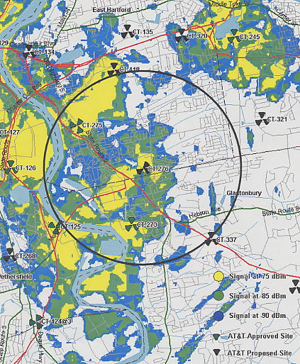

Scale 1:100,000

FIGURE 3

AT&T EXISTING AND PROPOSED COVERAGE WITH ANTENNAS AT
120 FEET AGL

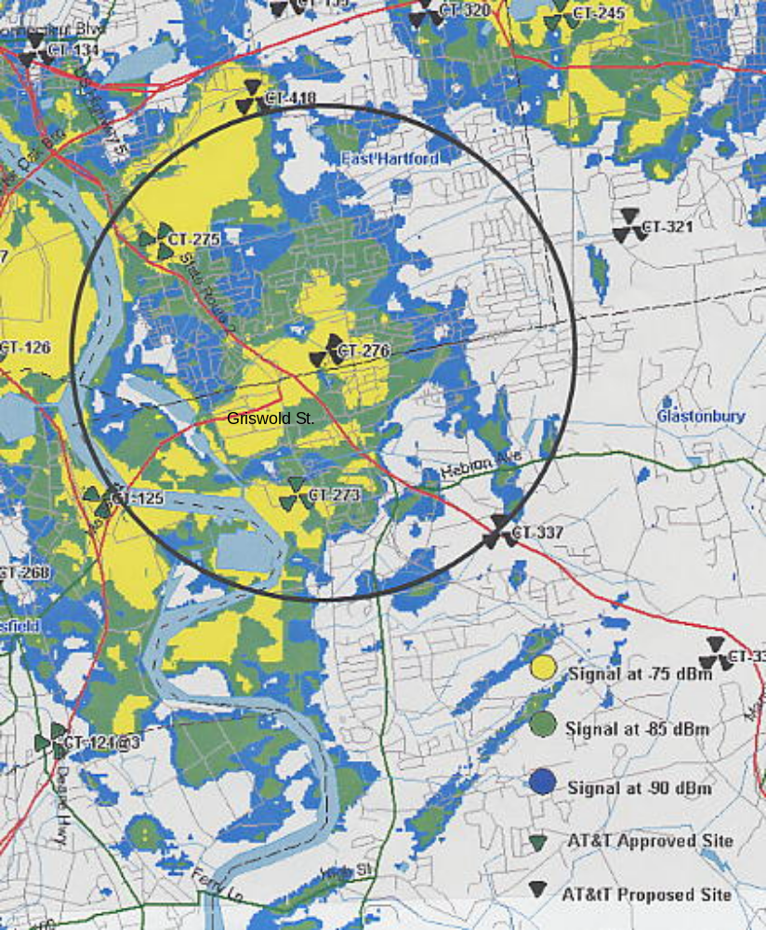
Rt. 3

Scale 1:100,000

- Crown proposes to install a 20-foot extension on top of the tower. AT&T would place three panel antennas at the 120-foot level. XM Radio would locate at the 130-foot level. (Crown/AT&T 1, p. 2)

