Petition No. 1052
BE 2012 W LLC
Newington, Connecticut
Staff Report
January 4, 2013

On December 3, 2012, the Connecticut Siting Council (Council) received a petition from BE 2012 W LLC (BE) for a declaratory ruling that no Certificate of Environmental Compatibility and Public Need is required for the installation of one 200 kW Bloom Energy Corporation fuel cell as a customer-side distributed resources project at the Walmart store at 3164 Berlin Turnpike in Newington, Connecticut. Council member Michael Caron and Siting Analyst David Martin visited the site on January 4, 2013 to review the proposal. Rob Streker, an engineer with Core States Group, represented BE at the field review.

BE’s fuel cell installation is one of several proposed at different locations around the state including several Walmart and Sam’s Club stores. BE was selected by The Connecticut Light and Power Company (CL&P) as a winning bidder in CL&P’s and The United Illuminating Company’s joint request for proposals for their “Low and Zero Emission Renewable Energy Credit (LREC/ZREC) Program, established under provisions of Public Act 11-80, An Act Concerning the Establishment of the Department of Energy and Environmental Protection and Planning for Connecticut’s Energy Future. As a result of its selection, BE has entered into a Standard Contract for the Purchase and Sale of Connecticut Class I Renewable Energy Credits (Standard Contract) with CL&P. BE’s selection and its Standard Contract was approved by PURA in its Docket No. 11-12-06.

BE’s installation would consist of one 200-kW Bloom solid oxide fuel cell, which would be fueled by natural gas. The gas would be brought in from a nearby road. The gas connection would be bored to the fuel cell site; no open trenching would be needed. The overall dimensions of the installation would be approximately 26 feet long by 8 feet wide by 6’ 9” tall. The fuel cell would provide a portion of Walmart’s electrical requirements, and any excess electricity generated would be sold to the grid.

The fuel cell would be located to the rear of the Walmart store (see aerial photograph on page 2), on a grassy strip near where trucks unload. The areas to the north, west, and south of the Walmart are comprised of commercial development. There are residences to the east of the Walmart store. But there is a stockade fence and evergreen trees that provide screening for these residences. The fuel cell would be located on the Walmart side of the stockade fence and should not be visible to any of the residential neighbors.

The fuel cells are designed to include extensive safety control systems that comply with applicable engineering standards. Sound levels generated by the fuel cell will meet all applicable requirements at any off-site noise receptors.

The proposed installation of the fuel cell is not expected to have any substantial adverse environmental impacts. It would reduce the emission of air pollutants that contribute to smog, acid rain, and global climate change. It would also contribute to the state’s use of renewable energy.

Aerial View of Walmart in Newington
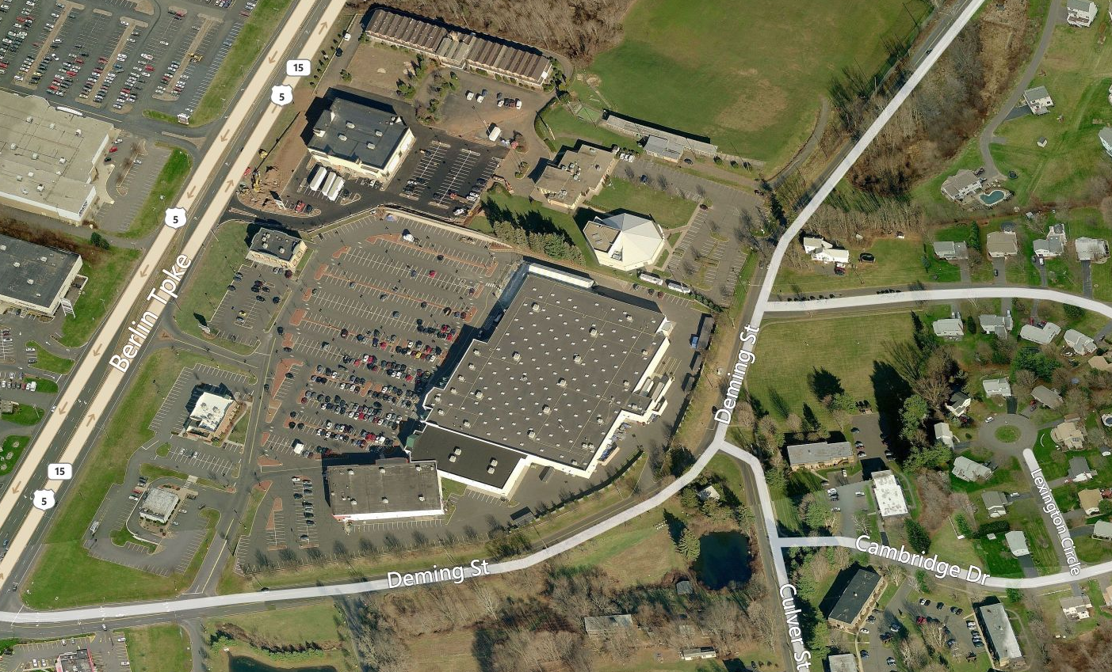
Proposed Fuel Cell Location

