Petition No. 1050
BE 2012 A LLC
Bridgeport, Connecticut
Staff Report
January 24, 2013

On December 3, 2012, the Connecticut Siting Council (Council) received a petition from BE 2012 A LLC (BE) for a declaratory ruling that no Certificate of Environmental Compatibility and Public Need is required for the installation of a 700 kilowatt (kW) Bloom Energy Corporation fuel cell facility as a customer-side distributed resources project at an AT&T facility at 522 Fairfield Avenue in downtown Bridgeport. Council member Dr. Barbara Bell and Council staff member Robert Mercier visited the site on January 22, 2013 to review the proposal. Rob Streker of Core States Group represented BE at the field review.

BE’s fuel cell installation is one of several proposed at different locations around the state. BE was selected by The United Illuminating Company (UI) as a winning bidder in The Connecticut Light and Power Company’s (CL&P) and UI’s joint request for proposals for their Low and Zero Emission Renewable Energy Credit (LREC/ZREC) Program, established under provisions of Public Act 11-80, An Act Concerning the Establishment of the Department of Energy and Environmental Protection and Planning for Connecticut’s Energy Future. As a result of its selection, BE has entered into a Standard Contract for the Purchase and Sale of Connecticut Class I Renewable Energy Credits (Standard Contract) with UI. BE’s selection and its Standard Contract was approved by PURA in its Docket No. 11-12-06.

BE’s installation would consist of three 200 kW and one 100 kW Bloom solid oxide, natural gas-fueled fuel cell units, for a total output of approximately 700 kW. The fuel cell facility would occupy a 67-foot by 25-foot area within a paved parking area on the west side of AT&T’s building. The location was selected to allow for easy interconnection with the buildings switchgear. Natural gas would be obtained from a gas main in the roadway adjacent to the site. The fuel cell would generate electricity for the AT&T facility and any excess electricity would be exported to the grid.

The fuel cell facility would be surrounded by an existing chain-link fence and brick wall. Area land use is commercial, industrial, and residential. The nearest residence is approximately 30 feet to the west. BE is conducting a noise study to ensure noise from the facility does not exceed state and local criteria. BE would install a sound barrier if necessary to meet the noise criteria.

The fuel cells are designed to include extensive safety control systems that comply with applicable engineering standards.

Notice was provided to the City of Bridgeport and abutting property owners on or about November 29, 2012. No comments were submitted to the Council from the City or any abutters. BE has met with the City during the design process.

The proposed installation of the fuel cell is not expected to have any substantial adverse environmental impacts. It would reduce the emission of air pollutants that contribute to smog, acid rain, and global climate change. It would also contribute to the state’s use of renewable energy. Staff recommends approval with the condition that the petitioner submit a letter stamped by a P.E. duly licensed in the State of Connecticut to certify that noise levels comply with the State of Connecticut noise control regulations.
.

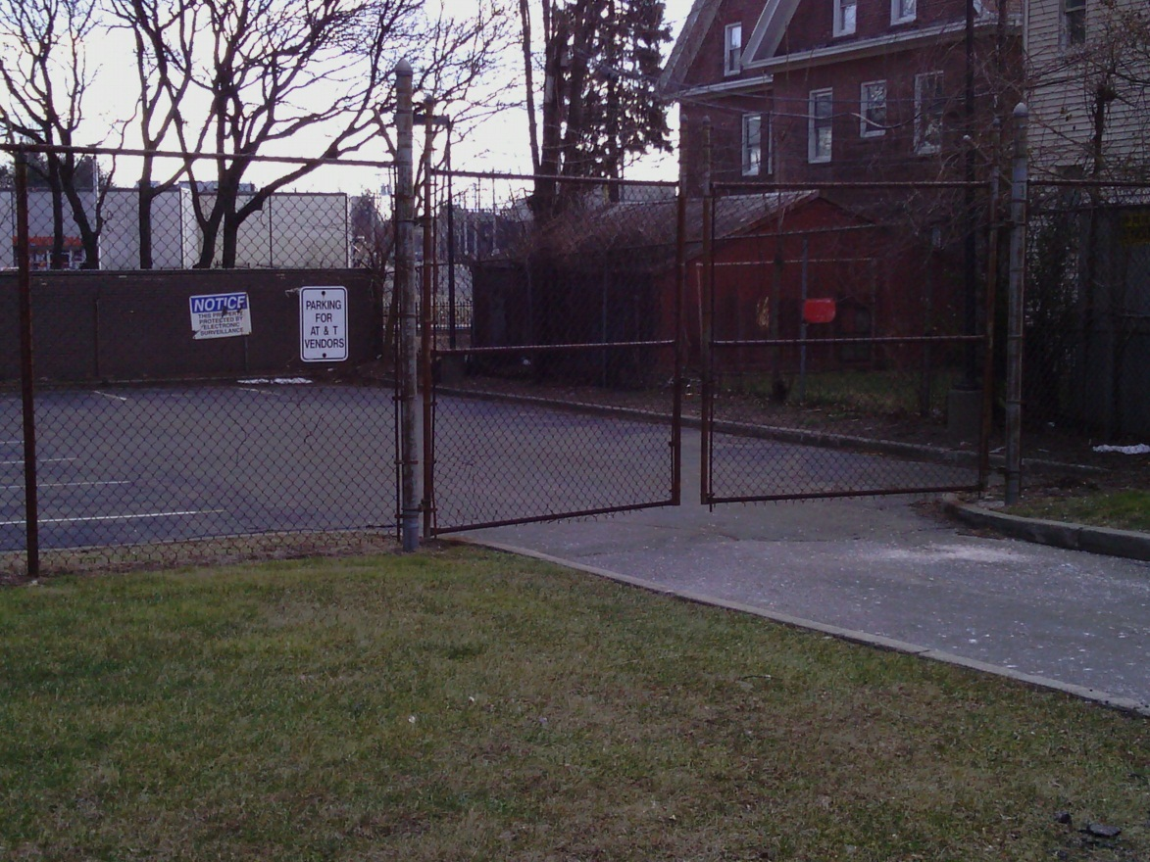
Location of site. Note residence to right.

Location of site, adjacent to AT&T building.

