Petition No. 1046
BE 2012 W LLC
Waterford, Connecticut
Staff Report
January 8, 2013

On December 3, 2012, the Connecticut Siting Council (Council) received a petition from BE 2012 W LLC (BE) for a declaratory ruling that no Certificate of Environmental Compatibility and Public Need is required for the installation of one 500-Kilowatt Bloom Energy Corporation fuel cell facility as a customer-side distributed resources project at the Walmart store at 155 Waterford Parkway North in Waterford, Connecticut. Council member Jerry Murphy and Siting Analyst David Martin visited the site on January 8, 2013 to review the proposal. Rob Streker and Richard Procanik, engineers with Core States Group, represented BE at the field review. Waterford municipal officials also attended the field review including: Tom Wagner, Planning Director; Mark Wujtewicz, Planner; Michael Glidden, Zoning Official; Peter Schlink, Fire Marshal; and Bruce Miller, Director of Fire Services.

BE’s fuel cell installation is one of several proposed at different locations around the state including several Walmart and Sam’s Club stores. BE was selected by The Connecticut Light and Power Company (CL&P) as a winning bidder in CL&P’s and The United Illuminating Company’s joint request for proposals for their “Low and Zero Emission Renewable Energy Credit (LREC/ZREC) Program, established under provisions of Public Act 11-80, An Act Concerning the Establishment of the Department of Energy and Environmental Protection and Planning for Connecticut’s Energy Future. As a result of its selection, BE has entered into a Standard Contract for the Purchase and Sale of Connecticut Class I Renewable Energy Credits (Standard Contract) with CL&P. BE’s selection and its Standard Contract was approved by PURA in its Docket No. 11-12-06.

BE’s installation would consist of two Bloom solid oxide, natural gas-fueled fuel cells, which would total approximately 500 kilowatts. The overall dimensions of the installation would be approximately 76 feet long by 8 feet wide by 6’ 9” high. The fuel cell system has been designed for the Walmart store’s base load, and any excess electricity generated would be sold to the grid.

The fuel cell would be located to the rear of the Walmart store (see aerial photograph on page 2), in an area currently used for storage and to place some small dumpsters. To bring natural gas to the fuel cell, BE would bore a route to the existing gas line behind the Walmart instead of digging an open trench. The Walmart store is located in a heavy commercial area with no residential neighbors nearby.

The fuel cells are designed to include extensive safety control systems that comply with applicable engineering standards. Sound levels generated by the fuel cell will meet all applicable requirements at any off-site noise receptors.

The Council did receive comments from Town of Waterford officials in support of the proposal (see attached email).

The proposed installation of the fuel cell is not expected to have any substantial adverse environmental impacts. It would reduce the emission of air pollutants that contribute to smog, acid rain, and global climate change. It would also contribute to the state’s use of renewable energy.

Aerial View of Walmart in Waterford 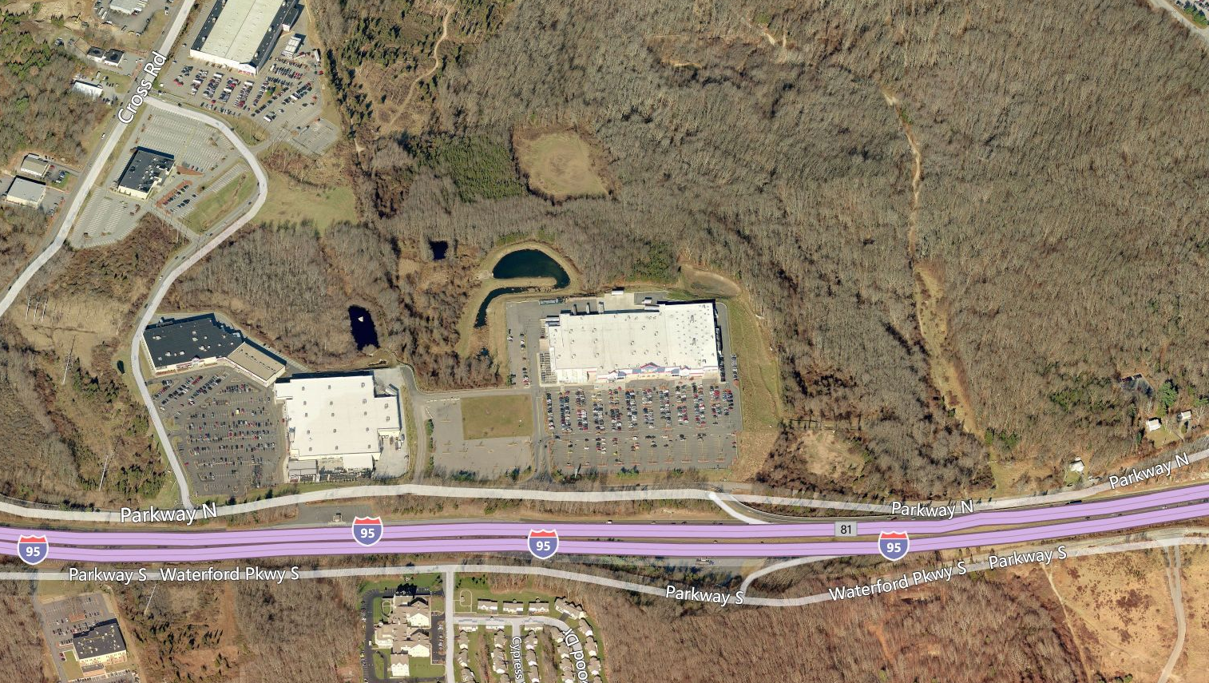
Proposed Fuel Cell Location

