PETITION NO. 1010 - New Cingular Wireless PCS, LLC petition for a declaratory ruling that no Certificate of Environmental Compatibility and Public Need is required for the proposed installation of a telecommunications facility on a water tank and associated equipment at a water treatment plant located at 455 Valley Road, Greenwich, Connecticut. | }  }  } | Connecticut  Siting  Council  March 29, 2012

Findings of Fact

Introduction

- On October 5, 2011, New Cingular Wireless PCS, LLC (AT&T), in accordance with provisions of Connecticut General Statutes (C.G.S) § 16-50k, submitted a Petition for a declaratory ruling (Petition) that a Certificate of Environmental Compatibility and Public Need is not required for the proposed installation of a concealed tower facility on top of an existing water tank at an Aquarion Water Company plant located at 455 Valley Road in Greenwich, Connecticut. (AT&T 1, p. 1)

- The party in this proceeding is the Petitioner. The intervenor is a group consisting of Lee Higgins, Kaori Higgins, Peter Janis, Elizabeth Janis, Richard Kosinski and Susan Kosinski (collectively “Intervenors”). (Transcript 1, February 9, 2012, 3:09 p.m. [Tr. 1], p. 5)

- The proposed facility would provide AT&T with coverage in the Cos Cob section of Greenwich and Stamford specifically along Valley Road, Westover Road, Palmer Hill Road and nearby residences. (AT&T 1, p. 7)

- In 2001, SNET Mobility, LLC (SNET), a predecessor of AT&T, applied to the Town of Greenwich Planning and Zoning Commission (P&Z) for the installation of an antenna attachment on the existing 46.5-foot tall water tank that is being considered in Petition No. 1010. SNET had proposed to install antennas on galvanized pipe frames that would be welded to the top of the water tank in three sectors with a total of 12 panel antennas, extending to a height of 52 feet above ground level (agl). SNET received approval for that installation from the Greenwich P&Z and the Greenwich Inland Wetlands Agency. SNET did not go forward with the antenna installation. (AT&T 3, pp. 1, 2)

- Pursuant to C.G.S. § 16-50m (c), the Council published public notice of the hearing in the Greenwich Time and the Connecticut Post on December 19, 2011. (Council’s Hearing Notice; Tr. 1, p. 5)

- On November 2, 2011, the Council held a public field inspection at the site of the proposed project with Chairman Robin Stein and Dr. Barbara Bell in attendance. (Field review notice dated October 31, 2011)

- On November 10, 2011, the Petitioner provided notice of the proposed project to all abutting property owners by certified mail. (AT&T 2, Tab 4)

- Following notification of the project, the Council received requests from nearby residents and from State Representative Fred Camillo to hold a hearing on the proposed project. (Record)

- At a Council meeting held on December 15, 2011, the Council voted to hold a hearing on Petition No. 1010. (Minutes of December 15, 2011 Council meeting)

- The Petitioner placed a four-foot by six-foot sign at 455 Valley Road, on January 26, 2012. The sign contained information regarding the proposed project and Council’s public hearing. (Pre-Hearing Conference Memorandum; AT&T 6, sign posting affidavit)

- Pursuant to C.G.S. § 16-50m, the Council, after giving due notice thereof, held a public hearing on February 9, 2012, beginning at 3:00 p.m. and continuing at 7:00 p.m. in the Cone Conference Room of Greenwich Town Hall, 100 Field Point Road, Greenwich, Connecticut. (Tr. 1, p. 3; Transcript 2, February 9, 2012, 7:00 p.m. [Tr. 2], p. 3)

- The Council and its staff conducted an inspection of the proposed site on February 9, 2012, beginning at 2:00 p.m. During the field inspection, the Petitioner flew a balloon at the proposed site to simulate the height of the proposed structure. The balloon was aloft on and off from 8:00 a.m. to 12:00 p.m. At approximately 12:00 p.m., the Petitioner raised a balloon from a point approximately 75 feet west of the water tank to allow the balloon to remain afloat. Weather conditions were windy and the balloon was not able to achieve the height of the proposed installation. (Tr. 1, pp. 17, 18, 29)

- The Council held a continued public hearing on February 22, 2012 at the Office of the Connecticut Siting Council, Ten Franklin Square, New Britain, Connecticut. (Transcript 3, February 22, 2012, 1:05 p.m. [Tr. 3], p. 3)

State Agency Comment

- Pursuant to C.G.S. § 16-50j (h), on December 16, 2011 and February 23, 2012, the following State agencies were solicited by the Council to submit written comments regarding the proposed facility: Department of Energy and Environmental Protection; Department of Public Health (DPH); Council on Environmental Quality; Public Utility Regulatory Authority; Office of Policy and Management; Department of Economic and Community Development; Department of Agriculture; Department of Transportation (DOT); and Department of Emergency Management and Homeland Security. (Record)

- On January 20, 2012, the Council received a response from the DOT stating it had no comment on the proposed project. (DOT Comments dated January 20, 2012)

- The Council received comments from the Drinking Water Section (DWS) of DPH dated March 7, 2012. The comments state that the proposed project is at the end of Mianus Mill Pond, which is an active source of public drinking water for the customers of Aquarion Water Company, Greenwich System. The DWS comments are:
- The property of the proposed site is defined as water company land and can be classified as Class I, II or III water company land.
- The proposed project is consistent with CGS §25-32(f), which specifically allows telecommunications towers on existing structures on water company land.
- If the proposed equipment shelter were located on Class I or II water company land, DPH would have direct statutory authority over the facility’s construction and operation.
- If the proposed building structure were on Class I or II water company land, Aquarion would have to apply to DPH for a Water Company Land Change in Use Permit. DPH would only approve the proposed use after determining that it would not have a significant adverse impact upon the present and future purity and adequacy of the public drinking water supply.
- If the proposed building structure were located on Class III water company land, Aquarion would not be required to obtain a permit from DPH.
(DPH Comments dated March 7, 2012)

- No other state agencies commented on the proposed project. (Record)

Existing and Proposed Wireless Coverage –AT&T

- AT&T is licensed by the Federal Communication Commission (FCC) to provide wireless communications services throughout Connecticut. (AT&T 1, p. 2)

- AT&T would provide service to the target using Cellular (800 MHz band), Personal Communications Services (PCS) (1900 MHz band), and Long-Term Evolution (LTE) (700 MHz band) frequencies. (AT&T 4, Response (Resp.) 3)

- There is an existing coverage gap in the North Mianus section of Greenwich, including Valley Road and Westover Road in Stamford. The target area currently has a signal level of between -82 dBm and -100 dBm. Refer Figure 4. (AT&T 5, Tab 2; Tr. 1, pp. 16, 17)

- At a height of 60 feet above ground level (agl), using cellular frequencies, the proposed site would provide approximately 0.69 square miles of coverage for in-building coverage (at > -74 dBm) and 0.75 square miles for in-vehicle coverage (at > -82 dBm). Refer to Figure 5. (AT&T 5, Tab 2)

- At a height of 60 feet agl, using cellular frequencies, the proposed site would provide coverage to approximately 0.29 miles along Mianus Road, 0.13 miles along Mimosa Drive, 0.09 miles along Palmer Hill Road, 0.16 along Sheephill Road, 0.3 miles along Valley Road and 0.85 miles along Westover Road, all at ≥ -82 dBm. (AT&T 5, Tab 2)

- A reduction in the height of AT&T’s antennas would result in significant gaps in coverage along Westover Road in Stamford. (Tr. 1, pp. 16, 17)

- The existing white pine trees adjacent to the water tank structure would have some impact on proposed coverage. At angles where the proposed antennas would align with the existing trees the signal would be blocked but coverage would still be adequate for the target area. (Tr. 3, pp. 9, 10)

Existing Water Treatment Plant

- The proposed facility would be located on an existing water tank located on a 2.6-acre parcel adjacent to the Mianus River, owned by Aquarion Water Company of Connecticut (Aquarion). The property is currently used as a water treatment plant. Refer to Figure 1. (AT&T 1, p. 2)

- The parcel was initially developed in 1954 and currently contains control buildings, garages, filtration tanks, and a water supply tank. (AT&T 1, p. 2)

- The existing water tank is a 30-foot diameter cylindrical steel structure with a domed top painted dark green. It has a steel vent on top of it, extending four feet six inches, making the total height of the existing structure 51 feet agl. (AT&T 1, p. 2)

- At the location of the water tank, Valley Road is approximately 10 feet above the base of the tank. (Tr. 3, p. 45)

Facility Description

- AT&T proposes to construct a 15-foot tower, enclosed by stealth housing, on top of the existing water tank. The housing, or “cap,” would be a cylindrical structure 15 feet in diameter and 15 feet high, and would be similar in appearance to the existing water tank. Refer to Figure 2. (AT&T 1, p. 2, Tab B)

- In order to install the tower and associated cap, AT&T proposes to reconstruct the top of the existing water tank. This step would extend its height from 46 feet 6 inches to 49 feet. With the cap installed on the top, the total height of the proposed facility would be 64 feet agl. (AT&T 1, p. 2, Tab B)

- The cap would be made out of a steel frame with fiberglass panels that would conceal the facility inside and be painted to match the existing water tank. (AT&T 1, p. 2)

- AT&T would install up to 12 panel antennas at a centerline height of 60 feet agl and other equipment within the concealed structure. (AT&T 1, p. 2)

- AT&T would install ground equipment inside a 10-foot by 15-foot shelter on a 20-foot by 20-foot compound southwest of the existing water tank. The shelter would have a pitched roof and brick-like exterior to match the existing buildings on the water plant property. (AT&T 1, p. 3, Tab B; Tr. 3, p. 35)

- AT&T could install landscaping, including eight to ten-foot trees, within its lease area on the Valley Road side of the equipment shelter to provide screening. AT&T would have to consult with and get the permission of Aquarion to plant any trees outside of the lease area. (Tr. 1, p. 11; Tr. 3, pp. 35, 43, 44)

- AT&T would use a battery backup system to provide power in the event of a power outage. The charge on the battery would last for approximately 8 to 12 hours depending on site usage. Battery life is checked monthly. (AT&T 4, Resp. 6; Tr. 1, p. 11)

- If a power outage exceeds 8 to 12 hours in duration, AT&T would attempt to acquire a temporary backup generator. (Tr. 1, p. 11)

- Access to the proposed site would be via the existing Aquarion parking lot. Utilities to the site would extend from The Connecticut Light and Power Company pole #6468. The utility pole is immediately adjacent to the proposed equipment shelter. (AT&T 1, Tab B; Tr. 1, p. 54)

- The site would be accessed by a sport utility type vehicle once a month for maintenance. (Tr. 1, p. 36)

- AT&T assumed that the existing water tank was empty when performing an overturning analysis on the structure as a worst-case scenario. The water tank and its foundation were found to be structurally capable of resisting overturning due to existing load and load associated with the proposed project. If the tank contained water, it would increase the stability of the structure. (AT&T 1, Tab B; Tr. 1, p. 52)

Environmental Considerations

- The host property parcel includes a significant paved area and buildings that extend to the edge of the Mianus River. The edge of the river and associated wetlands are well defined and delineated. (AT&T 1, p. 6)

- The nearest wetland would be approximately 55 feet from the closest corner of the proposed equipment shelter. (Tr. 1, p. 28)

- AT&T would install all appropriate sediment and erosion control measures for the proposed project to minimize any potential wetland impact, in accordance with the 2002 Connecticut Soil Erosion and Sediment Control Guidelines. (AT&T 1, p. 6; Tr. 1, p. 28; Tr. 3, p. 21)

- No aviation hazard marking or lighting would be required for the proposed tower by the Federal Aviation Administration. (AT&T 5, Tab 1)

- The proposed project would have no effect on historic, architectural or archaeological resources. (AT&T 2, Tab 3)

- The proposed project would have no known impact on extant populations of federal or state-listed Endangered, Threatened or Special Concern Species. (AT&T 4, Resp. 5; Tr. 1, p. 27)

- The proposed facility is located on Class II watershed land. Wireless facilities at water tank locations that are owned by water companies are allowed per CGS § 25-32(f). (AT&T 7, revised Resp. 7)

- There are approximately 80 wireless telecommunications locations on water tank sites within Connecticut. (AT&T 4, Resp. 7)

- If a temporary backup generator were to be used at the proposed site during a prolonged power outage, AT&T could place the generator downstream of the public water supply intake on the Aquarion property. Also, AT&T could use a portable propane generator for temporary backup power, which would allow any fuel spilled from the equipment to evaporate rather than flow into the water supply. Finally, if it were necessary to use a temporary diesel generator, AT&T could provide one utilizing tertiary spill containment. (Tr. 1, pp. 58, 61)

- The tower setback radius of the proposed installation would extend approximately 14 feet onto Valley Road to the west of the tank location. The tower setback radius would not encroach upon any other property boundaries. (AT&T 1, Tab B)

- AT&T could not remove trees from the property without permission from Aquarion. (Tr. 3, p. 28)

- There are three eastern white pine trees in close proximity to the existing water tank. The white pine tree species is prone to breakage. The closest tree to the tank exhibits poor form and could break under wind, snow or ice loading. The three trees may be pruned to promote tree health and minimize potential for failure, but maintenance of the nearest white pine may be ineffective. AT&T would coordinate with Aquarion regarding the removal of the nearest white pine. (AT&T 2, Tab 2; Tr. 1, p. 12)

- The proposed facility, including the equipment shelter, would be located within a FEMA-designated Zone X (unshaded) area, which has a 0.2 percent annual chance of flooding. It is outside of a FEMA-designated Zone X (shaded) area, which has a greater flood hazard and is between the limits of the 100-year and 500-year floods. (AT&T 4, Resp. 4)

- The air-conditioning unit at the proposed site would be the sole source of noise during daily operations. If the proposed project were approved, AT&T would submit the manufacturer’s specifications for the air conditioning unit to the Department of Energy and Environmental Protection, and determine compliance with state noise regulations. If necessary, any mitigations would be presented as part of the Development and Management Plan. (Tr. 1, p. 34; Tr. 3, pp. 8, 30)

- The cumulative worst-case maximum power density from the radio frequency emissions from the operation of AT&T’s proposed antennas is approximately 8.7 percent of the standard for Maximum Permissible Exposure (MPE), as adopted by the FCC, at the base of the water tank. This calculation was based on methodology prescribed by the FCC Office of Engineering and Technology Bulletin No. 65E, Edition 97-01 (August 1997) that assumes all antennas would be pointed at the base of the structure and all channels would be operating simultaneously, which creates the highest possible power density levels. Under normal operation, the antennas would be oriented outward, directing radio frequency emissions away from the tower, thus resulting in significantly lower power density levels in areas around the tower. (AT&T 1, Tab F)

- Accounting for steep topography to the northwest and southeast of the water tank, power density calculations away from the base of the tower were provided at 50-foot and 100-foot increments. All calculated power density levels were below the 8.7 percent of the MPE standard worst-case calculation. (AT&T 1, Tab F)

Visibility

- There are 76 residences within a 1,000-foot radius of the site. (AT&T 4, Resp. 2)

- The nearest residence is located at 460 Valley Road, approximately 154 feet northwest of the proposed site. (AT&T 4, Resp. 1)

- Some vegetation surrounding the water tank is higher than the water tank itself. The white pine trees immediately adjacent to the existing structure are approximately 90 to 100 feet tall. (Intervenors 2, A. 9; Tr. 3, p. 8)

- The relative elevation, color, design and existing tree cover in the area of the proposed facility would provide screening that would make the facility difficult to see from many locations within Greenwich. (AT&T 1, p. 5)

- AT&T could plant vegetation around the proposed equipment shelter to provide additional screening of the compound. (Tr. 3, p. 38)

- The proposed facility would be visible year-round from 12.2 acres within a two-mile radius of the site. It would be visible to 19 residences located within two miles of the proposed site. Residences that would have year-round views of the proposed installation include one on Chestnut Street, five on North Street, four on River Road, two on South Street, six on Valley Road and one on Walnut Street. Refer to Figure 6. (AT&T 1, Tab C)

- The proposed facility would be seasonally visible during leaf-off conditions from an additional 3.48 acres within a two-mile radius of the proposed facility. It would be seasonally visible from six residences, including two on Park Street and four on Valley Road. (AT&T 1, Tab C)

- The existing water tank is visible from a portion of Valley Road. (AT&T 1, Tab C; Intervenors 3, p. 5; Intervenors 5, p. 4)

- Visibility of the proposed tower from specific locations within a two-mile radius of the site is presented in the table below.

Location | Existing Water Tank | Proposed Facility Visibility | Approx. Distance to Tower
1. Intersection of South Street and Valley Road | No | Yes (year-round, through trees) | 0.11 miles southwest
2. Intersection of Valley Road and Park Street | No | Potentially (seasonal, through trees) | 0.07 miles southwest
3. North Street | No | Yes (year-round, through trees) | 0.05 miles southwest
4. Valley Road (Refer to Figure 3) | Yes | Yes (year-round, above trees) | 0.01 miles northwest
5. Intersection of North Street and Chestnut Street | No | Yes (year-round, above trees) | 0.10 miles southwest
6. Valley Road | No | Potentially (seasonal, through trees) | 0.12 miles northeast
7. River Road | No | Yes (year-round, through trees) | 0.08 miles southeast
8. Mianus River Natural Park | No | No | 0.32 miles south
9. Mianus River Park Trails | No | No | 0.47 miles north
10. Westover Elementary School | No | No | 1.29 miles southeast
11.Scalzi Park and J.M. Wright Technical High School | No | No | 1.73 miles southeast
12. Stillmeadow School | No | No | 1.05 miles east
13. Roxbury School | No | No | 1.6 miles northeast
14. Beth-El Cemetery | No | No | 1.82 miles north
15. Fort Stamford | No | No | 1.13 miles north
16. North Mianus School | No | No | 0.74 miles south
17. Central Middle School | No | No | 1.89 miles southwest
18. The Stanwich School | No | No | 1.33 miles northwest
(AT&T 1, Tab C)

- The proposed facility would not be visible from any historic properties, parks, or schools. (AT&T 1, p. 5)

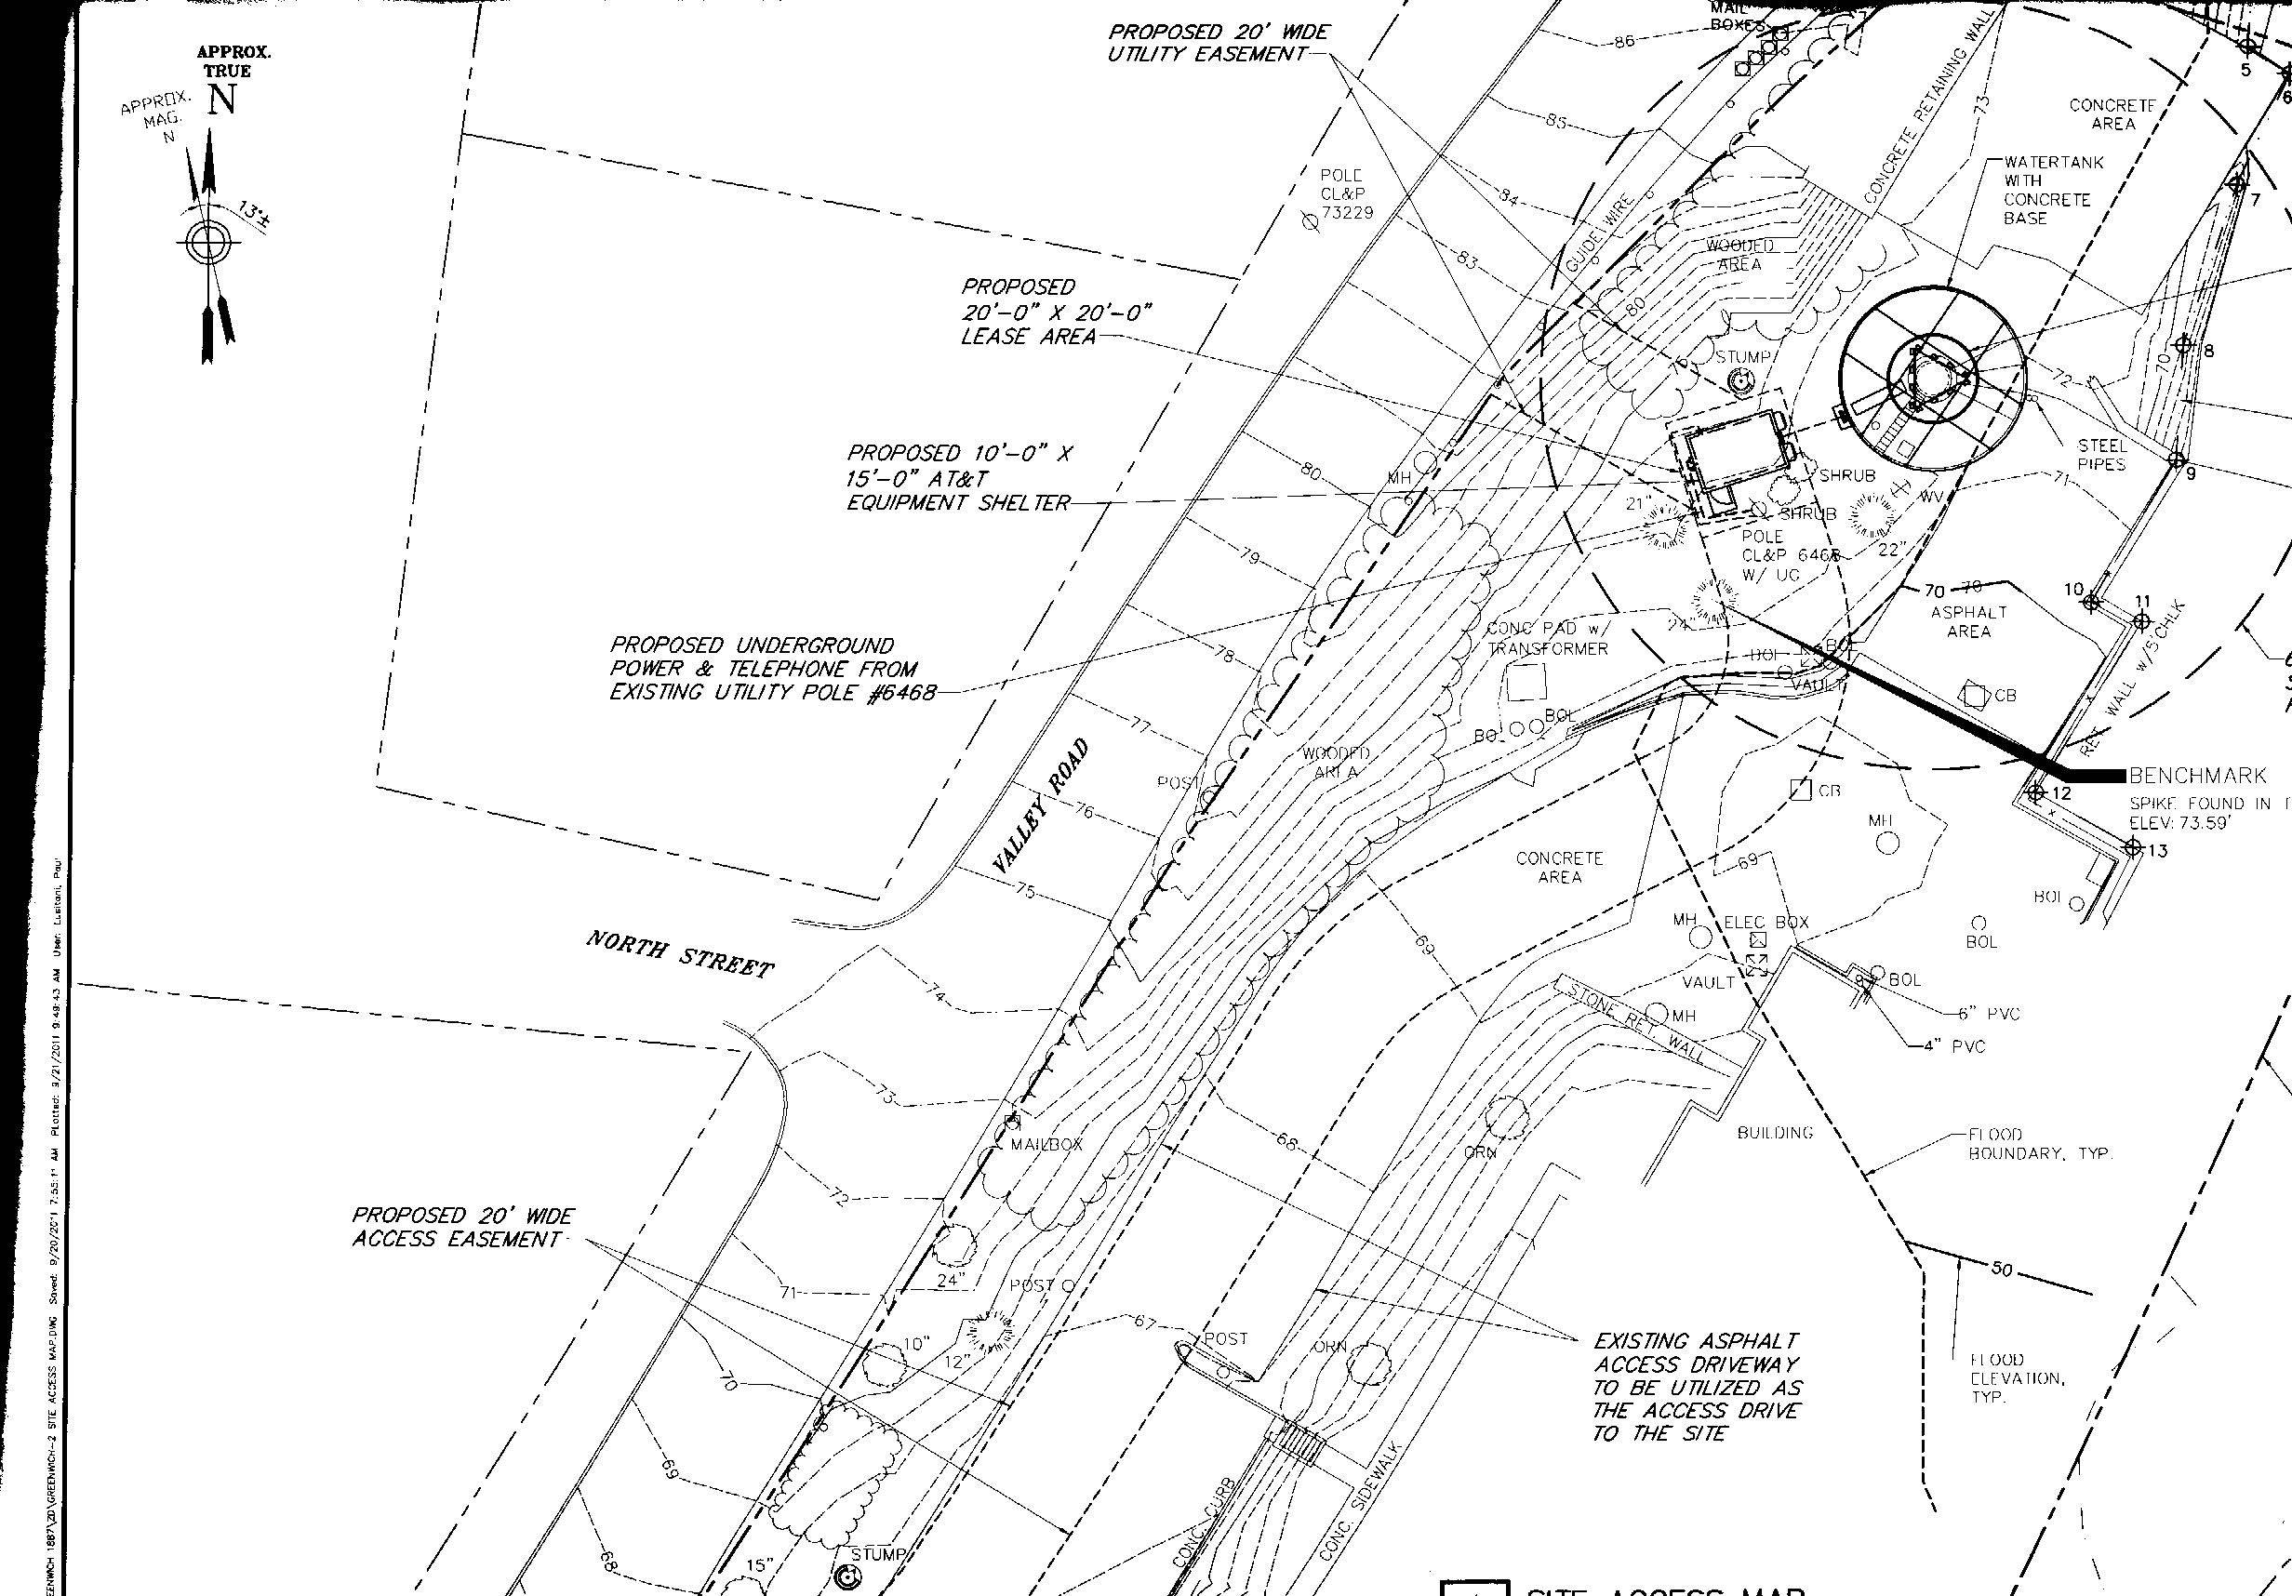

Figure 1. Site plan for the proposed facility. (AT&T 1, Tab B)
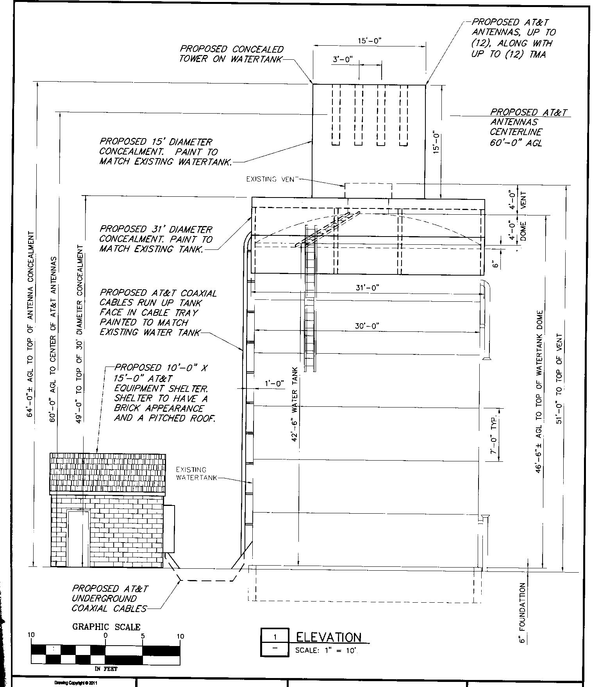

Figure 2. Drawing showing water tank and proposed tower installation. (AT&T 1, Tab B)
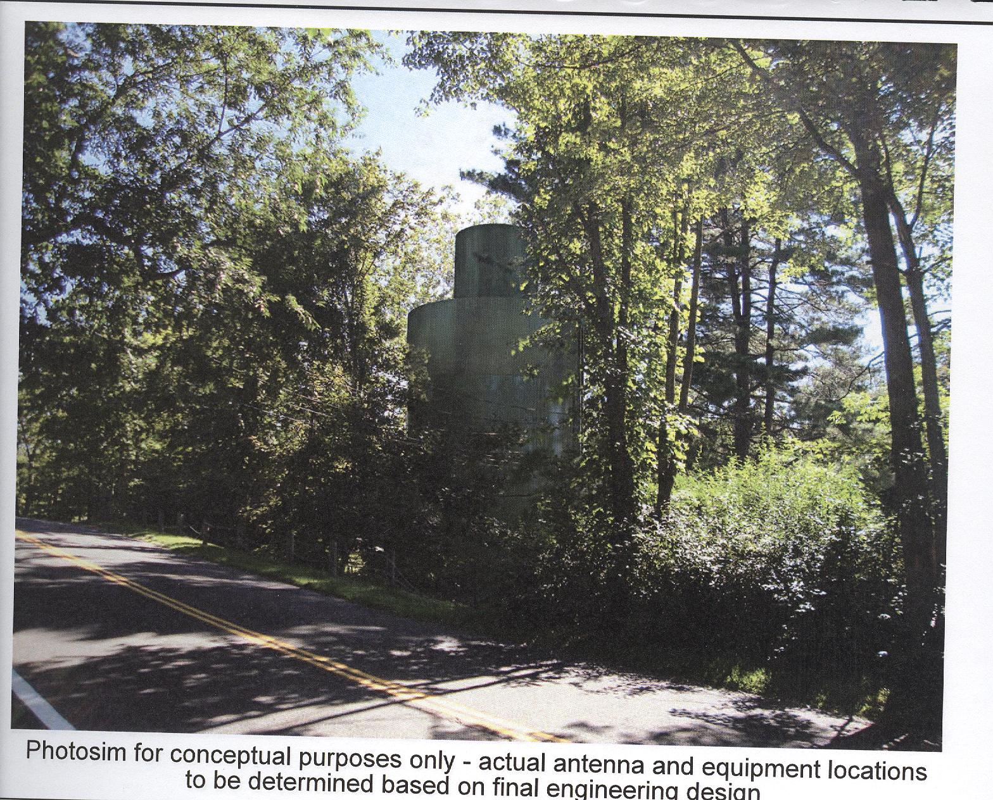

Figure 3. Photosimulation showing what the proposed facility would look like from Valley Road in Greenwich. (View #4 on viewshed map and table in Finding #54). (NAT/AT&T 4)
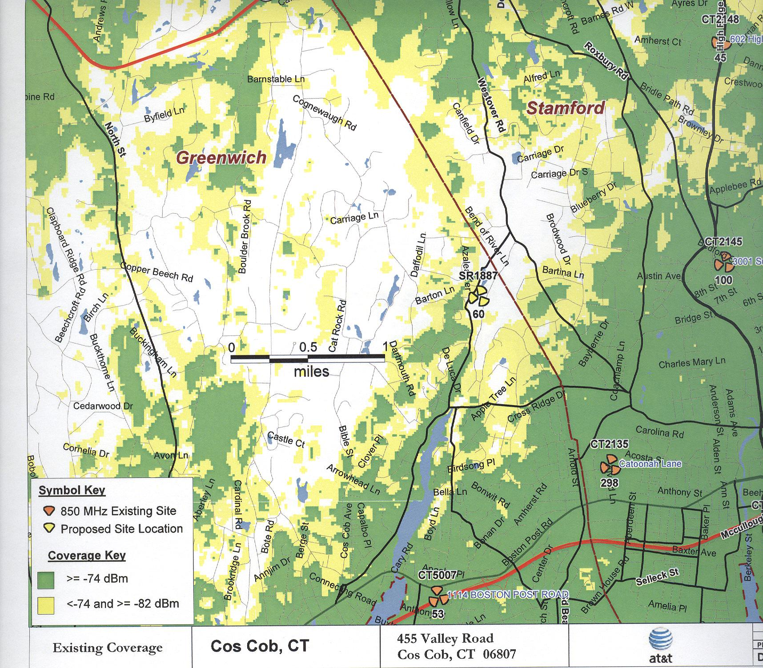

Figure 4. Existing AT&T coverage in the area of the proposed site. (AT&T 1, Tab G)

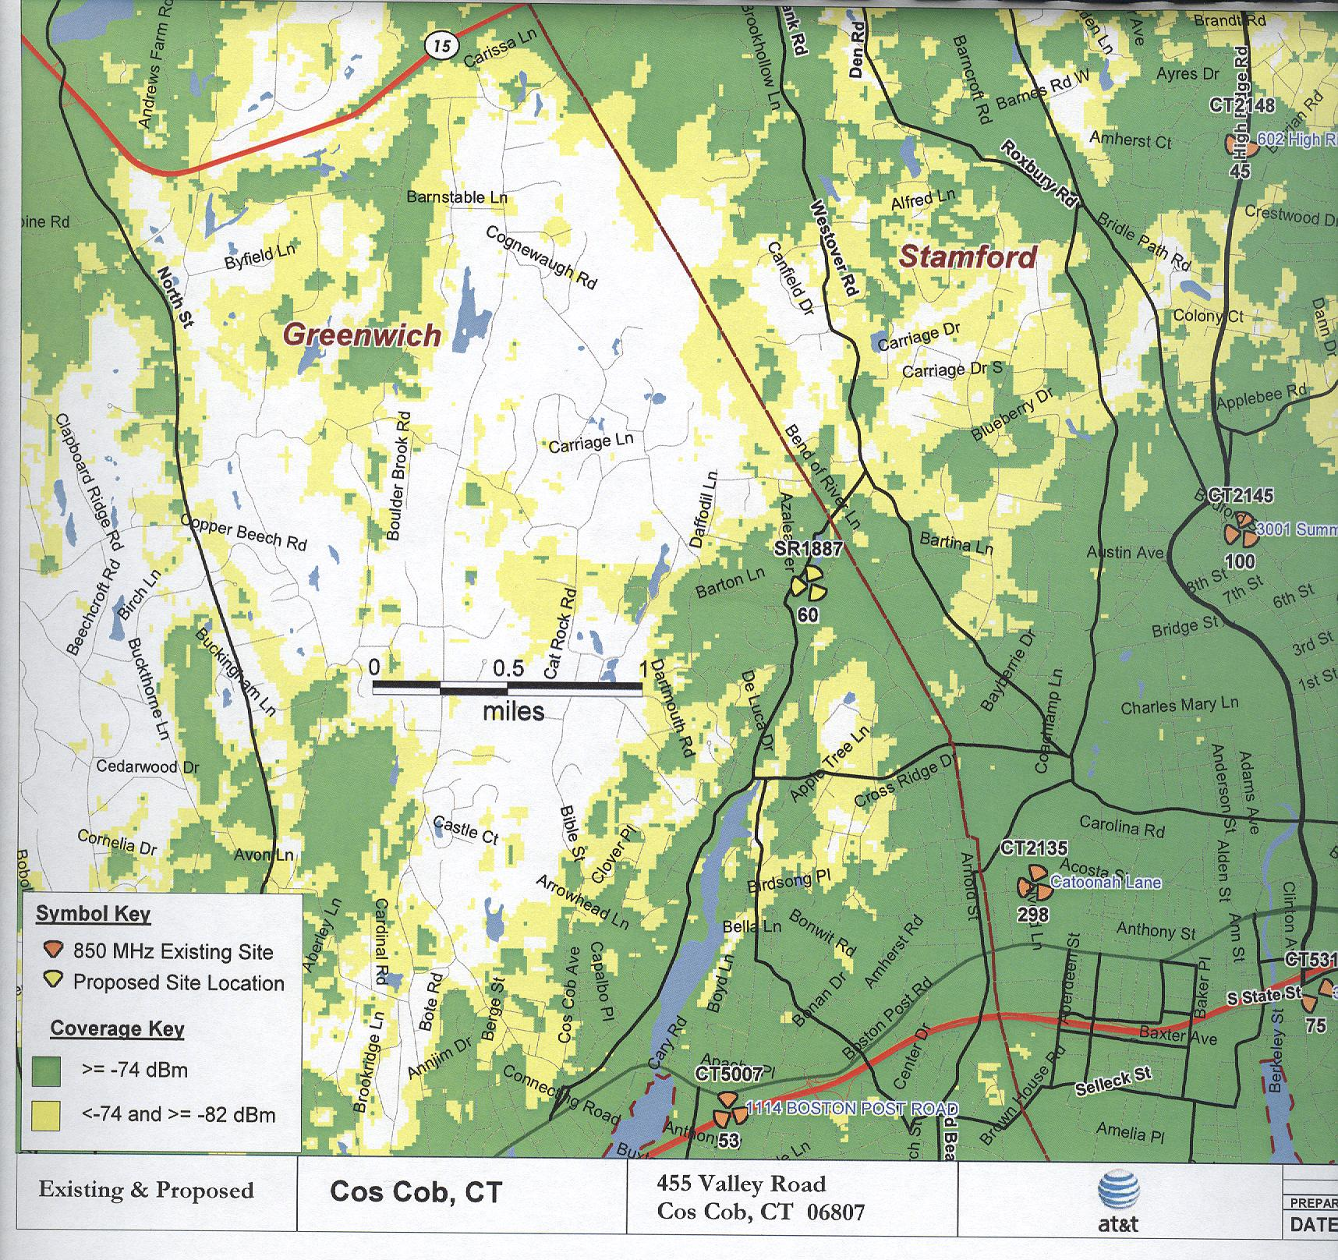

Figure 5. Plot showing existing AT&T coverage and coverage from the proposed site at 60 feet agl. (AT&T 1, Tab G)
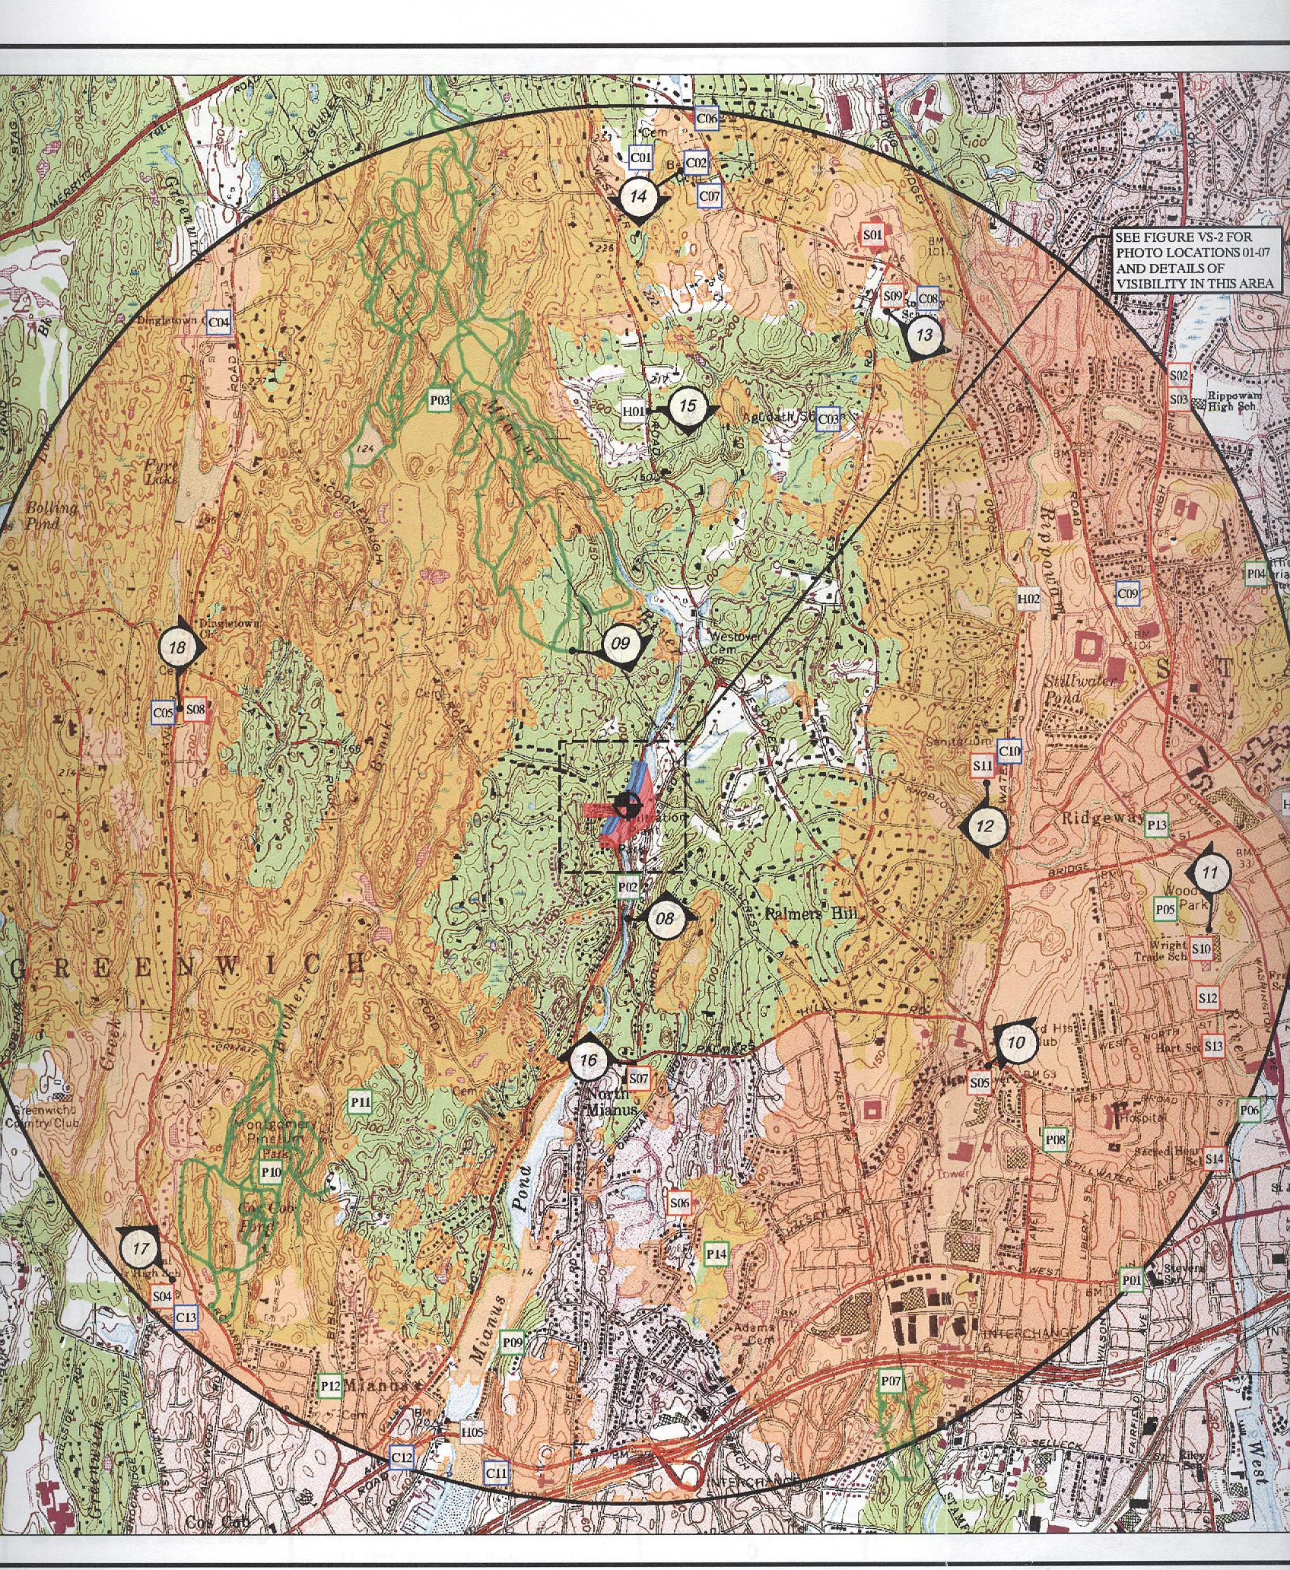

Figure 6. Viewshed analysis map showing potential visibility of the proposed tower. (AT&T 1, Tab C)

