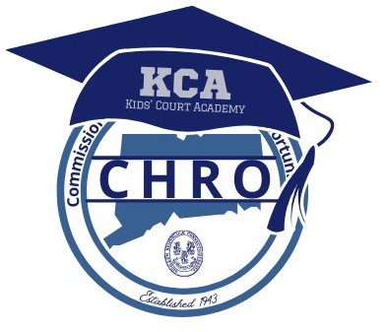
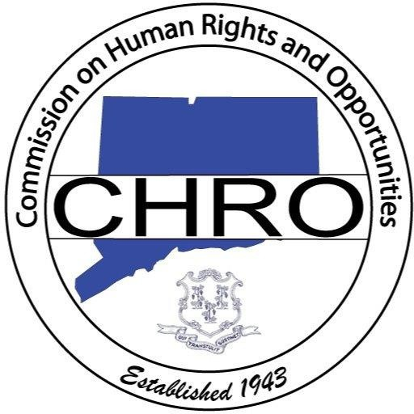

The mission of the Connecticut Commission on Human Rights and Opportunities is to eliminate discrimination through civil and human rights law enforcement and to establish equal opportunity and justice for all people within the state through advocacy and education.
THE HISTORY OF KIDS COURT

In 1993, then UConn Law students, Cheryl Sharp and Rae Thiesfield, developed and launched the first Kids Court Competition in the Greater Hartford area to educate students about social justice, diversity, and civil and human rights issues.
The competition, now sponsored by the Connecticut Commission on Human Rights and Opportunities, has been recognized nationally and locally and continues to run today. CT Kids Court Academy (KCA) is an extension of Kids Court. Tens of thousands of students have participated in Kids Court, and the hope is that thousands more will benefit from KCA. We are proud to partner with the State Department of Education for Year #6 of Kids Court Academy.
CHRO Executive Director Attorney Tanya A. Hughes
CHRO Deputy Executive Director Attorney Cheryl A. Sharp

KIDS COURT ACADEMY (KCA)
YEAR #6:
THE CRIMINAL JUSTICE SYSTEM & FAIR AND IMPARTIAL POLICING

An attorney and social justice pipeline program for middle and high school students
Co-sponsored by:
The State of Connecticut Commission on Human Rights and Opportunities
The Connecticut Bar Association
The Educational Working Group of the Department of Justice Connecticut State Department of Education
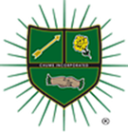
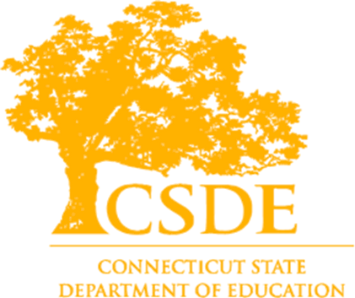
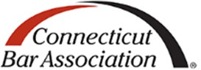
CHUMS

The CT Commission on Human Rights and Opportunities, in cooperation with state and federal partners, is co-sponsoring the sixth year of the CT Kids Court Academy. This attorney pipeline program is an outgrowth of the CT Kids Speak and Kids Court Competition developed on the campus of UConn Law School in 1993.

What is CT Kids Court Academy?
CT Kids Court Academy is an attorney pipeline program to develop interest in youth regarding civil and human rights law.

What is the focus of Kids Court Academy?
The program emphasizes civil and human rights law enforcement and social justice. It aims to enhance youth awareness of these areas through a series of one-hour sessions. During these sessions, students will delve into the law by reviewing cases or films. The law is a powerful tool! Learning will be facilitated by a professional in social justice or civil rights and will include peer exercises and interactive activities.

What are the objectives of Kids Court Academy?
- Support youth leadership development and interest in law by early exposure.
- Reduce discrimination and prejudice by including students from diverse areas.
- Create a pipeline for CT law schools.
- Inspire future change agents and civil rights leaders.
- Offer an after-school activity for academic enrichment and recreational fun.
- Provide a platform for youth to elevate their voices.
- Expose youth to the legislative and law-making processes
KCA

PROGRAM DESCRIPTION
The 16-week program, with a break in July, features bi-weekly remote meetings on Teams. Attorneys, law students, investigators, and other civil rights and social justice professionals will present cases, show films, and engage in discussions and activities with students for one hour.

ELIGIBILITY
Students are eligible to register for the Academy if they are in the 4th grade (maximum of 10 students), 5th grade (maximum 20students), middle school (6th-8th grade), or high school (9th-12th grade) in the state of Connecticut will be registered. Students will be eligible to participate in the Academy from year to year, once accepted, until they graduate from the Program.
ATTENDANCE
To get the greatest benefit from the Academy, attendance is required. The Program is seventeen weeks. Students may not miss more than 3 unexcused weeks of the Academy, or they will be in danger of being removed from the Program.

WHEN DOES YEAR #6 START?
Kids Court Academy begins on Tuesday, February 24, 2026, and ends October 20, 2026. The program will run from 3:45-4:45 via a Teams platform. The Academy will run every other Tuesday except for Holidays and scheduled days off. We will take a summer vacation during the month of July. A complete calendar will be released to all participants.

REGISTRATION
Teachers, students, and parents may register a student using the form online by clicking the following link: 2026 Kids Court Academy. For more information on Kids Court Academy, client the following link: Kids Speak and Kids Court.

