Careers in Disability Claims Examining
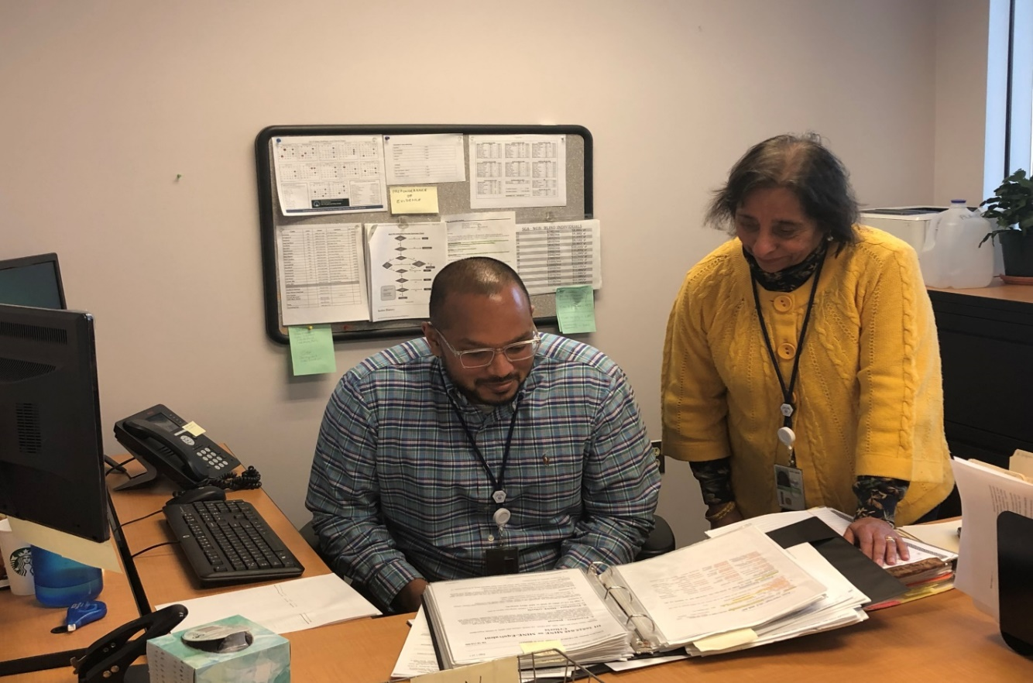
Helping to connect people with disabilities to vital Social Security benefits is an important role that Aging and Disability Services (ADS) Disability Claims Examiners perform daily. For a person whose disability prevents them from working, Social Security benefits can be the bridge needed to pay the rent, buy groceries and live independently. Time is of the essence and our Disability Claims Examiners work in a fast-paced environment, recognizing the importance of gathering and reviewing medical and work history documentation to keep the process moving smoothly and quickly for applicants who are eager to know if they qualify for benefits.
If you enjoy using your analytical skills to make eligibility decisions, and you have a background and understanding of medical terminology, vocational assessments, and functional capacity requirements for a wide range of jobs, a career as a Disability Claims Examiner in the Disability Determination Bureau of ADS may be the perfect match for you. A Master’s degree in rehabilitation counseling, psychology, counseling, special education, social work, or a related behavioral or social science is preferred, although a Bachelor’s degree in any of these areas will be considered.

Visit https://jobapscloud.com/ct/ to search for job openings.

