THE BESB BUZZ….

A Newsletter for Families of Children who are Blind or Visually Impaired

Volume 22  Spring 2019

Published by the State of Connecticut

Department of Rehabilitation Services (DORS)
Bureau of Education and Services for the Blind (BESB)

Feature Articles:
New Britain Museum of Art Trip, Music Is Boundless, UMass Boston Vision Studies Program, CVI at Home – Finding My Shoes, Ski Sundown – An Interview, Upcoming Events, Object Calendar Systems

In an effort to provide you with faster delivery of our newsletter and program flyers, save paper, and contain printing costs, we are now posting an expanded electronic version on our website: www.ct.gov/besb
(Newsletter is also available in Spanish on our website)
If you provide us with your e-mail address, we will send a copy of the newsletter directly to you by e-mail. Please give your preferred e-mail address to your child’s Teacher of the Visually Impaired.

Feel free to contact the newsletter’s co-editors with any suggestions at
lisa.pruner@ct.gov or adrienne.brown@ct.gov
We welcome your comments and ideas for future newsletter topics.

Look Where We’ve Been!



New Britain Museum of Art Trip

On Feb. 26th, seven elementary school students visited the New Britain Museum of Art for a “white glove tour” of the galleries. Under the guidance of a museum docent, students donned gloves and tactually explored several of the museum benches which ranged in form and texture from wavy wood to flat marble. A crowd favorite was a brass bench sculpted in the form of a bear (named Spencer!). Students were also able to feel some sculptures included in the museum’s permanent collection. The tour was followed by a hands-on art making experience in the museum’s classroom. Students created sculptures of their favorite foods using clay, beads, feathers, and wire. Chicken noodle soup, hotdogs, broccoli, and pizza were just some of the student-artist clay creations!

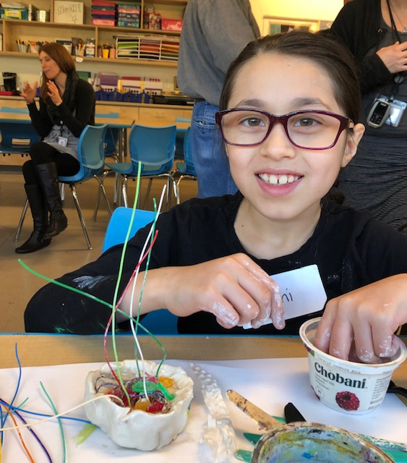

Music is Boundless:
A Pilot Expanded Core Curriculum (ECC) Activity

An ECC Field Day for students with multiple disabilities and their families was held Nov. 6, 2018. Instruments including drums, xylophones, and bells were explored. Colorful scarves and voice output buttons were also available. Students participated in a group song activity, wrote an object journal page to take home, and spent time with each other. A grant from the East Hartford Lions Club provided all materials. This trial activity was attended by five students of varying ages, seven parents & adults, and one sibling. With the overwhelming positive response we’ve received, we hope to offer future small group activities!

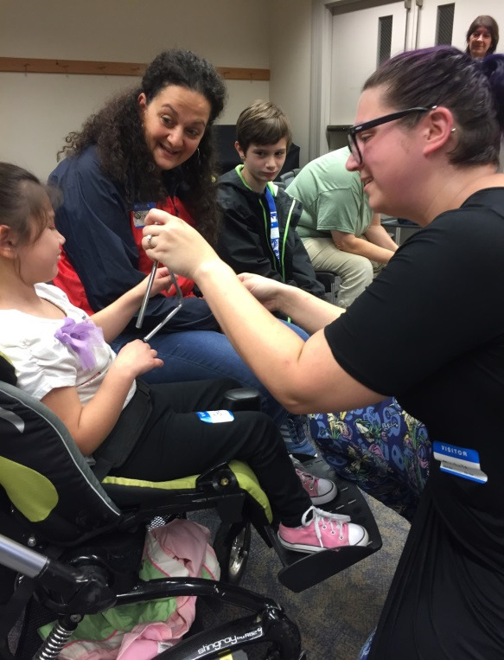
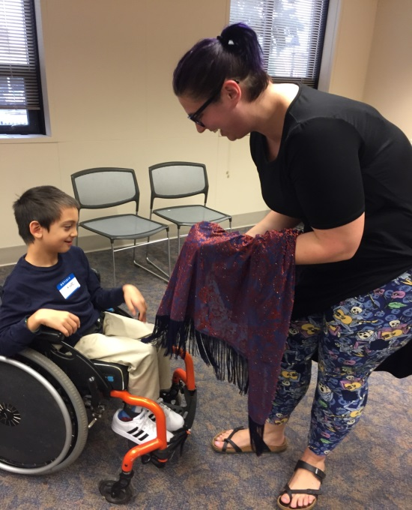

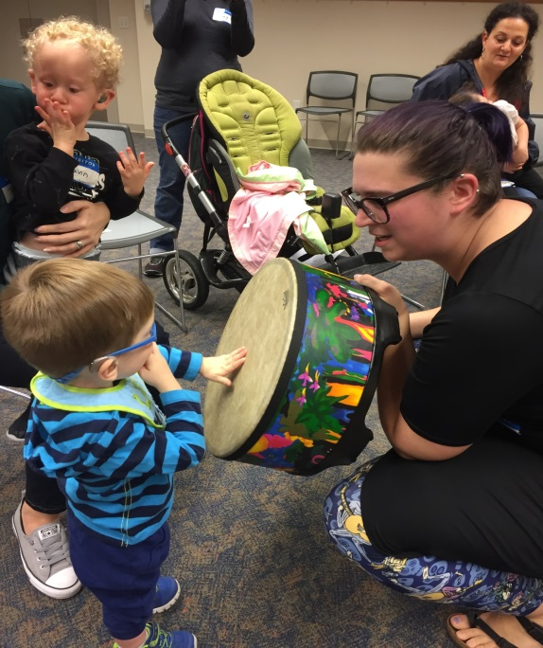
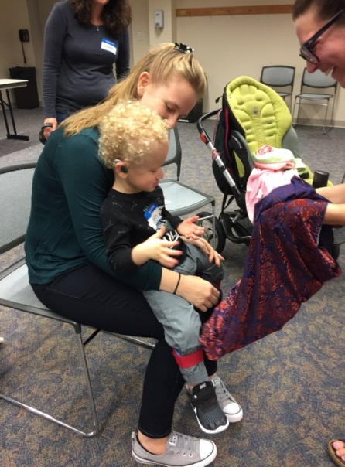

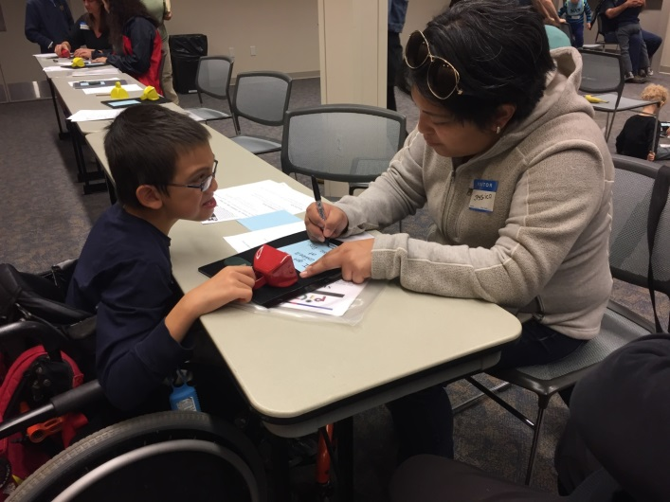

University of Massachusetts Boston
Vision Studies Program

Suzanne Cappiello, Education Consultant and
Connecticut State Liaison

The University of Massachusetts Boston Vision Studies Program is the only personnel preparation program in New England for Teachers of Students with Visual Impairments (TVI) and Orientation and Mobility Specialists (O&M). It is an online program which maintains a strong connection to the service delivery programs in each participating state. Through this connection, the TVI and O&M graduate students are provided with the crucial hands-on experiences they will need to become competent professionals.

Connecticut has had close to twenty TVIs graduate from the program and about 95% now work for the state of CT. We've had three O&M graduates and all now work within the state. There are presently four TVI candidates and one O&M candidate enrolled in the program. Most of them will graduate within the next two years. This is when we will probably feel the shortage even more than we do already...so this will be good timing for us!

For additional information visit the website at www.nercve.org. For scholarship information, you may contact Dr. Laura Bozeman at Laura.Bozeman@umb.edu.

activities for Students with multiple disabilities and their Families!

Upcoming BESB Event!

Horseback Riding Event for Grades 7-12
Monday, June 12, 2019 10:00am-12:00pm
Hidden Acres Farm, 45 Gabriel Drive, Naugatuck, CT

Contact: Michele Margenau Michele.Margenau@ct.gov

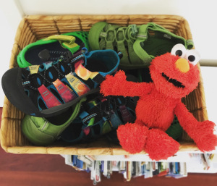

CVI at Home: Finding My Shoes
By Brenda Biernat

For children with cortical visual impairment (CVI), we want to provide the opportunity to use vision throughout their day. We do this by use of the CVI Range (Roman) and by incorporating an intentional approach, based on how the ten characteristics of CVI (Roman) impact each individual child. There are so many opportunities for this in the course of a child’s day, in the natural environment…right at home.
One of our house rules is: no shoes. We do not wear shoes inside the house. Consequently, this involves putting shoes on and taking them off, at least a few times a day. And that means – finding your shoes. A few times each day, we must find our shoes.
Knowing of my son’s lower visual field deficits (preferred visual fields), his shoes have always been kept in a basket that sits on top of a small chest of drawers instead of strewn across the closet floor, like my shoes. Sitting atop the chest, the basket is at the level of my son’s midriff, well up out of his lower visual field. His preferred color is yellow but at some point, a small stuffed Elmo entered the picture and landed in his shoe basket. The shoe basket was easily found by looking for bright red Elmo.
Once or twice a day, the task of finding shoes began with, “Go find your green lace shoes…” or fill in the blank shoes. Some days were harder than others. Depending on the time of day – or the time of year – the room could be dim. If my son showed frustration, it meant he could not perform the task and something needed to change. On those dim wintry days, flipping on the overhead light often did the trick.
Sometimes there were too many shoes (complexity of array), so a few pairs would be taken out and tucked away. This reduced the visual array and increased his chance of being successful at finding his shoes.
It helped that most of his shoes are brightly colored. Solid orange or green sandals are easier to find. Interestingly, the more visually complex, multi colored tie dye sandals (that I love) were never his favorite. Hmmm.
For a child with CVI, searching for an object is hard. Not only is the task of visually scanning and searching difficult, but the concept of how to look for things presents a challenge. It likely is not right there in front of you where you want it to be, so we will have to look. It might have rolled away, or be hidden beneath another object (object permanence). Especially when an object has gone missing, it helps to emphasize all the places where things might disappear to, and all the places we could look: on surfaces, on the floor, under a couch or a table, or under another shoe. Finding his shoes helps him practice this. The shoe is not right there on top, so we might need to move a shoe and look underneath. This direct instruction is essential for him.
Finding shoes also provides an opportunity to learn about and identify the salient features of a particular shoe. Before it is time to look for shoes, arrange the shoes intentionally, so that only the orange sandal strap or the green shoe lace you want him to find is visible. Is he able to visually locate the shoe by that sole salient feature? Or does he need to see the whole shoe before he can recognize it?
On a side note, by keeping shoes in a particular spot, he is learning how to organize himself, how to keep track of his belongings. If I keep my shoes right here in this spot, it will be easier for me, as a person with CVI, to find them later. For a young child, this may be easier said than done! This concept aligns with the expanded core curriculum and skills of independent living.
After a while, you might be able to add another pair of shoes to that basket. Kids grow fast, shoes come and go. The mix of shoes will change, and be novel.
Right now it’s almost time for school, and that means, time to go find shoes once again.
Brenda is the mom of an adorable 8 year old with CVI. She writes the blog, Start Seeing CVI, which you can check out here:
https://startseeingcvi.com/

Ski Sundown – An Interview!
By Evelyn Furey, Education Consultant

Cold hands but warm hearts! On January 26th BESB held their annual Adaptive Ski Program at Ski Sundown in New Hartford. Eleven students participated in this event and got to spend the day slope side with an amazing group of instructors from the STRIDE Adaptive Sports program. I think it’s safe to say they all shared a taste for adventure!
I had the opportunity to interview 2nd grader Kilee Vann after she participated in this event. Here are a few of her responses.
Me: Had you ever been skiing before this, Kilee?
Kilee: No, it was my first time.
Me: What was your favorite part of the day? Was there anything you didn’t like?
Kilee: My favorite part was that I got to have hot chocolate. There wasn’t anything I didn’t like.
Me: Did anything surprise you about skiing?
Kilee: The new kids and that I got to meet them.
Me: Is there anything you would want to tell other kids about this event who didn’t go this year?
Kilee: Tell them that skiing is the funnest time of the year…How come they only do it once a year?
Me: Do you want to keep skiing when you grow up?
Kilee: Yeah, but with the ski poles.
Although BESB only gets the chance to sponsor the ski program once a year, the STRIDE Adaptive Ski Program is available every weekend (and some weekdays) throughout the ski season. If you are interested in learning more about it follow this link: https://skisundown.com/Lessons-Packages/Lessons-Packages/Private-Lessons-Packages/Adaptive-Lessons

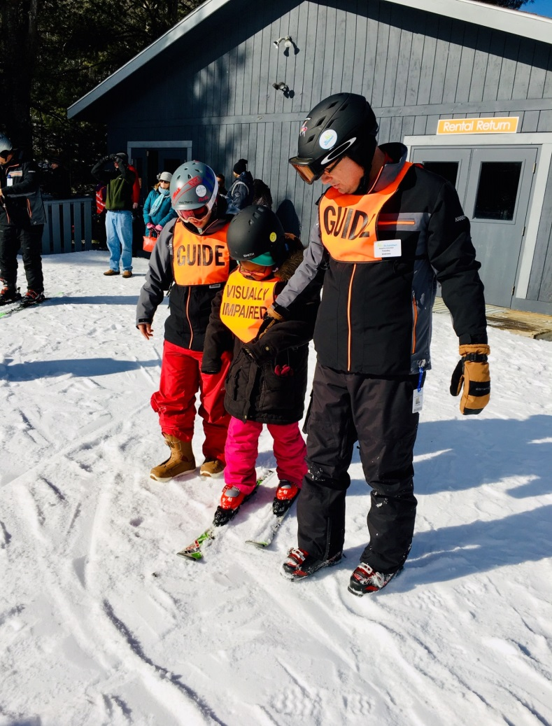


New Transition Resource Guide

A new resource guide will soon be available to families of transition-aged students. This guide is full of information which may be helpful as your child plans for the future. We will be distributing the resource guide electronically to the email address we have on file for you. Please check in with your education consultant or TVI that we have your most updated contact information. Don’t hesitate to reach out to me directly at barry.rita@ct.gov so I can ensure that your family receives this resource.
We would also like to introduce the term Pre-Employment Transition Services (PRE-ETS). PRE-ETS describes services provided to high school students between the ages of 16 and either graduation or age 21 by DORS-BESB Vocational Rehabilitation Services. In some cases we may serve students attending college or some kind of career preparation program or certification up to age 21.

Object Calendar Systems: Understanding What’s Next
Peg Palmer, Education Consultant
We all know the feeling: our calendar is lost or forgotten. And we are lost without it! Now imagine never knowing what is coming next. Each day, we are jolted from one activity to the next, unable to predict or control our day.
For many students with visual impairments, especially those with other added disabilities, this is their reality. They are not in that position because the adults around them don’t care about them. They are in that position because it seems impossible to convey to some of our children what their schedule is. Time and sequencing are abstract concepts and not easy to teach!
In preschool, there are picture calendars spread across the walls:
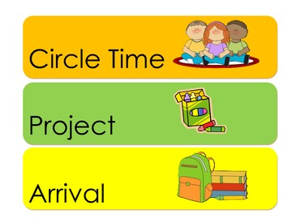
These simple picture calendars help young children understand and predict their day, long before they can read. For typically sighted young children, simply looking around their environment gives them clues as to what is coming next. An adult is putting dishes on a table: soon time to eat! An adult is getting their coat on: time to go out! When these pictures and events are not accessible to children, they are lost in time.
Besides being important to our sense of well-being, being able to predict and understand time concepts is also good for our brain development. Neuro-scientists have looked for areas in the brain where we understand the concept of time, but haven’t found it. More and more, they think that our understanding of time is scattered throughout the brain. For this reason, when we begin to understand the concept of time, it can knit parts of the brain together, creating new and more robust pathways. There also seems to be a tie in to language development and time understanding. It turns out that knowing about time is a very good thing! So, the question is: how do we help students understand what is coming next?
For students who have vision and can process visual information well, the picture schedule is frequently a good solution, modified to fit their visual needs. But what about for children who are totally blind, who have CVI or whose visual input doesn’t enable them to take in the visual information, who may be non-verbal or have other disabilities? An object calendar system might be the solution.
An object calendar system substitutes real objects for pictures and words. Instead of a picture of the cup or plate to reference “snack time,” or the words “snack time,” an object calendar box has the child’s cup in the slot. “Bathroom” might be a box of wipes or paper towels. “Playtime” is a toy that the child actually plays with. Since touch is so important for many of our students, having the actual object (not a small replica or a plastic version) helps them to process the information and leads them to be able to predict what is coming next. The key is repeated exposure to this system, the same way young children see a picture calendar thousands of times before we expect them to understand it.
While there are many ways to create a calendar box system, the important components are size (large enough to hold the objects), portability, and making it indestructible (or replaceable).
The objects symbols are the key. We suggest that team members and family work together to determine what to use. Objects will represent an activity. When just starting out, just as sighted children do best with very clear photos, using the exact cup that the child uses for “snack time” is highly suggested. Starting with just one object, presenting it before the activity, many times begins to help the child understand the meaning of the object. Using the same language is also very important. Determine the language and stick to it: if it’s snack, then it’s not drink, lunch, eat, etc.
Placing it in the calendar box and pulling it out of it is important! Just handing the child a cup is different from the object symbol of “cup.” As it becomes apparent that the child understands the connection, more objects can be added.
Here is one currently being used for one of my young students:

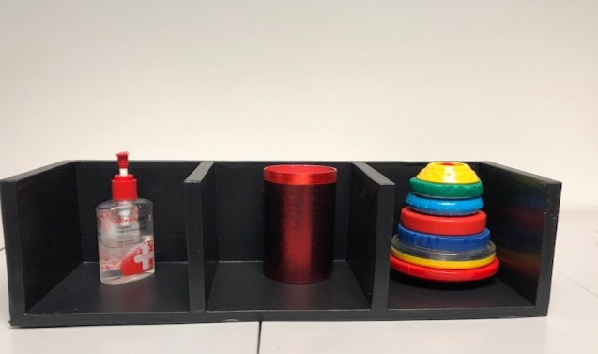

This calendar is working very well: chamber 1= wash hands (hand sanitizer), chamber 2 = drink/snack (cup), chamber 3 = playtime (toy).
Some calendar box systems include all done boxes and/or communication cards. The team and TVI should be able to help determine if any of this would be helpful for your child. Specialists in this field suggest we don’t use more than 3 activities at a time.
Coming back to it frequently throughout the day and using it helps the student begin to make the connections and bring meaning to these objects.
Consider using an object calendar system to teach time and sequencing!

Here are a few links with additional information on calendar systems:
http://www.pathstoliteracy.org/strategies/sequence-board-child-cvi

https://www.tsbvi.edu/curriculum-a-publications/1024-calendars-for-students-with-multiple-impairments-including-deafblindness

