The Resultant Contractor shall provide Assistive Technology (AT) evaluations and training to Clients (including the Department’s Vocational Rehabilitation Clients, Clients who are Deaf-Blind under the National Deaf-Blind Equipment Distribution Program (NDBEDP) or other Department Clients of all ages and all disabilities) at their home, at the worksite or other community location on a fee-for-service basis including but not limited to the following:

AT Evaluation: A full AT evaluation will include record review, interviews, evaluation or assessment of Client in the appropriate environment, i.e. school, the Department’s office or other community location as identified by the Department, and a final written report with findings and recommendations of AT device(s) and/or services, vendors who may supply recommended AT device(s) and/or software and price quotes.
- AT Evaluations for Clients who are Deaf-Blind: will contain all of the above but will focus on devices that are specific to Clients who are Deaf-Blind to increase their access to telecommunication services, internet access and advanced communications. The AT Evaluations will include recommendations of AT device(s) and/or software and recommendations for amount of training, if appropriate. AT Evaluations may be conducted at the Client’s home, an evaluator’s office or other location.
AT Workplace Evaluation: An AT Workplace Evaluation will include the Resultant Contractor traveling to a Client’s work environment to observe, interview and assess the work environment for Assistive Technology and /or accommodation(s). A final written report with findings and recommendations of AT device(s) and services, vendors who may supply recommended AT device(s) and/or software and price quotes will be completed.
AT Home to Work Evaluation: An AT Home to Work Evaluation will include the Resultant Contractor traveling to a Client’s home to assess for AT device(s) or accommodations needed in the home environment as well as traveling to the Client’s work environment to observe, interview and assess the work environment for Assistive Technology and /or accommodation(s). A final written report with findings and recommendations of AT device(s) and services, vendors who may supply recommended AT device(s) and/or software and price quotes will be completed.
AT Training: AT Training will include individualized training of the Department’s Client(s) on the utilization of recommended AT device(s) and/or software. Training will take place in the environment where the AT device(s) and/or software will be primarily utilized, and as determined by the Department. Training hours will be recommended in the written reports and approved and authorized, in advance, by the Department. Upon completion of the training hours, a brief final report will be required summarizing the results of the training and any further recommendations.
  - AT Training specific to Clients who are Deaf-Blind: will require experience in training Clients who are deaf-blind on how to use the equipment, knowledge of how to set up this equipment, and ensuring that the Client can effectively use the equipment. The equipment may need to be configured to meet the specific needs of the Client. An understanding of the deaf-blind culture and the various means of communication will also be necessary. Trainers will need to be proficient in one or a combination of the following: Braille, tactile sign language, and other communication styles. Training hours will be recommended in written reports and approved and authorized, in advance, by the Department.
  - Troubleshooting equipment and repair: During the activities included under AT Training to Clients who are Deaf-Blind, the Resultant Contractor may be asked by the Client to troubleshoot or repair a piece of equipment provided by the NDBEDP. The Resultant Contractor may invoice the Department for the time spent troubleshooting or repairing equipment. Repairs are only to be done on equipment the Resultant Contractor is familiar with and when the repair will not interfere with the warranty of the product. The Resultant Contractor should notify the Department in advance of making repairs.
  - Travel: Mileage will be compensated as outlined in the Fee for Service Table below.
  - Travel Time: For NDBEDP Clients only – time traveling from portal to portal for evaluations, training and troubleshooting will be compensated as outlined in the Fee for Service Table below.

Assistive Technology Services shall be paid at the rates outlined in the Fee for Service Table, below.

FEE FOR SERVICE TABLE

SERVICES | RATE | MAXIMUM UNITS  (additional hours require prior approval)
AT Evaluation | $100.00/hour | Up to 10 hours
AT Workplace Evaluation | $100.00/hour | Up to 10 hours
AT Home to Work Evaluation | $100.00/hour | Up to 10 hours
AT Training (or Troubleshooting/repairs for NDBEDP Clients) | $100.00/hour | Hours based on recommendations and pre-approval by Department Staff prior to completion
AT Travel | Mileage is determined by Mapquest.com or Google Maps and will be reimbursed at the current State of Connecticut mileage reimbursement rate for travel from portal to portal.
Travel Time (NDBEDP Clients only) | $50.00 / hour

- DEMOGRAPHICS

A1. ORGANIZATIONAL DEMOGRAPHICS -

Name of Organization/Provider:
Organization d.b.a Name:
Address:
Phone: | Secondary Phone: |  | Email:
Fed. I.D.: |  | Administrative/Executive Director Name:
Administrative/Executive Director Email:
Name and Title of Contact Person for AT Services: (This individual will assume the role of being responsible for all administrative supervision of AT services.)

Phone: |  | Email:
Contact Person for RFA:

Contact Person Phone: |  | Contact Person Email:

- SERVICE AREAS
Check the geographic areas you are interested in providing AT services:

Western Region – North West
Western Region – South
Northern Region – Central
Northern Region – East
Southern Region – Central
Southern Region – East

Western Region – North West

Barkhamsted
Bethlehem
Bridgewater
Canaan
Cheshire
Colebrook
Cornwall
Goshen
Harwinton
Kent
Litchfield
Middlebury
Morris
Naugatuck
New Hartford
Norfolk
North Canaan
Oxford
Plymouth
Prospect
Roxbury
Southbury
Salisbury
Sharon
Thomaston
Torrington
Warren
Washington
Waterbury
Watertown
Winchester
Wolcott
Woodbury

Western Region – South

Bethel
Bridgeport
Brookfield
Danbury
Darien
Easton
Fairfield
Greenwich
Monroe
New Canaan
New Fairfield
New Milford
Newtown
Norwalk
Redding
Ridgefield
Shelton
Sherman
Stamford
Stratford
Trumbull
Weston
Westport
Wilton

Northern Region – Central

Andover
Avon
Berlin
Bloomfield
Bristol
Burlington
Canton
Columbia
Coventry
East Granby
East Hartford
East Windsor
Ellington
Enfield
Farmington
Glastonbury
Granby
Hartford
Hartland
Hebron
Manchester
Mansfield
Marlborough
New Britain
Newington
Plainville
Rocky Hill
Simsbury
Somers
South Windsor
Southington
Stafford
Suffield
Tolland
Union
West Hartford
Wethersfield
Willington
Windsor
Windsor Locks

Northern Region – East

Ashford
Bolton
Brooklyn
Canterbury
Chaplin
Eastford
Hampton
Killingly
Plainfield
Pomfret
Putnam
Scotland
Sterling
Thompson
Vernon
Windham
Woodstock

Southern Region – East

Bozrah
Colchester
East Lyme
Franklin
Griswold
Groton
Lebanon
Ledyard
Lisbon
Lyme
Montville
New London
North Stonington
Norwich
Old Lyme
Preston
Salem
Sprague
Stonington
Voluntown
Waterford

Southern Region – Central

Ansonia
Beacon Falls
Bethany
Branford
Meriden
Chester
Clinton
Cromwell
Deep River
Durham
East Haddam
East Hampton
East Haven
Essex
Guilford
Haddam
Hamden
Killingworth
Madison
Middlefield
Middletown
Milford
New Haven
North Branford
North Haven
Old Saybrook
Orange
Portland
Seymour
Wallingford
West Haven
Westbrook
Woodbridge

Map of DORS Geographical Area
Northern Region – East
Northern Region - Central

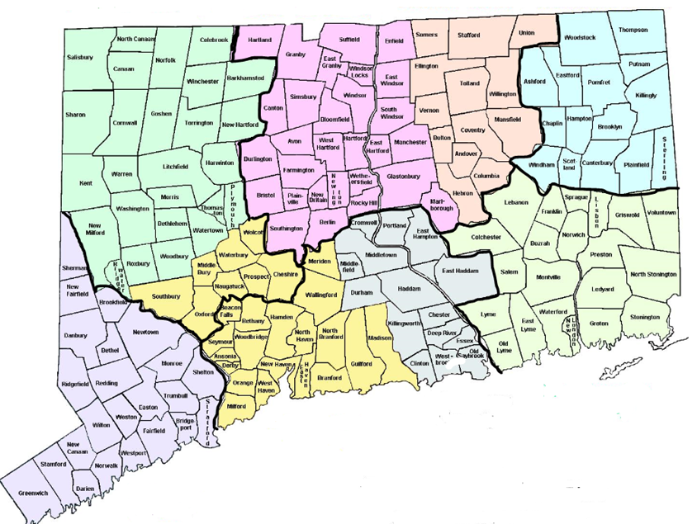
Southern Region - Central
Southern Region - East
Western Region – North West
Western Region - South
Southern Region - East
Northern Region - East

- EXPERIENCE

Complete all questions. Respondents shall be individuals or public, private, non-profit, for profit organizations or companies that have no less than four years of experience, or are certified by the Rehabilitation Engineering and Assistive Technology of North America (RESNA) as an Assistive Technology Professional (ATP), and have capabilities in providing one or more of the Assistive Technology Services.

- Describe the Assistive Technology related service(s) currently provided by the Respondent. Page limitation is one (1) single-sided page

- Indicate if individual or staff have the credential of Assistive Technology Profession (ATP) from Rehabilitation Engineering and Assistive Technology Society of North America (RESNA):
Yes
If yes, Certification Date:
For organizations, list the names and certification dates for employees:

No
If no, list the names of employees who will provide AT services and their individual years of experience (minimum of 4 years of experience or ATP required):

- Describe the disability population(s) primarily being served by the Respondent, including consumer age group(s), etc. Page limitation is one (1) single-sided page

- Do you or your organization have any specialized experience or training in communicating with the following populations for evaluations and trainings (with or without an interpreter):

Individuals who are monolingual Spanish speaking
Individuals who use American Sign Language
Individuals who Tactile Sign Language
Individuals who read Braille

Other, please explain:

5. Describe the Respondent’s ability to work with persons who are hard of hearing, persons who are deaf-blind, persons who have limited language skills and persons whose primary language is not English. Describe how the Respondent ensures cultural competency. Page limitation is one (1) single-sided page

D. SERVICES PROVIDED IN BUILDING OWNED OR RENTED

1. Does the Respondent have a facility where AT services can take place?
Yes No

If yes, please describe the accessibility of the facility (i.e.: ramped entrance, electronic door openers at entrance and exit, elevator to where services will be provided, accessible parking spaces, accessible bathrooms, etc). Page limitation is one (1) single-sided page

If yes, describe the proximity to public transportation of each facility at which the Respondent proposes AT Services can take place. Page limitation is one (1) single-sided page

- REFERENCES
List three professional references for Organization or for the Individual. At least one reference must be able to attest to work behavior of individual or of employee who will act in the role of Contact Person for AT Services at organization (in section A1.). At least two of the references must be persons not related to the Respondent or employee by blood or marriage and must have knowledge of the Respondent’s previous experience and abilities to provide services to Clients under this RFA:

NAME | E-MAIL ADDRESS | PHONE NUMBER

