Independent Living Centers (ILC) – Deaf Services
Connecticut has five Independent Living Centers (ILCs).
Look for the one that covers your area in Connecticut.
These centers provide tools, resources, and supports for integrating people with disabilities fully into their communities to promote equal opportunities, self-determination, and respect.

Access Independence
Deaf Service Advocate- Terri Ditimi
300 Long Beach Blvd. Suite #1, Stratford, CT 06615
(203) 916-9012 (videophone)
(203) 378-6977 (voice)
tditimi@accessinct.org
Service areas: Bridgeport, Darien, Easton, Fairfield, Greenwich, Monroe, New Canaan, Norwalk, Shelton, Stamford, Stratford, Trumbull, Weston, Westport, and Wilton.

Center for Disability Rights
Deaf Service Advocate- Sue Catale
369 Highland St. West Haven, CT 06516
(203) 680-3967 (videophone)
sue@cdr-ct.org

Service areas: Ansonia, Bethany, Branford, Chester, Clinton, Cromwell, Deep River, Derby, Durham, East Haddam, East Hampton, East Haven, Essex, Guilford, Haddam, Hamden, Killingworth, Lyme, Madison, Middlefield, Middletown, Meriden, Milford, New Haven, North Branford, North Haven, Old Lyme, Old Saybook, Orange, Portland, Seymour, Wallingford, West Haven, Westbrook, and Woodridge

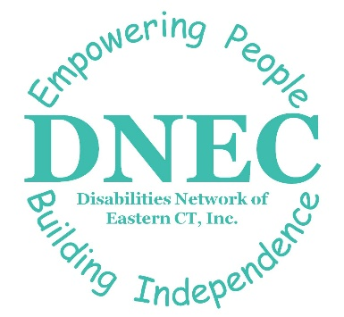
Disabilities Network of Eastern Connecticut (DNEC)
Deaf Service Advocate – Alyson Dolan
19 Ohio Ave. Norwich, CT 06360
(860) 237-4515 (videophone)
adolan@dnec.org
Service areas: Ashford, Bozrah, Brooklyn, Canterbury, Chaplin, Colchester, Columbia, Coventry, East Lyme, Eastford, Franklin, Griswold, Groton, Hampton, Killingly, Lisbon, Lebanon, Ledyard, Mansfield, Montville, New London, North Stonington, Norwich, Plainfield, Pomfret, Preston, Putnam, Salem, Scotland, Sprague, Sterling, Stonington, Thompson, Union, Voluntown, Waterford Windham, and Woodstock.

Independence Northwest
Deaf Service Advocate -
1183 New Haven Rd. Suite 200 Naugatuck, CT 06770
(203) 490-2373 (videophone)

Service areas: Barkhamsted, Beacon Falls, Bethel, Bethlehem, Bridgewater, Brookfield, Canaan, Cheshire, Colebrook, Cornwall, Danbury, Goshen, Hartland, Harwinton, Kent, Litchfield, Middlebury, Morris, Naugatuck, New Fairfield, New Hartford, New Milford, Newtown, Norfolk, North Canaan, Oxford, Prospect, Redding, Ridgefield, Roxbury, Salisbury, Sharon, Sherman, Southbury, Thomaston, Torrington, Warren, Washington, Waterbury, Watertown, Winchester, Wolcott, and Woodbury.

Independence Unlimited
Deaf Service Advocate – Dana O’ Leary
151 New Park Ave.
North Annex | Suite D Hartford, CT 06106
(860) 724-2742 (Videophone)
Dana@independenceunlimited.org

Service areas: Granby, East Granby, Suffield, Windsor Locks, Windsor, Bloomfield, Ellington, Simsbury, Canton, Avon, West Hartford, Hartford, Farmington, New Britain, Plainville, Bristol, Burlington, Plymouth, Berlin, Wethersfield, Rocky Hill, East Hartford, Glastonbury, Manchester, Marlborough, Hebron, Andover, Bolton, Vernon, Tolland, Enfield, East Windsor, Newington, South Windsor, Southington, Somers, Stafford, Tolland, and Willington.

