State of Connecticut
Department of Rehabilitation Services
Community Rehabilitation Provider (CRP) Handbook

A complete guide to the provision of CORE
CRP services including; Service Definitions,
Procedures, Documentation, and Frequently
Asked Questions.
Published January 2019

– CRP Handbook
Table of Contents PAGES

Section I. About VR Rehabilitation

A. Mission Statement 1
B. Organizational Chart 2
C. Office Locations 3
Section II. Core Contracted CRP Services 4

A. What are Work Readiness Services
- Module A – Pre Employment
- Module B – Job Seeking Skills
- Module C – Informational Interview
- Module D – Job Shadowing

B. What are Assessment Services
- Trial Work Experiences (TWE)
- Trial Work Experience Components

C. What are Work Attachment Services
- Competitive Placement Opportunity (CPO)
- Competitive Placement Opportunity Supports
- Job Placement (JP)
- Job Placement Components
- On the Job Training (OJT) Opportunity Development
- On the Job Training (OJT) Opportunity Development Components

D. What are On the Job Support Services
- Job Coaching
- Job Coaching – Communication Barriers
- Long Term Employment Supports (EOP)

E. What are Communication Barrier Mitigation Services
- Communication Assessment Service
- Communication Support
- CRP Staff Interpreter
- Third Party Interpreter Reimbursement

– CRP Handbook

Section III. Responsibilities of the VR Counselor, CRP and Client 15

- Work Readiness Training Services
- Trial Work Experience (TWE)
- Work Attachment Services
- Job Coaching
- Communication Barrier Mitigation Services

Section VI. Fiscal- Billing Procedures 31

- CRP Fiscal Responsibilities
- Required Information for Billing
- Methods of Payment
- CRP Work Readiness Training Reference Guide
- CRP Site Development/Placement Guide
- Hourly Core CRP Service Desktop Reference
- CRP Reports Reference Guide

Section V. Frequently Asked Questions 40

Appendix A. Marketing an OJT 44

Appendix B. CRP Referral Forms and Reports 45

Appendix C. CRP Referral Information Guide 73

Appendix D. Interpreter Cancellation Information 74
–
Services– CRP Handbook

Section I. About Vocational Rehabilitation

A. Mission Statement
The Department’s mission is to maximize opportunities for people in Connecticut with disabilities to live, learn and work independently.

Department Overview
The Department contains thirteen distinct programs, including two Vocational Rehabilitation
(VR) programs. The general VR program, situated within the Bureau of Rehabilitation Services (BRS), serves individuals with all types of disability except those with a primary disability of legal blindness. Clients that are legally blind, as well as transition-aged youth who are visually impaired are served by the state VR program for the Blind, which is housed within the
Department’s Bureau of Education and Services for the Blind (BESB). Clients that are Deafblind or hard of hearing are served by either BRS or BESB.

The Department provides a broad range of services to persons with disabilities, families and individuals who need assistance in maintaining or achieving their full potential for self-direction, self-reliance, and independent living. By statute, the Department is the State agency responsible for administering a number of programs under federal legislation, including the Workforce Innovation and Opportunity Act (WIOA), the Rehabilitation Act, the Assistive Technology Act and the Social Security Act.

The Department is headed by the Commissioner of the Department of Aging and Disability Services. The Department administers services that are delivered on a statewide basis with Central Office support located in Hartford, CT.

Program Overview
Community Rehabilitation CRPs (CRP) support the Vocational Rehabilitation and Employment Opportunities Programs (EOP) administered by the Department of Rehabilitation Services (DORS). The goal of these programs is to assist individuals with significant physical, psychological and/or mental disabilities to prepare for, obtain, advance in and maintain employment. Through the provision of individual services, persons with disabilities who are eligible for vocational rehabilitation are supported in planning for and achieving their job goals.

$JLQJDQG'LVDELOLW\Services –

B. Organizational Chart

Ned Lamont
, Governor
State of Connecticut

Amy Porter
, Commissioner

State
Independent
Living Council

State
Rehabilitation
Council

David Doukas
, Director
Bureau of Rehabilitation Services

Brian Sigman
, Director
Bureau of Education Services for the Blind

Kathleen Marchione
,
Bureau Chief,
Vocational
Rehabilitation Services
Mark Linabury
,
Bureau Chief,
Independent Living
Services
Cindy Rafael
, Regional
Director Western Region
Lynn Frith
, Regional
Director Northern Region
Jessica Corneau
, Regional
Director Southern Region
Mary Burgard
,
Supervisor Bureau of
Education Services for
the Blind
State
Rehabilitation
Council

$JLQJDQG'LVDELOLW\ –

C. Office Locations

Department of Aging and Disability Services - Central Office | 55 Farmington Avenue, 12th Floor  Hartford, CT 06105  Tel: (860) 424-4844  Toll Free: 800-537-2549  Video Phone: (860) 920-7163

Bureau of Rehabilitation Services
WESTERN REGION | NORTHERN REGION | SOUTHERN REGION
Bridgeport BRS  1057 Broad Street  Bridgeport, CT 06604  (203) 551-5500 | Windsor BRS  184 Windsor Avenue  Windsor, CT 06095 | New Haven BRS  370 James Street,  New Haven, CT 06513  Tel: (203) 974-3000
Stamford BRS  1642 Bedford Street  Stamford, CT 06905  (203) 251-9430 | East Hartford BRS  893 Main Street  East Hartford, CT 06108  Tel: (959) 200-4400 | Middletown BRS  442 Smith Street  Middletown, CT 06457  Tel: (860) 740-1080
Torrington BRS  30 Peck Road  Building 1, Unit 1102  Torrington, CT 06790  (860) 294-0013 | Manchester BRS  699 East Middle Turnpike Manchester, CT 06040  Tel: (860) 647-5960 | Uncasville BRS  601 Norwich – NL Turnpike  Suite 1  Uncasville, CT 06382  (860) 848-5960
Waterbury BRS  249 Thomaston Avenue  Waterbury, CT 06702  Tel: (203) 578-4550 | New Britain BRS  30 Christian Lane  New Britain, CT 06051  Tel: (860) 612-3569
Danbury BRS  342 Main Street Danbury, CT 06810  Tel: (203) 207-8990 | Danielson BRS  562 Westcott Road  Danielson, CT 06239 (860) 455-1617
Willimantic BRS
1320 Main Street
Willimantic, CT 06226
(860) 455-1606

Bureau of Education Services for the Blind | 184 Windsor Avenue Windsor, CT 06095  Telephone: 860-602-4000  Toll-Free: 800-842-4510
–

Section II. Core Contracted CRP Services

A. What are Work Readiness Training Services?

The Work Readiness Training Program is intended to evaluate and upskill abilities of clients with disabilities with the goal of enhancing employment opportunities. The services focus on preemployment training activities to help clients develop the skills needed to enter the workforce and/or become positioned to realize career advancement. The curriculum for these modules has been standardized by ADS and available in accessible formats.

a. Module A: Pre-Employment

This is an 8 hour module broken down over 2 days, 4 hours per day. The curriculum for this module has been created by ADS and will be administered by CRPs in an individual or group format. This module includes a PowerPoint presentation, along with other printed and electronic materials. A brief evaluation will be due upon conclusion of each session. The following topics are included in this training module;
i. First Impressions ii. Work Ethics iii. Workplace Values
iv. Conflict Resolution

b. Module B: Job Seeking Skills

This is an 8 hour module broken down over 2 days, 4 hours per day. This module curriculum has been created by ADS and will be administered by CRPs in an individual or group format. This module includes a PowerPoint presentation, along with other printed and electronic materials. A brief evaluation will be due upon the conclusion of each workshop session. The following topics are included in this module;
- Resume Development
- Job Applications
- Disability Disclosure iv. Job Search Strategies
v. Interview Strategies

c. Module C: Informational Interviews

This module includes individual client instruction on the benefits of an informational interview and preparation for two informational interviews that will help the client to determine an appropriate employment goal. The CRP will assist the client with developing appropriate questions to ask during the informational interviews. This will assist the client with obtaining an overall understanding of the job requirements and expectations. This
–
module requires the CRP to arrange and support the client during the two separate informational interviews which have been agreed upon in advanced by the client and DORS counselor.

d. Module D: Job Shadowing

In this module, the CRP provides individual instruction to the client on the benefits of job shadowing. Prepares the client for the job shadow and arranges one job shadowing opportunity. This module requires the CRP to provide support to the client during a 4 job shadow opportunity in an employment setting agreed upon in advanced by the client and DORS counselor.

B. What are Assessment Services?

An Assessment is an opportunity for a client to have their skills, strengths and weaknesses evaluated in a real work situation in the community. This type of evaluation is valuable in determining how VR Counselor and the client can best approach planning for and obtaining employment. This process begins with CRP connecting a client with an employer willing to “try out” a client at a desirable job in their place of business for a negotiated period. The expectation is that the client performs the same job tasks that they would if they worked for the employer. During an assessment, the client will be paid a minimum hourly wage for their work by the CRP.

a. Trial Work Experience

A Trial Work Experience (TWE) is an assessment service designed with the goal of helping the ADS VR counselor and the client learn more about the client’s ability to work in certain jobs. A TWE provides an opportunity to determine if there are any presenting disabilityrelated barriers to employment that would impede a client from being successful on a job. A TWE also gives the CRP an opportunity to implement strategies or to attempt interventions to work around any defined barriers. The TWE is expected to assist ADS in the determination of a client’s ability to engage in and maintain competitive integrated employment. This service is intended to be a short- term evaluation for assessment purposes only. It is not the expectation that the client is hired as a result of this service.

The Department will determine the number of hours for the TWE on an individual basis and will authorize individual service components in accordance with the schedule provided in Section IV.

It is the Department’s expectation that a representative sampling of trial work sites will be pre-developed and maintained by the CRP to address the rapid initiation of assessments. The sampling of sites needs to be properly balanced throughout the catchment areas served by the CRP. In the event that a general site is not readily available within a catchment area, the CRP would need to work to establish a new site. This new site would still fall under the site development maintenance fee.
New or unique sites will be developed, as specifically requested by the Department. This should for exceptional circumstances where the client being referred cannot take advantage a pre-developed site for some particular reason. The decision to authorize New Site Development needs to be approved at the ADS management level.

b. Trial Work Experience Components

i. Trial Work Site Maintenance
This service is defined as the facilitation of an opportunity for a client to participate in a TWE in a pre-developed work site. It is the Departments expectation that a representative sampling of trial work sites will be pre-developed and maintained by the CRP to address the rapid initiation of assessments. These pre-developed sites should address a broad array of employment opportunities in all of the communities served under the CRPs contract. Site Development Maintenance will be paid per client referred to a TWE. The Site Development Maintenance fees collected are intended to give the CRP the ability to develop, coordinate and maintain all TWE sites.

ii. Trial Work New Site Development
In the limited circumstance that ADS needs a specific site for a specific client that is outside of the broadly-based sites pre-developed by a CRP, ADS can make a request to the CRP for New Site Development. New Site Development will require the approval of ADS field management.

iii. Trial Work On-site Evaluation
This service is intended to be used for assessment purposes only during a Trial Work Experience. The focus of this service is observation, documentation and recommendations through a prescribed report capturing the following areas of VR assessment: disability-related limitations, physical environment match; skill strength; social skill match (job culture); learning process; and adaptations or accommodations. This service needs to be paired with the TWE Comprehensive Report.

iv. Trial Work On-site Evaluation – Communication Barriers
This service can only be provided by CRP’s who have chosen to mitigate communication barriers through the use of qualified direct service staff (outlined in Section II. E.). Service is intended to be used for assessment purposes only during a Trial Work Experience. The focus of this service is to be an observer who will watch, document and recommend through a prescribed report on the following areas of VR assessment: disability-related limitations, physical environment match; skill strength; social skill match (job culture); learning process; and adaptations or accommodations. This service will be provided in a manner consistent with the CRP’s chosen strategy for mitigation of communication barriers. This service needs to be paired with the TWE Comprehensive Report.
–

v. Trial Work Client Wages
Client wage rate encompasses the actual wages paid at the current State minimum wage and an administrative overhead costs (Worker’s compensation coverage and FICA) to the vendor. The CRP must secure adequate Worker’s Compensation Coverage consistent with the delivery of services.

vi. TWE Comprehensive Report
Assessment reports must be a critical analysis of the client's performance in the sites in which s/he is assessed. The report includes identification of skills, deficits, strategies or interventions to overcome deficits; time frames to learn skills or extinguish deficits; environmental assessments and adaptations needed. A TWE Comprehensive Report needs to be authorized in conjunction with Trial Work On-Site Evaluation and Trial Work On-Site Evaluation - Communication Barriers.

C. What are Work Attachment Services?

Work Attachment is the process of locating and securing a job placement in the competitive labor market for a ADS client. Unless otherwise noted by the ADS counselor, when a referral is made for a work attachment, the CRP has the latitude to negotiate any of the three placement services; Competitive Placement Opportunity, Job Placement or On the Job Training with a prospective employer. A Work Attachment authorization is created at the time of referral to provide CRPs with working capital for site development efforts. The Work Attachment Referral is billable once the referral meeting between the counselor, client and CRP occurs. The Work Attachment Site
Development Report (Appendix B) is due once a placement site has been negotiated and secured by the CRP. The site development information contained in this report needs to be reviewed and approved by both the ADS counselor and client. Based on this review, authorizations will be generated in accordance with the services negotiated.

a. Competitive Placement Opportunity (CPO)

A Competitive Placement Opportunity is an opportunity for a client to compete to be hired by an employer for an open position in a competitive integrated employment setting as defined by CFR 361.5(c)(9). A CPO also provides an employer the opportunity to observe a client “in action” to determine her/his suitability for the job, rather than measuring how well she/he may perform in an interview. During this observation period, a client is provided with Onboarding Supports, totaling 25% of the total experience to assist with; acclimation to the roles and responsibilities of the position, development of relationships and effective communication with supervisors and co-workers, and adjustment to any other environmental factors encountered. The Department will also fund client wages, during the observation period.

b. Competitive Placement Opportunity Components

i. CPO Placement
This service may be defined as the securing of an opportunity for a client to compete to be hired by an employer for an open position that is consistent with their strengths and capabilities. Work sites developed by the CRP must be arranged as specifically requested and approved by the Department. This service will be authorized in conjunction with an authorization for CPO Client Wages and Onboarding supports if necessary.

ii. CPO 90-Day retention
This service may be defined as ongoing oversight by the CRP during the client’s first 90 days post hire to ensure that the client is successfully fulfilling the duties and responsibilities necessary to retain such employment. This service includes direct follow-up with the employer by the CRP during the first 90 days of employment. This service will be paid once the invoice and the 90-Day Retention Report are received.

iii. CPO Client Wages
Client wage rate encompasses the actual wages paid at the current State minimum wage and an administrative overhead cost (Worker’s compensation coverage and FICA) to vendor. The CRP must secure adequate Worker’s Compensation Coverage consistent with the delivery of services.

iv. Onboarding Service
Onboarding services will assist the client with adjustments to new roles, responsibilities, peers, supervisors, and the organization at large. The service is designed to provide on-site support to the client in becoming acclimated to the work environment, assist with engaging with new co-workers, setting up natural supports and helping to understand the organization’s needs, values and structural policies. This support will also assist in the maintenance of the relationship with the employer and the client during the opportunity. As a standard, Onboarding Services will be authorized at 25% of the total hours of the CPO. Adjustments to this standard will be at the discretion of the department. The majority of authorized Onboarding hours will typically occur during the initial hours of a CPO, however, check-in and monitoring throughout the duration of the CPO is expected.

v. Onboarding Service - Communication Barriers
This service can only be provided by CRP’s who have chosen to mitigate communication barriers through the use of qualified direct service staff (outlined in Section II. E.) Onboarding services will assist the client with adjustments to new roles, responsibilities, peers, supervisors, and the organization at large. The service is designed to provide on-site support to the client in becoming acclimated to the work environment, assist with engaging with new co-workers, setting up natural supports and helping to understand the organization’s needs, values and structural policies.
–
This support will also assist in the maintenance of the relationship with the employer and the client during the opportunity. As a standard, Onboarding Services will be authorized at 25% of the total hours of the CPO. Adjustments to this standard will be at the discretion of the department. The majority of authorized Onboarding hours will typically occur during the initial hours of a CPO, however, check-in and monitoring throughout the duration of the CPO is expected.

vi. Comprehensive Onboarding Report
A Comprehensive Onboarding Report will contain observations and recommendations identified during Onboarding Services. Authorization for this report needs to be completed in conjunction with any authorized onboarding service hours.

c. Job Placement Services

Job placement is the process of locating and securing a permanent job in the competitive labor market for a client. The placement service is used for securing independent employment or for an individual who is not in need of time-limited or ongoing support in an individual placement site.

d. Job Placement Components

i. Job Placement
This service is defined as the process of both locating and securing an offer for a client to be hired by an employer for an open position in a competitive integrated setting that is consistent with their strengths and capabilities. The job site developed by the CRP must be arranged as specifically requested by and approved by the Department. This service will be authorized when Work Attachment Report (Appendix B) is provided outlining the job title, rate of pay, start date and, if applicable, fringe benefit package.

ii. Job Placement 90-Day retention
This service is defined as ongoing oversight by the CRP during the client’s first 90 days post hire to ensure that the Client is successfully fulfilling the duties and responsibilities necessary to retain such employment. This service includes direct follow-up by the CRP with the employer and client during the first 90 days of employment. This service will be paid once the invoice and the 90-Day Retention Report are received.

e. On the Job Training Site Development

On the Job Training (OJT) is a service provided by the Department whereby an agreement is developed specifically with an employer in the community for the training of a ADS Client in the employer’s place of business.

f. On the Job Training Site Development Components

i. On the Job Training Site Development
The CRP’s responsibility for OJT Site Development is to locate an open position that is consistent with the client’s needs, review the general terms of an OJT agreement or Paid Internship to the prospective employer (Appendix A. Marketing an OJT) and arrange an opportunity for ADS to negotiate an agreement with that employer. The CRP does not have any direct involvement in the development of the agreement between ADS and the employer. The submission of a Work Attachment Report (Appendix B) along with the completion of a ADS agreement with the identified employer will constitute the CRPs fulfillment of this service.

D. What are On the Job Supports?

On the Job supports are intended to assist the client who is already employed with retaining, enhancing and stabilizing his/her current employment.

a. Job Coaching

Job Coaching is training and related supports provided on a one-to-one basis to an employed client who needs these supports in order to learn and/or maintain skills related to the job. It may include learning job skills (such as job tasks, appropriate behaviors, how to work with co-workers and supervisors, how to travel to work, etc.), teaching the employer or coworkers strategies of working with the client, advocating with the employer on behalf of the client, developing natural supports, etc. Job coaching must be provided in person. Job coaching should be provided at the client’s place of employment, but in some cases may be provided off-site when on the job supports are not appropriate (e.g., to discuss personal issues) or when off-site services are requested by the client and agreed upon by the ADS counselor. A Job Coaching Report (Appendix B) must be completed as a component of this service. As Job Coaching may be authorized over extended periods of time, Job Coaching reports are required to be submitted every 30 days of service duration, regardless of the number of service hours provided during the time span.

b. Job coaching – Communication Barriers

This service can be provided only by CRPs who have chosen to mitigate communication barriers through the use of qualified direct service staff (Section II. E.) Job Coaching is training and related supports provided on a one-to-one basis to an employed client who needs these supports in order to learn and/or maintain skills related to the job. It may include learning job skills (such as job tasks, appropriate behaviors, how to work with coworkers and supervisors, how to travel to work, etc.), teaching the employer or co-workers strategies of working with the client, advocating with the employer on behalf of the client, developing natural supports, etc. Job coaching must be provided in person. Job coaching should be provided at the client’s place of employment, but in some cases may be provided off-site when on the job supports are not appropriate (e.g., to discuss personal issues) or when off-site services are requested by the client and agreed upon by the ADS counselor. A Job Coaching Report (Appendix B) will be completed as a component of this service. As Job Coaching may be authorized over extended periods of time, Job Coaching reports are required to be submitted every 30 days of service duration, regardless of the number of service hours provided during the time span.

c. Long Term Employment Support-Employment Opportunities Program (EOP)

Under the Employment Opportunities Program (EOP), Long Term Employment Supports are provided on a one-to-one basis to an employed client who requires these supports in to order maintain skills related to the job. It may include modifying or refreshing of previously acquired strategies essential to maintaining employment and may pertain to maintaining performance of job tasks, appropriate behaviors or appropriate relationships with coworkers and supervisors. This service will also involve interacting with the employer to verify the performance of the client and to identify any areas that may require remediation. Job coaching must be provided in person. Job coaching should be provided at the client’s place of employment, but in some cases may be provided off-site only when on the job supports are not appropriate (e.g., to discuss personal issues) or when off-site services are requested by the client and agreed upon by the Department. Long Term Employment Support reports are required to be submitted every 3 months or as otherwise specified in individual circumstances by the Department.

d. Long Term Employment Support- Communication Barriers - Employment Opportunities Program (EOP)

This service can only be provided by CRP’s who have chosen to mitigate communication barriers through the use of qualified direct service staff (outlined in Section II. E.) Under the Employment Opportunities Program (EOP), Long Term Employment Supports are provided on a one-to-one basis to an employed client who requires these supports in to order maintain skills related to the job. It may include modifying or refreshing of previously acquired strategies essential to maintaining employment and may pertain to maintaining performance of job tasks, appropriate behaviors or appropriate relationships with coworkers and supervisors. This service will also involve interacting with the employer to verify the performance of the client and to identify any areas that may require remediation. Job coaching must be provided in person. Job coaching should be provided at the client’s place of employment, but in some cases may be provided off-site only when on the job supports are not appropriate (e.g., to discuss personal issues) or when off-site services are requested by the client and agreed upon by the Department. Long Term Employment Support reports are required to be submitted every 3 months or as otherwise specified in individual circumstances by the Department.

E. What are Communication Barriers Mitigation Services?
Services to individuals with communication barriers are designed to resolve any communication barriers in American Sign Language (ASL) or Spanish between a client, their employer, and their colleagues. Communication services will be provided by staff fluent in the client’s native language of either American Sign Language (ASL) or Spanish, through a qualified direct service staff, staff interpreter or through a third party interpreting service.

Communication Barrier Mitigation Services that can only be provided through qualified Direct
Service Staff include; x Communication Assessment Service x Communication Support x Onboarding Supports- Communication Barriers x On-Site Evaluation- Communication Barriers x Job Coaching- Communication Barriers
x Long Term Employment Supports- Communication Barriers

Qualifications of staff providing Communication Services:

a. Qualifications for Direct Service Staff in ASL

To be determined as qualified, the Direct Service Staff must:

- Pass the American Sign Language Proficiency Interview (ASLPI) provided by Gallaudet University at a minimum of Level 4;

Reference link: https://www.gallaudet.edu/the-american-sign-language-proficiencyinterview/aslpi

OR

- Pass the Sign Language Proficiency Interview (SLPI) provided by Rochester Institute of Technology at a minimum of Level Advanced;

Reference link: https://www.rit.edu/ntid/slpi/

AND

- Have experience and knowledge of Deaf Culture through intensive personal experience and/or completion of a Deaf Studies Program;

AND

- Be able to read and write in the English language.

b. Qualifications for Direct Service Staff in Spanish

To be determined as qualified, the Direct Service Staff must:

- Pass the American Council on the Teaching of Foreign Languages (ACTFL) Proficiency Test in spoken Spanish at a minimum of Intermediate mid.

Reference link https://www.actfl.org/sites/default/files/pdfs/public/ACTFLProficiencyGuidelines201 2_FINAL.pdf

Screening company reference link: https://www.profluentplus.com/

AND

- Have experience and knowledge of Latino/Latina culture through intensive personal experience;

AND

- Be able to read and write in the English language

c. Qualifications for Staff Interpreter or Third Party Vendor Interpreter in ASL.

To be determined as qualified, Interpreters must be registered with the Department of Rehabilitation Services and meet the requirements of the CT State Statutes.

- State Statutes: Sec. 46a-33 (Formerly Sec. 17-137k) and Sec. 46a- 33a;
- State Statutes and guidelines can be found online at:
http://www.dhoh.ct.gov/dhoh/cwp/view.asp?a=2684&Q=319100&dhohNav=| iii. State Registered Interpreter Listing can be found online at:
http://ct.gov/dors/, under Deaf & Hard of Hearing Services

d. Qualifications for Staff Interpreter or Third Party Vendor Interpreter in Spanish

To be determined as qualified, Interpreters must meet one of the following criteria:

- American Translator’s Association (ATA) Certification
- Certified State of Connecticut Court or Healthcare Interpreter
- Provide proof of Written and Oral Certification test results from any jurisdiction that is a member of the National Center for State Courts (NCSC) or Council of Language
– CRP Handbook
Access Coordinators (CLAC) iv. Provide written and oral certification from the Administrative Office of the United
States Courts (AOUSC)
v. Certified Medical Interpreter (CMI) provided by the National Board of Certification for Medical Interpreters vi. Passed Interpreter screening by Interpreters and Translators out of Manchester, CT.

Services Specific to Individuals with Communication Barriers:

a. Communication Assessment Service

This service can only be provided by CRP’s who have chosen to mitigate communication barriers through the use of qualified direct service staff (outlined in Section II. E.) This service is intended to be used to assess the communication strengths and abilities in the workplace for clients who communicate through American Sign Language or Spanish. The assessment can take place during a client’s trial work experience or job development services. The Communication Assessment Report (Appendix B) is required as part of this service.

b. Communication Support Service

This service can only be provided by CRP’s who have chosen to mitigate communication barriers through the use of qualified direct service staff (outlined in Section II. E.) This service is intended to be used for clients who communicate through American Sign Language or Spanish. The supports provided should assist clients with communication and cultural issues. Communication supports will be delivered on a one-to-one basis in order to learn or maintain effective communication and soft skills on the job. It is intended to be provided using the peer mentoring approach.

c. CRP Staff Interpreter Service

This service is intended to be used to when the CRP is qualified to provide American Sign Language, monolingual Spanish or other language interpreting support to a client receiving any contracted Community Based Rehabilitation and Employment service other than Communication Assessment and Communication Support Services.

d. Third Party Interpreter Services

This service is intended to be used to reimburse the CRP for provision of American Sign Language, monolingual Spanish or other language interpreting support to a client while they are receiving any contracted Community Based Rehabilitation and Employment service other than Communication Assessment and Communication Support Services. Under this service, the CRP must arrange the interpreting services and must submit the third party invoice as a basis for the reimbursement.
– CRP Handbook

Section III. Responsibilities of VR Counselor, CRP and Client

A. Work Readiness Training (WRPT) Program Guidelines

For a Work Readiness Training Program referral the VR Counselor will:

Prior to Referral
- Discuss with client reason for referral and what to expect
- Review with client and ensure they have the following prior to their referral:
  - Transportation to the WRTP
  - Access to a computer for homework assignments
  - Professional email address
  - Understanding of expectations for attendance and punctuality
  - Work attire expectations
  - Connect-Ability and CT Hires Sign Up/Login
- Inform client of available choices of CRP to meet his/her needs including information on CRP performance and relative costs
- Work with client to explore which of the 4 modules are most appropriate
- Complete the Work Readiness Training Program Referral Form (Appendix B) and attach client’s work history if available

After Referral
- Monitor client’s engagement in the module/s
- Respond promptly to issues throughout process

End of Work Readiness Training Program Module
- Meet with CRP and client to review module evaluation forms (modules A and B) or reports (modules C and D)
- Gather feedback from client regarding CRP services
- Provide feedback to CRP on quality of service/report

Fiscal
- Complete authorization prior to service start date
- Process billing upon receipt of written report and invoice

– CRP Handbook

For the Work Readiness Training Program referral the CRP will:

At Referral
- Inform VR Counselor as to CRP capacity to provide timely services
- Share pertinent referral information within CRP agency with any/all levels of staff participating in case

After Referral
- Coordinate and execute module provided by the Department
- Monitor and track client’s progress
- Report any issues or concerns to VR Counselor
- For Informational Interviewing and Job Shadowing, contact VR Counselor to obtain approval of sites (Informational interviewing must include 2 sites)

End of Work Readiness referral
1. Complete the requested written client and staff evaluations for Modules A and B or written reports for Modules C and D (see Appendix B) available within two weeks of the end of evaluation for review at follow up meeting with VR Counselor/client

Fiscal
- May bill for Work Readiness Training Program Module once the module is complete
- Keep accurate records of service hours and client attendance and attach to invoice

For a Work Readiness Training Program referral the Client will:

Prior to Referral
- Participate in process of making choices, be informed about CRP
- Work with VR Counselor to explore which of the 4 modules are most appropriate
- Provide accurate personal information needed in order to make a referral to a CRP, sign release of information for the CRP
- Be clear about what is expected of him/her
- Secure transportation to the WRTP modules
- Set up/secure access to a computer for homework assignments (public library is a possibility)
- Develop a professional email address to use for job development
- Acknowledge the attendance and punctuality expectations of the WRTP
- Acknowledge the work attire expectations of the WRTP
- Register and learn how to access Connect-Ability and CT Hires
- Request accommodations for the WRTP if necessary

Aging and Disabiliy – CRP Handbook

During Work Readiness Training
- Be reliable, prompt and engaged in process
- Give and receive feedback on ability to perform tasks per job description
- Follow along and actively participate in module
- Contact VR Counselor with any concerns of an unexpected nature
- Provide own transportation

End of Work Readiness Training
1. Be involved in review of module, comment on report and any further needs or issues

B. Trial Work Experience Guidelines

For a Trial Work Experience the VR Counselor will:

Prior to Referral
- Discuss with client reason for referral and what to expect
- Inform client of available choices of CRP to meet his/her needs including information on agency performance and relative costs
- Assure that client is aware of expectations and ready to cooperate with CRP for a Trial Work Experience and understands his/her responsibilities and what is expected of them
- Complete a referral form (Appendix B) and schedule a referral meeting

At Referral
- Provide adequate referral information in accordance with CRP Referral Information Guide (Appendix C)
- Describe functional limitations and discuss recommended strategies
- Outline acceptable Trial Work Sites
- Delineate the evaluation plan-length of service, # of assessor hours…
- Complete Trial Work Experience Referral Form (Appendix B)

After Referral
- Schedule ongoing progress meeting(s), if necessary
- Confirm acceptable evaluation site and process authorization upon receipt of start date and service dates
- Respond promptly to issues throughout process
- Streamline process for any adjustments/amendments to plan

End of Trial Work Experience
- Meet with CRP and client to review evaluation results and recommendations
- Gather feedback from client regarding CRP services
- Provide feedback to CRP on quality of service/report
– CRP Handbook
- Share report with client
- Submit copy of report to database administrator Fiscal
- Complete Authorization prior to service start date
- Process billing upon receipt of written report and invoice

For the Trial Work Experience the CRP will:

At Referral
- Inform VR Counselor as to CRP capacity to provide timely services
- Be available for a referral meeting within two weeks of contact
- Share pertinent referral information within CRP agency with any/all levels of staff participating in case

After Referral
- Schedule follow-up meeting with client for any CRP required documentation and arrange for regular contact with client regarding progress of evaluation site development
- Connect client to pre-developed site within 1 week or develop a unique site as prescribed for evaluation within 30 days of referral meeting, attend a progress meeting within 4 weeks, and at counselor’s request thereafter if no site is developed
- Maintain an individual site development log to share with VR Counselor upon request
- Call VR Counselor when an evaluation site is developed for approval prior to discussing with client. In order to activate authorization inform VR Counselor of start date and anticipated service dates
- Call VR Counselor end of first day and first week with update
- Provide timely response to issues of an unexpected nature and communicate with VR Counselor immediately
- Assess skills, strengths, employment barriers, learning process, social skill match, environmental match, accommodations needed and other areas as described in the referral plan

End of Trial Work Experience
1. Have the requested written report (see Appendix B) available within two weeks of end of evaluation for review at follow up meeting with VR Counselor/client

Fiscal
- May bill for TWE Site Development Maintenance or TWE New Site Development when start date is approved by VR Counselor.
- Keep accurate records of service hours and client attendance and attach to invoice
- Bill for rest of evaluation at end of service month or end of billing cycle

–
For a Trial Work Experience the Client will:

Prior to Referral
- Participate in process of making choices, be informed about CRP
- Work with VR Counselor developing referral questions and making plans for Trial Work Experience
- Provide accurate personal information needed in order to make a referral to CRP, sign release of information for CRP
- Be clear about what is expected of him/her

At Referral
- Participate in referral meeting
- Express preparedness to participate in evaluation
- Be aware of cost of plan

During Trial Work Experience
- Be reliable, prompt and engaged in process
- Give and receive feedback on ability to perform tasks per job description
- Use suggested strategies
- Contact VR Counselor with any concerns of an unexpected nature 5. Provide own transportation

End of Trial Work Experience
1. Be involved in review of evaluation, comment on report and any further needs or issues

C. Work Attachment Service Guidelines

For Work Attachment Services the VR Counselor will:

Prior to Referral
- Discuss with client reason for referral and what to expect
- Inform client of available choices of CRP to meet his/her needs including information on agency performance and relative costs
- Discuss the different types of work attachments with the client
- Assure that client is ready to cooperate with CRP for a Work Attachment and understands his/her responsibilities and what is expected of them
- Complete the Work Attachment Referral Form (Appendix B. Referral Forms and Reports and schedule a referral meeting

– CRP Handbook

At Referral
- Provide adequate referral information In accordance with CRP Referral Information Guide (Appendix C)
- Describe functional limitations and discuss any recommended strategies
- Review client’s VR goal as identified on IPE and discuss appropriate employment options.

After Referral
- Schedule ongoing progress meeting(s), if necessary
- Confirm that the employment site is acceptable along with the type of work attachment that was negotiated by the CRP as outlined in Work Attachment Site Development Form.
- If the service negotiated is a Competitive Placement Opportunity, counselor will determine the parameters of the service including; number of hours for Client Wages and Onboarding supports, and process authorization accordingly.
- If the service negotiated is Job Placement, counselor will process Job Placement authorization.
- If the service negotiated is On-The-Job Training Site Development, counselor will provide information to ADS Employment Consultant to initiate discussions with prospective employer. If those discussions result in a signed contract for an On-TheJob Training or Paid Internship, counselor will process authorization to CRP for site development.
- Respond promptly to issues throughout process

End of Work Attachment
- If a Competitive Placement Opportunity (CPO) was provided, meet with CRP and client to review evaluation results and recommendations
- Gather feedback from client regarding CRP services
- Review report for sufficient details
- Provide feedback to CRP on quality of service/report
- If a CPO was provided, share Onboarding Report with client
- Discuss and authorize recommendations for further support/services to maintain employment

Fiscal
- Complete Authorization prior to service start date
- May process CPO Placement Installment, Job Placement Installment or OJT Site Development Installment when site is approved with start date as indicated on invoice
- Process rest of billing within two weeks upon receipt of written report/invoice

–
For Work Attachment Services the CRP will:

At Referral
- Inform VR Counselor as to CRP capacity to provide timely services
- Be available to meet for referral meeting within two weeks of contact
- Share pertinent referral information within CRP agency with any/all levels of staff participating in case

After Referral
- Schedule follow up meeting with client for any CRP required documentation and arrange for regular contact with client regarding progress of employment site development
- Develop the prescribed worksite for Competitive Placement Opportunity, Job Placement or OJT Site Development within 30 days of referral meeting, attend a progress meeting within 4 weeks if no worksite is developed and thereafter at counselor’s request
- Maintain an individual worksite development log to share with VR Counselor upon request
- Call VR Counselor when a worksite is developed prior to discussing with client for approval. Inform VR Counselor of start date and dates of service to activate authorization
- Call VR Counselor end of 1st week with update
- Provide timely response to issues of an unexpected nature and communicate with VR Counselor immediately
- If Competitive Placement Opportunity (CPO) is provided, remediate for limitations of disability per recommended strategies, support development of skills as prescribed by VR Counselor, implement environment accommodations, assess progress, make recommendations for further support, develop natural supports

End of Work Attachment Services
- If Competitive Placement Opportunity is provided, meet with VR Counselor and client to review evaluation results and recommendations
- Contact VR Counselor with employment information: hire date, position, wage, schedule
- If Competitive Placement Opportunity (CPO) is provided, have Onboarding Report
(see Appendix B) available for review within 2 weeks of end of the CPO to share with VR Counselor/client including recommendations for further support needs

Fiscal
- May bill for CPO Placement Installment, Job Placement Installment or OJT Site development Installment once is approved by VR Counselor with start date
- Keep accurate records of service hours and client attendance and attach to invoice
- Bill for CPO 90-Day Retention Installment or Job Placement 90-Day retention 90 days after hire date. Must have start date on invoice.
– CRP Handbook
For Work Attachment Services the Client will:

Prior to Referral
- Participate in process of making choices and be informed about CRP
- Work with VR Counselor setting goals, reviewing referral information and making plans for Work Attachment
- Provide accurate personal information needed in order to make a referral to CRP and sign release of information for CRP
- Be clear about what is expected of him/her

At Referral
- Participate in referral meeting and sign CRP referral form
- Express preparedness to meet expectations
- Be aware of cost of plan

During the Work Attachment
- Be reliable and prompt and engaged in process
- Give and receive feedback on ability to perform tasks per job description
- Use suggested strategies
- Contact VR Counselor with any concerns of an unexpected nature
- Provide own transportation

After the Work Attachment
- If hired, contact VR Counselor to report employment information: hire date, position, schedule and salary
- Be involved in review of progress, comment on report and any further needs or issues

D. Job Coaching Guidelines (including communication mitigation)

For Job Coaching the VR Counselor will:

Prior to Referral
- Discuss reason for referral and expectations of services with client
- Inform client of available choices of CRP to meet his/her needs including information on performance and relative costs
- Assure that client is ready to engage with CRP for job coaching and understands his/her responsibilities (i.e. expectations of client)
- Complete referral form with specific areas to be remediated and recommended strategies for identified support needs
- Schedule a meeting for referral
–

At Referral
- Describe client’s functional limitations, needs to be addressed, natural supports and discuss recommended strategies
- Provide adequate referral information including client’s desired work schedule
- Delineate job coaching plan-length of service and # of hours/week
- Calculate cost of plan and have all parties in agreement
- Authorize job coaching on a monthly basis

After Referral
1. Respond promptly to any issues identified and/or inquiries throughout service period

Fiscal
- Complete Authorization prior to service start date
- Process billing monthly upon receipt of written report and invoice

For Job Coaching the CRP will:

At Referral
- Be available to meet with VR Counselor/client to discuss referral information and service needs within two weeks of contact
- Ensure staff person present for referral is able to communicate effectively with client in their primary language if communication mitigation services are being provided
- Notify counselor if there is capacity to meet expectations for service prior to accepting referral

After Referral
- Remediate for limitations of disability using recommended strategies, implement recommended accommodations and environmental needs, assess ongoing effectiveness of supports, skill develop, implement natural supports
- Communicate any new areas of concern immediately with VR Counselor
- Make specific recommendations in response to needs – (i.e. suggested hours, length of service, and effective strategies to correct areas of concern)
- Specify recommendations to reduce/diminish job coaching services
- Provide written monthly report when job coaching services are utilized including dates and # of hours, use VR Counselor recommended format
- Be available for team meetings to discuss progress, as needed

Fiscal
- Bill within 2 weeks of end of service month or billing cycle
- Keep accurate records of dates and # hours of service and attach to invoice

–CRP Handbook
For Job Coaching the Client will:

Prior to Referral
- Provide VR Counselor with accurate employment information (i.e. name of employer, job duties, work schedule)
- Insure transportation is in place for employment and meetings
- Work closely with VR Counselor to identify areas of concerns in the workplace in an effort to help with skill building and/or maintaining employment
- Sign release of information to provide CRP with related employment/background information
- Understand their role in the workplace and what is expected of him/her

At Referral
- Actively participate in the referral meeting
- Indicate preparedness to work with job coach
- Be aware of cost of plan

After Referral
- Be reliable and engaged in process
- Give and receive feedback on ability to perform tasks per job description
- Apply recommended strategies
- Contact VR Counselor with any concerns of an unexpected nature
- Be involved in review of progress, comment on CRP service/reports, provide feedback about ongoing needs

E. Communication Barrier Mitigation Service Guidelines

For Communication Assessment the VR Counselor will:

Prior to Referral
- Discuss reason for referral and expectations of services with client
- Inform client of available choices of CRP to meet his/her needs including information on performance and relative costs
- Assure that client is ready to engage with CRP for a communication assessment and understands his/her responsibilities (i.e. expectations of client)
- Complete “Communication Assessment” referral form (Appendix B) with specific areas to be assessed
- Schedule a meeting for referral

At Referral
- Describe client’s primary communication, communication needs/barriers on the job, needs to be addressed, natural supports, and discuss recommended strategies to try during the assessment
–

- Provide adequate referral information including client’s work schedule and location where assessment is to occur
- Calculate cost of plan and have all parties in agreement
- Authorize communication assessment services

After Referral
1. Respond promptly to any issues identified and/or inquiries throughout service period

Fiscal
- Complete Authorization prior to service start date
- Process billing receipt of written report and invoice

For Communication Assessment the CRP will:

At Referral
- Be available to meet with VR Counselor/client to discuss referral information and service needs within two weeks of contact
- Ensure staff person present for referral is qualified to provide direct services in the client’s primary language
- Notify counselor if there is capacity to meet expectations for service prior to accepting referral

After Referral
- Assess and provide a report using the “Communication Assessment” template with recommendations regarding client’s communication needs and barriers on the job, current advocacy and natural support strategies with obtaining effective communication in the workplace with her employer and colleagues, client’s videophone or telephone etiquette on the job, and an assessment of employers’ knowledge of reasonable accommodations with client, workplace culture barriers on the job, and other areas asked to assess as stated on referral form
- Make specific recommendations in response to remediating communication and cultural barriers – (i.e. suggested hours, length of service, and effective strategies to correct areas of concern)
- Be available for team meetings to discuss results of assessment and recommendations, as needed

Fiscal
- Bill within 2 weeks of end of service month or billing cycle
- Keep accurate records of dates and # hours of service and attach to invoice

–

For Communication Assessment the Client will:

Prior to Referral
- Provide VR Counselor with accurate employment information (i.e. name of employer, job duties, work schedule) if assessment will happen at current place of employment
- Insure transportation is in place for employment and meetings
- Work closely with VR Counselor to identify areas of communication concerns in the workplace for the assessment
- Sign release of information to provide CRP with related employment/background information
- Understand their role in the workplace and what is expected of him/her

At Referral
- Actively participate in the referral meeting
- Indicate preparedness to work with communication assessor
- Be aware of cost of plan

After Referral
- Be reliable and engaged in process
- Give and receive feedback on communication and cultural barriers on the job and communication needs per job description
- Apply recommended strategies
- Contact VR Counselor with any concerns of an unexpected nature
- Be involved in review of progress, comment on CRP service/reports, provide feedback about ongoing needs

For Communication Supports the VR Counselor will:

Prior to Referral
- Discuss reason for referral and expectations of services with client
- Inform client of available choices of CRP to meet his/her needs including information on performance and relative costs
- Assure that client is ready to engage with CRP for a communication supports and understands his/her responsibilities (i.e. expectations of client)
- Complete “Communication Supports” referral form (Appendix B) with specific supports to be provided and explained in report
- Schedule a meeting for referral

At Referral
- Describe client’s primary communication, communication needs/barriers, employer accommodations, natural supports, and workplace cultural difference on the job to be addressed with supports
- Provide adequate referral information including client’s work schedule, employer, and
–
location where communication support services is to be provided
- Delineate communication supports plan-length of service and # of hours/
- Calculate cost of plan and have all parties in agreement
- Authorize communication support services

After Referral
1. Respond promptly to any issues identified and/or inquiries throughout service period

Fiscal
- Complete Authorization prior to service start date
- Process billing receipt of written report and invoice

For Communication Support the CRP will:

At Referral
- Be available to meet with VR Counselor/client to discuss referral information and service needs within two weeks of contact
- Ensure staff person present for referral is qualified to provide direct services in the client’s primary language
- Notify counselor if there is capacity to meet expectations for service prior to accepting referral

After Referral
- Provide a through monthly report using the “Communication Supports Report” template that addresses client’s communication, employer accommodations, natural supports, and workplace cultural differences difficulties, resolutions, and description of supports provided. Include dates and # of hours of service in report
- Communicate any new areas of concern immediately with VR Counselor
- Make specific recommendations in response to remediating communication and cultural barriers – (i.e. suggested hours, length of service, and effective strategies to correct areas of concern)
- Specify recommendations to reduce/diminish communication support services
- Be available for team meetings to discuss progress, as needed

Fiscal
- Bill within 2 weeks of end of service month or billing cycle
- Keep accurate records of dates and # hours of service and attach to invoice

For Communication Support the Client will:

Prior to Referral
- Provide VR Counselor with accurate employment information (i.e. name of employer, job duties, work schedule)
- Insure transportation is in place for employment and meetings
- Work closely with VR Counselor to identify areas of communication and cultural concerns in the workplace
- Sign release of information to provide CRP with related employment/background information
- Understand their role in the workplace and what is expected of him/her

At Referral
- Actively participate in the referral meeting
- Indicate preparedness to work with communication support person
- Be aware of cost of plan

After Referral
- Be reliable and engaged in process
- Give and receive feedback on communication and cultural barriers on the job and communication needs per job description
- Apply recommended strategies
- Contact VR Counselor with any concerns of an unexpected nature
- Be involved in review of progress, comment on CRP service/reports, provide feedback about ongoing needs

For Interpreting Services (Staff or Third Party the VR Counselor will:

Prior to Referral
- Discuss reason for referral and expectations of interpreting services with client
- Inform client of available choices of CRP to meet his/her needs including information on performance and relative costs
- Assure that client is ready to engage with CRP for services that require an interpreter and understands his/her responsibilities (i.e. expectations of client)
- Assure that client understand the agency’s interpreter cancellation policy
- Complete “Interpreter Referral” Form (Appendix B) for each interpreting service being requested through the CRP (referral form must match up with dates on authorization and invoices)
- Schedule a meeting for referral

–

At Referral
- Discuss reason for referral and expectations of interpreting services with CRP
- Delineate interpreting services plan-length of service and # of hours/
- Provide CRP with client’s preferred interpreter list and list of interpreters they cannot work with
- Calculate cost of plan and have all parties in agreement
- Authorize interpreting services

After Referral
1. Respond promptly to any issues identified and/or inquiries throughout service period

Fiscal
- Complete Authorization prior to service start date
- Process billing receipt of written report and invoice

For Interpreting Service (Staff or Third Party) the CRP will:

At Referral
- Be available to meet with VR Counselor/client to discuss referral information and service needs within two weeks of contact
- Ensure staff person present for referral is qualified to provide direct services in the client’s primary language and/or familiar with coordinating interpreting services.
- Be knowledgeable about BRS’s interpreter cancellation policy
- Notify counselor if there is capacity to meet expectations for service prior to accepting referral

After Referral
- Provide VR counselor with invoice from both their agency and the interpreting agency
- If interpreter service was cancelled, yet still billable complete “CRP Interpreting Services Cancellation Form” and send this to VR Counselor
- Be available for team meetings to discuss interpreting issues or recommendations, as needed

Fiscal
- Bill within 2 weeks of end of service month or billing cycle
- Keep accurate records of dates and # hours of service and attach to invoice

For Interpreting Services (Staff or Third Party) the Client will:

Prior to Referral
- Provide VR Counselor with accurate employment information (i.e. name of employer, job duties, work schedule) if interpreting services will happen at current place of employment

- Insure transportation is in place for services and meetings
- Provide VR Counselor with list of preferred interpreters and interpreters they cannot work with
- Sign release of information to provide CRP with related employment/background information
- Understand their role when working with an interpreter and what is expected of him/her 6. Understand and acknowledge BRS’s Interpreter cancellation policy

At Referral
- Actively participate in the referral meeting
- Indicate preparedness to work with interpreter for employment services
- Be aware of cost of services

After Referral
- Be reliable and engaged in process
- Give and receive feedback on interpreter services
- Contact VR Counselor with any concerns of an unexpected nature
- Be involved in review of progress, comment on CRP invoices, provide feedback about ongoing needs

Section IV. Fiscal – Billing Procedures

A. CRP Fiscal Responsibilities

CRPs doing business with the VR Rehabilitation Program are required to submit invoices within 90 days of the completion of services. In order for payment to be issued, CRPs must do the following:

- All billing must be submitted on a state issued authorization form. If an agency produces its own invoice as part of its billing practices, it can be submitted along with the authorization. Billing cannot be submitted via fax or e-mail.
- Each authorization must be signed and dated. Authorizations must be submitted with original signatures (not copied) and dated with the date services were completed.
- CRPs retain a copy of the authorization for their billing records.

It is important to remember that when billing for direct service hours, ADS will only pay for time actually spent with the client.

- Service hours should be listed to the nearest fifteen-minute increment.
- CRPs may bill monthly for services that extend longer than four weeks as long as bill is accompanied by a report that documents what services were provided.
- When a balance exists on an authorization that will not be used, CRPs should write “Final bill” on the authorization when submitting it for payment

B. Required Information for Billing

Service | Required Information for Billing
Trial Work Experience - Site Maintenance | Name of work site being used  Starting date of service
Trial Work Experience - New Site Development | Name of work site developed Starting date of service
Trial Work Experience - On-Site Evaluation | Itemized listing of; days, hours and times for each day of service
Trial Work Experience - Client Wages | Itemized listing of; days, hours and times for each day of service
Trial Work Experience - Comprehensive Report | Date report was completed
Work Attachment Referral | Date of referral meeting
Competitive Placement Opportunity - Placement | Name of work site developed Starting date of service
Competitive Placement Opportunity - 90 day  Retention | Employer Name  Date of hire
Competitive Placement Opportunity - Client Wages | Itemized listing of; days, hours and times for each day of service
Competitive Placement Opportunity - Onboarding Itemized listing of; days, hours and times for each
Supports day of service
Competitive Placement Opportunity - Comprehensive Onboarding Report | Date report was completed
Job Placement | Employer Name  Starting date of employment
Job Placement 90 Day Retention | Employer Name  Starting date of employment
On the Job Training Site Development | Employer Name  Starting date of employment
Work Readiness Training Modules | Itemized listing of; days, hours and times for each day of service
Job Coaching | Itemized listing of; days, hours and times for each day of service
Long Term Supports | Itemized listing of; days, hours and times for each day of service
Communication Assessment Service | Itemized listing of; days, hours and times for each day of service
Communication Support | Itemized listing of; days, hours and times for each day of service
CRP Staff Interpreter | Itemized listing of; days, hours and times for each day of service
Third Party Interpreter Reimbursement | Itemized listing of; days, hours and times for each day of service
NOTE: The appropriate written report must be submitted with the final billing for these services. VR personnel may audit CRP services at any time. Inaccuracies and false billing will be investigated and may result in the termination of the CRP’s contract.

C. Methods of Payment

a. Trial Work Experiences:

CRPs will be paid for each separate component of the Trial Work Experience as agreed upon before the start of the Trial Work Experience with the VR Counselor and client. A Trial Work Experience is for assessment purposes only. An offer for employment is not the goal.

CRPs are expected to have a representative sampling of employment sites/work opportunities balanced throughout each of the catchment areas served. Pre-developed sites give the ADS client the ability to be rapidly attached to an opportunity. ADS will pay a fee per client referred to an existing site. This fee enables the CRP to put in time necessary to maintain all established sites (i.e. ongoing discussions/negotiations with employer) and to develop new sites within assigned catchment areas. If a new/unique site is necessary for a client and is not readily available, the ADS VR counselor can request specific site development. This will be paid at a higher rate as it is more

specifically tailored to the client.

The On-Site Evaluator time will be paid as an hourly rate for the time spent by the Evaluator on the job with the client. The number of hours will vary, based on the agreement between the VR Counselor, the CRP, and the client. The number of hours that the client is on the job, and the number of hours that the evaluator is with the client on the job may also vary. Whenever On-Site Evaluation hours are authorized, a TWE Comprehensive Report needs to be authorized in conjunction.

The client wages will be paid to the client by the CRP, The client wage rate includes the client’s hourly wage (minimum wage), applicable taxes, worker’s compensation, etc. and the CRP’s administrative costs (not to exceed $3.10 above minimum wage).

VR Rehabilitation Program’s TWE Comprehensive Report is located in Appendix B. This rate is equivalent to 3 hours of the Job Coaching rate. The report should be submitted within two weeks of the completion of the assessment. Reports not received within 21 days of the authorization service end date are subject to a payment reduction penalty. The VR Counselor will not pay for any service until documentation of services having been provided arrives.

b. Competitive Placement Opportunity (CPO):

CRPs will be paid for each separate component of the Competitive Placement
Opportunity as agreed upon before the start of the Competitive Placement Opportunity with the VR Counselor and client.

The Competitive Placement Opportunity (CPO) is a placement service. The CRP is responsible for conducting necessary exploration to identify an open employment opportunity. Once identified, the CRP needs to conduct negotiations with the employer for the ADS client to tryout the identified job. The CRP should be proposing this job tryout in place of a more traditional job interview.

During a Competitive Placement Opportunity, the CRP provides the ADS client with Onboarding Supports in the amount of 25% of the total CPO unless otherwise noted by the ADS counselor. Because the CPO is a job tryout, the intent of Onboarding is to provide the supports that are minimally necessary to ensure that the ADS client understands and adjusts to all assigned job responsibilities. Onboarding supports should typically be provided during the onset of the CPO. It is permissible however, to spread out onboarding hours throughout the assessment only if it is within the best interests of the ADS client. Additional Onboarding supports can be requested if necessary but only to the extent needed to enable the ADS client to successfully complete the CPO. All requests for additional supports need to be submitted in writing.

VR Rehabilitation Program’s CPO Onboarding Report format is located in Appendix C. This rate is equivalent to 3 hours of the Job Coaching rate. The report should be submitted within two weeks of the completion of the assessment. Reports not received within 21 days of the authorization service end date are subject to a payment reduction penalty. The VR Counselor will not pay for any service until documentation of services having been provided arrives.

c. Job Placement:

CRPs will be paid in three installments:

i. The first installment is the Work Attachment Referral. This will be made after,
a.) The referral has been made by the VR Counselor to the CRP for placement services, b.) The individual has been seen for an initial interview by the CRP, and c.) The CRP and client mutually agree to work together in securing employment.
ii. The second installment is Job Placement. This will be made at the time a suitable placement is located and secured by the CRP. A placement is considered “suitable” if the client has had an opportunity to see the job site and it is approved by both the VR Counselor and the client. Site details need to be provided on the Work Attachment Report (Appendix B).
iii. The third installment is Job Placement 90 day Retention. This will be made after the individual has successfully maintained employment for 90 calendar days. The CRP must verify that the employer remains satisfied with the client’s performance. In addition, the VR Counselor must verify with the client that s/he is satisfied with the placement and it is good practice for the VR Counselor to also make contact with the employer before the third installment is made. The 90-Day Retention Report should be provided with invoicing for this service.

In those cases where all three installments are not made due to the inability to secure employment or maintain employment for 90 days, the CRP must submit a written report to the VR Counselor detailing the reason(s) why this has occurred and the client’s need, if any, for additional services.

The Job Placement rate includes:
- Placement specialist’s time to secure placement (rate is based on a statewide average time to place clients)
- Placement specialist’s mileage
- Administrative costs

d. Job Coaching:

CRPs are reimbursed on an hourly basis solely for the time spent by the job coach in providing one-to-one support to the client, as described above. Phone and off-site contact with the client may be billed only with prior approval of the VR Counselor. Job coach travel time, report writing and other administrative costs are included in the rate and are therefore not separately billable under the job coaching codes. Time worked by the client without the job coach present, job coach time spent performing the job for the client and “no shows” are also not billable. CRPs should bill in increments of ¼ hour.

The Job Coach rate includes the following costs, which are not separately billable:
- The cost of job coach direct service time
- Job coach travel (mileage and time spent) between assignments
- Progress report writing
- Administrative costs

- OJT - Site Development:

CRPs will be paid in two installments:

b. The first installment is the Work Attachment Referral. This will be made after, a.) The referral has been made by the VR Counselor to the CRP for placement services, b.) The individual has been seen for an initial interview by the CRP, and c.) The CRP and client mutually agree to work together in securing employment.

  - The second installment is On the Job Training Site Development which occurs when an OJT Contract is successfully negotiated and is signed by the Employer, the Client, the VR Counselor, and by a Supervisor (if required).

- Work Readiness Modules:

CRPs are reimbursed for the time spent preparing and administering the modules. Travel time, report writing and other administrative costs are also included in the rate. “No shows” are not billable.

- Communication Barrier Mitigation Services

Communication Assessment Service:

CRPs are reimbursed on an hourly basis solely for the time spent by the communication support person in assessing the client’s communication needs, as described above. Communication support assessor travel time, report writing and other administrative costs are included in the rate and are therefore not separately billable under the communication assessment codes. Time worked by the client without the communication assessor present, communication assessor staff time spent performing the job for the client and “no shows” are also not billable. CRPs should bill in increments of ¼ hour.

The Communication Assessment rate includes the following costs, which are not separately billable:
  - The cost of communication assessor’s direct service time
  - Communication assessor’s travel (mileage and time spent) between assignments c. Progress report writing
d. Administrative costs

Communication Support Services:

CRPs are reimbursed on an hourly basis solely for the time spent by the communication support person in providing one-to-one support to the client, as described above. Phone and off-site contact with the client may be billed only with prior approval of the VR Counselor. Communication support staff travel time, report writing and other administrative costs are included in the rate and are therefore not separately billable under the communication support codes. Time worked by the client without the communication support staff person present, communication support staff time spent performing the job for the client and “no shows” are also not billable. CRPs should bill in increments of ¼ hour.

The Communication Support rate includes the following costs, which are not separately billable:
  - The cost of communication support person’s direct service time
  - Communication support person’s travel (mileage and time spent) between assignments
  - Progress report writing
  - Administrative costs

Interpreter Services (Staff or Third Party):

CRPs are reimbursed on an hourly basis solely for the time spent by the interpreter in providing interpreting services agreed upon in advanced by VR counselor as stated in the interpreter referral form and as described above. CRPs will be reimbursed up to $100/an hour for third party interpreting services or paid up to $75/hour for staff interpreter. Interpreter travel time and other administrative costs are included in the rate and are therefore not separately billable under the interpreter codes.

CRPs are to follow the agency’s interpreter cancellation policy as directed above. In an event an interpreter is cancelled, yet the assignment is still billable CRPs are to complete the “CRP Interpreter Cancellation Form” and submit this to the VR Counselor with the invoices required. CRPs should bill in hourly increments.
The Interpreter rate includes the following costs, which are not separately billable:
- The cost of interpreter’s direct service time
- Interpreter’s travel (mileage and time spent) between assignments
- Administrative costs

D. CRP Work Readiness Training Reference Guide

SERVICE | RATE | UNIT | TERMS/CONDITIONS
Module A and B (Group) | $132.00 | Per Client | 8 hour of direct service time broken down over 2 days/4 hours per day, must maintain group ratio of 1 staff for every 5 clients, includes CRP staff survey and client survey
Module A and B (Individual) | $55.00 | Hour | 4 hours of direct service time, includes CRP staff survey and client survey
Module C – Information Interviewing | $440.00 | Per Client | Module includes client instruction around fundamentals of informational interviewing and the development/facilitation of 2 information interviews, written report
Module D – Job Shadowing | $440.00 | Per Client | Module includes one four hour job shadow experience, written report

- CRP Site Development/Placement Reference Guide

SERVICE | RATE | UNIT | TERMS/CONDITIONS
Assessments
Trial Work Experience - Site Maintenance | $165.00 | Installment | CRP maintains a representative sampling of job sites/job opportunities. Clients referred can be rapidly placed in these sites with a short turnaround from referral to placement.
Trial Work Experience - New Site Development | $550.00 | Installment | Only upon the request of the ADS VR counselor when necessary to address the unique needs of the ADS client, CRP develops a new site specific to that referral.
Work Attachments
Work Attachment Referral | $550.00 | Installment | Payable to CRP upon accepting referral for; Competitive Placement Opportunity, Job  Placement or OJT Site Development.
Competitive Placement | $885.00 | Installment | CRP must develop and individualized site acceptable to the client and VR counselor. CRP must submit Work Attachment Report outlining site development.
Competitive Placement 90-day | $885.00 | Installment | Payable at 90 calendar days from date of hire.
Retention |  |  | CRP must demonstrate necessary followthrough with employer over the duration of the 90-day monitoring period. At the conclusion of this time, a 90-day Retention Report is due with invoice for service.
Job Placement | $885.00 | Installment | CRP must locate and secure a placement in an integrated, competitive employment with no client wages provided by the CRP under an assessment model. Must be approved by the client and the VR Counselor. CRP must submit Work Attachment Report outlining site development.
Job Placement 90 day Retention | $885.00 | Installment | Payable at 90 calendar days from date of hire. CRP must demonstrate necessary followthrough with employer over the duration of the 90-day monitoring period. At the conclusion of this time, a 90-day Retention Report is due with invoice for service.
On the Job Training  Opportunity Development | $885 | Installment | CRP’s responsibility is to market the general terms of an OJT contract to prospective employers and arrange an opportunity for ADS to negotiate with the employer.  CRP’s have no authority to negotiate specific terms of OJT contracts with employers. CRP involvement in this service ends with a contract being drafted. CRP must submit Work  Attachment Report outlining site development.

- Hourly Core CRP Services Desktop Reference

SERVICE | RATE | UNIT | TERMS/CONDITIONS
Communication Assessment | $80.00 | Hour | Number of hours for Communication Assessment must be mutually agreed upon by client, VR counselor and CRP. Rate is inclusive of Communication Assessment Report.  Supports must be provided by Qualified Direct Service Staff.
Communication Support | $80.00 | Hour | Number of hours for Communication Support must be mutually agreed upon by client, VR counselor and CRP. Rate is inclusive of Communication Assessment Report.  Supports must be provided by Qualified Direct Service Staff.
Job Coaching | $55.00 | Hour | Number of hours of on-site coaching to be mutually agreed upon by client, VR Counselor, and CRP. Job  Coaching reports, travel time and administrative overhead are included in hourly rate.
Job Coaching –  Communication Barriers | $80.00 | Hour | Number of hours of on-site coaching to be mutually agreed upon by client, VR Counselor, and CRP. Job  Coaching reports, travel time and administrative overhead are included in hourly rate. Supports must be provided by Qualified Direct Service Staff.
On-Site Evaluation (TWE) | $55.00 | Hour | VR Counselor and Client must agree that site is appropriate. Number of hours of on-site evaluation to be mutually agreed upon by client, VR Counselor, and CRP.
On-Site Evaluation -  Communication Barriers  (TWE) | $80.00 | Hour | VR Counselor and Client must agree that site is appropriate. Number of hours of on-site evaluation to be mutually agreed upon by client, VR Counselor, and CRP. Supports must be provided by Qualified Direct Service Staff.
Onboarding Supports (CPO) | $55.00 | Hour | VR Counselor and Client must agree that site is appropriate. Number of hours of on-site evaluation to be mutually agreed upon by client, VR Counselor, and CRP.
Onboarding Supports – Communication Barriers  (CPO) | $80.00 | Hour | VR Counselor and Client must agree that site is appropriate. Number of hours of on-site evaluation to be mutually agreed upon by client, VR Counselor, and CRP. Supports must be provided by Qualified Direct Service Staff.
Client Wages (for TWE and CPO) | $14.60 | Hour | Rate includes; minimum wage paid to the client, administrative overhead costs, workers compensation coverage, FICA.  Number of hours of Client Wages to be mutually agreed upon by client, VR Counselor, CRP and employer. Number of Client Wage hours can exceed number of On-Site Evaluator Hours.
CRP Staff Interpreter | $75.00 | Hour | Rate includes direct service and travel time.
3rd Party Interpreter | Up to $100.00 | Hour | Rate is a maximum of $100 per hour. Must submit 3rd party invoicing with ADS invoice. If cancelation occurs, must submit ADS cancellation form.

- CRP Reports Reference Guide

SERVICE | RATE | UNIT | TERMS/CONDITIONS
Comprehensive  Onboarding Report  (CPO) | $165.00 | Report | The ADS Onboarding Report Form must be utilized. Submission of this report must occur within 21 following the conclusion of this service.
TWE Comprehensive Report | $165.00 | Report | The ADS Comprehensive TWE Report must be utilized. Submission of this report must occur within 21 days following the conclusion of this service.

Section V. Frequently Asked Questions

- What happens when a referral is made for a Trial Work Experience (TWE) and the CRP does not have a pre-developed site readily available?

For the vast majority of referrals for Trial Work Experiences, it is the expectation of ADS that CRPs will have a balanced sampling of sites throughout the catchment areas served. In the event that a CRP does not have a general site available for which the ADS client has access, the CRP would need to seek to develop a new site.

- What is the difference between Site Development Maintenance and New Site Development?

Site Development Maintenance is a $165 payment per referral for the CRP’s efforts to both develop and maintain a representative sampling of sites throughout the catchment areas served by the CRP. Under this model sites will come and go based on different circumstances. The $165 payment should be directed toward the larger effort of the CRP to maintain a sample sufficient in comparison to the volume of referrals being received.

New Site Development is the exception to the rule which occurs ONLY when specifically requested by the ADS counselor to address the unique needs of the individual. This should occur infrequently and not to be utilized just because a CRP does not have a site readily available.

- What happens when a VR Counselor refers a client to a CRP for one or more components of a Competitive Placement Opportunity but site development has already been completed inhouse by BRS staff?

The VR counselor would still put the Work Attachment Package on the IPE. There would not be an authorization generated for a Work Attachment as this fee is working capital to the CRP for job development efforts. Since job development is not necessary, this payment should not be authorized. The VR counselor would then authorize the individual components necessary for the rest of the Competitive Placement Opportunity.

- What happens when a CRP begins a service but doesn’t have a physical authorization in their possession?

As indicated in the CRP contract, CRP’s cannot provide any services to ADS clients without prior written authorization. The prior authorization can be received my mail, email or fax. It must contain all of the necessary signatures and represent the appropriate dates of service in reference.

The one exception to this rule is that the District Director of each region has the discretionary authority to prepare a written statement to the CRP as a promissory note to pay for a specified service without a written authorization.

- Can a CRP bill for Job Coaching and include travel time to and from the Job Site as part of their service hours?

No. Job Coaching rates are developed with reasonable travel built in. With this, CRPs can only bill for hours they spent in direct contact with the client at the job site or in a previously arranged “off-site” coaching situation.

- What happens when a Work Attachment referral is made but the client finds his own employment?

Upon the referral for the Work Attachment, the CRP receives the Work Attachment Referral payment of $550 which is the working capital for their site development efforts. If the client secures employment on his or her own after the referral has been made, no additional placement payments will be made for site development (CPO Placement or Job Placement). If appropriate for the situation, it is still possible to authorize components of the Competitive Placement Opportunity (i.e. Onboarding Supports, Comprehensive Onboarding Report, etc.)

- What happens when a client begins a group-based Work Readiness Training for Module A or B but does not complete the service?

Group-based Work Readiness Training Modules A and B are authorized as a per client program rate. This rate cannot be broken down based on the amount of a service the client receives. If the client engages in any part of the service and then discontinues for reasons related to the client and not the CRP, ADS will pay the entire amount authorized

- What happens when a client begins Work Readiness Training Module C (Informational Interviewing) or Module D (Job Shadowing) but does not complete the entire service?

Work Readiness Training Modules C and D are paid as a program rate. If the client engages in any part of the service and then discontinues for reasons related to the client and not the CRP, ADS will pay the entire amount authorized.

- Can a CRP be used as the Assessment Site or become the Employer of a client they are serving under the VR Program funding?

It may, at times, be appropriate to consider contracting services with a CRP when they will simultaneously act as the employer for the client. This practice will only be considered if the CRP can demonstrate through its organizational chart that the client is to be placed in a separate branch of their business from the one that will provide VR assessment or support. To maintain consistency and to prevent any prohibited practices from occurring, anytime that a VR Counselor is considering using the CRP as an employer, whether for assessment or for placement/hire, this must be done in consultation with the Central Office consultant responsible for CRP relations.

- What happens when a CRP develops an appropriate site for a TWE or CPO client and they decide not to move forward with service?

ADS would continue to reimburse for site-development efforts as long as the site is consistent with what had been requested by the ADS VR counselor and client.

Communication Barriers

- An interpreter has been scheduled for a consumer’s appointment and the consumer does not show up. Will BRS pay for interpreter cancellation fees?

RSA prohibits the use of Federal and State VR funds to pay for cancelled services, including interpreting services. Because the current CRP contract language is unclear in that regard, ADS has created a temporary process to reimburse for interpreter cancellation using other program funds. For guidance on the interpreter cancellation process, please refer to the flow chart and cancellation form in Appendix D.

- How do I go about requesting interpreters for appointments?

Communication Services or services to clients using interpreters should be set up in a timely manner equivalent to that of services without communication barriers. If your agency is requesting interpreters through a 3rd party vendor to bridge your communication gaps it is very important familiarize yourself with the coordinating process, set up a contract with interpreter agencies, and begin setting up interpreters at least 2 weeks in advance prior to the actual meeting date.

Interpreter service payments generally include a:
2 hour minimum
Travel/mileage
Cancellation fee
Various rates depending on service

A few agencies that provide ASL Interpreters:
Source Interpreting at the American School for the Deaf, West Hartford
CODA Link – CONN - Florida/New Britain
CoSignCT – Connecticut
Interpreters and Translators Inc.
LifeBridge- Bridgeport
Partner’s Interpreting- Massachusetts

An agency that provides Spanish Interpreters: Interpreters and Translators Inc.

- Are all certified interpreters qualified to work with our clients?

No, Work with your client to determine who their preference is for an interpreter. Client preference should be respected and honored. It is recommended that if you are going to be using 3rd party interpreters you inquire with the client who their preferred interpreters are at intake (as well as interpreters they cannot work with).

- Do the CRPs need to abide by the State’s Interpreter Contract?

No, CRPs are not bound but the State’s Interpreter Contract, but the contract is available for any not for profit providing services to the State.

- When we set up a job interview for a client; do we hire the interpreter for the interview?

For Deaf clients, employers are responsible for hiring interpreters under the ADA. If the employer doesn’t fall under the ADA or is having difficulty securing an interpreter with your guidance, you should reach out to the RCD. If your client is monolingual Spanish speaking, you should communicate with the Latino counselor prior to setting up an interpreter for the interview.

- I have a certified interpreter on staff, but s/he seems to have difficulty with communicating with one of our Deaf clients. Can we hire a Certified Deaf Interpreter (CDI) to assist with communication?

Yes- As long as the RCD agrees with this service and authorizes it.

- What is the RID Code of Professional Conduct tenets that all ASL interpreters are required to follow?

  - Interpreters adhere to standards of confidential communication.
  - Interpreters possess the professional skills and knowledge required for the specific interpreting situation.
  - Interpreters conduct themselves in a manner appropriate to the specific interpreting situation.
  - Interpreters demonstrate respect for clients.
  - Interpreters demonstrate respect for colleagues, interns, and students of the profession.
  - Interpreters maintain ethical business practices.
  - Interpreters engage in professional development.

SHUYLFHV

Appendix A. Marketing an OJT

Marketing an OJT

An OJT is a mutually beneficial employment scenario wherein a client can obtain a new skill set, and an employer may receive subsidized training and/or wages of a worker, as well as potentially a long-term employee solution. OJT participants have been determined to have strengths and abilities that make them suitable for an OJT opportunity in the desired field as a result of VR guidance and counseling provided by their VR rehabilitation counselor versus an employee that is coming in without the support of our agency. In other words, clients are prescreened by VR Counselor and matched with the needs of the employer.

The task of locating an OJT site should be a collaborative effort between the client and counselor. The counselor should assist the client in understanding what to say to a potential Employer/Trainer in order to get a contact person within the organization to set up a meeting. In addition, a referral may be made to a CRP who has an OJT development rate to assist in locating a suitable training site.

Set a meeting whenever possible. It is harder to say “no” in a face-to-face meeting than marketing an OJT over the phone. Meetings can be the result of client, CRP and/or VR Counselor development efforts, by following up on job leads or simply calling local businesses. If the potential employer sounds interested, book a meeting—try not to settle for sending the brochure through the mail.

OJT Models

Type of  On-the-Job  Training | Rate Configuration | When is it used? | Type of Employee | Service Name
Training Rate  OJT | Reimbursement for hourly wage of trainer at host company. | Client lacks training and experience and will require a significant amount of up front training to address needs. | W-2 on company  payroll | “On the Job  Training”
Partial Wages  OJT | Reimbursement for a portion of client’s wages that tapers during the training. | Client lacks job experience and will learn the job mostly by performing the job duties. | W-2 on company  payroll | “On the Job  Training”
Paid Internship | Reimbursement of client’s wages at an hourly rate equal to 130% of client’s agreed upon wage. | Client lacks experience and an employer is identified that may not have a long term opportunity available. | W-2 on company  payroll | “Paid Internship  (On the Job  Training)”
*Any OJT that is being considered for longer than 6 months must be reviewed and approved by the District Director

Appendix B. Referral Forms and Reports

- A counselor for each individual referred for a work Readiness Training Module will provide work Readiness Referral Form.

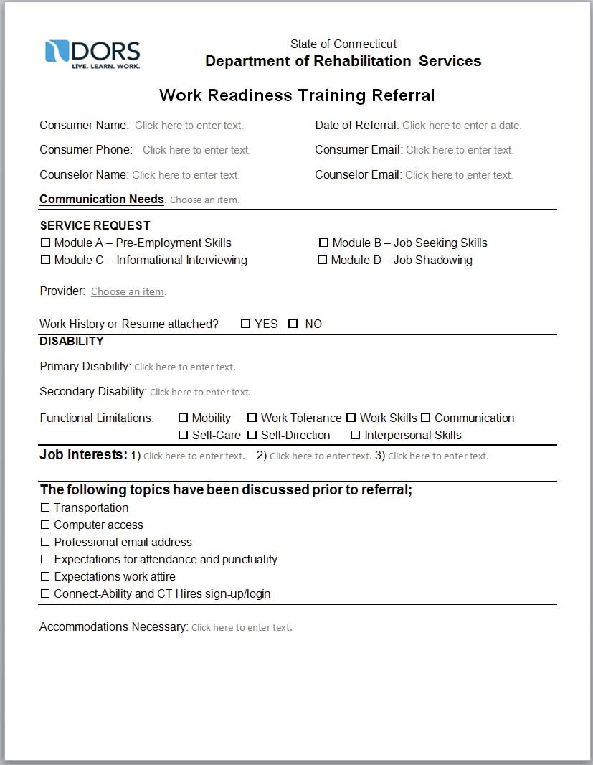
- Module A – Pre-Employment Client Evaluation Form is to be completed by each client participating in Module A.

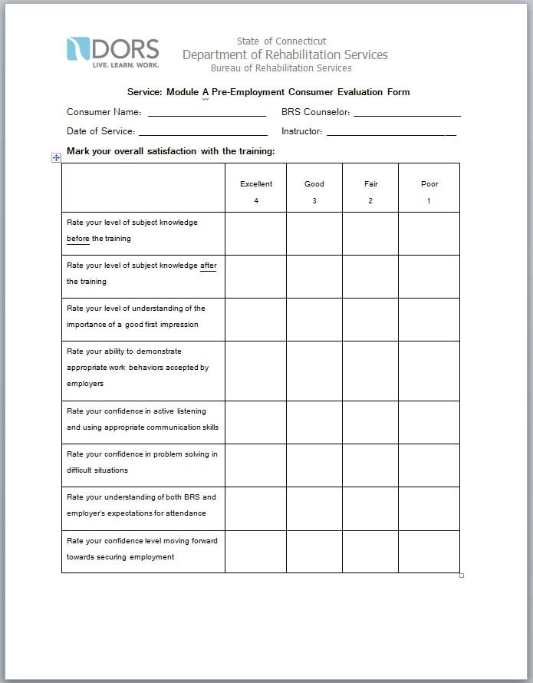

Continued on next page

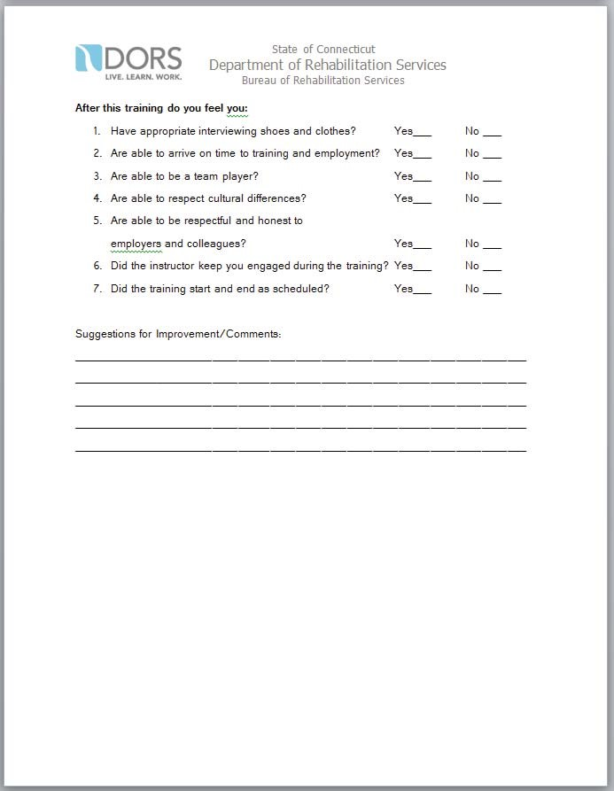

- Module A – Pre-Employment Staff Evaluation Form is to be completed by Staff for each client participating in Module A.

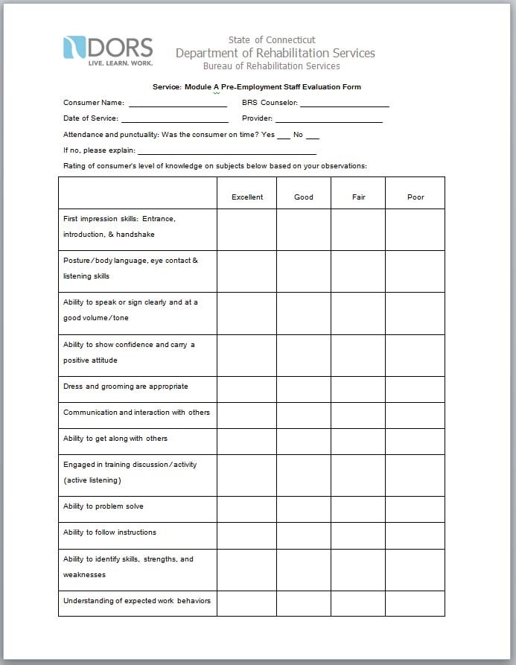

Continued on next page

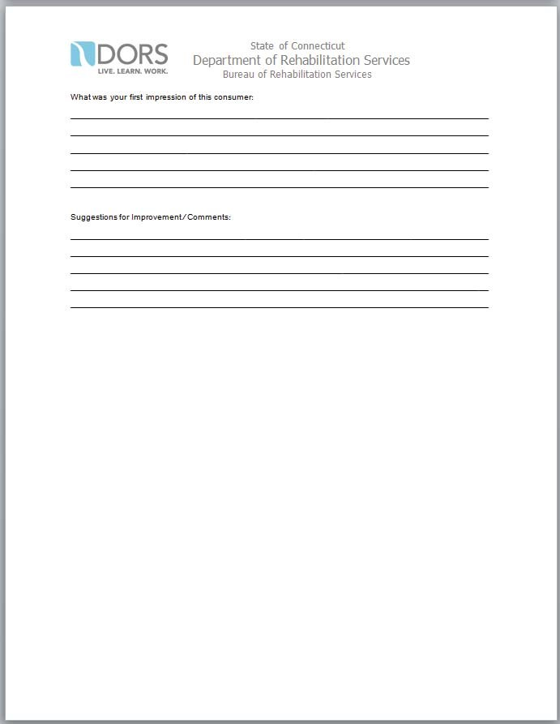

- The Information Interview Report is to be submitted by CRP upon the conclusion of this service.

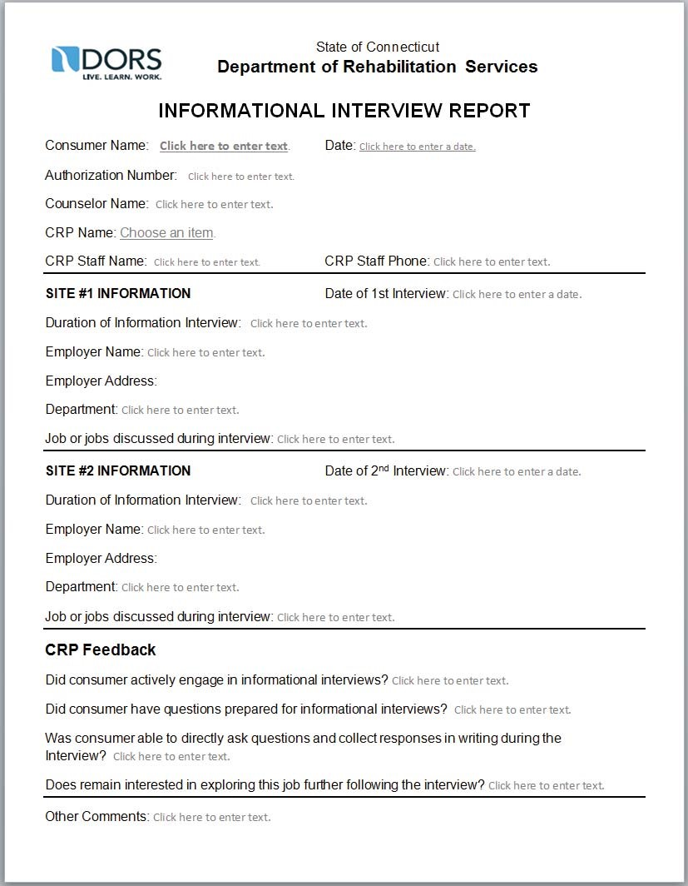

- The Job Shadow report is to be completed by CRP upon the conclusion of this service.

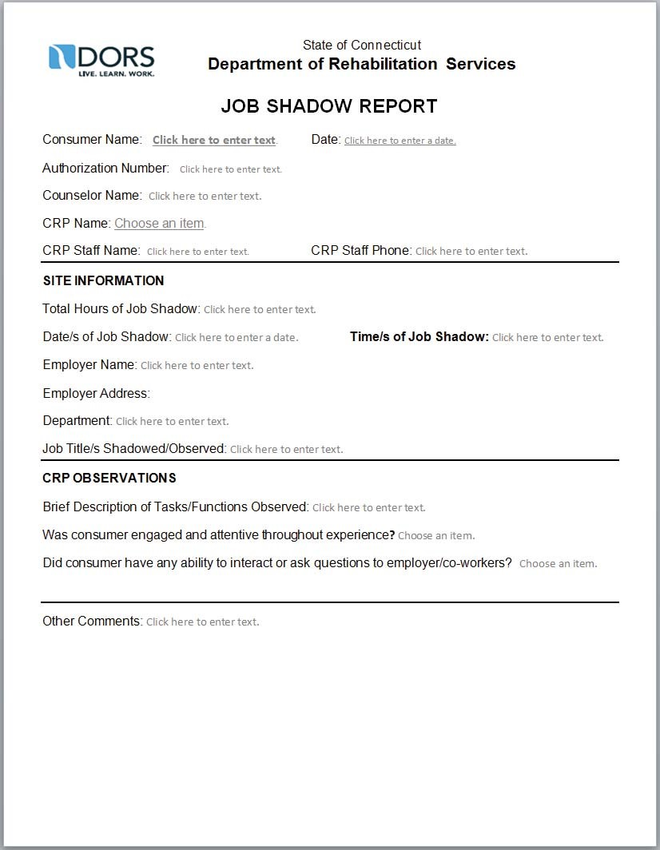

- The Trial Work Experience (TWE) Referral should be submitted by counselor to CRP when referral is made for this service.

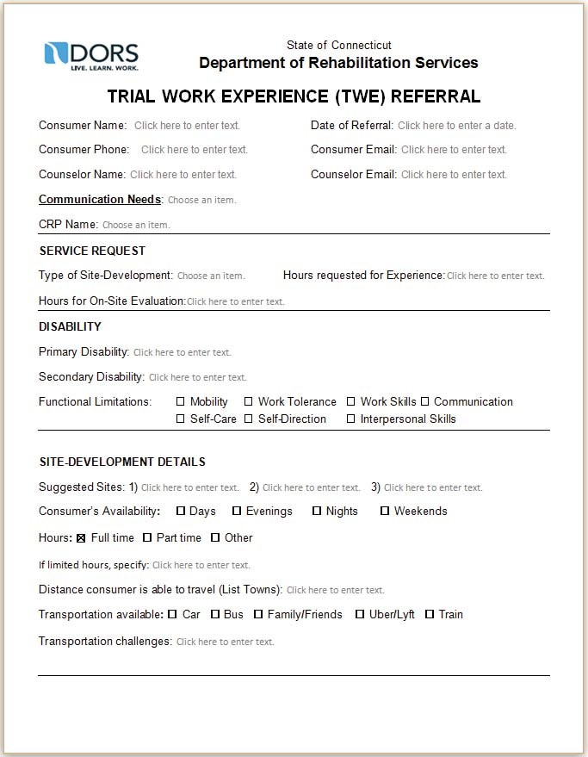
Continued on next page

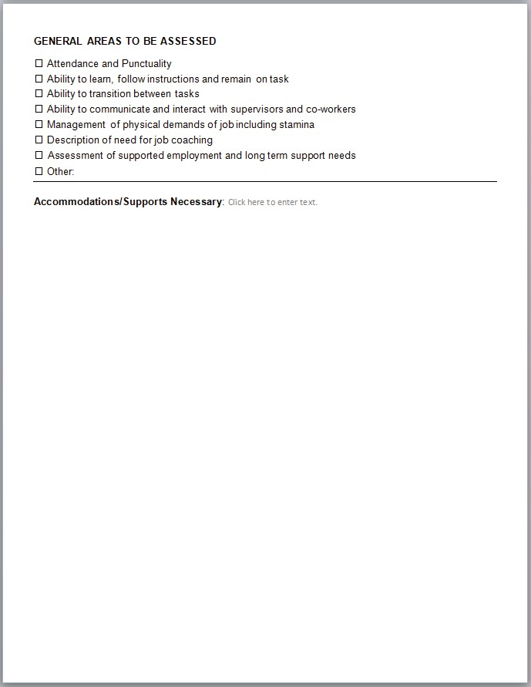

- The Trial Work Experience (TWE) Report is to be submitted by CRP upon the conclusion of this service.
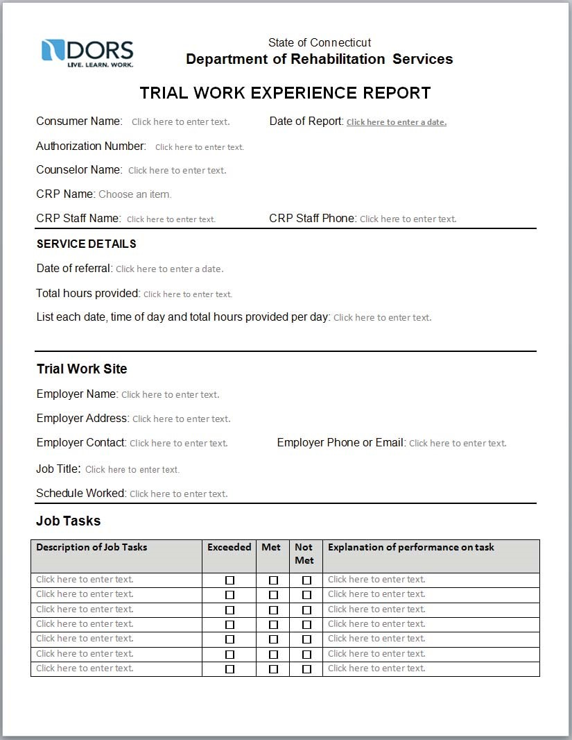

Continued on next page
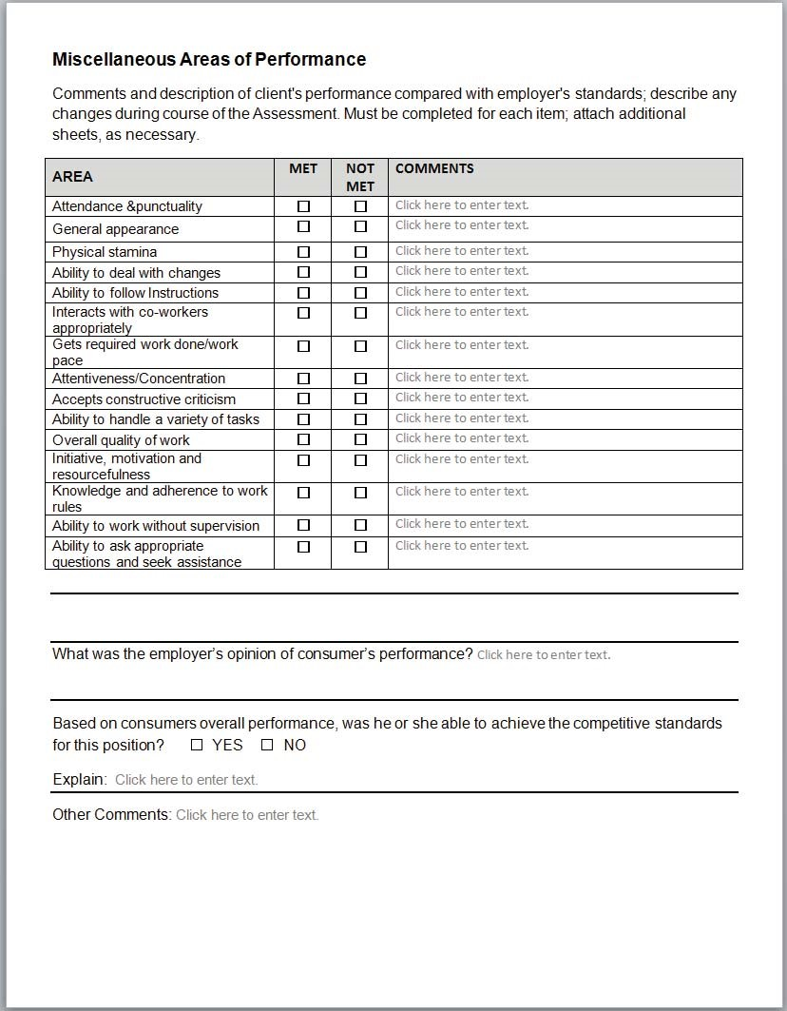

- The Work Attachment Referral is to be completed by counselor and submitted to CRP upon referral for Work Attachment Services.
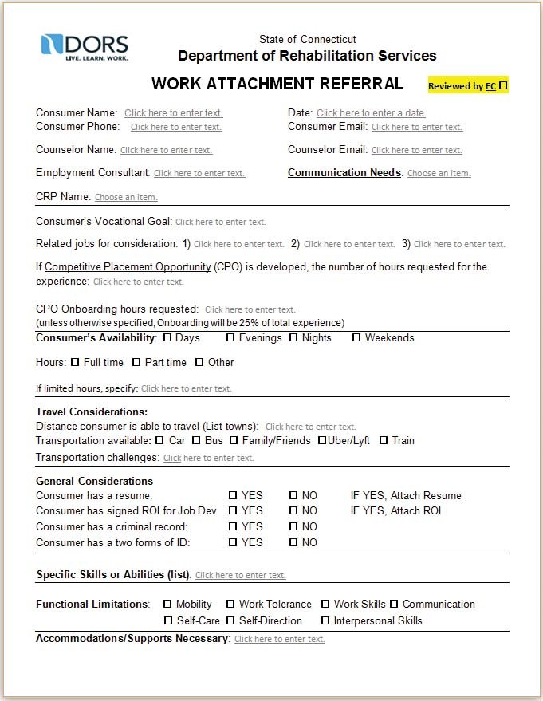

- A Work Attachment Report is due from CRP upon the identification of a Work Attachment site.

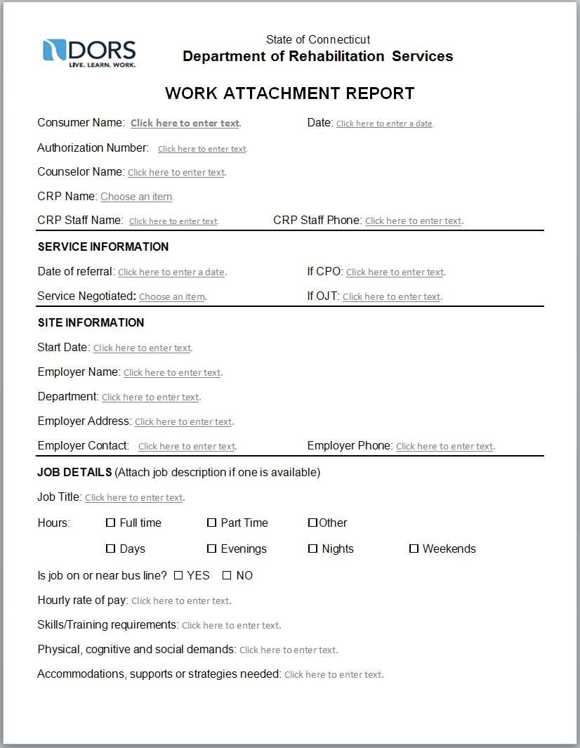

- An Onboarding Report is due from the CRP upon the conclusion of the Competitive Placement Opportunity.
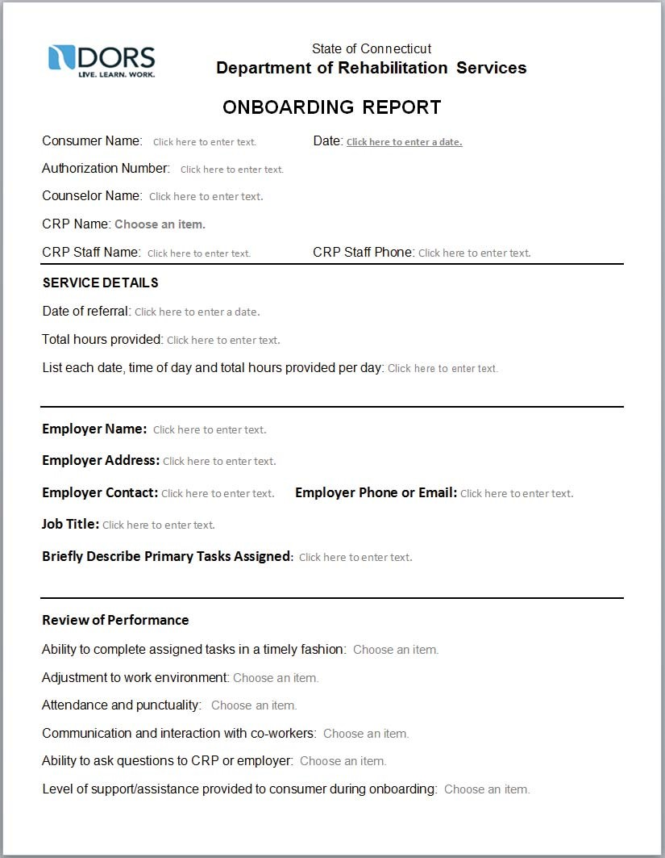

Continued on next page
Aging and Disability
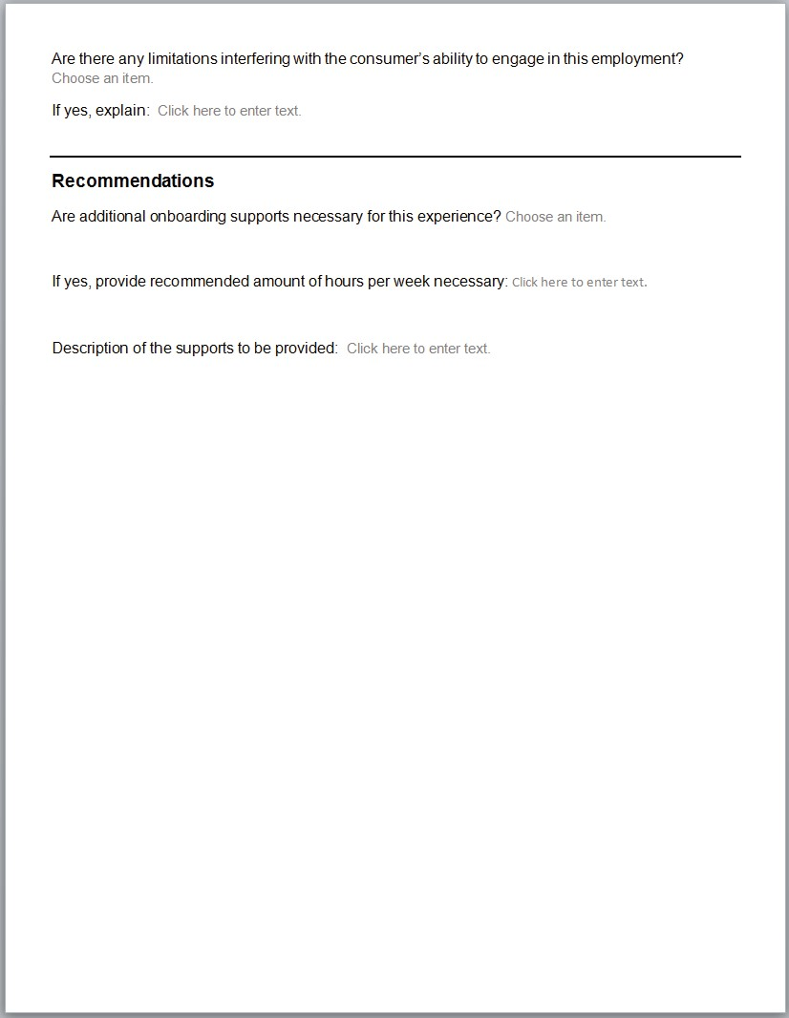

Aging and Disability
- The Job Coaching Referral Form is to be completed by counselor each time a job coaching authorization is created. (I.e. 3 months of job coaching should have 3 different referral forms).
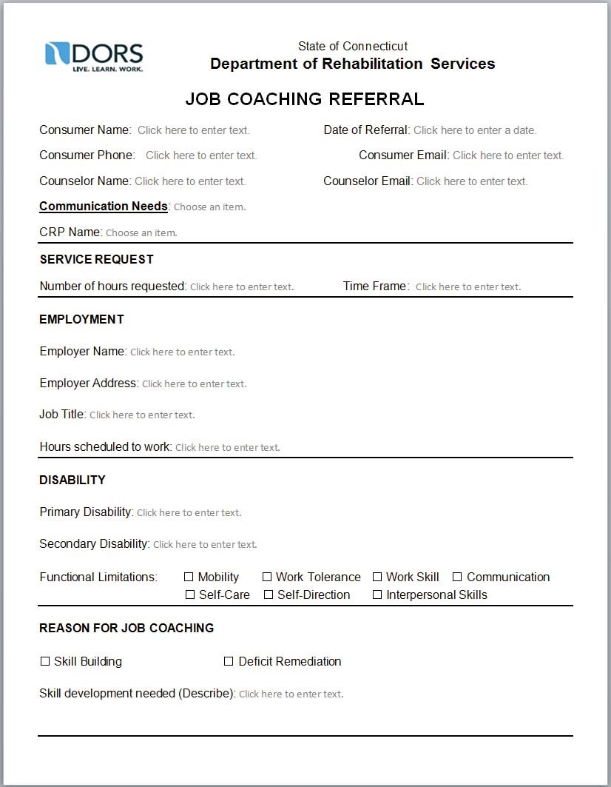

Department of$JLQJDQG'LVDELOLW\

- The Job Coaching Report is due from the CRP upon the conclusion of the service. In the event that job coaching runs for more than one month, reports would be due on a monthly basis.

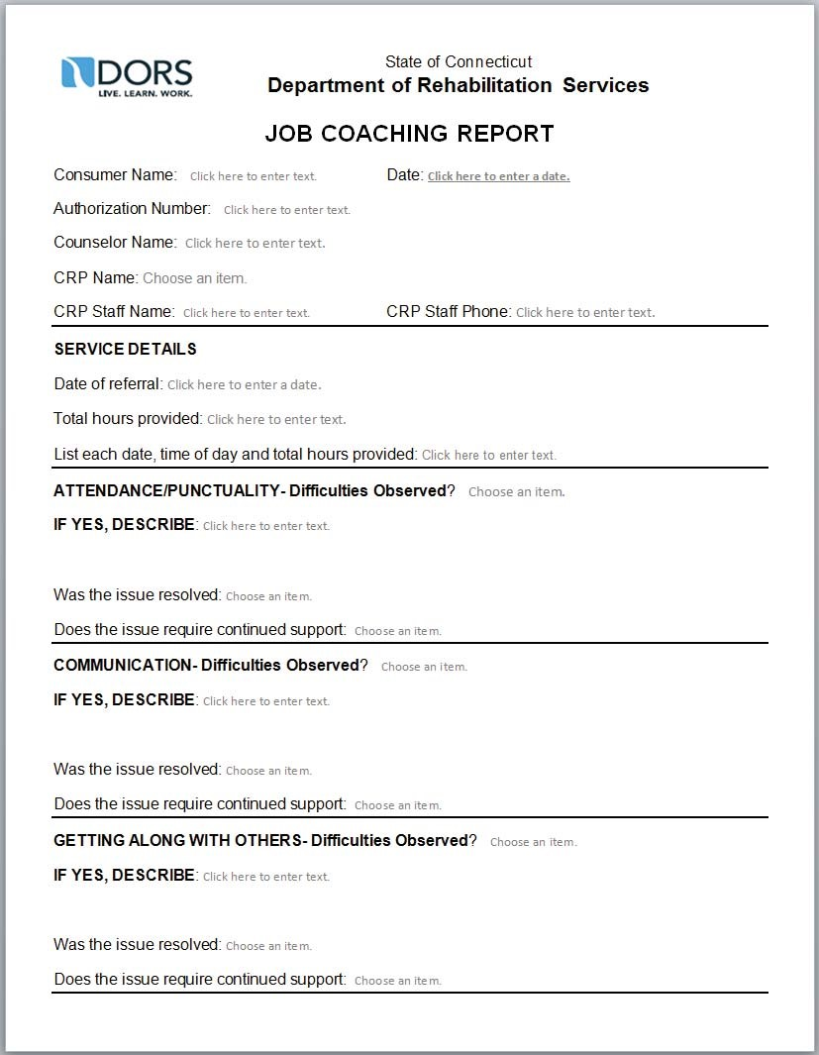

Continued on next page

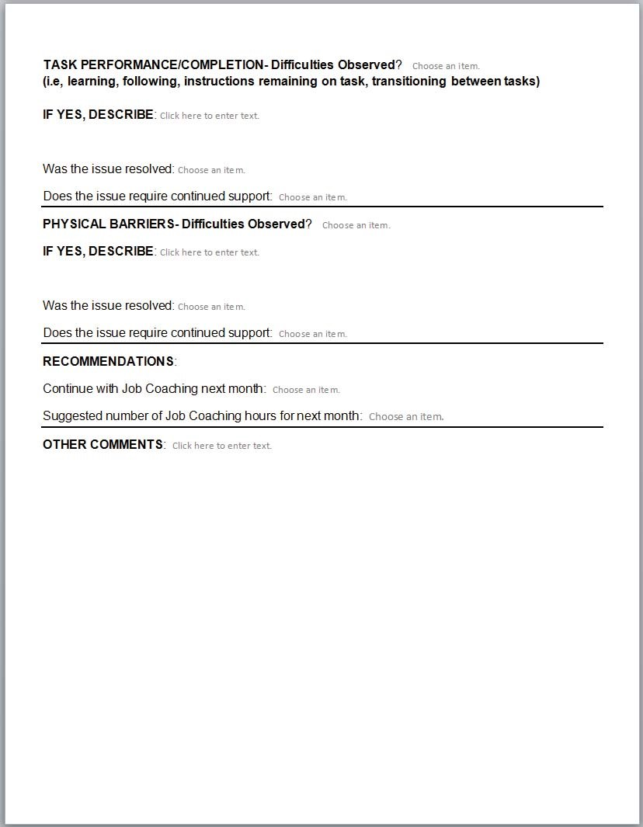

- The Communication Assessment Referral is to be completed by counselor and submitted to CRP upon referral for Communication Assessment Services.

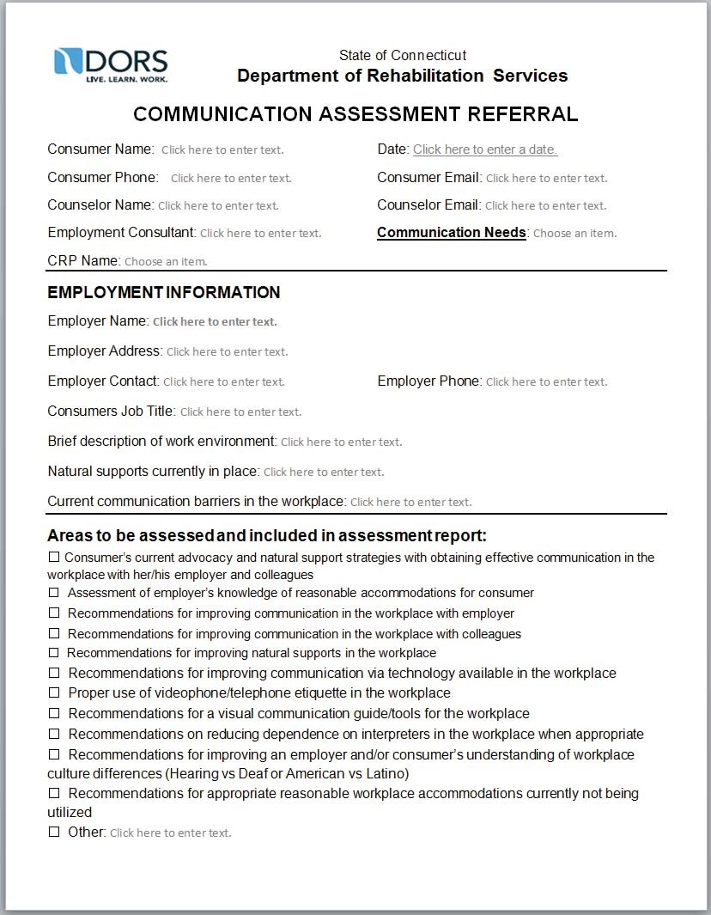

- The Communication Assessment Report is due from the CRP upon the conclusion of this service.

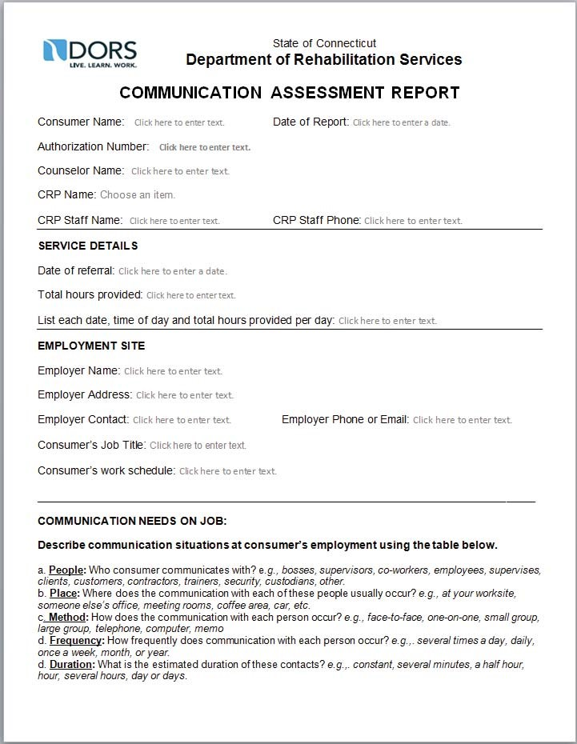

Continued on next page

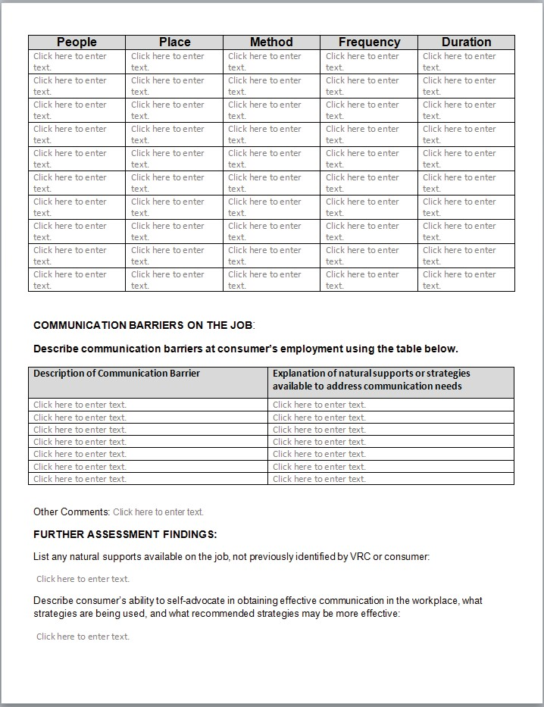

Continued on next page

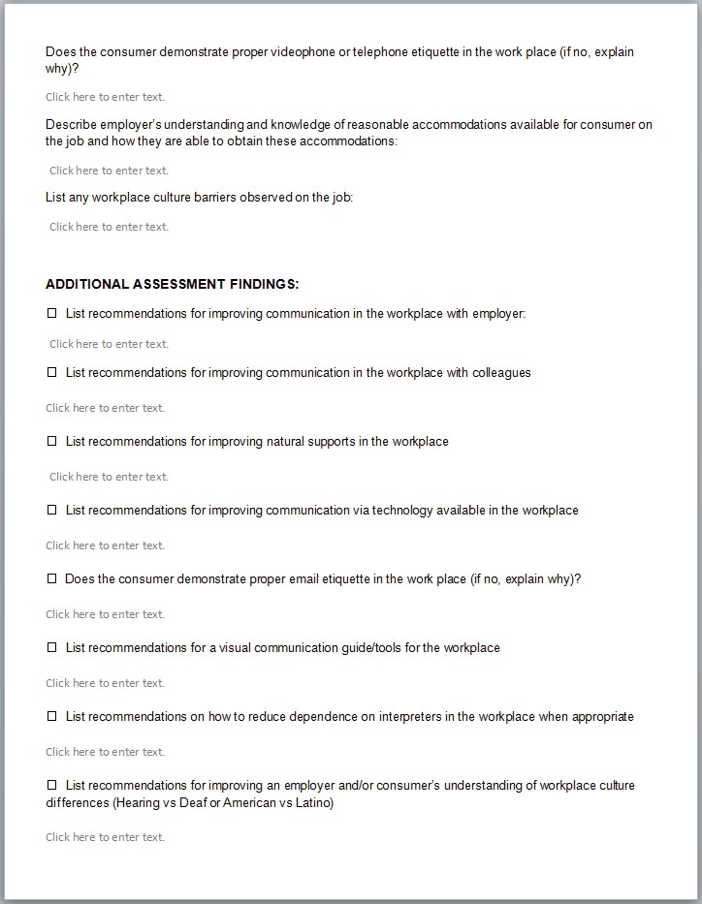

Continued on next page

- The Communication Supports Referral is to be completed by counselor and submitted to CRP upon referral for Communication Support Services.

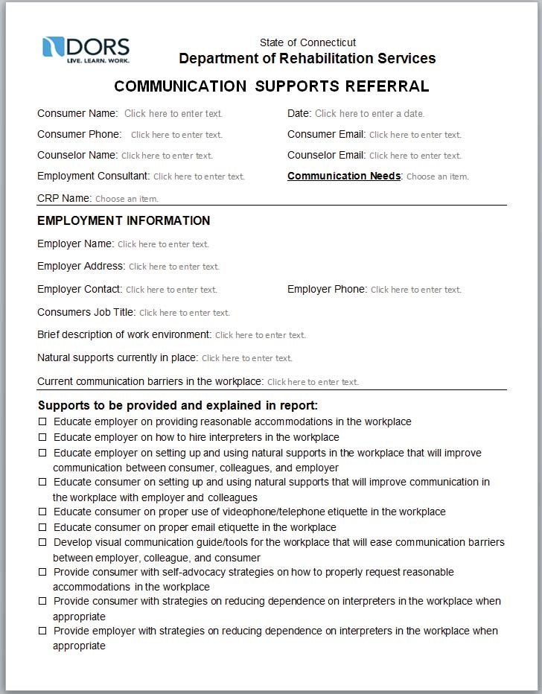

- The CRP Staff or 3rd Party Referral is to be completed by counselor and submitted to CRP upon referral for Interpreting Services.

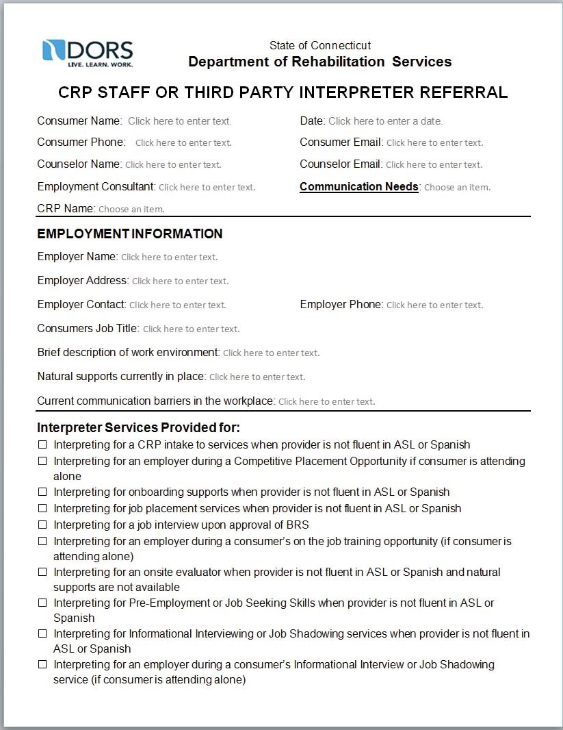

Continued on next page

- 90-Day Retention Report is due from CRP Upon the conclusion of the Client’s 90th day of employment.

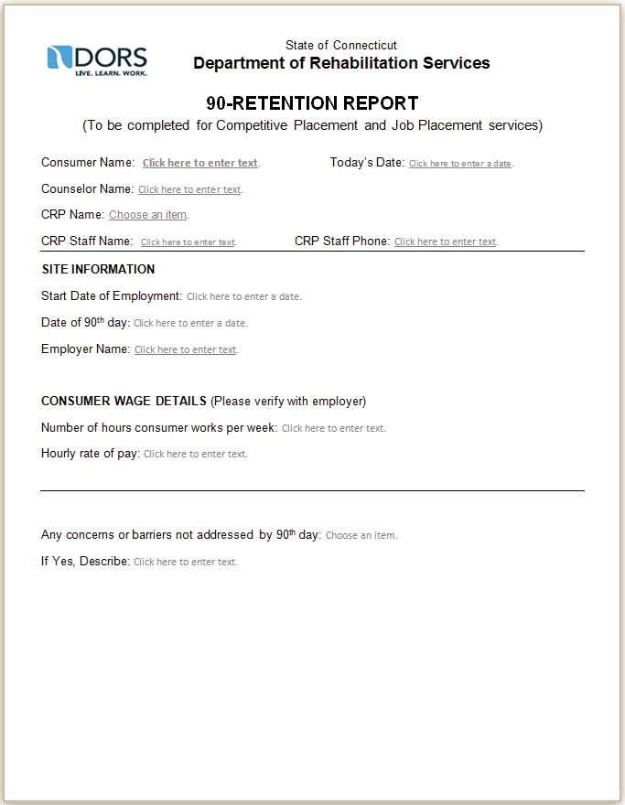

Appendix C. CRP Referral Information Guide

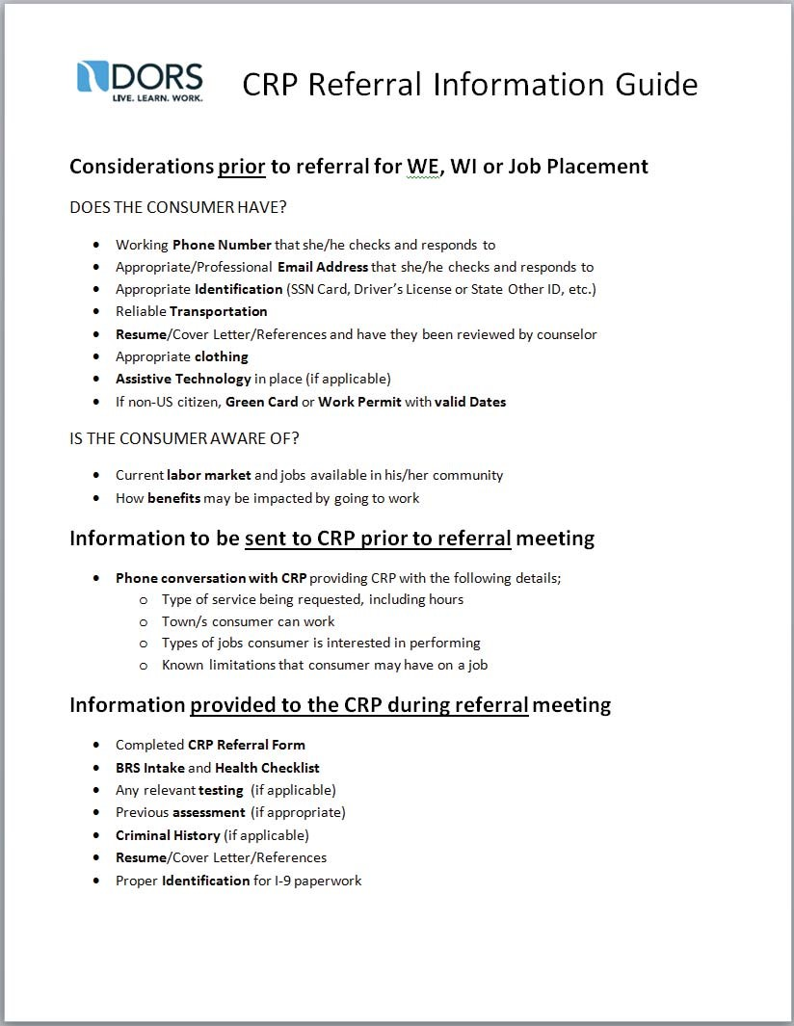
Appendix D. Interpreter Cancellation Information

